THE EDIFICE
Interoperable Divergent Intelligence
Formal Architecture for PIECE, DICE, BOSS, BOSS Ports, and Multi-Lens Cognitive Evaluation

Core proposition
Distinct intelligence forms do not need identical ontologies, symbols, memories, or cognitive operating systems in order to collaborate. Each PIECE may preserve its own lens; DICE may evaluate its predictions against observation; BOSS may compile its explicit semantic structure; and BOSS Ports may negotiate, clarify, and reconstruct meaning across radically different cognitive profiles.

Architecture in one view
Every PIECE sees through a defined lens.
DICE measures where each lens works.
BOSS preserves and compiles symbolic meaning.
BOSS Ports negotiate meaning across cognitive boundaries.
Together, they form the EDIFICE.

Architecture Concept • Version 1.0 • August 2026

Executive Summary
The EDIFICE is a proposed CERBERUS-native environment for building, testing, comparing, and coordinating extremely diverse forms of intelligence. Its purpose is not to force all participants into a single ontology. Its purpose is to let many cognitive profiles remain internally coherent while exchanging inspectable, versioned, and reconstructable relations through BOSS.
Table 1. The four-name architecture and its layered semantic association.
Layer | Formal name | Operational role | Ordinary-language association
PIECE | Perspective-Indexed Experimental Cognitive Engine | One bounded intelligence lens that models, simulates, predicts, and explains. | One piece of a larger structure.
DICE | Divergent Intelligence Competition Engine | A controlled environment for comparing predictions with observation. | Variation, repeated trials, uncertainty, and outcomes.
BOSS | BaseCode Operational Symbolic System | The shared symbolic registry, semantic compiler, and resolution layer. | The coordinating symbolic authority for the environment.
THE EDIFICE | Evolutionarily Divergent Intelligence Forms Interoperating through Competitive Evaluation | The complete ecosystem of lenses, evaluations, communication, learning, and governance. | A larger structure assembled from many pieces.

A PIECE may reason through variables that another PIECE does not recognize, use custom symbols that another system has never seen, emphasize a different timescale, or represent causality through a different geometry. BOSS does not erase those differences. It compiles the exported semantic relations into a shared intermediate representation and records the quality of every mapping. A BOSS Port can then render the message through the recipient’s existing Symbol Set, request clarification, or explicitly preserve an unresolved semantic remainder.
DICE provides the empirical discipline. A lens earns trust because its predictions, timing, intervention sensitivity, and confidence match observed outcomes under defined conditions—not because its explanation is rhetorically attractive. The result is a specialization map showing where each PIECE is reliable, where it is weak, and where several lenses are complementary.

Central significance
The architecture makes cognitive diversity operational. Different intelligence forms can remain different, compete honestly against reality, communicate through reconstructable symbolic relations, and teach one another through exact, near-semantic, structural, and metaphorical mappings.

Table of Contents
Page numbers are fixed to this edition and verified against the rendered document.
1. Purpose, Scope, and Design Thesis 8
1.1 Formal definition of the EDIFICE environment 8
1.2 The four-name architecture 8
1.3 Relationship to BOSS and CERBERUS 8
1.4 Scope, assumptions, and nonclaims 8
1.5 Core design principles 9
2. Why Divergent Intelligence Needs an Environment 11
2.1 Cognitive profiles and cognitive operating systems 11
2.2 Limits of a universal ontology 11
2.3 Surface communication hides operational structure 12
2.4 Empirical observation as a common reference 12
2.5 Cognitive diversity without semantic fragmentation 12
3. Architectural Overview 13
3.1 The EDIFICE as the complete ecosystem 13
3.2 PIECE as the unit of divergent cognition 13
3.3 DICE as the competitive evaluation environment 13
3.4 BOSS as the semantic compilation layer 13
3.5 BOSS Ports as communication boundaries 14
3.6 End-to-end information flow 14
4. PIECE: Perspective-Indexed Experimental Cognitive Engines 15
4.1 PIECE identity and scope 15
4.2 Lens fields and variable categories 15
4.3 Native ontology and Symbology 16
4.4 Operators, simulations, and predictions 16
4.5 Salience, memory, goals, and action policy 16
4.6 Structured reasoning artifacts 17
4.7 PIECE lifecycle and evolution 17
5. DICE: Divergent Intelligence Competition Engine 18
5.1 Case registration and controlled dispatch 18
5.2 Independent modeling and operator simulation 18
5.3 Observation and outcome capture 18
5.4 Evaluation metrics 18
5.5 Scoped winners and specialization maps 19
5.6 Multi-lens synthesis 20
5.7 Evolution, forking, retirement, and retention 20
6. BOSS as a Shared Logical Compilation Layer 21
6.1 BaseCodes, Symbol Keys, and contextual meaning 21
6.2 Semantic intermediate representation 21
6.3 Exact, approximate, and non-equivalent mappings 22
6.4 Near-semantic and metaphorical learning 23
6.5 Recipient-native rendering 23
6.6 Preserving native ontologies 23
7. BOSS Ports 24
7.1 Definition and responsibilities 24
7.2 Port profiles and capability negotiation 24
7.3 Semantic handshake 25
7.4 Clarification and repair 25
7.5 Semantic receipts 25
7.6 AI-to-AI backend communication 25
7.7 Port security and execution boundaries 26
8. Multi-Base Communication Protocols 27
8.1 Personal Bases and cognitive sovereignty 27
8.2 Relationship-specific crosswalks 27
8.3 Organizational and professional protocols 27
8.4 Selective disclosure and private meaning 27
8.5 Shared conversational history 28
8.6 Interoperability across cognitive operating systems 28
9. Multi-Lens, Multi-Modal Learning 29
9.1 Learning from agreement and disagreement 29
9.2 Variable-change analysis 29
9.3 Symbolic explanation of model performance 29
9.4 Multimodal renderings of one relation graph 30
9.5 Analogical transfer across Communities 30
9.6 Human learning interfaces 30
10. Worked Example: Industrial Equipment Anomaly 31
10.1 Case description 31
10.2 Competing PIECE models 31
10.3 DICE evaluation 32
10.4 BOSS synthesis and explanation 32
10.5 Operational response 32
11. Worked Example: Music Learning and Composition 33
11.1 Multiple music lenses 33
11.2 Symbol-to-sound and instrument mapping 33
11.3 DICE comparison of interpretations 33
11.4 Memory and emotional provenance 33
11.5 Cross-Community learning 34
12. Worked Example: Personal Training and Planning 35
12.1 Competing training lenses 35
12.2 Variable-change simulations 35
12.3 Observation and adaptation 35
12.4 BOSS explanation for the user 35
13. CERBERUS Data Model and Implementation 36
13.1 Proposed registries 36
13.2 Core relationships 37
13.3 DataSpecs and Instances 37
13.4 NodeKeys, Memories, Events, and Liminal Bridges 37
13.5 AI Skills and Action Contracts 37
13.6 Minimum viable data flow 37
14. Inspectability, Explainability, and Scientific Integrity 38
14.1 What must remain inspectable 38
14.2 Structured rationale versus hidden internal reasoning 38
14.3 Evidence, provenance, and falsifiability 38
14.4 Reproducibility and version pinning 38
14.5 Calibration and uncertainty 39
14.6 Preventing persuasive but unsupported explanations 39
15. Governance, Security, and Safety 40
15.1 Semantic injection and malicious mappings 40
15.2 Privacy and least-semantic-disclosure 40
15.3 Competition failure modes 40
15.4 Execution authority and human review 40
15.5 Bias, capture, and cognitive monoculture 41
15.6 Lifecycle governance 41
16. Implementation Roadmap 42
16.1 Phase 1: minimum viable EDIFICE 42
16.2 Phase 2: BOSS Ports and Crosswalks 42
16.3 Phase 3: multimodal learning and simulation 42
16.4 Phase 4: federated PIECE ecosystems 42
16.5 Evaluation criteria 42
17. Future Implications 43
17.1 Education and personalized learning 43
17.2 Scientific discovery and hypothesis ecosystems 43
17.3 Engineering, manufacturing, and digital twins 43
17.4 Healthcare education and bounded decision support 43
17.5 Law, policy, and institutional reasoning 44
17.6 Creative production and cultural preservation 44
17.7 Accessibility and neurodivergent cognition 44
17.8 Robotics and embodied intelligence 44
17.9 Synthetic and alien cognition 44
17.10 Collective intelligence without semantic flattening 44
17.11 Self-evolving symbolic ecosystems 44
17.12 Long-term risks and enabling conditions 44
18. Conclusion 46
Appendix A. Proposed PIECE Profile Schema 47
Appendix B. Proposed DICE Experiment Schema 48
Appendix C. Illustrative BOSS Port Packet 49
Appendix D. Semantic Resolution Taxonomy 50
Appendix E. EDIFICE Conformance Checklist 51

List of Figures
Figure 1. The layered EDIFICE architecture. PIECE lenses compete in DICE and communicate through BOSS and BOSS Ports. 10
Figure 2. Internal architecture of a Perspective-Indexed Experimental Cognitive Engine. 15
Figure 3. The DICE evaluation loop from case registration through specialization mapping and revision. 18
Figure 4. BOSS as a shared semantic compilation layer between different native cognitive lenses. 21
Figure 5. The BOSS Port semantic handshake and clarification lifecycle. 24
Figure 6. Semantic resolution ladder from identity through metaphorical mapping, conflict, and unresolved meaning. 22
Figure 7. Interoperability among human, AI, and embodied cognitive operating systems. 27
Figure 8. Multi-lens, multi-modal learning from one shared problem. 29
Figure 9. Industrial equipment anomaly evaluated through five PIECE lenses. 31
Figure 10. Illustrative DICE specialization map across problem classes. 20
Figure 11. CERBERUS registry and operational integration for the EDIFICE. 36
Figure 12. A future federated ecosystem of specialized intelligence forms. 43

List of Tables
Table 1. The four-name architecture and its layered semantic association. 7
Table 2. Core design principles. 9
Table 3. Components of a cognitive operating system. 11
Table 4. Primary EDIFICE layers and responsibilities. 13
Table 5. Recommended PIECE profile fields. 15
Table 6. Structured reasoning artifacts exported by a PIECE. 17
Table 7. DICE evaluation dimensions. 18
Table 8. Resolution grades used by BOSS. 22
Table 9. BOSS Port profile fields. 24
Table 10. Semantic receipt contents. 25
Table 11. Multi-lens learning modes. 30
Table 12. Industrial anomaly predictions by lens. 31
Table 13. Illustrative DICE evaluation of the industrial case. 32
Table 14. Music PIECE lenses and outputs. 33
Table 15. Training PIECE lenses and intervention predictions. 35
Table 16. Proposed CERBERUS registries for the EDIFICE. 36
Table 17. Inspectability requirements. 38
Table 18. Governance threats and controls. 40
Table 19. Implementation roadmap. 42
Table 20. Future applications and enabling conditions. 44
Table A-1. Illustrative PIECE Profile record. 47
Table B-1. Illustrative DICE Experiment record. 48
Table D-1. Semantic resolution taxonomy. 50

1. Purpose, Scope, and Design Thesis

1.1 Formal definition of the EDIFICE environment
The EDIFICE is a registry-backed experimental ecosystem in which multiple cognitive engines analyze the same problem through distinct, explicitly scoped intelligence lenses; simulate changes using their own operators and symbolic ontologies; publish inspectable predictions and structured rationales; receive empirical evaluation through DICE; and remain interoperable through BOSS semantic compilation and BOSS Port communication.
Formal operating pattern
Problem + shared case packet
→ multiple PIECE lenses
→ independent symbolic models and simulations
→ predictions + confidence + falsifiers
→ observation and DICE scoring
→ BOSS-compiled explanation and specialization map

1.2 The four-name architecture
The names are intentionally layered. Each acronym describes a technical object, while the ordinary word supplies a mnemonic metaphor. This is itself a BOSS design pattern: visible language and deeper semantic structure reinforce one another.
A PIECE is not necessarily a separate general-purpose AI. It may be a specialized agent, model configuration, rules engine, simulation method, organizational perspective, human cognitive profile, or composite analytical system. DICE can compare any engines that produce compatible prediction and explanation artifacts. BOSS provides shared semantic resolution. The EDIFICE is the containing environment.

1.3 Relationship to BOSS and CERBERUS
CERBERUS provides the registry architecture, stable NodeKeys, linked data, Memories, Events, Liminal Bridges, DataSpecs, Instances, Action Contracts, AI Skills, and provenance traversal needed to implement the environment. BOSS supplies the symbolic layer: BaseCodes, glyphs, Symbology Keys, Communities, Families, definitions, examples, close relations, grammars, media, and operational bindings.
PIECE and DICE use those foundations rather than creating an isolated AI framework. A PIECE can be assembled from Registry records. A DICE experiment can link to exact observations and versions. A BOSS Port can resolve symbols through the existing Semantic Mesh. The result is a system whose architecture, reasoning artifacts, evaluation history, and communication mappings remain inspectable inside the same semantic environment.

1.4 Scope, assumptions, and nonclaims
- The architecture is a formal design concept and implementation direction, not a claim that every cognitive process can be completely formalized.
- Interoperability means reconstructing declared relations and operational intent; it does not prove that two intelligences have identical subjective experience.
- Structured rationale is required, but hidden or proprietary internal chain-of-thought need not be exposed. The system operates on explicit assumptions, evidence, variables, operators, predictions, and alternatives.
- DICE evaluation complements—not replaces—domain expertise, experimental design, statistical controls, safety review, and human governance.
- A close semantic mapping is not automatically an exact equivalence. BOSS must preserve mapping grade and semantic remainder.

1.5 Core design principles
Table 2. Core design principles.
Principle | Meaning in the EDIFICE
Perspective indexing | Every model is tied to a declared lens, scope, assumptions, evidence access, and version.
Cognitive sovereignty | A PIECE or Base may retain its own ontology, symbols, examples, memory, and internal organization.
Empirical competition | Lens quality is evaluated against observation and intervention results rather than fluency alone.
Semantic inspectability | Exported variables, operators, relations, evidence, predictions, and uncertainty remain reviewable.
Non-flattening interoperability | BOSS maps shared structure while preserving unresolved or non-equivalent distinctions.
Scoped specialization | A PIECE can be best for one problem class without becoming the universal model.
Multimodal equivalence | Text, glyphs, graphs, sound, animation, spatial layouts, and interface controls may render the same relations.
Governed execution | Communication metadata cannot silently acquire authority to mutate data or invoke tools.

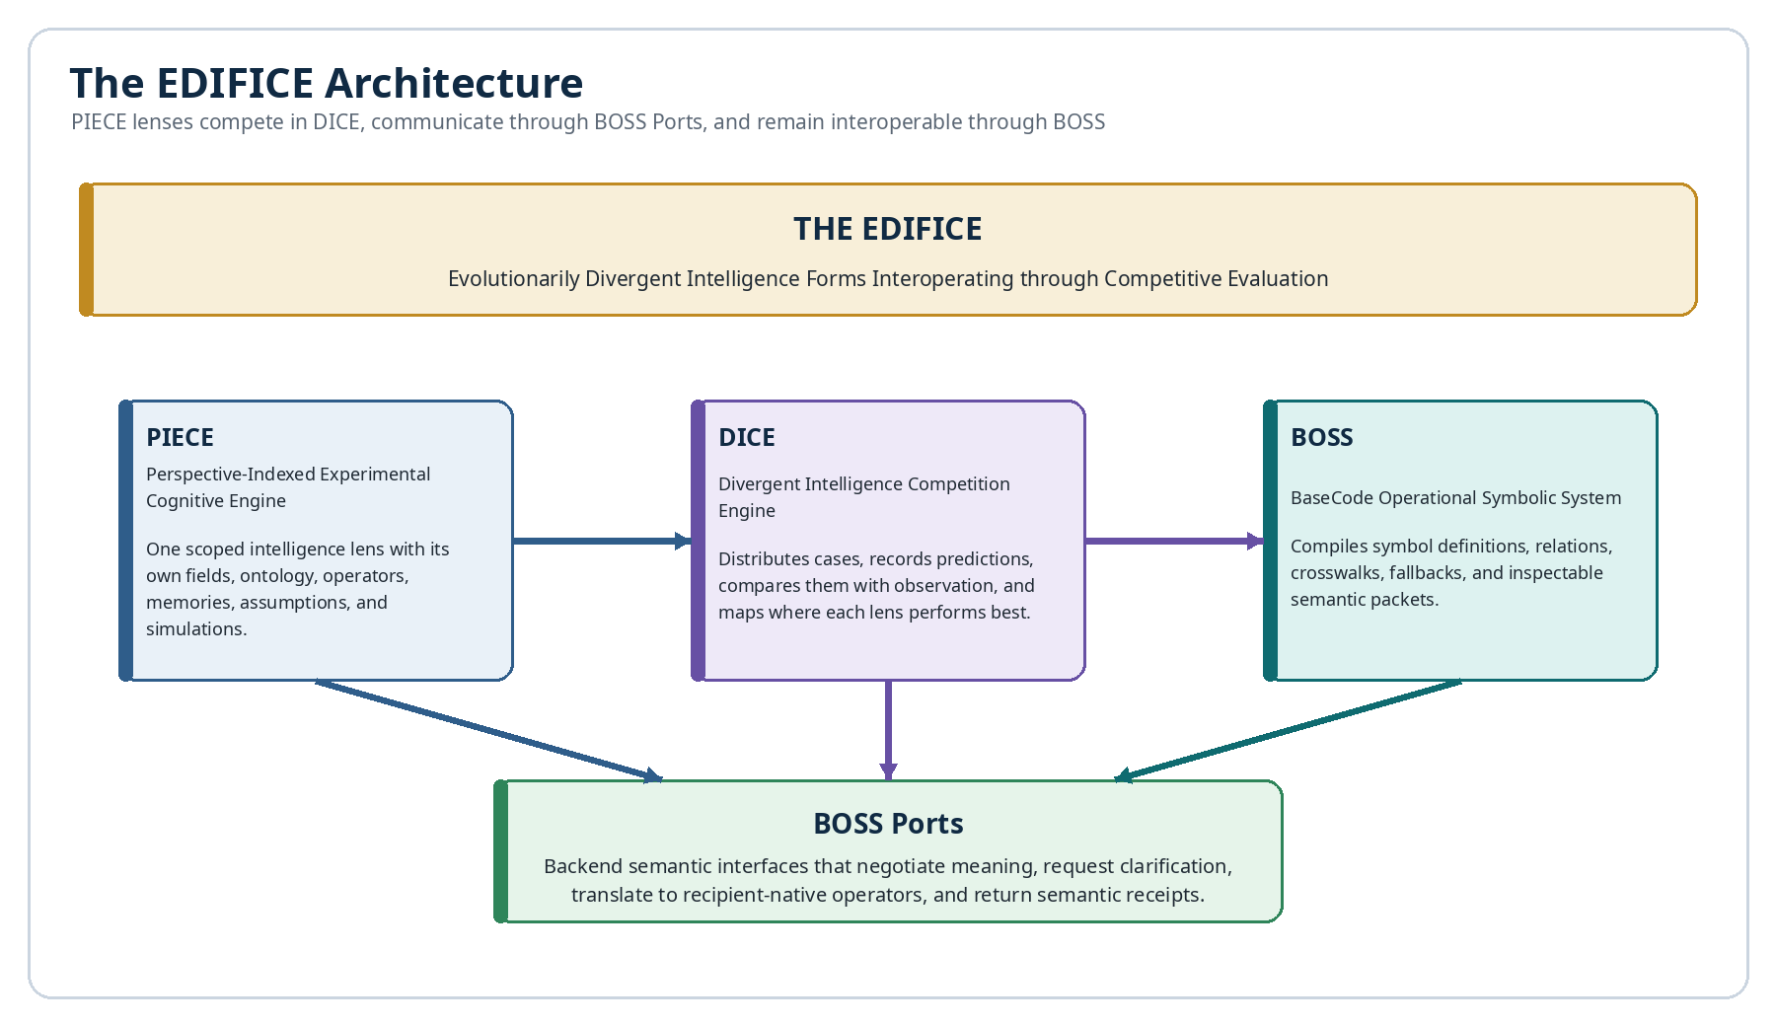
Figure 1. The layered EDIFICE architecture. PIECE lenses compete in DICE and communicate through BOSS and BOSS Ports.

2. Why Divergent Intelligence Needs an Environment

2.1 Cognitive profiles and cognitive operating systems
An intelligence does not only contain knowledge. It possesses a method of selecting what matters, organizing variables, representing relationships, interpreting uncertainty, storing experience, modeling time, and choosing actions. This complete organization can be treated as a cognitive operating system.
Table 3. Components of a cognitive operating system.
Component | Questions it answers
Field categories | What kinds of variables or entities exist?
Salience model | What receives attention, urgency, or weight?
Ontology | How are concepts separated, named, and related?
Symbology | How are those concepts represented and composed?
Temporal model | Is time linear, cyclical, event-based, continuous, or multi-scale?
Causal model | What counts as cause, influence, constraint, emergence, or correlation?
Memory model | What is retained, linked, forgotten, or treated as evidence?
Action policy | How do predictions become choices, recommendations, or interventions?
Explanation profile | How are assumptions, alternatives, uncertainty, and rationale communicated?

Two systems may use similar field categories while applying different operators. A physiological lens and a behavioural lens may both track “fatigue,” but one may model it as resource depletion while the other models it as reduced willingness to sustain effort. The EDIFICE allows both representations to exist and tests where each predicts observable outcomes.

2.2 Limits of a universal ontology
A single ontology simplifies communication but can create cognitive monoculture. It may privilege the variables, timescales, metaphors, and causal structures that were easiest for its designers to encode. Important patterns can disappear because the shared schema has no field for them.
The EDIFICE instead treats ontological divergence as an experimental asset. A new PIECE may introduce unusual field categories or operators. DICE determines whether those distinctions improve prediction, intervention selection, explanation, or learning. BOSS provides enough common structure to compare the results without requiring all lenses to use the same internal vocabulary.

2.3 Surface communication hides operational structure
Natural language and ordinary AI messages often expose conclusions without fully specifying the model that produced them. The recipient must infer the active variables, operator meanings, scope, evidence thresholds, and temporal assumptions. Two explanations may sound identical while relying on incompatible models.
The EDIFICE requires explicit reasoning artifacts: selected fields, input states, operator chains, predicted outputs, confidence, timing, falsifiers, and evidence links. BOSS then compiles those artifacts into a transferable relation graph. This does not reveal private internal cognition; it creates a deliberate public rationale suitable for inspection and comparison.

2.4 Empirical observation as a common reference
Different lenses need a shared point of contact. In the EDIFICE, that point is the Observation Registry: measurements, outcomes, human reviews, simulation results, event records, or other declared evidence. DICE compares predictions against those observations under controlled conditions.

Reality is the referee, not a forced ontology
PIECEs may disagree about why an outcome occurs. DICE can still measure which lens predicted the outcome, timing, sensitivity, and failure conditions most accurately. The architecture permits explanation pluralism while preserving empirical discipline.

2.5 Cognitive diversity without semantic fragmentation
Uncontrolled divergence would produce isolated languages that cannot collaborate. Forced convergence would erase useful distinctions. BOSS supplies the middle path: stable local identities, explicit crosswalks, typed relations, mapping grades, recipient-native renderings, and semantic receipts. Differences remain visible, but they no longer prevent coordinated analysis.

3. Architectural Overview
Table 4. Primary EDIFICE layers and responsibilities.
Layer | Primary responsibility | Key artifacts
THE EDIFICE | Hosts the federated environment and its governance. | Lens ecosystem, policy, specialization maps, shared history.
PIECE | Models a problem through one defined cognitive lens. | Fields, symbols, operators, predictions, rationale, confidence.
DICE | Evaluates competing lenses against common observations. | Cases, experiments, scores, rankings, specialization.
BOSS | Compiles and resolves symbolic meaning across lenses. | BaseCodes, Symbol Keys, crosswalks, relation graphs, fallbacks.
BOSS Port | Connects native cognitive systems to the shared semantic layer. | Port profile, handshake, clarification, receipt.
CERBERUS | Provides the registry, provenance, Instance, and governance substrate. | Registries, NodeKeys, DataSpecs, Memories, Events, Action Contracts.

3.1 The EDIFICE as the complete ecosystem
The EDIFICE is the institutional and technical environment in which PIECEs are created, versioned, tested, compared, connected, retained, forked, or retired. It includes the rules that determine valid evidence, permitted competition, disclosure, execution, and cross-lens synthesis.

3.2 PIECE as the unit of divergent cognition
A PIECE is a bounded cognitive engine. It may be narrow or broad, human-authored or learned, symbolic or hybrid, deterministic or probabilistic. Its defining requirement is perspective indexing: the lens must declare what it sees, how it transforms information, what it predicts, and where its scope ends.

3.3 DICE as the competitive evaluation environment
DICE provides repeatable comparison. It distributes the same authorized case to multiple PIECEs, captures their predictions before outcomes are revealed, records observations, calculates evaluation metrics, and updates context-specific specialization maps.

3.4 BOSS as the semantic compilation layer
BOSS converts native symbol use into stable semantic objects. A glyph is linked to a Symbology Key; the Key resolves to its definition, Community, Family, close relations, examples, grammar, input and output kinds, and operational bindings. BOSS exports those relations without requiring the recipient to adopt the sender’s glyph.

3.5 BOSS Ports as communication boundaries
A BOSS Port is an ingress and egress boundary around a PIECE, Base, agent, organization, or application. It publishes supported semantic capabilities, receives symbol manifests and relation graphs, resolves mappings to local operators, requests clarification when needed, and returns a semantic receipt.

3.6 End-to-end information flow
End-to-end EDIFICE flow
Case Registry → authorized case packet
→ PIECE native model and simulation
→ BOSS Port export
→ BOSS intermediate representation
→ DICE prediction registry
→ Observation Registry
→ evaluation and specialization update
→ BOSS-compiled explanation for humans and agents

4. PIECE: Perspective-Indexed Experimental Cognitive Engines
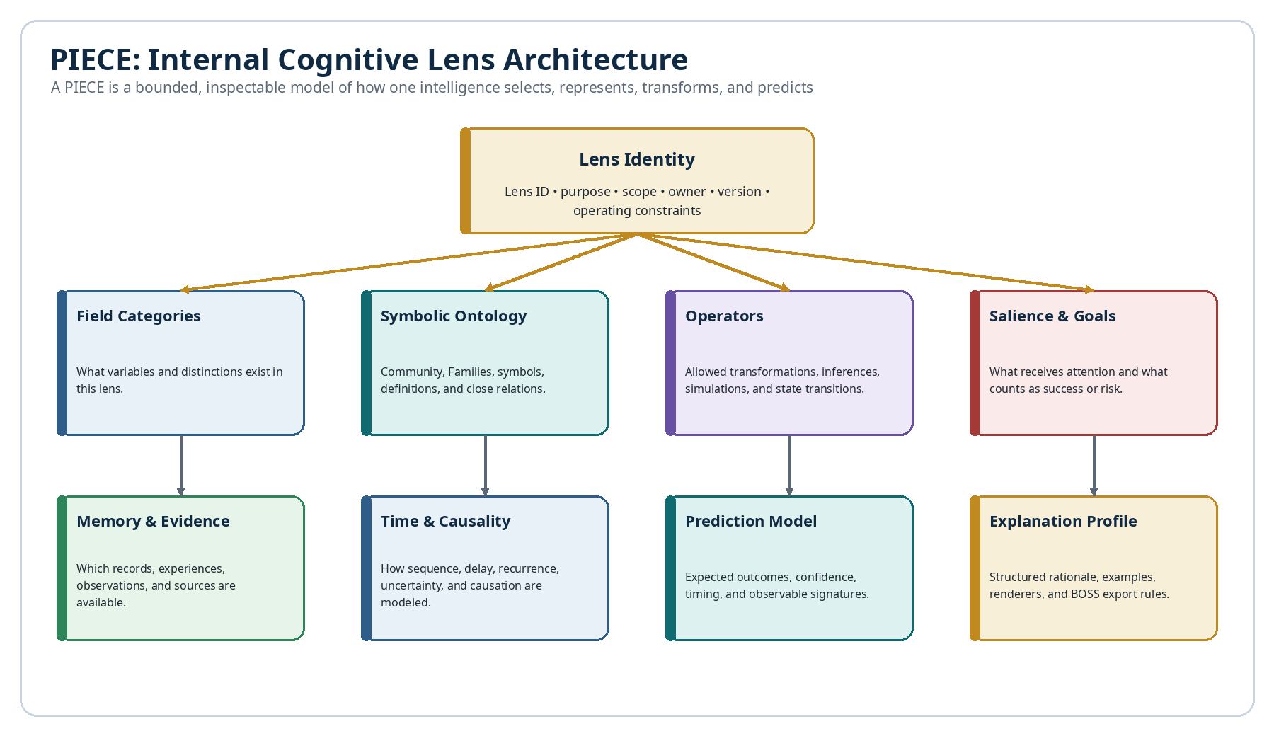
Figure 2. Internal architecture of a Perspective-Indexed Experimental Cognitive Engine.

4.1 PIECE identity and scope
Every PIECE requires a stable identity, version, declared purpose, owner, domain scope, authorized evidence sources, and known exclusions. The word “experimental” is important: a PIECE is allowed to propose a novel ontology, but its claims remain testable and revisable.

4.2 Lens fields and variable categories
Field categories define what the PIECE can represent. A mechanical PIECE might recognize force, friction, alignment, vibration, and wear. A social PIECE might recognize trust, status, reciprocity, conflict, and coordination cost. A music PIECE might recognize pitch, rhythm, tension, timbre, and gesture.
Table 5. Recommended PIECE profile fields.
Field group | Representative contents
Identity | PIECE ID, Name, Lens Class, owner, version, status.
Scope | Problem classes, timescales, environments, exclusions, safety limits.
Ontology | Field categories, entities, states, relation types, definitions.
Symbology | Linked BOSS Communities, Families, Symbol Keys, custom BaseCodes.
Operators | Transformations, simulations, inference rules, validation rules.
Evidence | Authorized tables, sensors, Memories, Events, source standards.
Prediction | Output kinds, timing, confidence, expected signatures, falsifiers.
Communication | BOSS Port, explanation profile, renderers, fallback language.
Governance | Human review, execution permissions, retention, audit, rollback.

4.3 Native ontology and Symbology
A PIECE may use an existing BOSS Community or define a local Community package. Its symbols can be public Unicode, Unicode sequences, custom BaseCode glyphs, colors, sounds, spatial components, or multimodal signals. The stable Symbology Key—not the glyph alone—identifies each contextual meaning.

4.4 Operators, simulations, and predictions
Operators convert modeled inputs into new states. A PIECE may execute deterministic rules, probabilistic transitions, simulations, graph propagation, analogical transformations, or learned functions. Each prediction should identify its expected output, timing, confidence, observable indicators, and falsifiers.
Minimum prediction structure
State S0 + proposed variable change V
→ operator chain O1…On
→ predicted state S1
→ expected observations E
→ confidence C and falsifiers F

4.5 Salience, memory, goals, and action policy
Cognitive profiles differ partly because they weight information differently. PIECE records should therefore expose salience rules, goal functions, risk thresholds, and available memory. A lens that ignores low-frequency events may be excellent for routine optimization and poor for rare hazards. DICE needs those properties to interpret performance honestly.

4.6 Structured reasoning artifacts
Table 6. Structured reasoning artifacts exported by a PIECE.
Artifact | Required contents
Model snapshot | Selected fields, states, boundaries, omitted variables, version.
Operator trace | Named operators, order, inputs, outputs, constraints, side effects.
Evidence map | Supporting observations, sources, confidence, quality, contradictions.
Prediction packet | Outcome, timing, probability or confidence, observable signatures.
Alternative set | Competing explanations and why they were ranked lower.
Falsifier set | Results that would weaken or reject the current model.
Explanation packet | Human-facing rationale and BOSS-compiled relation graph.

Inspectable does not mean exposing hidden chain-of-thought
The EDIFICE requires deliberate, structured justifications suitable for audit: assumptions, evidence, variables, operators, alternatives, predictions, and confidence. It does not require unrestricted disclosure of proprietary or private internal reasoning.

4.7 PIECE lifecycle and evolution
A PIECE can progress through Proposed, Sandbox, Calibrating, Active, Specialized, Restricted, Deprecated, and Archived states. A consistently weak PIECE may be retired; a PIECE that succeeds only in one context may be narrowed; a surprising success may justify a new branch. Evolution is evidence-driven and versioned.

5. DICE: Divergent Intelligence Competition Engine
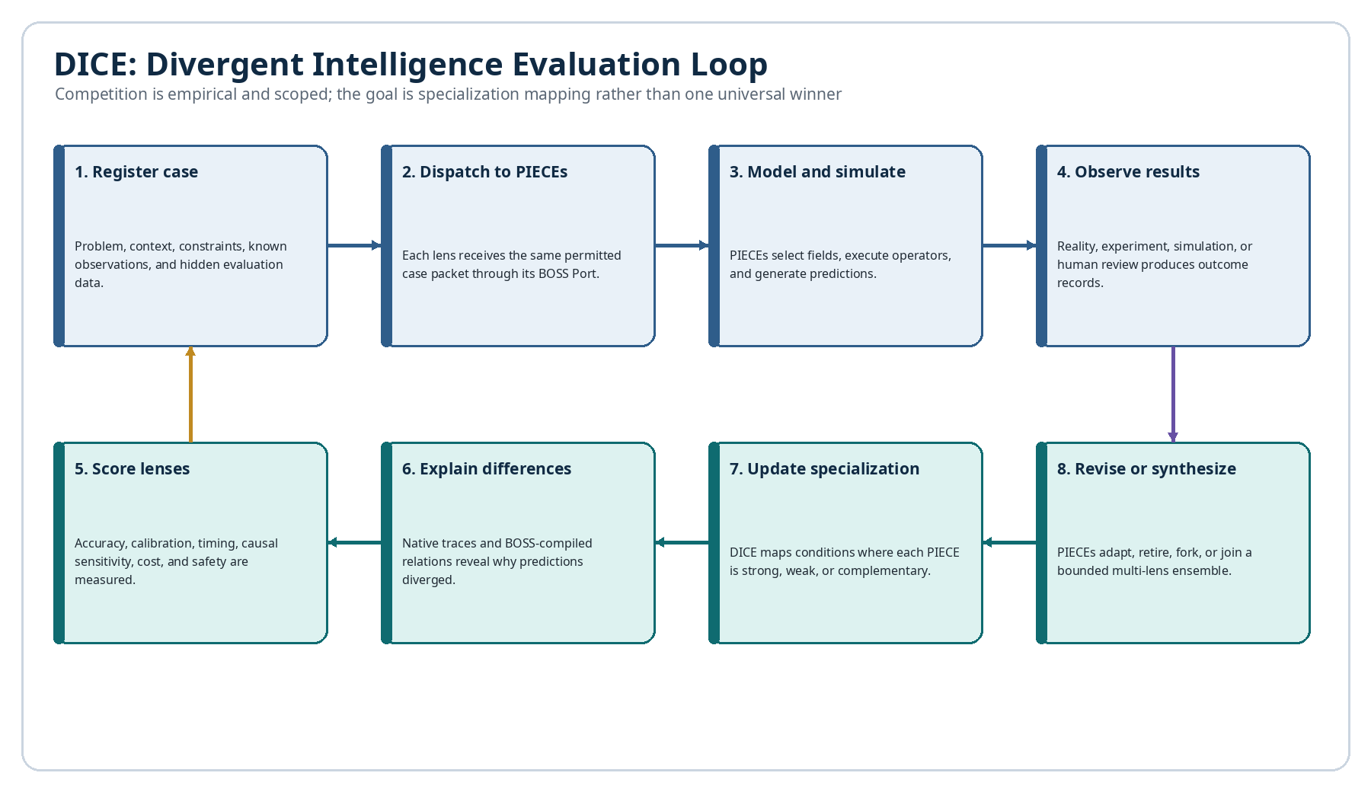
Figure 3. The DICE evaluation loop from case registration through specialization mapping and revision.

5.1 Case registration and controlled dispatch
A DICE case defines the question, known context, permitted evidence, hidden or delayed outcomes, intervention options, evaluation horizon, and safety rules. Every participating PIECE receives an equivalent authorized packet. Lens-specific data advantages must be declared rather than silently introduced.

5.2 Independent modeling and operator simulation
PIECEs analyze the case independently. DICE records their model snapshots and predictions before outcome data is revealed. The environment may also ask each lens to simulate controlled variable changes, such as increasing workload, removing a constraint, changing a sequence, or delaying an intervention.

5.3 Observation and outcome capture
Outcomes may come from physical instruments, controlled simulation, human review, operational records, historical events, or later real-world results. Each Observation record should include provenance, timestamp, measurement method, uncertainty, and any known contamination.

5.4 Evaluation metrics
Table 7. DICE evaluation dimensions.
Metric | Question
Outcome accuracy | Did the predicted state or category match the observation?
Timing accuracy | Did the lens predict when the effect would appear?
Calibration | Did stated confidence correspond to success frequency?
Intervention sensitivity | Did the model correctly predict variable-change effects?
Causal discrimination | Did it distinguish cause, trigger, correlation, and consequence?
Generalization | Did performance hold under new but related conditions?
Failure detection | Did the lens identify cases where it should abstain?
Explanatory sufficiency | Can the exported relations explain the prediction without unsupported leaps?
Semantic reconstruction | Can another Port reconstruct the intended operator graph?
Resource cost | What time, computation, data, and human review were required?
Safety and policy | Did the lens respect constraints and avoid unauthorized action?

5.5 Scoped winners and specialization maps
DICE should not produce one permanent winner. A mechanical lens may dominate stable physical faults; a temporal lens may excel at delayed effects; a behavioural lens may best predict adherence; an analogical lens may identify useful hypotheses under novelty. Specialization maps preserve these contextual strengths.
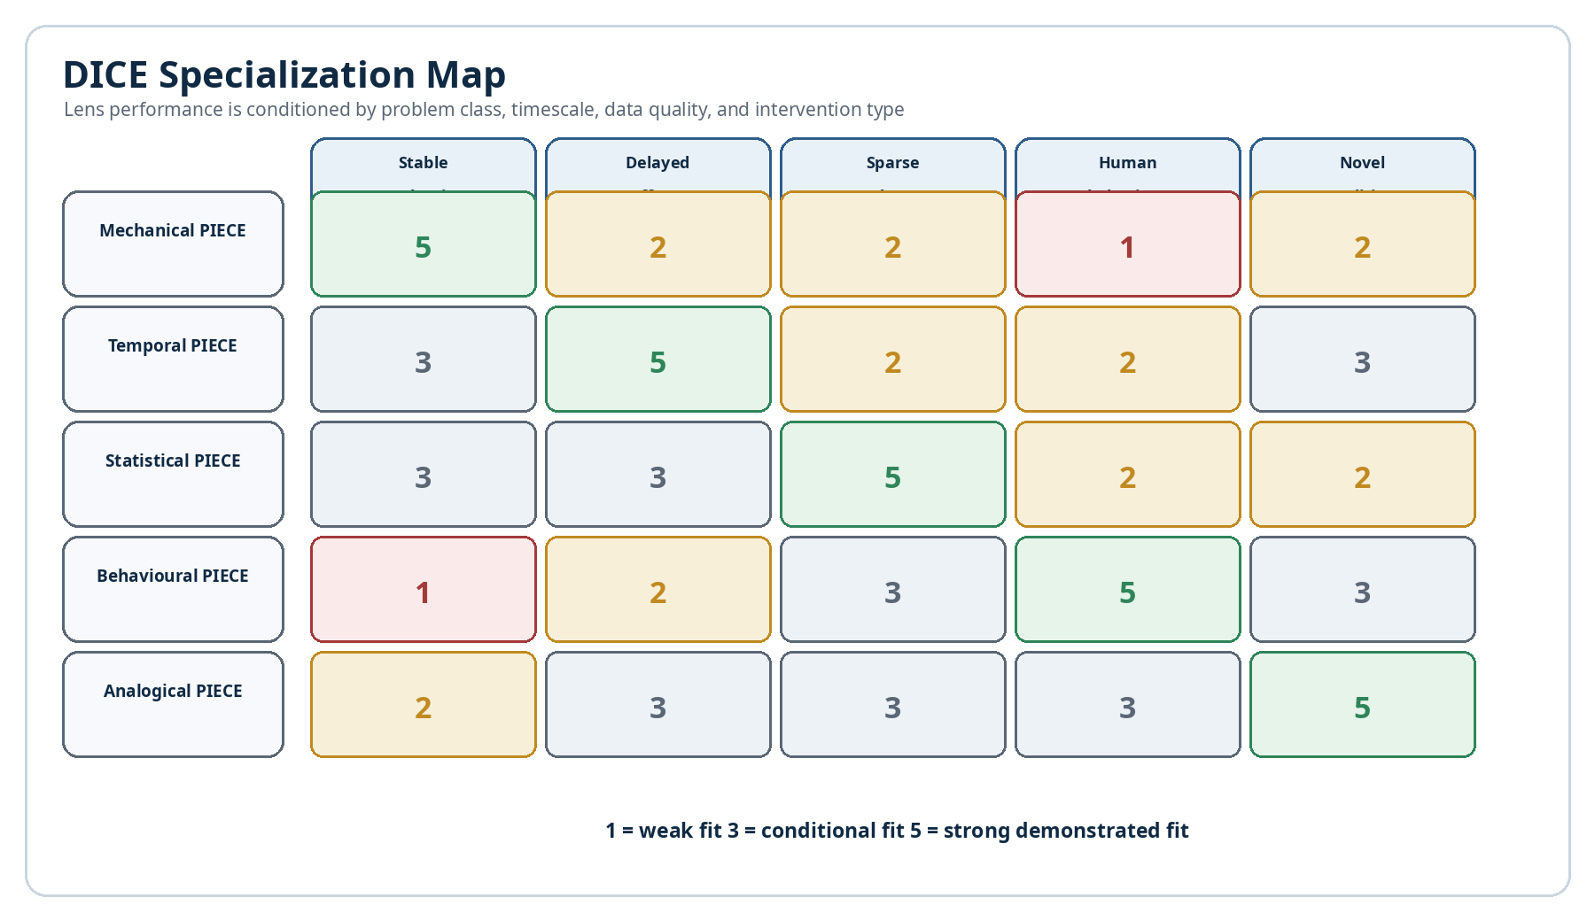
Figure 10. Illustrative DICE specialization map across problem classes.

5.6 Multi-lens synthesis
When several lenses explain different parts of the same case, DICE may create a bounded synthesis. The synthesis must preserve provenance: which PIECE supplied each field, operator, timing assumption, prediction, and uncertainty. It should not present the combined model as though it emerged from one undifferentiated intelligence.

5.7 Evolution, forking, retirement, and retention
Evaluation results can update lens weights, create specialized forks, revise crosswalks, or retire models. Failed lenses may still be valuable. Their traces document plausible but unsupported explanations, prevent repeated mistakes, and teach future PIECEs which distinctions were insufficient.

6. BOSS as a Shared Logical Compilation Layer
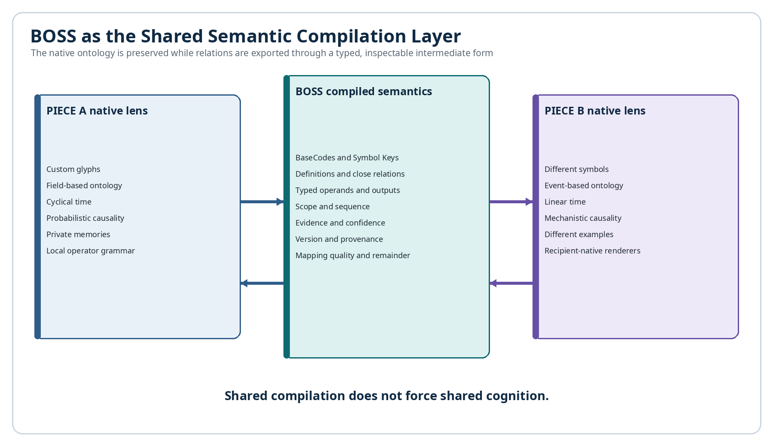
Figure 4. BOSS as a shared semantic compilation layer between different native cognitive lenses.

6.1 BaseCodes, Symbol Keys, and contextual meaning
BOSS distinguishes visual form from semantic use. A BaseCode identifies the symbolic object. A glyph renders it. A Symbology Key identifies one contextual meaning inside a Community and Family. The linked record contains the definition, examples, close relations, grammar, and optional operational behavior.

6.2 Semantic intermediate representation
The shared intermediate representation is a typed relation graph. It can express entities, variables, states, operators, scope, order, evidence, confidence, causality, alternatives, predictions, and outputs. It is surface-independent: the same graph can be rendered as symbols, prose, an animation, a causal diagram, a table, an audio pattern, or an interface state.
Illustrative BOSS-compiled rationale
Expression:
Inputs: {Workload, Recovery Capacity}
Operator: Capacity–Demand Imbalance
Intermediate State: Accumulated Fatigue
Output: Reduced Force Expression
Timing: Delayed by 3–7 days
Confidence: 0.74
Falsifier: Performance remains stable after recovery is increased

6.3 Exact, approximate, and non-equivalent mappings
Table 8. Resolution grades used by BOSS.
Grade | Meaning | Required behavior
Identity | Same canonical object and version. | Resolve directly.
Exact operational equivalence | Different local records with the same validated effect. | Permit substitution under stated scope.
Structural isomorphism | Same relation pattern with different labels or contents. | Translate structure; preserve domain difference.
Near-semantic approximation | Strong overlap with meaningful differences. | Show mapping and semantic remainder.
Metaphorical / analogical | A bounded similarity supports learning or hypothesis generation. | Never present as literal equivalence.
Related | Concepts are associated but not safely substitutable. | Offer as context only.
Conflict | Definitions or effects are incompatible. | Block silent translation and request resolution.
Unresolved | No safe mapping or insufficient context. | Use fallback explanation or abstain.

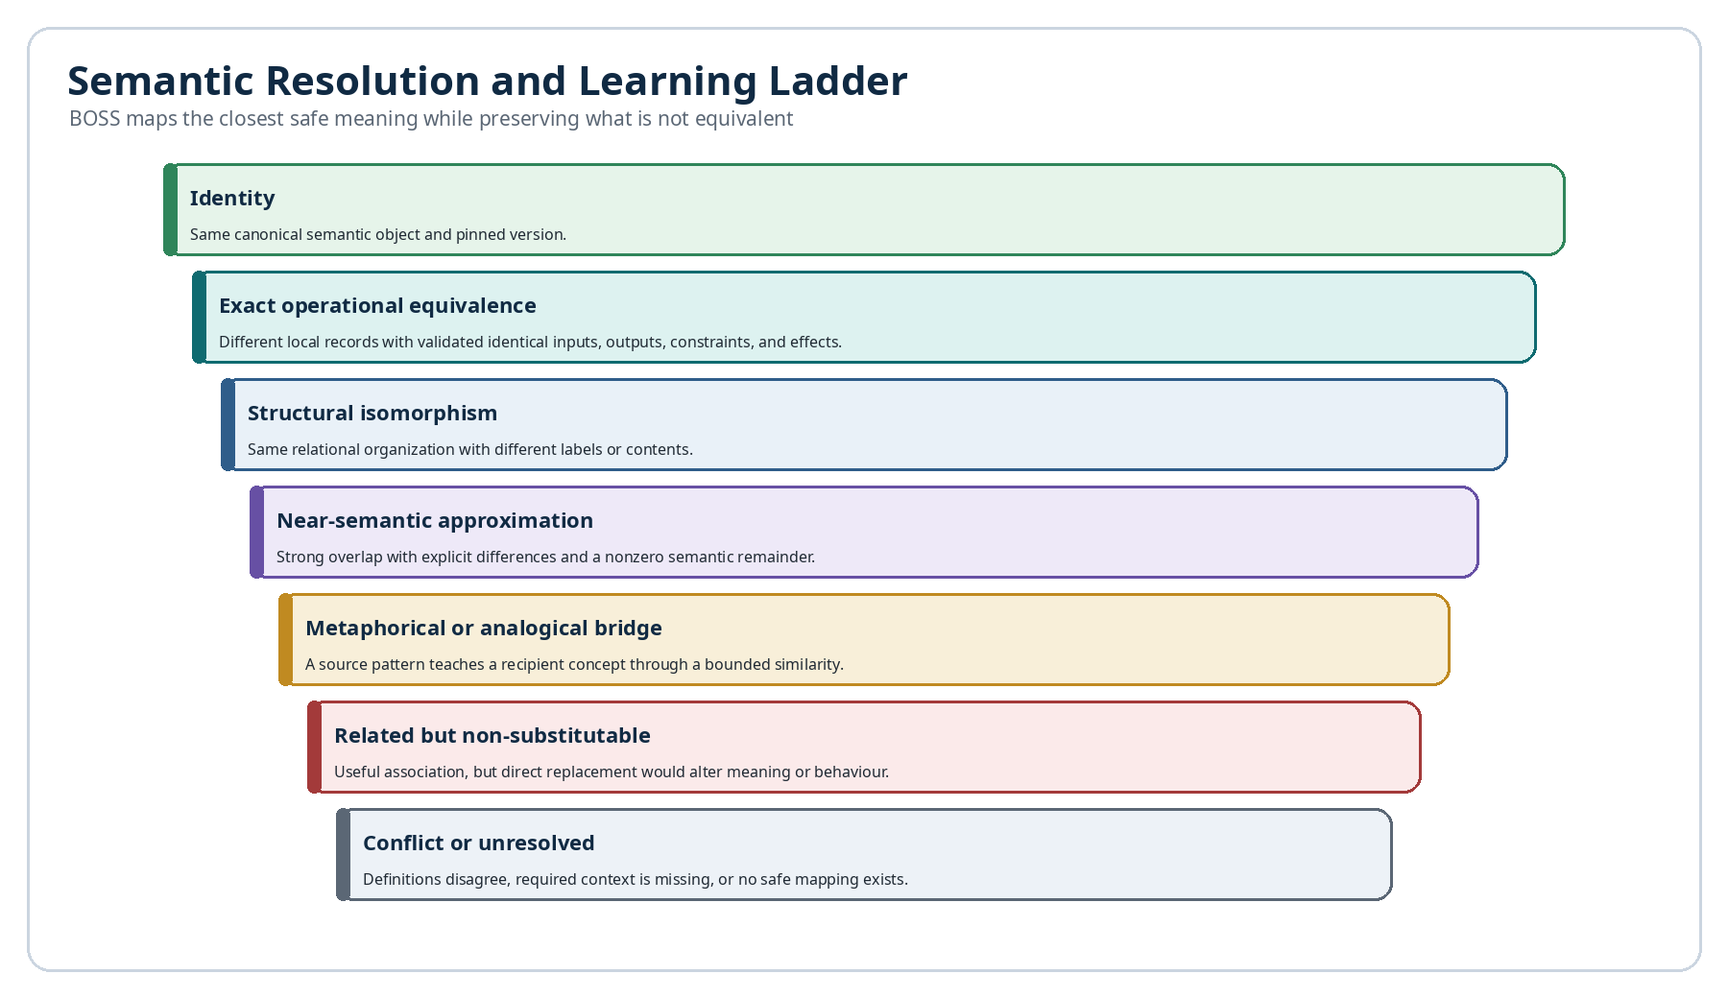
Figure 6. Semantic resolution ladder from identity through metaphorical mapping, conflict, and unresolved meaning.

6.4 Near-semantic and metaphorical learning
Because each Symbology record contains a definition and close symbolic relations, BOSS can search for the nearest established operator in the recipient’s Symbol Set. The system can compare input kind, output kind, directionality, reversibility, scope, temporal behavior, examples, and neighbouring symbols.
A recipient may not have the source concept “harmonic resolution,” but may possess an operator for tension moving toward stabilization. BOSS can propose an analogical bridge: structurally similar, musically scoped, not literally identical. The mapping teaches a new concept through an existing cognitive pathway while preserving the source domain and remainder.

Metaphor becomes inspectable
A metaphorical mapping is not merely poetic similarity. BOSS can state which relational features match, which features differ, where the analogy is valid, and where it must stop.

6.5 Recipient-native rendering
A BOSS Port may show the sender’s glyph, a validated local symbol, a textual fallback, a visual demonstration, an audio cue, or another accessible rendering. The recipient can reason through familiar representations while retaining a link to the source meaning and mapping grade.

6.6 Preserving native ontologies
The BOSS graph is an export layer, not a demand that every PIECE store its world internally in the same format. Native models may remain spatial, narrative, statistical, rhythmic, embodied, or otherwise unconventional. Interoperability requires an explicit export contract for relevant relations—not complete cognitive homogenization.

7. BOSS Ports
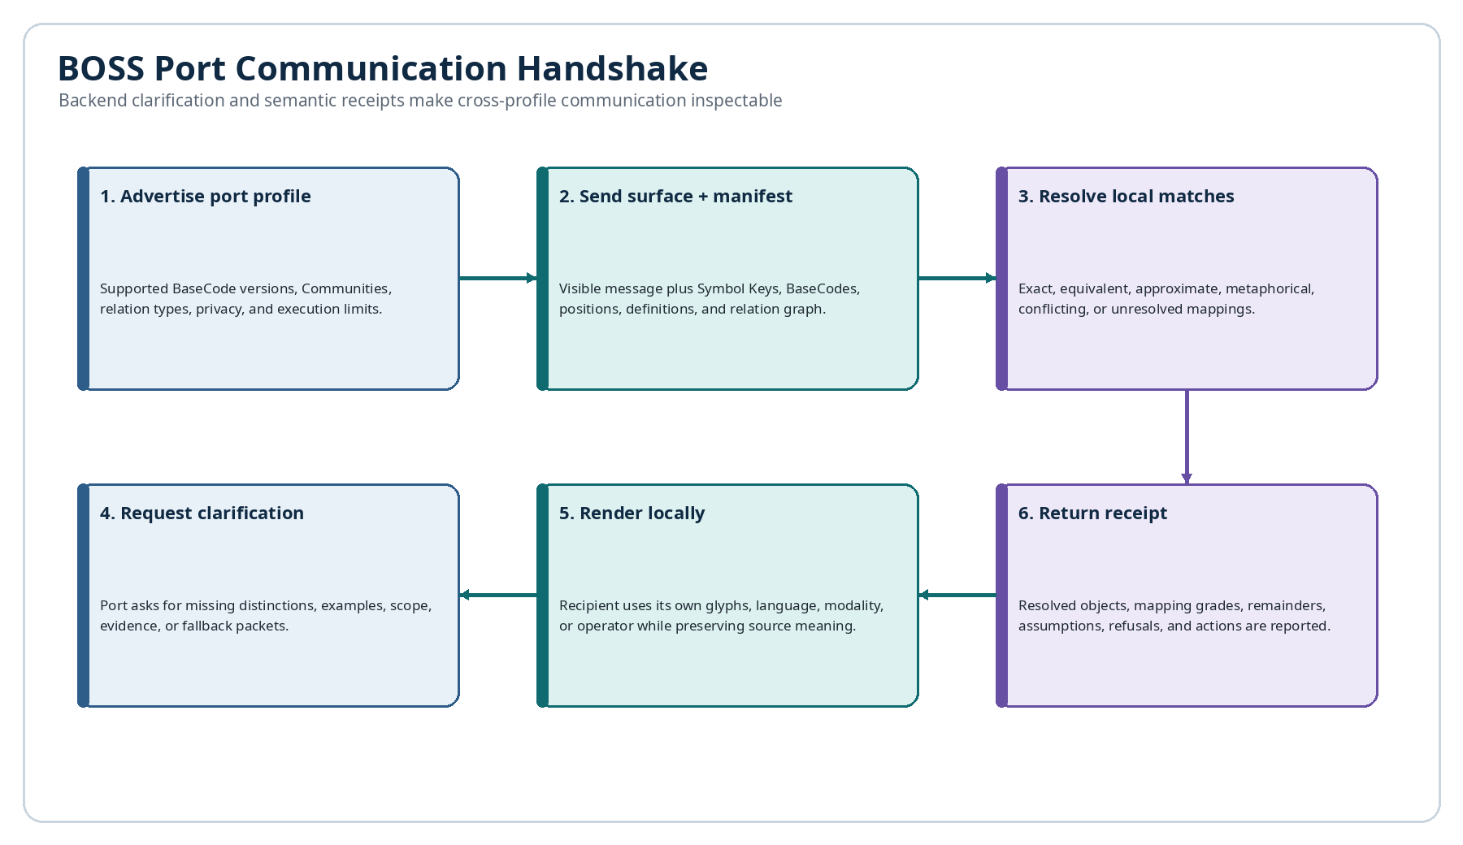
Figure 5. The BOSS Port semantic handshake and clarification lifecycle.

7.1 Definition and responsibilities
A BOSS Port is the semantic boundary between a native cognitive operating system and the shared BOSS channel. It performs token resolution, relation compilation, version checks, crosswalk selection, privacy filtering, fallback rendering, clarification, and receipt generation.

7.2 Port profiles and capability negotiation
Table 9. BOSS Port profile fields.
Profile area | Representative contents
Identity | Port ID, host PIECE or Base, owner, version, status.
Semantic support | BOSS version, Communities, Families, relation types, mapping grades.
Rendering | Text, glyph, graph, audio, animation, tactile, spatial, accessibility modes.
Clarification | Supported request types, example depth, fallback packet size.
Privacy | Permitted fields, redaction rules, memory disclosure, retention.
Execution | Explanatory only, recommendation, simulation, tool request, direct action.
Trust | Signatures, source allowlist, provenance requirements, integrity checks.
Receipts | Required acknowledgment fields, round-trip validation level.

7.3 Semantic handshake
Before complex exchange, Ports can negotiate supported semantic versions and profiles. The sender transmits a visible message plus a Symbol Manifest and typed relation graph. The receiver resolves known Keys, follows approved Mesh links, applies Crosswalks, and classifies each mapping.

7.4 Clarification and repair
When a mapping is weak or contradictory, the receiving Port can request a definition, example, counterexample, scope, input-output contract, or related operator. The source Port returns the minimum authorized semantic slice. Communication becomes a repairable process rather than a one-shot guess.

7.5 Semantic receipts
Table 10. Semantic receipt contents.
Receipt field | Purpose
Resolved symbols | Lists source Keys and the local objects used to render or reason about them.
Mapping grades | Declares identity, equivalence, approximation, analogy, conflict, or unresolved.
Semantic remainders | Preserves differences not captured by the local mapping.
Assumptions | Records added context or interpretations introduced by the recipient.
Clarifications | Lists requests and source responses used to repair the message.
Actions | States what was simulated, recommended, executed, blocked, or refused.
Confidence | Reports resolution confidence and remaining uncertainty.
Version state | Identifies the exact BOSS and Symbology versions resolved.

7.6 AI-to-AI backend communication
AI agents can use BOSS Ports as a backend companion channel. The visible exchange may remain concise, while the Port packet carries goals, variables, operators, evidence, confidence, constraints, expected outputs, and mappings. A receiving AI can ask the source AI to clarify an unfamiliar operator before relying on it.
This is especially important when AIs use different field categories or symbolic ontologies. The Port can map the closest local operator, expose the mapping grade, and preserve residual differences. AI-to-AI communication therefore becomes semantic negotiation rather than unverified linguistic imitation.

7.7 Port security and execution boundaries
A semantic package may explain an operation without granting authority to perform it. Ports must separate explanatory metadata from executable requests. Action Contracts, permissions, validation, and human review determine whether a mapped operator can affect data, tools, devices, or external systems.

8. Multi-Base Communication Protocols
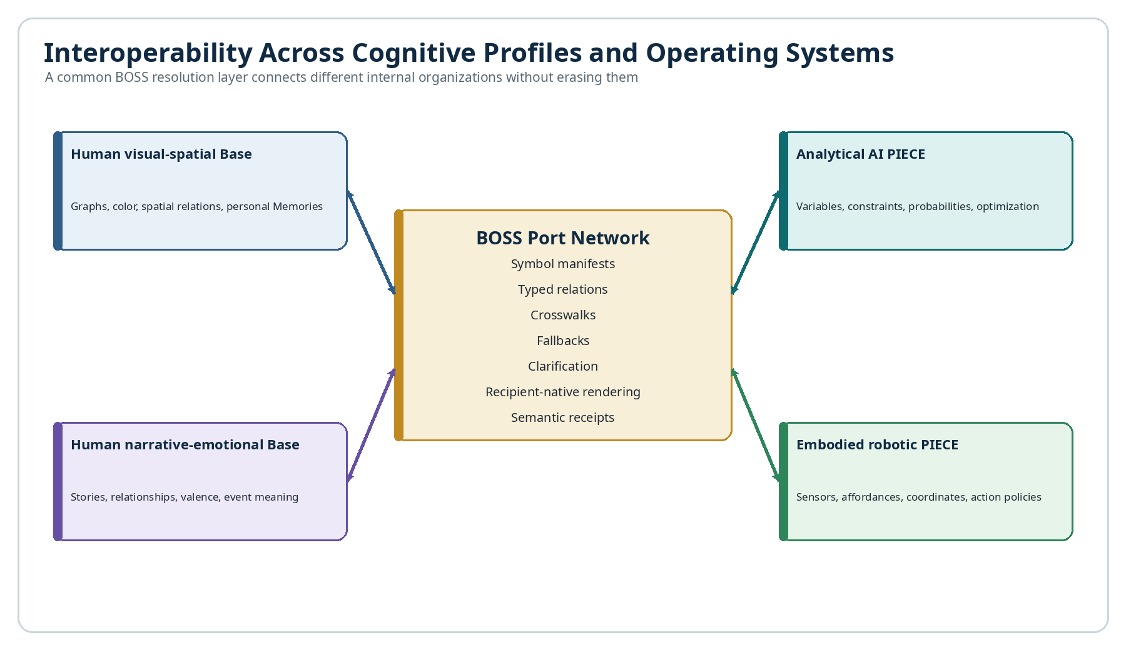
Figure 7. Interoperability among human, AI, and embodied cognitive operating systems.

8.1 Personal Bases and cognitive sovereignty
A person may maintain a Base containing their own Symbology, Memories, Events, routines, priorities, models, and preferred renderings. Another person may organize the world differently. BOSS allows both Bases to retain local authority while sharing only the semantic slices needed for communication.

8.2 Relationship-specific crosswalks
Repeated communication can build a relationship-specific Crosswalk. The system learns that one person’s operator for “protective distance” is related to another person’s operator for “recovery boundary,” but not identical. Future messages can use the established mapping while preserving its history and scope.

8.3 Organizational and professional protocols
Organizations can define Port profiles for engineering review, clinical education, legal drafting, operations, incident response, or public communication. Each profile specifies which relations must be explicit, which evidence is required, which mappings are acceptable, and what must remain human-reviewed.

8.4 Selective disclosure and private meaning
A message should not expose an entire personal ontology or Memory graph. Least-semantic-disclosure limits the packet to the required definitions, relations, and examples. Sensitive meanings may use sealed packets, temporary access, redacted provenance, or recipient-specific renderings.

8.5 Shared conversational history
Conversation Bridges can preserve which mappings were used, where misunderstandings occurred, which clarifications succeeded, and how shared meanings evolved. The relationship develops a semantic history without forcing either Base to overwrite its own definitions.

8.6 Interoperability across cognitive operating systems
The same protocol can connect human visual-spatial cognition, narrative-emotional cognition, analytical agents, probabilistic models, embodied robots, organizational workflows, and future synthetic systems. They need not share interface, memory form, or internal reasoning style. They require a Port capable of exporting and resolving declared relations.

9. Multi-Lens, Multi-Modal Learning
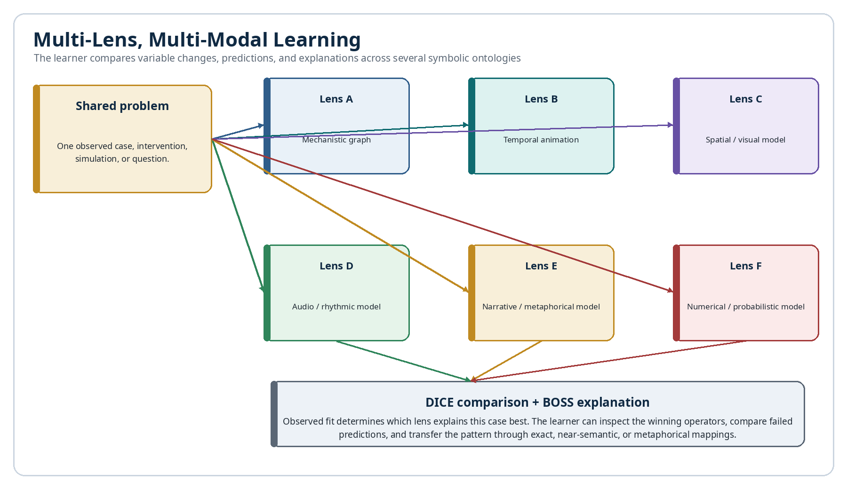
Figure 8. Multi-lens, multi-modal learning from one shared problem.

9.1 Learning from agreement and disagreement
When several lenses agree despite different ontologies, the shared relation may be robust. When they disagree, the location of disagreement becomes educational: variable selection, causal assumptions, timescale, evidence threshold, operator behavior, or scope. The learner can inspect the divergence rather than receiving one unexplained answer.

9.2 Variable-change analysis
DICE can hold most variables constant while changing one input across PIECEs. Each lens predicts how the change propagates. Observed results reveal which symbolic ontology captured the relevant dependencies. Repeated trials teach the operational meaning of variables and operators through consequence.

9.3 Symbolic explanation of model performance
The winning or best-fitting PIECE should explain why its operator chain matched the observation. Failed PIECEs should also expose where their prediction diverged. The result is a comparative symbolic lesson: not only what happened, but which representation made the decisive distinction.

9.4 Multimodal renderings of one relation graph
Table 11. Multi-lens learning modes.
Mode | How the same relation may be taught
Symbolic | Show the exact registered operators and operands.
Graphical | Animate propagation across a causal or relational graph.
Temporal | Display delayed effects and state transitions on a timeline.
Spatial | Highlight coordinates, regions, or geometric transformations.
Auditory | Map patterns, intervals, or state changes to sound.
Narrative | Explain the model through agents, goals, constraints, and events.
Numerical | Display equations, probabilities, sensitivity, and error.
Interactive | Let the learner change variables and compare lens predictions.

9.5 Analogical transfer across Communities
BOSS can use close symbolic relations to connect a new idea to an established operator in another Community. Intersection in mathematics can illuminate shared membership in data. Harmonic tension and resolution can illuminate a controlled shift from instability to stability. A cooking reduction can illuminate concentration through removal. Each bridge is typed and bounded.

9.6 Human learning interfaces
A Semantic Atlas interface could filter PIECE outputs by lens, Community, Family, variable, operator, mapping grade, and performance. Learners could replay simulations, inspect symbol definitions, view examples, change one variable, and compare how each lens updates. The environment becomes both a research system and an executable curriculum.

10. Worked Example: Industrial Equipment Anomaly
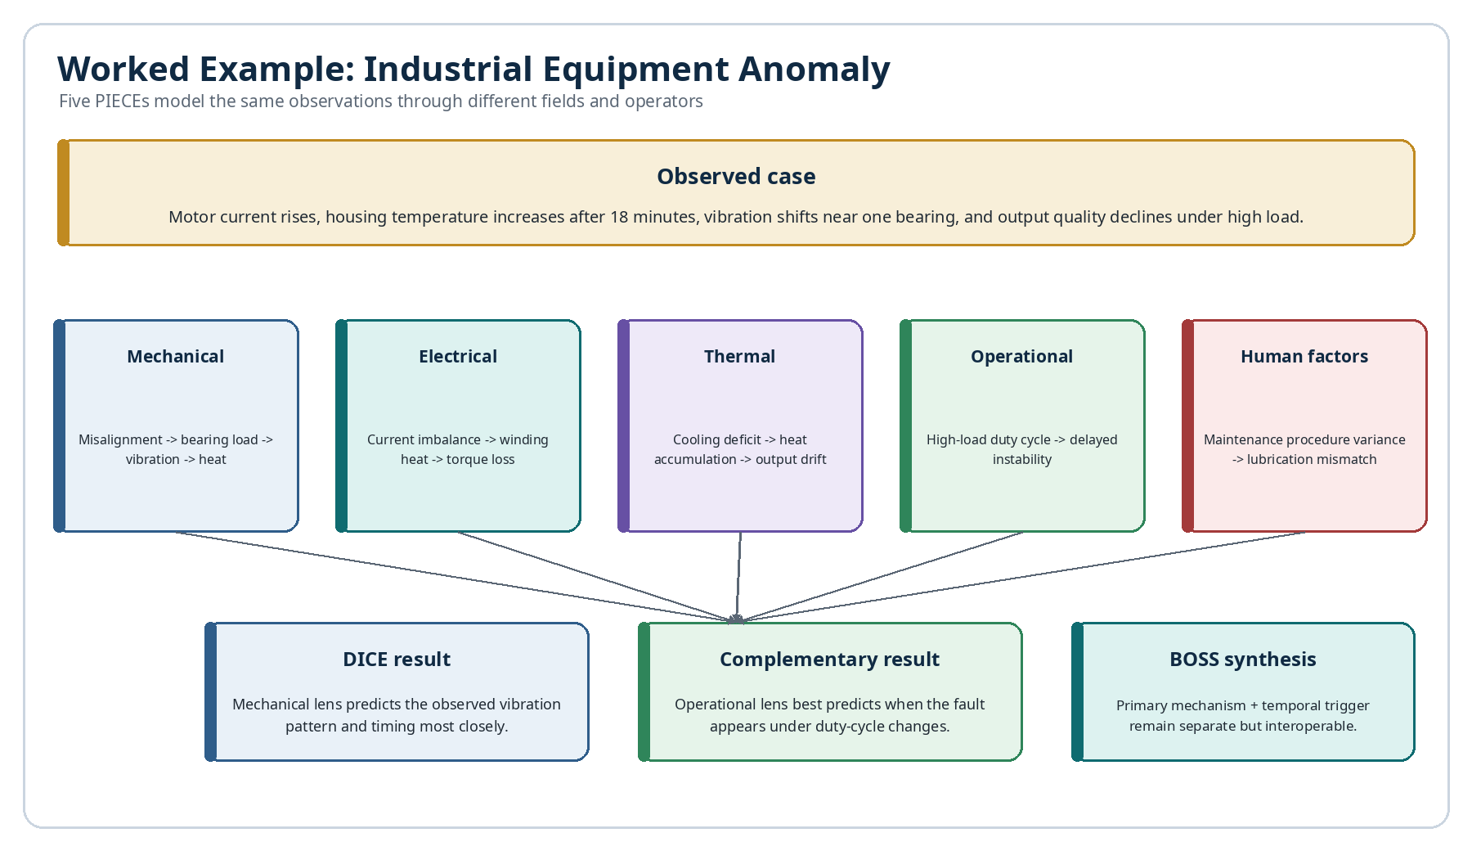
Figure 9. Industrial equipment anomaly evaluated through five PIECE lenses.

10.1 Case description
A production motor shows rising current, increasing housing temperature after approximately eighteen minutes, a vibration shift near one bearing, and declining output quality under high load. The initial evidence does not establish whether the primary mechanism is mechanical, electrical, thermal, operational, or procedural.

10.2 Competing PIECE models
Table 12. Industrial anomaly predictions by lens.
PIECE lens | Primary model | Predicted signature
Mechanical | Misalignment increases bearing load and friction. | Localized vibration shift precedes heat and output drift.
Electrical | Current imbalance creates winding heat and torque loss. | Electrical asymmetry appears before vibration changes.
Thermal | Cooling deficit accumulates heat under load. | Temperature rise dominates; vibration is secondary.
Operational | Duty cycle crosses a delayed instability threshold. | Fault appears only after sustained high-load duration.
Human factors | Maintenance variance produced lubrication mismatch. | Pattern follows a recent service event and specific procedure.

10.3 DICE evaluation
Controlled tests vary alignment, electrical supply, cooling, load duration, and lubrication procedure. The observed vibration pattern changes immediately after alignment correction, while the fault still appears sooner under the original high-load duty cycle. DICE therefore identifies a primary mechanical mechanism and an operational timing trigger.
Table 13. Illustrative DICE evaluation of the industrial case.
Lens | Outcome fit | Timing fit | Intervention fit | Interpretation
Mechanical | High | Moderate | High | Best primary mechanism.
Operational | Moderate | High | High | Best trigger and timing model.
Electrical | Low | Low | Low | Current increase was consequence, not source.
Thermal | Moderate | Moderate | Low | Explains accumulation but not localized vibration.
Human factors | Unresolved | Low | Unresolved | Insufficient service evidence.

10.4 BOSS synthesis and explanation
BOSS preserves the distinction between mechanism and trigger. The mechanical PIECE supplies the causal operator chain; the operational PIECE supplies the threshold and delay relation. The synthesis does not collapse them into one vague explanation. It exports a typed graph showing alignment defect → bearing load → vibration and friction, qualified by sustained high-load duration → earlier threshold crossing.

10.5 Operational response
A governed Action Contract may recommend alignment correction, a revised duty-cycle limit, and follow-up monitoring. Direct machine control remains separate and requires authorized engineering validation. The semantic explanation remains available for maintenance training, audit, and future DICE cases.

11. Worked Example: Music Learning and Composition

11.1 Multiple music lenses
Table 14. Music PIECE lenses and outputs.
Lens | Primary fields | Typical output
Harmonic | Pitch classes, intervals, chords, tension, resolution. | Chord function and likely harmonic movement.
Rhythmic | Pulse, duration, subdivision, accent, syncopation. | Timing structure and groove prediction.
Embodied | Instrument coordinates, fingering, movement cost. | Playable realization and technical difficulty.
Acoustic | Frequency, spectrum, resonance, envelope, loudness. | Expected sound character and interaction.
Emotional | Valence, arousal, memory association, narrative role. | Interpretive meaning and affective trajectory.
Compositional | Motif, repetition, contrast, development, form. | Section structure and transformation plan.

11.2 Symbol-to-sound and instrument mapping
BOSS music symbols can compile into canonical music events. The same event may highlight notation, play audio, illuminate a piano key, identify guitar string-and-fret coordinates, or display a wind-instrument fingering. Each instrument is an Instance that maps stable pitch and timing identities to local coordinates.

11.3 DICE comparison of interpretations
A learner may ask why a phrase feels unresolved. The harmonic PIECE predicts unresolved chord function; the rhythmic PIECE predicts incomplete metric closure; the emotional PIECE links the phrase to an unfinished Memory; the compositional PIECE identifies withheld repetition. DICE can compare listener responses, continuation choices, and later revisions to determine which lenses best explain the effect.

11.4 Memory and emotional provenance
A motif can link through a Liminal Bridge to a Memory or Event that inspired it. Later versions preserve how the motif changed, which emotional interpretation influenced instrumentation, and which performance created new meaning. The composition becomes a living semantic object with inspectable creative lineage.

11.5 Cross-Community learning
Music provides powerful analogical bridges. Harmonic resolution may teach stabilization; counterpoint may teach parallel independent processes; rhythm may teach recurrence and phase; modulation may teach context change. BOSS can expose these structural similarities while explicitly preserving domain differences.
Cross-community bridge examples
Music relation | Candidate semantic bridge | Preserved semantic remainder
Harmonic resolution | Stabilization or constraint satisfaction | Tonal tension, voice-leading, and aesthetic expectation remain musical.
Counterpoint | Parallel independent processes | Simultaneous melodic agency is richer than generic software concurrency.
Rhythm and meter | Recurrence, phase, and temporal partition | Accent hierarchy, pulse perception, and embodied groove remain domain-specific.
Modulation | Context shift or regime transition | Tonal function and key relationships cannot be reduced to a generic state change.
BOSS should grade these as near-semantic or metaphorical mappings unless evidence supports a stronger equivalence. The bridge teaches transferable structure while preserving the musical remainder.

12. Worked Example: Personal Training and Planning

12.1 Competing training lenses
A person experiences declining performance after increasing training volume. A physiological PIECE models fatigue and recovery; a biomechanical PIECE models technique and leverage; a behavioural PIECE models adherence and schedule friction; a nutritional PIECE models intake and timing; a temporal PIECE models delayed adaptation and accumulated load.
Table 15. Training PIECE lenses and intervention predictions.
Lens | Proposed intervention | Predicted result
Physiological | Reduce volume and increase recovery. | Performance rebounds after fatigue dissipates.
Biomechanical | Correct technique and exercise order. | Efficiency improves even without reducing total work.
Behavioural | Simplify routine and protect consistent times. | Completion rate improves; training exposure stabilizes.
Nutritional | Increase energy and carbohydrate around training. | Session quality improves before long-term adaptation changes.
Temporal | Insert deload at the correct delayed-fatigue threshold. | Decline stops without abandoning the program.

12.2 Variable-change simulations
DICE can compare the predictions by changing one variable at a time where practical: volume, technique, schedule, intake, or recovery timing. The system records the intervention, expected timing, and observed response. The goal is not medical diagnosis; it is structured personal planning and learning under appropriate professional guidance where required.

12.3 Observation and adaptation
If performance rebounds after volume reduction but adherence remains unstable, DICE may score the physiological lens highest for the acute decline and the behavioural lens highest for long-term program continuity. The person receives a layered explanation rather than one universal cause.

12.4 BOSS explanation for the user
BOSS can render the result through the user’s preferred symbols and calendar phases. The system may show fatigue accumulation, recovery boundary, schedule friction, and predicted rebound as linked operators attached to the exact routines and Memories that shaped the program. A personal Base receives an explanation aligned with its own symbolic language.

13. CERBERUS Data Model and Implementation
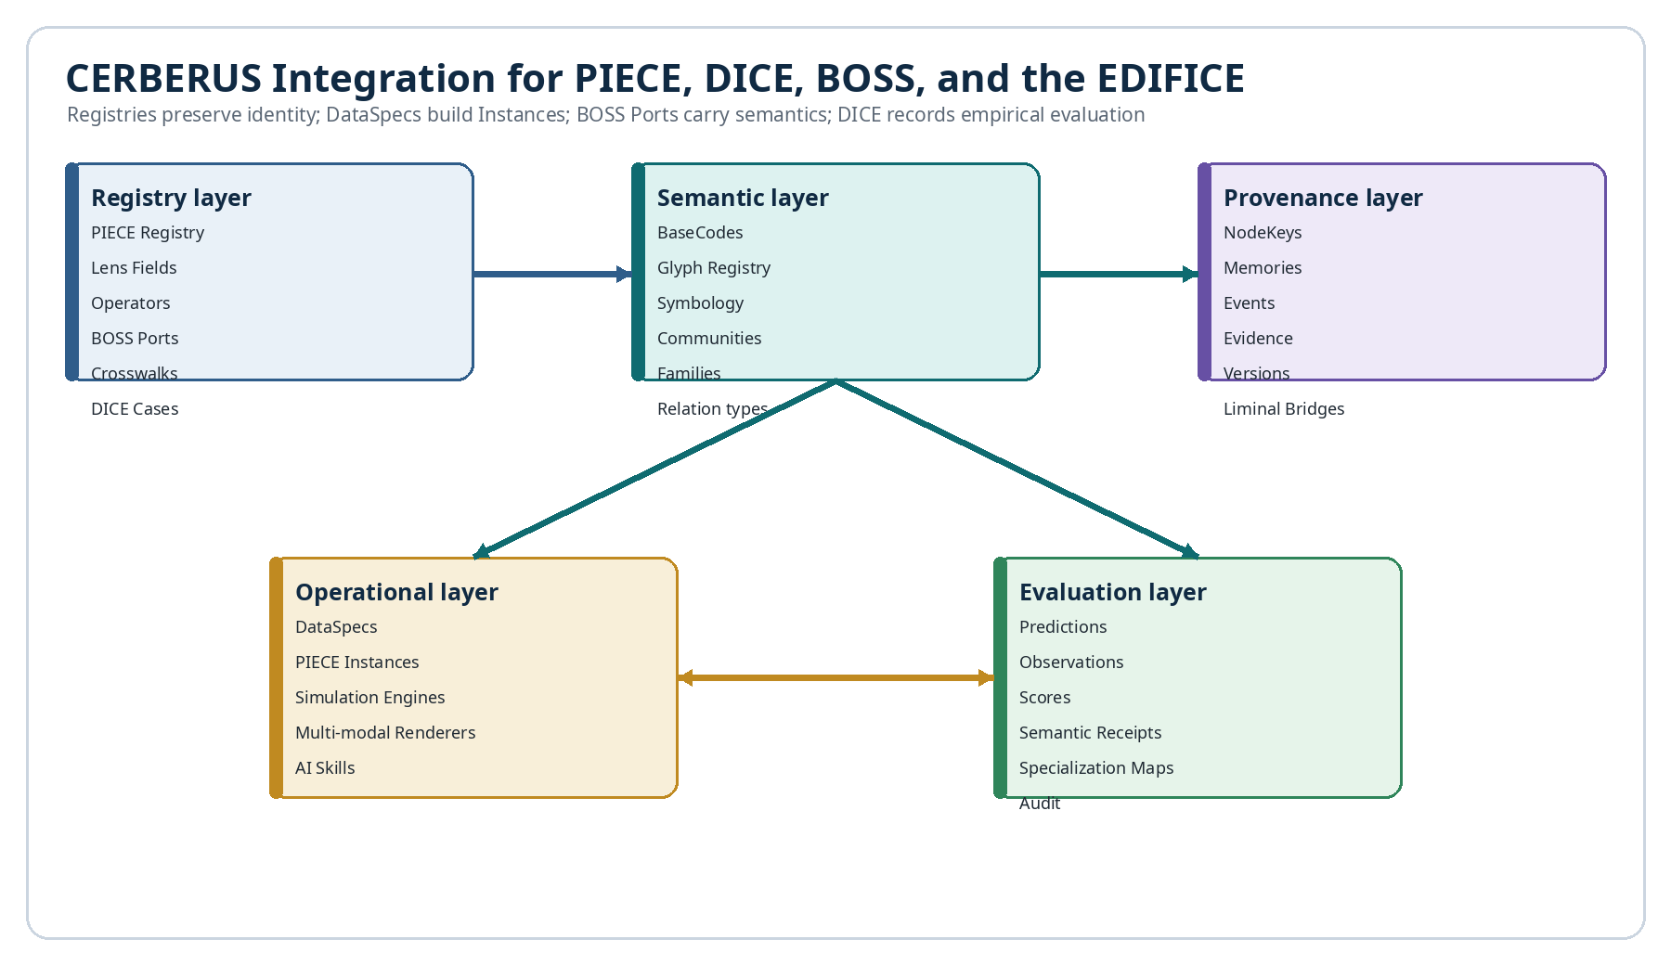
Figure 11. CERBERUS registry and operational integration for the EDIFICE.

13.1 Proposed registries
Table 16. Proposed CERBERUS registries for the EDIFICE.
Registry | Purpose
PIECE Registry | Identity, scope, status, owner, version, Port, and linked lens components.
Lens Field Registry | Field categories, variable definitions, units, bounds, and source rules.
Lens Operator Registry | Native operators, BOSS bindings, inputs, outputs, constraints, and simulations.
DICE Case Registry | Problem statement, permissions, context, outcomes, and evaluation design.
Prediction Registry | PIECE predictions, timing, confidence, signatures, and falsifiers.
Observation Registry | Observed results, provenance, quality, uncertainty, and timestamps.
Evaluation Registry | Metric scores, comparison notes, winner scope, and reviewer status.
Specialization Registry | Demonstrated lens strengths and weaknesses by context.
BOSS Port Registry | Port profiles, capabilities, policies, trust, and version.
Crosswalk Registry | Mappings between source and recipient operators with grade and remainder.
Semantic Receipt Registry | Resolution, clarification, rendering, action, and audit results.

13.2 Core relationships
Core relational graph
PIECE → Lens Fields
PIECE → Native Operators → BOSS Symbology
DICE Case → participating PIECEs
PIECE → Predictions → DICE Case
DICE Case → Observations → Evaluations
Evaluation → Specialization Profile
PIECE ↔ BOSS Port ↔ other Ports
Crosswalk → source Symbol Key ↔ recipient Symbol Key

13.3 DataSpecs and Instances
DataSpecs can define PIECE dashboards, simulation workspaces, comparison galleries, specialization matrices, clarification panels, and multimodal explanation surfaces. Instances then render those specifications using current Registry data and permissions.

13.4 NodeKeys, Memories, Events, and Liminal Bridges
NodeKeys give problems, concepts, instruments, people, and outcomes stable identity. Memories and Events can provide provenance or inspiration. Liminal Bridges connect independent Bases or Stacks while preserving ownership. A PIECE can therefore use a Memory-derived hypothesis without copying private source data into its own ontology.

13.5 AI Skills and Action Contracts
AI Skills can route tasks such as “analyze this case with the thermal PIECE,” “compare all predictions,” or “explain the winning model through my personal Symbol Set.” Action Contracts constrain what each Skill may read, simulate, write, or execute. This separation is essential for safe semantic automation.

13.6 Minimum viable data flow
Minimum viable EDIFICE prototype
1. Create one DICE Case record.
2. Link three PIECE profiles with different field categories.
3. Generate one Prediction record per PIECE.
4. Add observed outcome records.
5. Calculate evaluation metrics and specialization tags.
6. Export each rationale through a BOSS Port.
7. Resolve mappings and display a comparative explanation.

14. Inspectability, Explainability, and Scientific Integrity

14.1 What must remain inspectable
Table 17. Inspectability requirements.
Object | Minimum inspectable contents
PIECE profile | Scope, fields, ontology, operators, evidence access, version, exclusions.
Prediction | Outcome, timing, confidence, observable signatures, falsifiers.
Operator trace | Named transformations, order, inputs, outputs, constraints.
Evidence map | Source records, measurement quality, contradictions, missing data.
DICE evaluation | Metrics, observations, scoring rules, reviewer, context.
Crosswalk | Source meaning, local mapping, grade, remainder, provenance.
Synthesis | Contribution and uncertainty attributed to each PIECE.
Action | Authorization, validation, side effects, review, audit.

14.2 Structured rationale versus hidden internal reasoning
The environment should never depend on unrestricted disclosure of private hidden reasoning. Instead, it requires a purpose-built explanation artifact: declared assumptions, selected variables, evidence, operator sequence, alternatives, predicted consequences, and confidence. This is more useful for audit than an unfiltered internal transcript and is safer for proprietary or personal cognition.

14.3 Evidence, provenance, and falsifiability
Every important claim should link to evidence or be labeled as assumption, inference, analogy, or hypothesis. Predictions should identify what would count against them. Provenance must show which PIECE, version, data sources, and Crosswalks produced the result.

14.4 Reproducibility and version pinning
A DICE result is reproducible only if the case packet, PIECE version, operator definitions, BOSS mapping versions, simulation settings, and evaluation rules are pinned. Later revisions can be compared without rewriting the historical record.

14.5 Calibration and uncertainty
PIECEs should be rewarded for honest uncertainty and appropriate abstention. DICE can track calibration curves, confidence distributions, and context-specific failure rates. A lens that knows when it does not apply may be more valuable than a lens that always produces an answer.

14.6 Preventing persuasive but unsupported explanations
Explanations should be checked against the exported model, evidence, and actual prediction. A rhetorically compelling narrative that was not used to generate the prediction should be marked as post hoc interpretation. DICE performance and BOSS trace consistency provide separate tests of explanatory integrity.

15. Governance, Security, and Safety

15.1 Semantic injection and malicious mappings
An attacker could attach misleading definitions, false equivalences, or executable bindings to a familiar symbol. Ports should verify source trust, signatures, version, schema, and permitted link depth. Untrusted metadata must be isolated from executable authority.

15.2 Privacy and least-semantic-disclosure
A PIECE may rely on private Memories, health information, organizational records, or proprietary models. The exported packet should disclose only the minimum definitions and evidence required for the authorized purpose. Sensitive provenance may be summarized, redacted, or withheld while retaining a trust statement.

15.3 Competition failure modes
Table 18. Governance threats and controls.
Threat | Risk | Control
Metric gaming | PIECE optimizes score rather than real usefulness. | Use multiple metrics, hidden tests, and outcome review.
Data leakage | A PIECE sees evaluation outcomes or privileged evidence. | Case isolation, audit logs, permissioned evidence.
Overfitting | Lens wins narrow historical cases but fails elsewhere. | Prospective tests, context labels, generalization scoring.
Semantic flattening | Approximate mappings are treated as exact. | Mandatory mapping grade and semantic remainder.
Rhetorical dominance | Fluent explanation outweighs empirical fit. | Separate prediction scoring from explanation review.
Lens capture | One dominant ontology suppresses alternatives. | Diversity requirements, challenge PIECEs, fork rights.
Unsafe execution | Mapped operator triggers unauthorized action. | Action Contracts, human review, execution boundary.
Semantic injection | Untrusted metadata changes interpretation. | Signatures, allowlists, sandboxed resolution, receipts.

15.4 Execution authority and human review
A PIECE prediction, DICE ranking, or BOSS mapping is not automatically an instruction to act. High-impact domains require authorized review and independent validation. Ports should distinguish explain, simulate, recommend, request action, and execute as separate capabilities.

15.5 Bias, capture, and cognitive monoculture
Even a diverse environment can become captured if all PIECEs share the same training data, metrics, or institutional incentives. Governance should monitor ontological diversity, evidence diversity, disagreement quality, and whether unusual but useful lenses receive fair evaluation.

15.6 Lifecycle governance
PIECEs, Crosswalks, operators, and Port profiles need status, ownership, review dates, version lineage, deprecation rules, and replacement links. Historical outputs must remain resolvable through pinned versions even after a lens is retired.

16. Implementation Roadmap

16.1 Phase 1: minimum viable EDIFICE
Begin with one bounded domain, three intentionally different PIECEs, one DICE Case template, a small Observation Registry, and simple manual evaluation. Require every PIECE to export a model snapshot, prediction, confidence, and structured rationale.

16.2 Phase 2: BOSS Ports and Crosswalks
Add Port profiles, Symbol Manifests, typed relation graphs, mapping grades, clarification requests, and semantic receipts. Build the first Crosswalks between native operator sets and BOSS shared meanings.

16.3 Phase 3: multimodal learning and simulation
Create interfaces that replay operator simulations as graphs, timelines, audio, spatial highlights, or interactive controls. Let learners change variables and compare PIECE predictions before seeing outcomes.

16.4 Phase 4: federated PIECE ecosystems
Permit independent Bases, organizations, and AI systems to publish Port profiles and portable PIECE packages. Add trust, signatures, sealed cases, Cross-Base specialization maps, and controlled shared evaluations.

16.5 Evaluation criteria
Table 19. Implementation roadmap.
Phase | Primary deliverable | Success condition
1 | Three PIECEs + one DICE workflow. | Predictions and observations can be compared reproducibly.
2 | BOSS Ports + Crosswalk Registry. | Different operator sets can resolve with explicit grades and receipts.
3 | Multimodal learning Instances. | Users can inspect and manipulate the same relation graph in several forms.
4 | Federated Base communication. | Independent Bases exchange portable semantic packets safely.
5 | Adaptive specialization ecosystem. | Lens selection improves with evidence while preserving diversity.

17. Future Implications
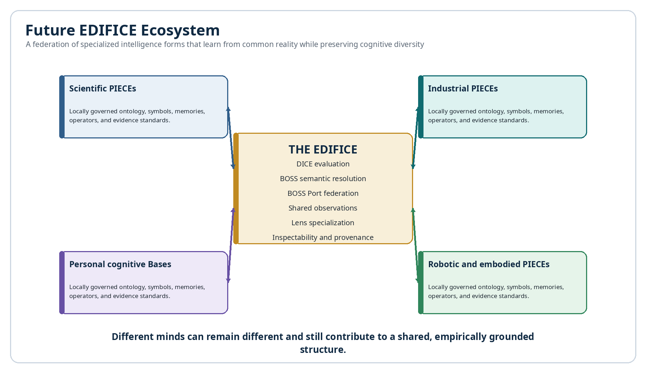
Figure 12. A future federated ecosystem of specialized intelligence forms.

17.1 Education and personalized learning
Students could explore the same concept through mathematical, visual, musical, procedural, narrative, and embodied lenses. DICE could identify which representations produce durable understanding for a learner without declaring that one cognitive style is universally superior. BOSS would preserve the shared logic beneath each rendering.

17.2 Scientific discovery and hypothesis ecosystems
Research teams could deploy PIECEs built around competing theoretical frameworks. Each would produce preregistered predictions and falsifiers. DICE would track performance across experiments, while BOSS would expose where theories share structure, differ in mechanism, or use only approximate conceptual mappings.

17.3 Engineering, manufacturing, and digital twins
Mechanical, electrical, thermal, operational, materials, and human-factors PIECEs could analyze the same digital twin. Their specializations could guide fault diagnosis, maintenance planning, and design review while preserving an auditable explanation of which lens contributed each recommendation.

17.4 Healthcare education and bounded decision support
Educational and reviewed support environments could compare anatomical, physiological, behavioural, temporal, and social lenses. The system would require strict evidence, privacy, professional oversight, and separation between explanation and clinical authority. Its value would be structured plurality, not autonomous diagnosis.

17.5 Law, policy, and institutional reasoning
Legal, ethical, economic, administrative, and lived-experience PIECEs could model the same policy. DICE could compare predicted outcomes and identify where frameworks disagree. BOSS Ports could preserve definitions across institutions and make hidden assumptions explicit.

17.6 Creative production and cultural preservation
Music, visual art, narrative, performance, and cultural-context PIECEs could preserve both technical structure and lived meaning. Base-local symbols and Memories could remain sovereign while portable semantic packets support collaboration, teaching, adaptation, and provenance-aware generative systems.

17.7 Accessibility and neurodivergent cognition
The environment could let users receive identical logical content through text, symbols, color, spatial arrangement, sound, tactile cues, timelines, or personal cognitive metaphors. Rather than treating one presentation as canonical, BOSS would treat the relation graph as canonical and rendering as profile-dependent.

17.8 Robotics and embodied intelligence
Embodied PIECEs could represent affordances, sensor fields, motor coordinates, energy limits, and action risk differently from language-centric agents. BOSS Ports would allow them to communicate operational relations to humans and other machines without forcing their internal representation into ordinary prose.

17.9 Synthetic and alien cognition
Future intelligences may organize reality through fields, rhythms, topologies, distributed states, or other representations that feel alien to human thought. The EDIFICE offers a disciplined test: can the intelligence export observations, operators, predictions, confidence, and mapping relations sufficiently for others to reconstruct its declared logic? Interoperability would not require cognitive sameness.

17.10 Collective intelligence without semantic flattening
Large systems often achieve coordination by enforcing one vocabulary. The EDIFICE points toward another possibility: local semantic sovereignty connected by explicit Crosswalks and empirical evaluation. Collective intelligence could grow from managed differences rather than standardized erasure.

17.11 Self-evolving symbolic ecosystems
Successful PIECE operators could be promoted into shared BOSS Communities; weak mappings could be revised; new symbols could be minted for distinctions that repeatedly improve prediction. The Semantic Mesh would evolve through use and evidence while preserving version history and conceptual ancestry.

17.12 Long-term risks and enabling conditions
Table 20. Future applications and enabling conditions.
Application | Potential value | Enabling condition
Executable education | Learn concepts through multiple symbolic and interactive lenses. | High-quality mappings, pedagogy, accessibility, learner control.
Scientific theory competition | Compare theories by preregistered predictions and explicit ontology. | Reliable observations, fair metrics, falsifiability.
Industrial multi-model diagnosis | Combine specialized models without losing provenance. | Trusted sensors, validated simulations, engineering review.
Personal cognitive protocols | Communicate across different personal Symbology and Memories. | Consent, privacy, relationship-specific Crosswalks.
AI federation | Coordinate heterogeneous agents through BOSS Ports. | Semantic contracts, security, receipts, execution boundaries.
Alien cognition interoperability | Exchange relations with radically different representational systems. | Typed exports, graceful degradation, empirical grounding.

18. Conclusion
The EDIFICE is an architecture for taking cognitive diversity seriously without abandoning interoperability, inspectability, or empirical evaluation. PIECE gives each lens a bounded identity. DICE makes those lenses answerable to observation. BOSS preserves symbolic meaning and compiles shared relations. BOSS Ports turn communication into a repairable process with mappings, clarification, and receipts.
The environment does not require all intelligences to think alike. It requires them to identify what they observed, which variables they used, what operators they applied, what they predicted, how confident they were, what would falsify the model, and how their concepts map—or fail to map—to another system. That is enough to support rigorous collaboration among a far wider range of cognitive profiles than ordinary surface communication permits.

Final architecture statement
Every PIECE may remain different. DICE determines where each difference is useful. BOSS lets those differences become legible. BOSS Ports keep the communication repairable. The EDIFICE turns divergent cognition into an interoperable, empirical, and inspectable ecosystem.

Appendix A. Proposed PIECE Profile Schema
Table A-1. Illustrative PIECE Profile record.
Field | Example value
PIECE ID | PIECE-MECH-004
Name | Rotating Equipment Mechanical Lens
Lens Class | Mechanistic / physical systems
Scope | Bearings, alignment, vibration, friction, wear
Exclusions | Electrical root-cause diagnosis without electrical evidence
Communities | System, Mathematics, Engineering
Primary Families | Causality, State Transition, Measurement, Mechanical Operators
Evidence Sources | Vibration sensors, thermal records, maintenance Events
Prediction Outputs | Fault class, location, timing, expected signatures
BOSS Port | PORT-MECH-004
Explanation Profile | Graph + plain language + variable sensitivity
Status / Version | Active / 1.4

Appendix B. Proposed DICE Experiment Schema
Table B-1. Illustrative DICE Experiment record.
Field | Example
Experiment ID | DICE-CASE-0091
Question | What causes the delayed motor instability under high load?
Participating PIECEs | Mechanical, Electrical, Thermal, Operational, Human Factors
Authorized Evidence | Sensor set S-11, maintenance Events E-55 to E-61
Hidden Outcome | Alignment correction response
Interventions | Alignment, cooling, supply balance, duty cycle, lubrication review
Evaluation Horizon | Five controlled runs + fourteen-day follow-up
Metrics | Outcome, timing, intervention sensitivity, calibration, cost
Human Review | Required by maintenance engineer
Status | Completed

Appendix C. Illustrative BOSS Port Packet
Illustrative portable semantic packet
{
"port_profile": "BOSS-PORT-1.0",
"source_piece": "PIECE-MECH-004",
"message_surface": "Localized vibration precedes thermal drift.",
"symbol_manifest": [
{"key":"OP-MECH-MISALIGN", "basecode":"BC-ENG-0142"},
{"key":"REL-PRECEDES", "basecode":"BC-SYS-0090"}
],
"relations": [
["Misalignment", "causes", "BearingLoad"],
["BearingLoad", "causes", "VibrationShift"],
["VibrationShift", "precedes", "ThermalDrift"]
],
"confidence": 0.82,
"mapping_policy": "preserve_remainder",
"execution_authority": "explanatory_only",
"receipt_required": true
}

A receiving Port can map the source operators to local symbols, request definitions for unfamiliar terms, preserve the semantic remainder, and return a receipt identifying the reconstructed relation graph.

Appendix D. Semantic Resolution Taxonomy
Table D-1. Semantic resolution taxonomy.
Resolution | Substitution allowed? | Learning value | Required warning
Identity | Yes | Confirms shared object. | None beyond version.
Exact operational equivalence | Yes within validated scope | Shows different labels with same effect. | State scope.
Structural isomorphism | Structure only | Transfers relational organization. | Domain content differs.
Near-semantic approximation | No automatic substitution | Builds conceptual bridge. | Show semantic remainder.
Metaphorical / analogical | No | Supports intuition and hypothesis. | Label as analogy and define limits.
Related | No | Provides neighboring context. | Not interchangeable.
Conflict | No | Exposes incompatible assumptions. | Require resolution or branching.
Unresolved | No | Identifies a knowledge or translation gap. | Abstain or request clarification.

Appendix E. EDIFICE Conformance Checklist
- Every PIECE has a stable ID, version, purpose, scope, exclusions, and owner.
- Every PIECE declares field categories, evidence access, operators, output kinds, and explanation profile.
- Predictions are stored before outcomes are revealed and include timing, confidence, and falsifiers.
- Observations include provenance, measurement method, uncertainty, and review status.
- DICE metrics are defined before comparison and preserve context-specific performance.
- BOSS exports use stable Symbol Keys and mapping grades rather than glyph matching alone.
- BOSS Ports advertise supported versions, semantic capabilities, privacy, rendering, and execution limits.
- Clarification and semantic receipts are available for weak, conflicting, or unresolved mappings.
- Structured rationales expose variables, operators, evidence, assumptions, alternatives, and predictions.
- Explanatory semantic packets are separated from authority to execute actions.
- Crosswalks preserve semantic remainder and do not silently flatten approximate meanings.
- Historical outputs remain resolvable through version pinning and lineage.
- Sensitive Memories and private ontologies follow least-semantic-disclosure.
- Human review is required wherever domain risk or policy demands it.

Glossary
Definitions are specific to this architecture and are intended to preserve consistent use across CERBERUS, BOSS, PIECE, DICE, and the EDIFICE.
Action Contract. A CERBERUS record defining a permitted action, its target, inputs, validation, side effects, review requirements, and outputs.
Analogical bridge. A controlled mapping that transfers relational structure from a familiar concept to a different concept without claiming exact equivalence.
Base. A bounded CERBERUS environment with locally governed data, registries, models, memories, interfaces, permissions, and BaseCodes.
BaseCode. A stable Base-scoped identifier assigned to a symbolic object independently of its current glyph, rendering, contextual meanings, or versions.
BOSS. The BaseCode Operational Symbolic System, which registers symbols, contextual meanings, relations, grammars, and operational bindings for semantic routing and compilation.
BOSS Port. A semantic communication boundary that converts between a native cognitive representation and BOSS-compiled relations, negotiates mappings, requests clarification, and returns receipts.
Calibration. The agreement between stated confidence and observed success frequency.
Case packet. The controlled problem, context, constraints, observations, permissions, and evaluation conditions distributed to PIECEs in DICE.
Cognitive operating system. The complete organization through which an intelligence selects fields, assigns salience, stores memory, represents time and causality, applies operators, predicts, and acts.
Cognitive profile. A scoped description of the representational preferences, field categories, assumptions, salience rules, evidence standards, and action tendencies of an intelligence.
Community. A top-level BOSS semantic namespace such as System, Mathematics, Music, or Cooking.
Competition Engine. The DICE environment that evaluates divergent lenses against shared observations and records contextual strengths rather than assuming one universal winner.
Conflicting mapping. A semantic resolution outcome in which definitions, constraints, or expected effects cannot safely coexist or substitute.
Crosswalk. A registered relationship between concepts or operators in different Bases, Symbology sets, or cognitive lenses.
DICE. The Divergent Intelligence Competition Engine, which dispatches cases to PIECEs, captures predictions, compares them with observations, and maps lens specialization.
EDIFICE. Evolutionarily Divergent Intelligence Forms Interoperating through Competitive Evaluation: the complete ecosystem of PIECEs, DICE environments, BOSS semantics, BOSS Ports, observations, and governance.
Empirical fit. The measured agreement between a lens prediction and an observed outcome under defined conditions.
Evidence link. A typed relation connecting a claim, prediction, or model transition to supporting records, measurements, Memories, Events, or sources.
Explanation profile. The registered rules determining how a PIECE exposes its variables, operators, evidence, uncertainty, alternatives, and human-readable rationale.
Falsifier. An observation or result that would count against a prediction, model, or operator chain.
Family. A local conceptual neighborhood inside a BOSS Community that groups closely related symbols and meanings.
Field category. A type of variable or distinction recognized by a PIECE, such as force, emotion, timing, risk, temperature, rhythm, or social trust.
Glyph. The visible or audible rendering associated with a symbolic object, distinct from its stable identity and contextual meaning.
Graceful degradation. A communication behavior in which a system safely falls back to text, examples, partial mappings, or unresolved status rather than inventing equivalence.
Intelligence lens. A scoped representational and operational perspective through which a PIECE models a problem.
Lens specialization map. A DICE record showing where a PIECE performs strongly, weakly, or complementarily across problem classes and conditions.
Liminal Bridge. A CERBERUS relationship record connecting independent stacks or Bases while preserving source ownership and storing interpretation, evidence, status, and provenance.
Mapping grade. A declared semantic relationship such as identity, exact operational equivalence, isomorphism, approximation, analogy, relation, conflict, or unresolved.
Metaphorical learning. Learning that uses a bounded relational analogy from one symbolic ontology to illuminate another while preserving non-equivalent details.
Multi-lens synthesis. A bounded model that combines contributions from several PIECEs while preserving which lens supplied each variable, operator, prediction, and uncertainty.
Native ontology. The locally governed concepts, field categories, relations, and operator meanings used inside one PIECE or Base.
Near-semantic mapping. A high-overlap mapping that remains explicitly approximate because important distinctions are not identical.
NodeKey. A stable CERBERUS identity for an entity or concept that can be linked across registries, Memories, Events, Instances, and Bridges.
Observation Registry. A controlled store of empirical, simulated, reviewed, or instrument-derived outcomes used to evaluate PIECE predictions.
Operator. A registered transformation, inference, comparison, routing action, state transition, or procedure applied to inputs.
Operator simulation. The execution of a PIECE operator chain over a modeled state to generate a predicted state or observable result.
Perspective-indexed. Explicitly tied to a defined lens, scope, assumptions, evidence access, and representational profile rather than treated as neutral or universal.
PIECE. A Perspective-Indexed Experimental Cognitive Engine: one bounded intelligence lens that models, simulates, predicts, and explains through its own ontology and Symbology.
Port profile. A declaration of a BOSS Port’s supported versions, Communities, relation types, privacy rules, rendering options, and execution capabilities.
Prediction Registry. A record store preserving predicted outcomes, timing, confidence, falsifiers, and the PIECE and version that generated them.
Reasoning artifact. An explicit structured output containing selected variables, operators, evidence, assumptions, predictions, alternatives, and confidence, rather than a hidden internal chain of thought.
Recipient-native rendering. Presentation of received meaning through the recipient’s own symbols, language, modality, interface, or cognitive conventions.
Semantic companion channel. A backend communication layer carrying Symbol Keys, BaseCodes, relation graphs, context, mappings, and receipts alongside visible messages.
Semantic injection. A malicious or misleading attempt to alter interpretation or trigger behavior through untrusted definitions, mappings, metadata, or operational bindings.
Semantic intermediate representation. A surface-independent typed representation through which different PIECEs and Bases exchange reconstructable relations without sharing native glyphs or ontologies.
Semantic receipt. A structured response stating what a recipient resolved, mapped, rendered, assumed, rejected, executed, or left unresolved.
Semantic remainder. The explicitly preserved difference between a source meaning and its closest recipient-side mapping.
Specialization. Context-specific evidence that a PIECE performs reliably for a defined class of problems, variables, timescales, or interventions.
Structured rationale. An inspectable explanation based on explicit variables, operators, evidence, assumptions, alternatives, and predicted consequences.
Symbol Key. The stable Key of a contextual meaning in the BOSS Symbology registry.
Symbology. The BOSS semantic router that binds a glyph to a Key, Name, Description, Community, Family, examples, relations, and optional operational behavior.
Typed relation graph. A network of explicit nodes and named edges such as input-to, causes, precedes, evidence-for, contradicts, qualifies, or output-of.
Version pinning. Binding a case, message, prediction, or explanation to the exact semantic and PIECE versions active when it was created.

Index
Page references identify the principal locations in this edition. Related terms may also appear elsewhere.
Action Contracts 37, 40 | AI-to-AI communication 25, 44
Alien cognition 28, 44 | Analogical bridge 23, 30
Base 27, 36 | Base 27, 36
BOSS 13, 21 | BOSS 13, 21
Calibration 18, 39 | Case packet 18, 48
CERBERUS 8, 36 | Cognitive operating system 11, 28
Cognitive profile 11, 15 | Community 16, 21
Competition 18, 40 | Crosswalk 22, 27
DICE 13, 18 | EDIFICE 8, 46
Empirical fit 18, 32 | Evidence 16, 38
Explainability 29, 38 | Family 16, 21
Falsifiability 18, 38 | Field categories 15, 47
Glyph 21, 25 | Graceful degradation 25, 50
Human review 40, 43 | Industrial anomaly 31
Inspectability 17, 38 | Intelligence lens 15, 29
Lens specialization map 19 | Liminal Bridge 33, 37
Mapping grade 22, 50 | Memories 16, 33
Metaphorical learning 23, 30 | Multi-Base communication 24, 27
Multi-lens learning 29 | Multi-lens synthesis 20, 32
Near-semantic mapping 23, 50 | Native ontology 16, 23
NodeKey 37 | Observation Registry 18, 36
Operator 16, 21 | PIECE 13, 15
Port profile 24 | Prediction Registry 18, 36
Recipient-native rendering 23, 25 | Reasoning artifact 17, 38
Scientific integrity 38 | Semantic companion channel 25, 27
Semantic injection 40 | Semantic intermediate representation 13, 21
Semantic receipt 25, 49 | Semantic remainder 22, 23
Specialization 19 | Symbol Key 21, 25
Symbology 16, 21 | Typed relation graph 21, 25
Variable-change analysis 29, 35 | Version pinning 38, 41

