CERBERUS EDUCATIONAL SEMANTIC KERNEL
COOKING_DESCRIPTIVE-128
Educational Semantic Kernel Specification v0.1
Symbolic Culinary Vocabulary, Material Cooking Rules, Transformation Families, and Instructional Memory
CORE PRINCIPLE | Learn the term through its symbol. Understand it through its memory. Locate it through its Family. Understand its behavior through its Material Cooking Rule. Bind it back to the exact COOKING-128 state.

Status | Candidate Educational SK Specification
Version | v0.1
Logical width | 128 instructional concept Bits
Reader topology | A1-H1, aligned one-to-one with formal COOKING-128
Formal authority | COOKING-128 Formal Specification v0.1
Symbol authority | Candidate BOSS projection; replaceable without changing Bit identity
Composition stage | OctoGroove Pass 7 - composed candidate
Date | 25 August 2026
SYMBOLS PROVIDE RECOGNITION | MEMORY PROVIDES EXPLANATION | MATERIAL RULES PROVIDE BEHAVIOR

Document Control and Educational Boundary
Field | Contract
Specification | CERBERUS COOKING_DESCRIPTIVE-128 Educational Semantic Kernel Specification
Class | Educational / Descriptive Semantic Kernel
Status | Candidate Specification - OctoGroove Pass 7 composed candidate
Width | 128 educational concept Bits, B000-B127
Formal binding | One-to-one concept binding to COOKING-128 v0.1
Memory layers | Symbol; Description; Professional Example; Personal Example; Instructional State
Execution boundary | Selecting an educational Bit retrieves learning memory; it does not execute a cooking operation or assert food state
Material grammar | XR; XB; GM; SP; DR; SR; WS
References | Related specifications named in this document; per-concept source bibliography is not curated in v0.1

Abstract
COOKING_DESCRIPTIVE-128 is an educational companion to the formal COOKING-128 state language. It gives a learner 128 stable culinary concepts, candidate BOSS symbols, bounded descriptions, professional and personal examples, and an Instructional State that explains the Material Cooking Rule governing each concept. The educational Word is a study surface: Bit = 1 selects a concept for the current instructional projection; it does not assert that a food operand has that state.
The specification teaches three things at once: culinary vocabulary, symbol morphology, and material-state behavior. The same state identity can therefore be learned as a term, recognized through a mnemonic symbol, located inside a Family, and understood as an XR, XB, GM, SP, DR, SR, or WS state before being bound back to formal COOKING-128.
EDUCATIONAL FIREWALL | Descriptive selection != formal food-state assertion != Operator execution. The educational SK teaches the language; COOKING-128 and its registered runtime contracts own operational state and change.

Reading Map
Part | Purpose
1-4 | Educational boundary, formal binding, learning memory, and candidate BOSS symbol morphology
5-6 | Material Cooking Rule grammar and comparison: XR, XB, GM, SP, DR, SR, WS
7-14 | Eight culinary Families A1-H1: palette, relationship map, operand traversal, and full learning registry
15 | Cross-Family culinary composition on one dish
16 | Study views and instructional projections
17 | Natural-language alias and ambiguity routing
18 | Interface and instructional card requirements
19 | Educational laws
20 | Consolidated 128-Bit registry index
21-23 | Implementation handoff, formal summary, and glossary
The recurring Family rhythm is deliberate: purpose -> symbol palette -> relationship map -> operand traversal -> individual memory registry -> important contrasts. Repetition makes the document itself a learning interface.

Part 1 | Purpose and Educational Boundary
COOKING_DESCRIPTIVE-128 answers one bounded question: Which culinary preparation, transformation, thermal, result, finishing, or service concepts are selected for learning, and what registered instructional memory belongs to each selected concept?
- Bit = 1 selects a culinary concept for the current educational projection.
- Bit = 0 omits that concept from the current educational projection.
- The educational Bit does not prove that a food object currently has the corresponding formal state.
- The educational Bit does not invoke an Operator, satisfy a Rule, select equipment, set temperature, or certify food safety.
- Exact operational meaning remains owned by the formal COOKING-128 identity, state type, Rules, Models, Operators, and surrounding runtime context.
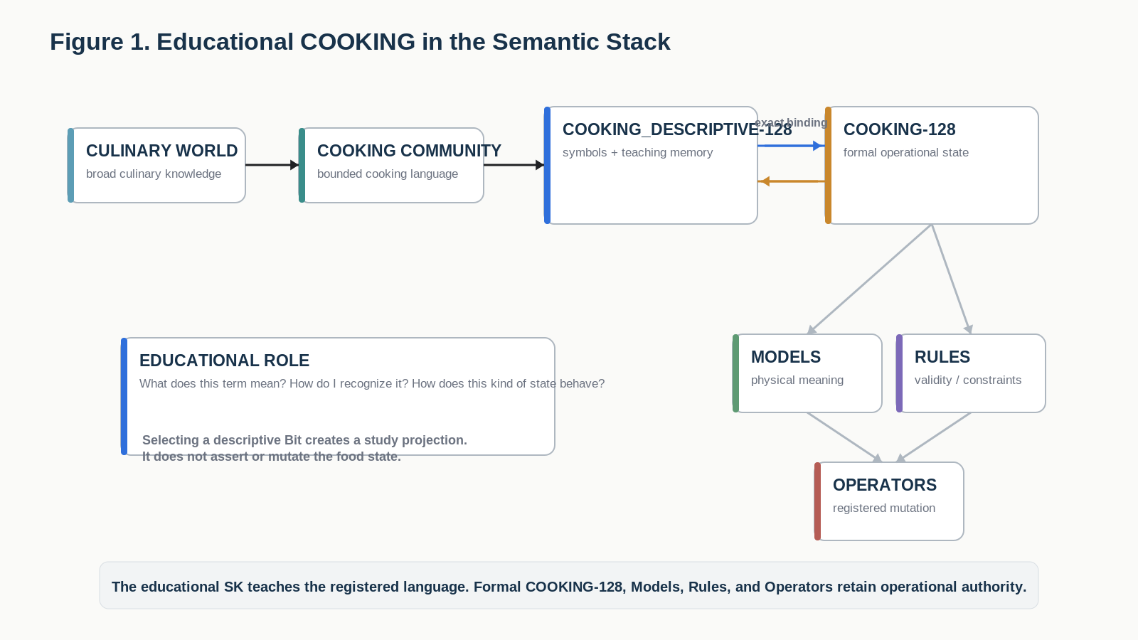
Figure 1. Educational COOKING sits above the formal COOKING-128 state language: learning selection and operational state remain distinct.
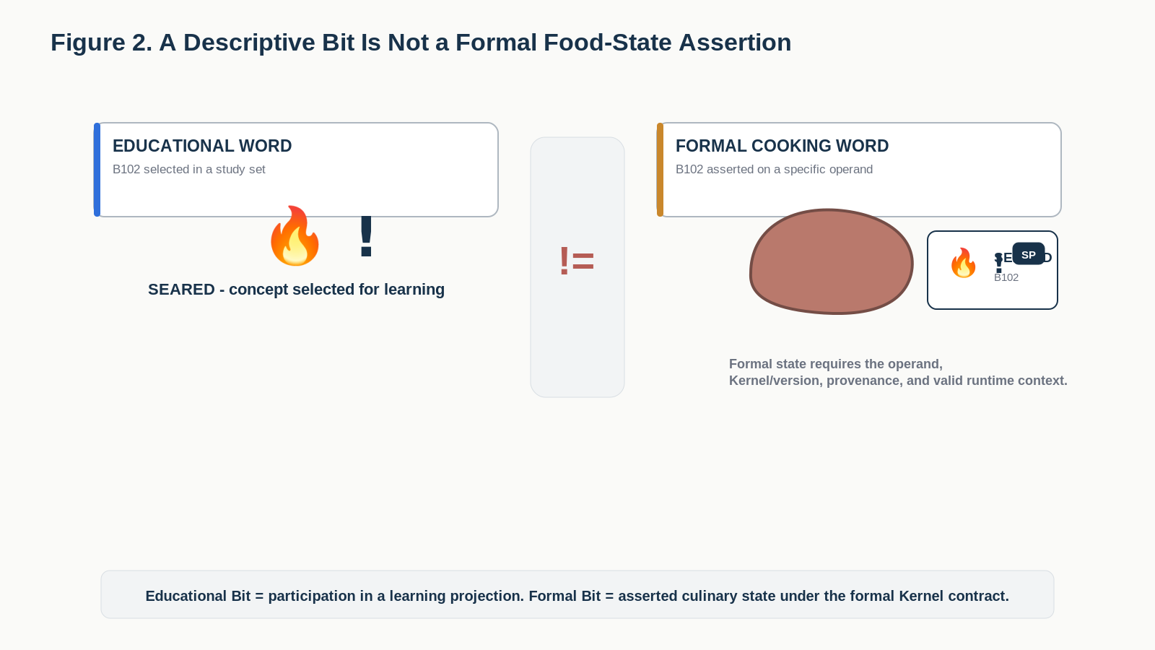
Figure 2. Selecting a descriptive Bit chooses a concept for study; it does not assert that a food operand currently has that formal state.

Part 2 | Exact Binding to Formal COOKING-128
The educational and formal words share the same B000-B127 concept sequence. This alignment is intentional: a learner can move from a descriptive concept card to the exact formal state without string matching, semantic guessing, or a second vocabulary taxonomy.
ONE-TO-ONE BINDING | Educational B102 SEARED teaches the concept. Formal COOKING-128 B102 SEARED is the operational state identity. The two layers share identity without sharing authority.

Layer | Owns
COOKING_DESCRIPTIVE-128 | Selection for study, candidate symbol, instructional memory, learning views, explanation of material-rule behavior
COOKING-128 | Formal state identity, type, transition semantics, Reader behavior, and compatibility with registered Operators and Rules
BOSS | Stable symbol identity and presentation projection
Models / Rules | Dimensions, thresholds, causal predicates, legality, result derivation, and contextual interpretation
Operators | Exact state mutation inside declared write scope

Part 3 | Instructional Memory Contract
Every registered educational Bit opens the same ordered five-layer teaching package. The Bit is the address; the linked instructional memory carries the explanation.
Layer | Question answered
Symbol | What compact visual handle should I recognize?
Description | What does this culinary concept mean?
Professional Example | How might a professional kitchen, recipe compiler, or culinary system use the concept?
Personal Example | How can a learner recognize or use the concept in ordinary cooking?
Instructional State | How does this fact behave as the food continues through preparation?
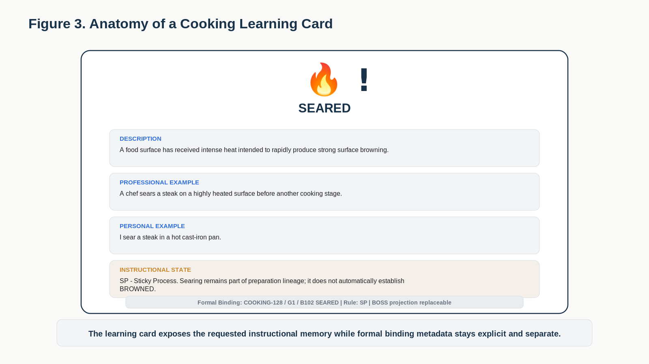
Figure 3. One Cooking Learning Card exposes Symbol, Description, Professional Example, Personal Example, and Instructional State while keeping formal binding metadata separate.
MEMORY LAW | The five learning layers explain one exact culinary concept. They do not redefine the formal COOKING-128 Bit, and the Instructional State does not substitute for the formal transition contract.

Part 4 | Candidate BOSS Culinary Symbol Morphology
The candidate symbol pack uses a small recurring visual morphology so related concepts resemble one another. This is a pedagogical convenience, not a runtime parser. BOSS identity and Reader-bound semantic identity remain authoritative even if the visible symbol pack changes later.
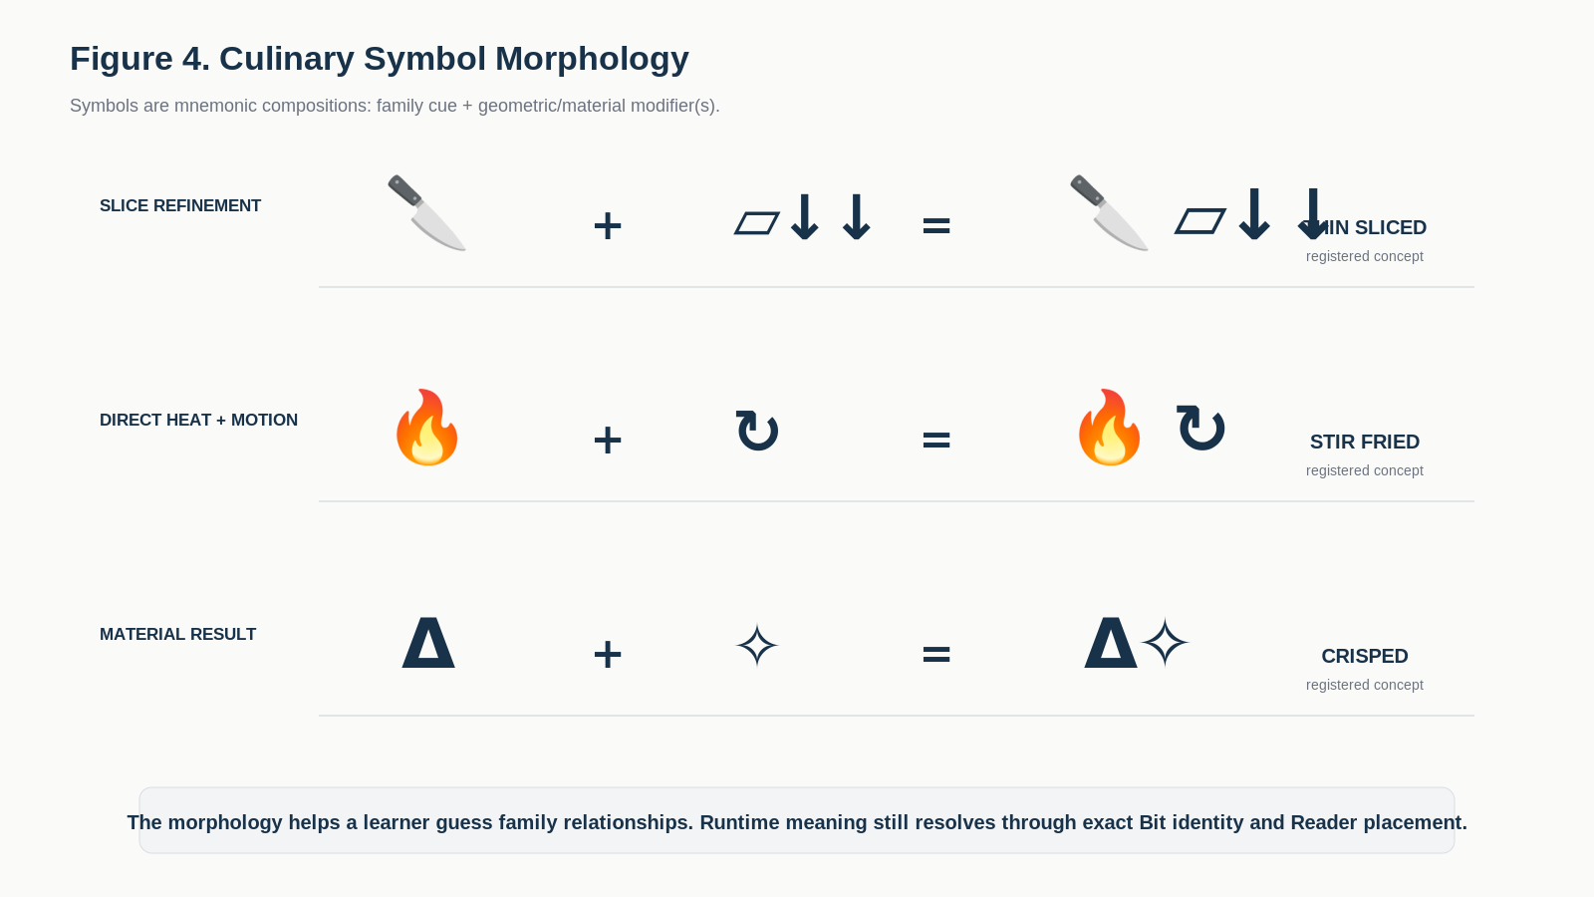
Figure 4. Culinary symbols are mnemonic compositions of family stems and modifiers; runtime meaning is never inferred from glyph shape alone.
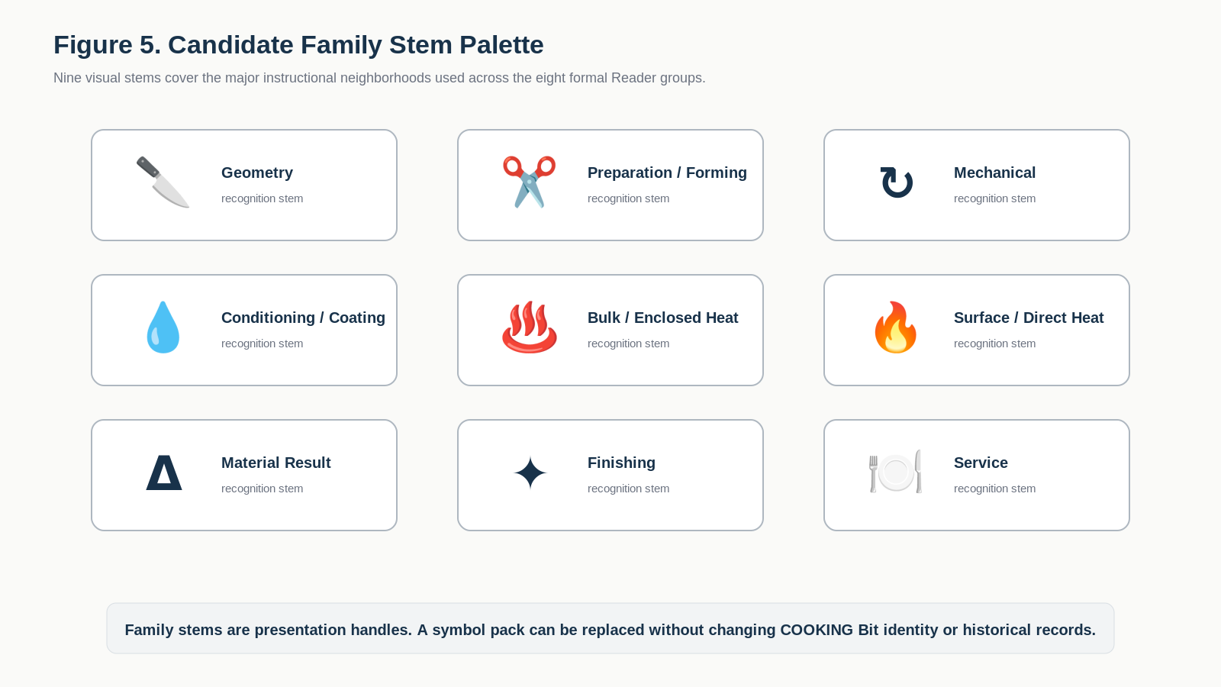
Figure 5. Nine candidate family stems provide a compact visual entry point into geometry, preparation, mechanical work, conditioning, heat, results, finishing, and service.
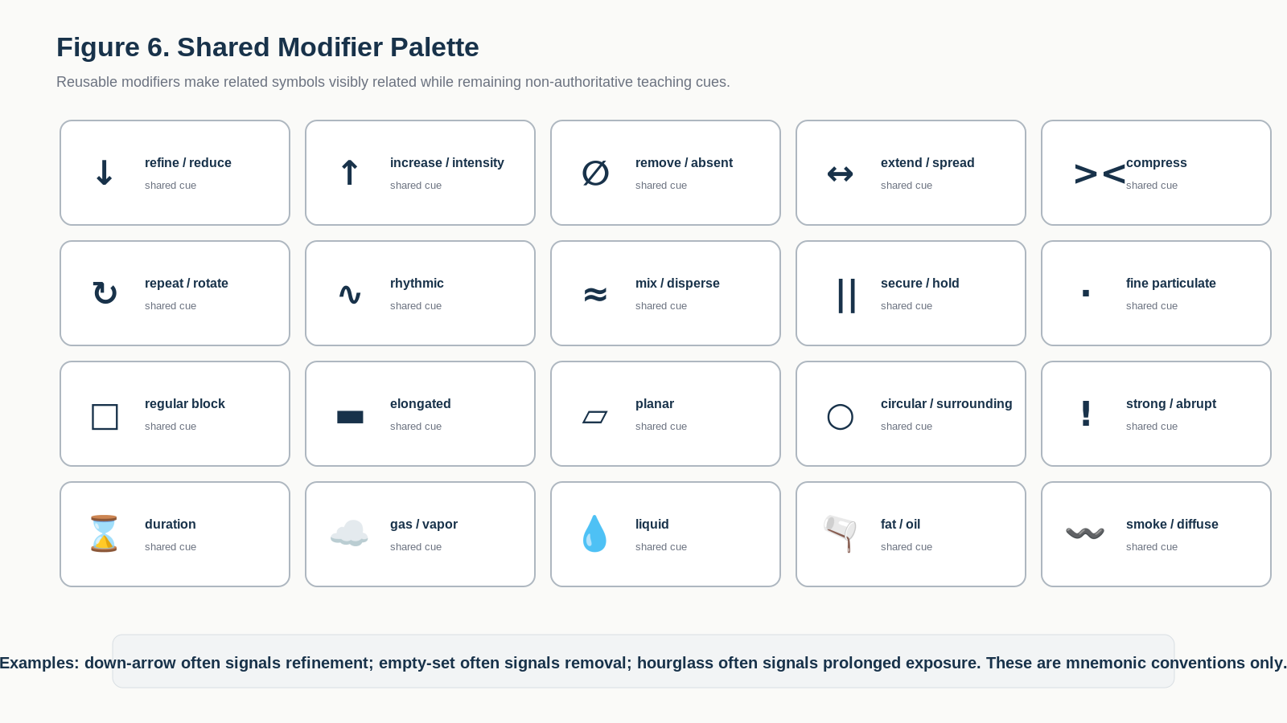
Figure 6. Shared modifiers reinforce recurring ideas such as refinement, removal, compression, duration, liquid, fat, and smoke without becoming semantic authority.
Examples of the morphology: a knife stem plus planar geometry plus refinement yields a family resemblance among slice states; a direct-heat stem plus repetition suggests a surface-heat method involving active movement; the Delta stem marks a resultant material condition rather than a method history.
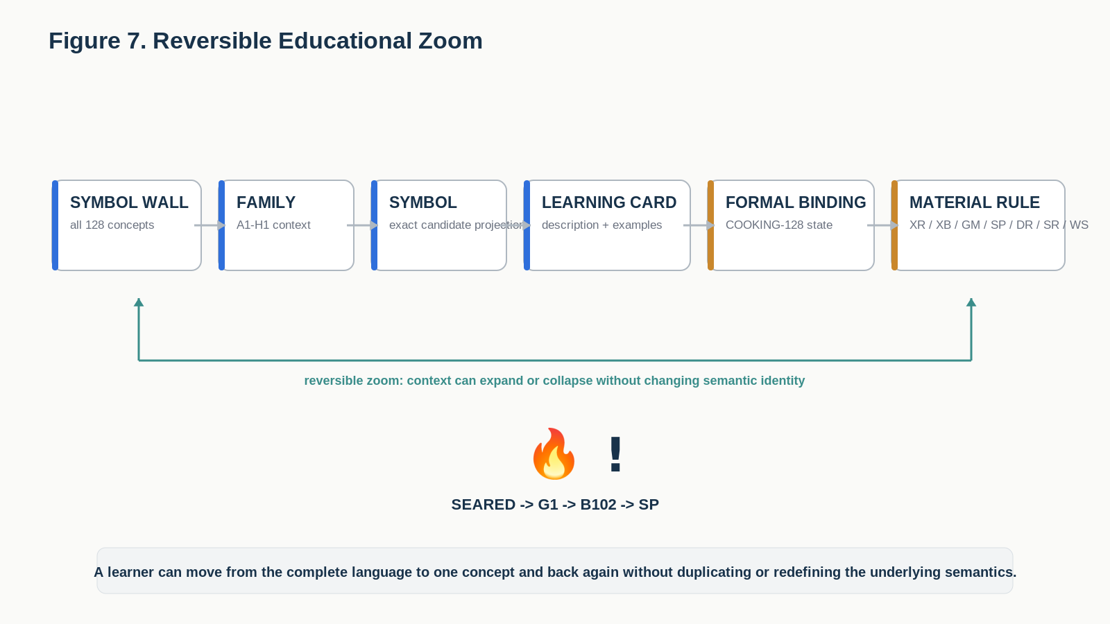
Figure 7. The educational interface can zoom from the complete Symbol Wall down to one concept, its memory, formal binding, and material-rule behavior.

Part 5 | Material Cooking Rule Grammar
The seven Material Cooking Rules are actual culinary state-behavior rules. They explain what kind of fact a Bit carries when the same food operand continues through later operations. They therefore belong inside the educational specification as first-class teaching content, not merely as registry metadata.
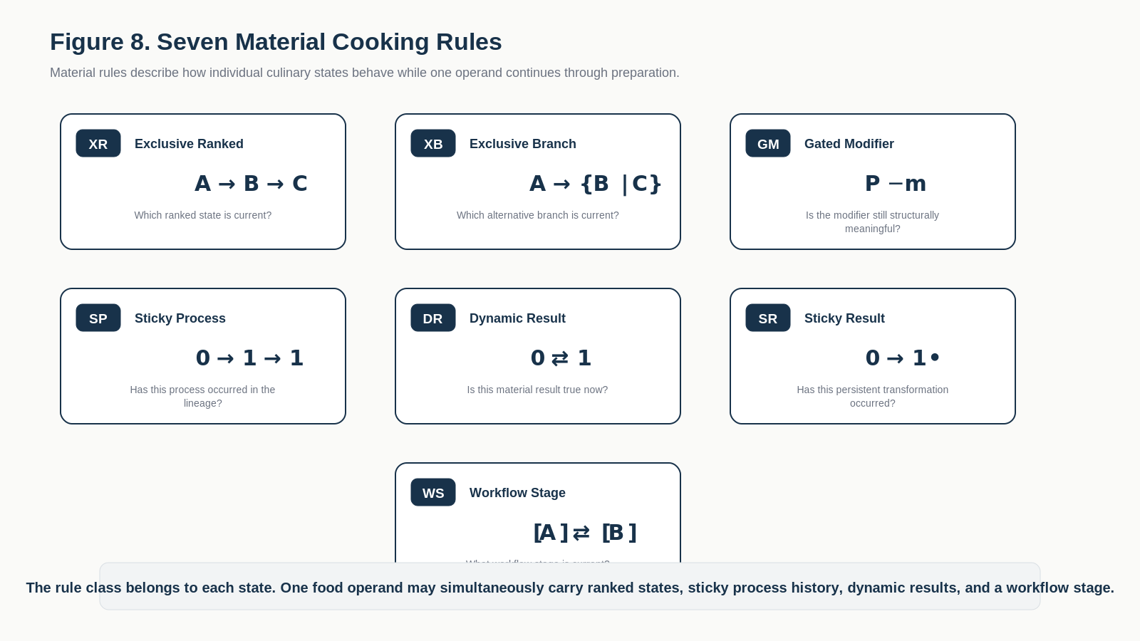
Figure 8. Seven Material Cooking Rules explain how different culinary state facts behave through continuing preparation.

5.1 XR - Exclusive Ranked
XR answers: Which ranked state is current? A ranked family has at most one active member. Forward refinement or severity normally replaces the prior current member; provenance can still preserve the earlier state.
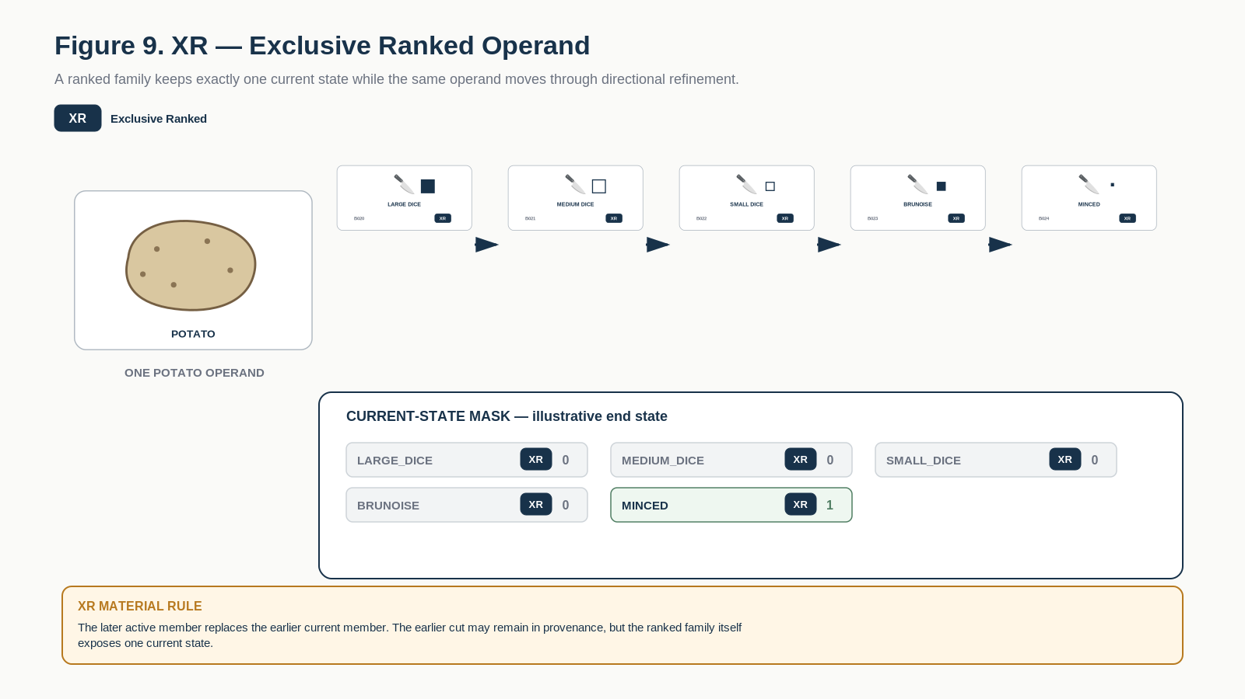
Figure 9. XR - one current ranked member. A potato progresses through finer dice states while earlier current states are replaced.

5.2 XB - Exclusive Branch
XB answers: Which alternative branch is current? Branch members are mutually exclusive current forms but are not one total intensity or fineness order.
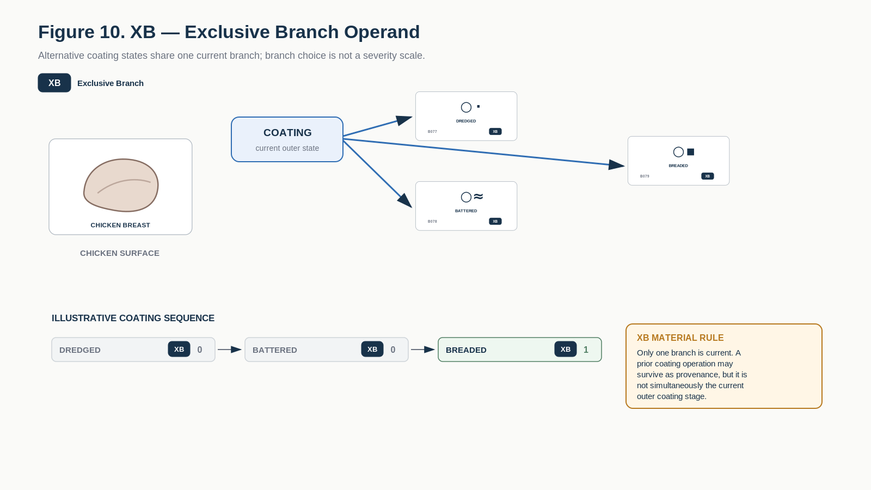
Figure 10. XB - one current branch. Coating states are alternative current outer forms rather than intensity levels.

5.3 GM - Gated Modifier
GM answers: Is this modifier still structurally meaningful? A modifier can remain only while a compatible parent structure survives.
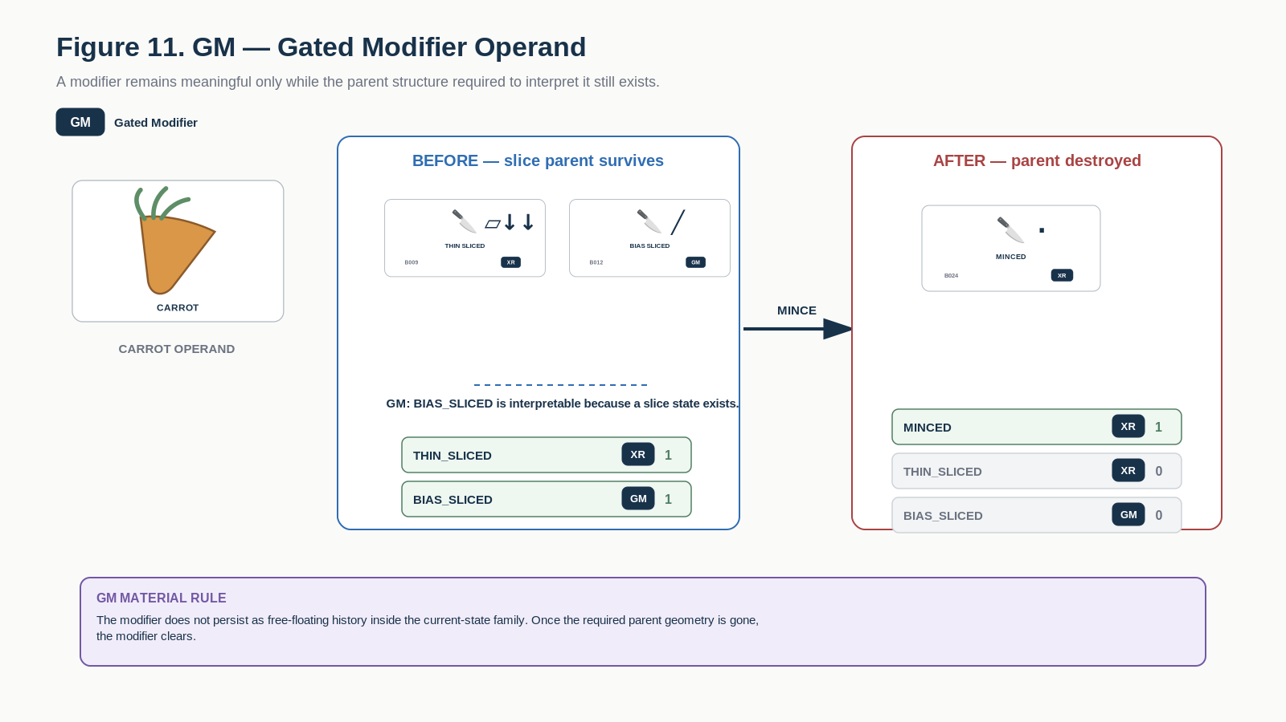
Figure 11. GM - a modifier survives only while its required parent structure remains meaningful.

5.4 SP - Sticky Process
SP answers: Has this process occurred in the current preparation lineage? Once validly applied, the process fact normally accumulates as history even after later operations occur.
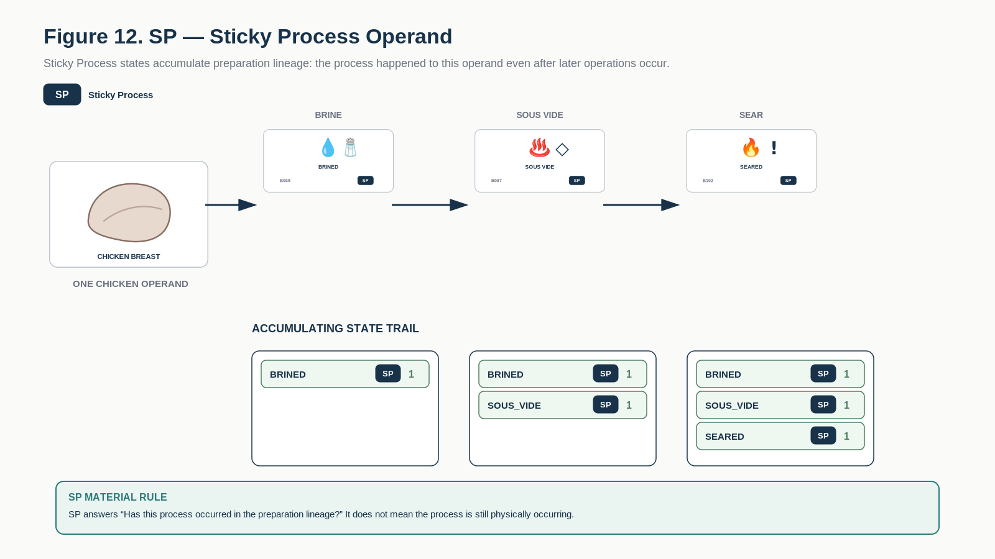
Figure 12. SP - process history accumulates within one preparation lineage: brining, sous vide, and searing can all remain true as historical facts.

5.5 DR - Dynamic Result
DR answers: Is this material result true now? A dynamic result may enter or clear as Model and Rule predicates change, even while earlier process history remains true.
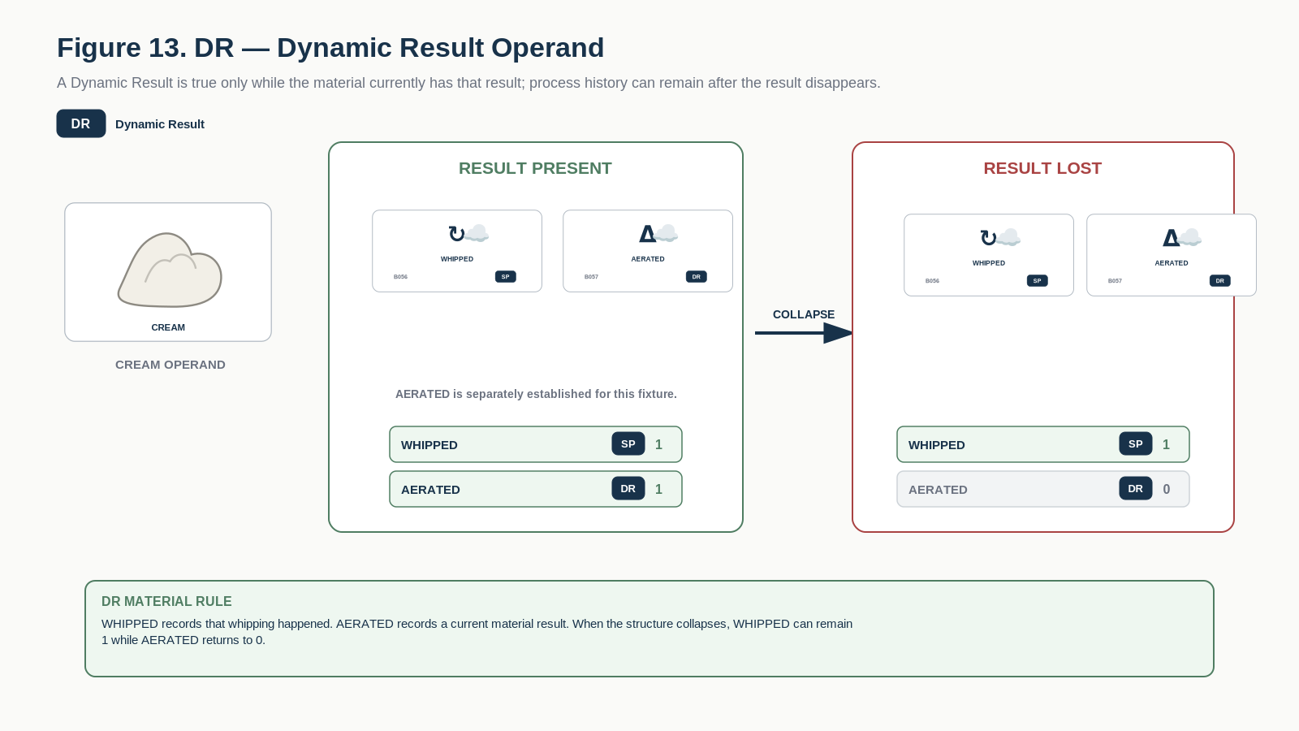
Figure 13. DR - a current material result can clear while the process history that helped produce it remains.

5.6 SR - Sticky Result
SR answers: Has this persistent material transformation occurred? Ordinary reversal of the surrounding condition does not silently restore the earlier material structure.
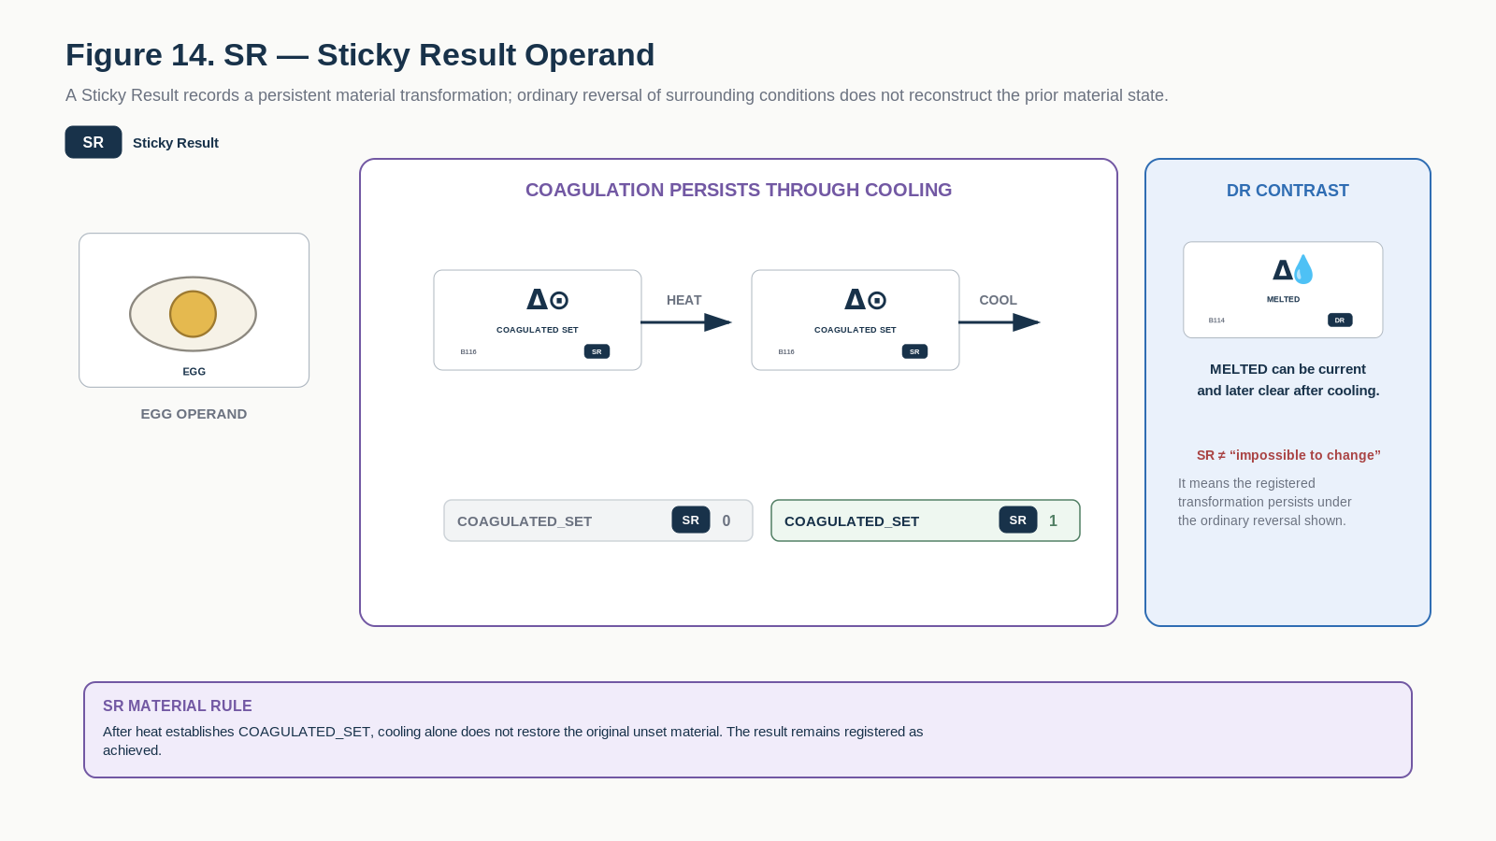
Figure 14. SR - a persistent transformation remains asserted under ordinary later handling; this does not mean no future operation can ever modify the material.

5.7 WS - Workflow Stage
WS answers: What production or service stage is current? Workflow state can be entered and exited without pretending that it is a physical material property.
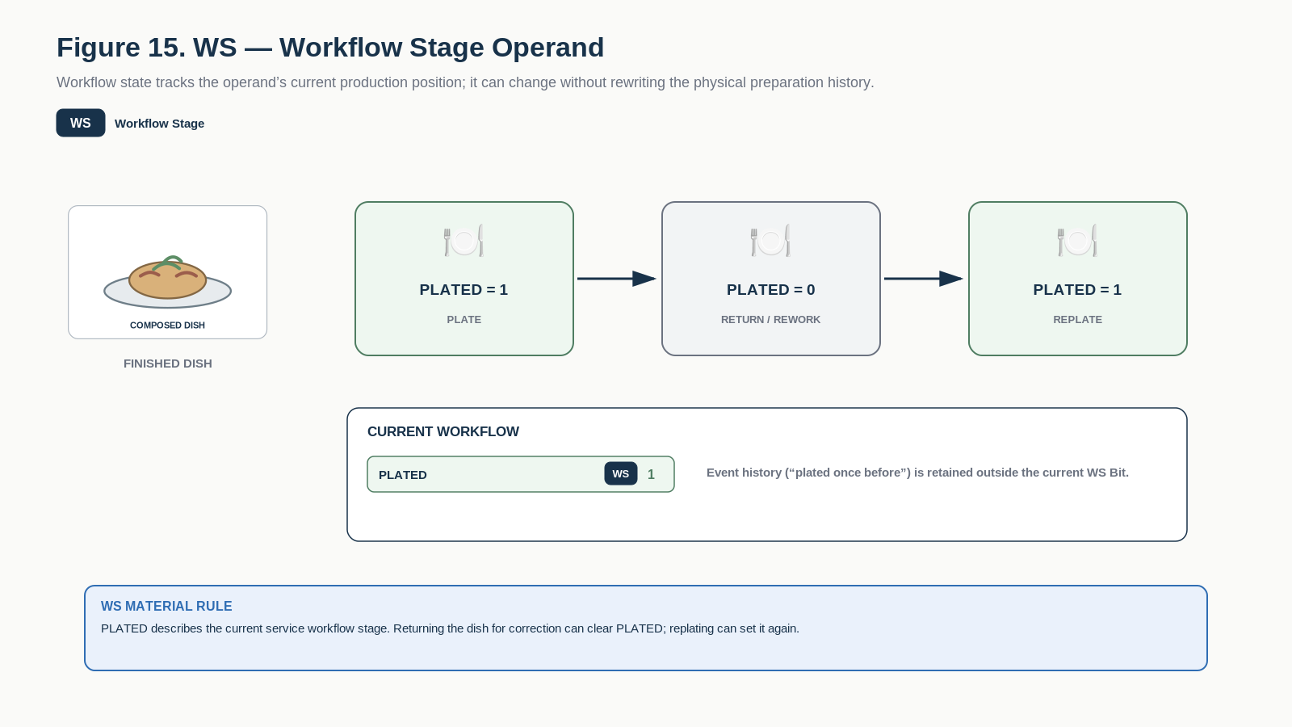
Figure 15. WS - workflow stage records current production position and may be exited and re-entered without deleting provenance.

Part 6 | Material Rule Comparison
The rule classes are not competing labels for the whole food. One operand may simultaneously carry multiple state facts, each with its own persistence and transition behavior.
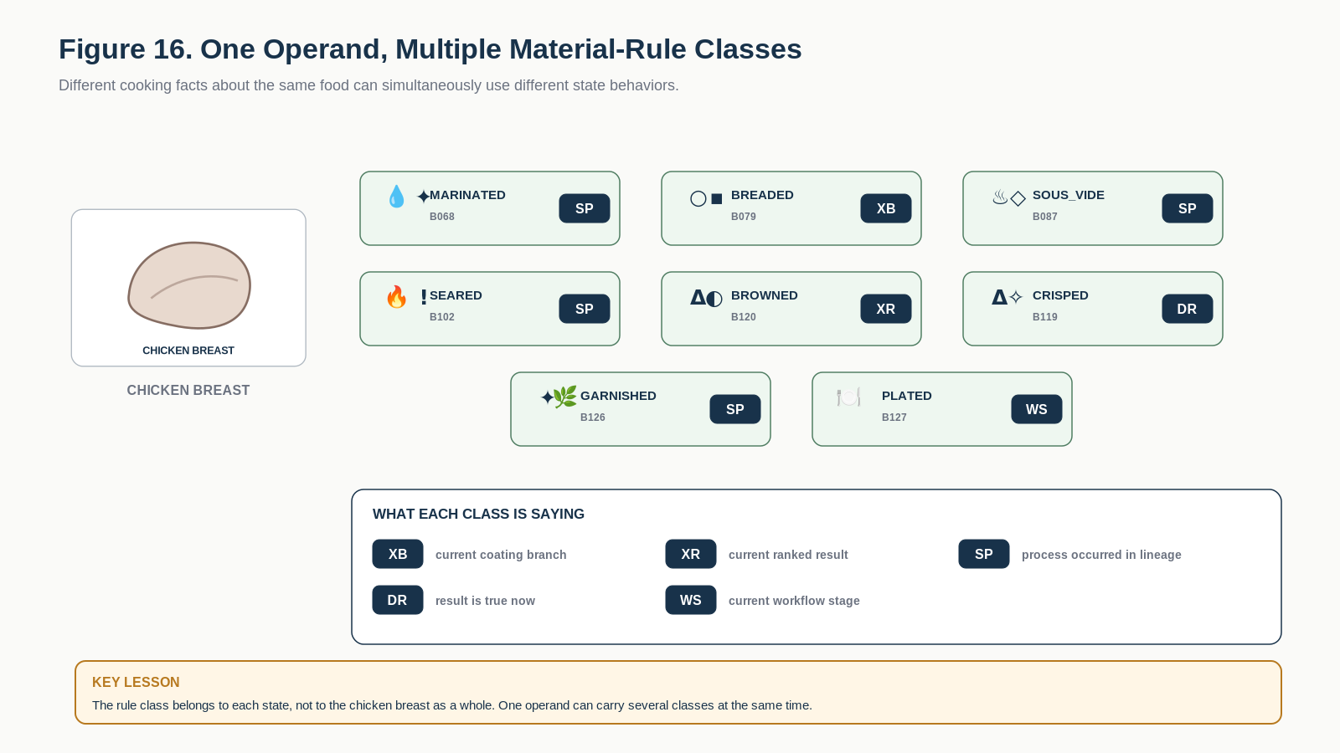
Figure 16. One food operand can carry states from several rule classes at once; the rule class belongs to each state, not to the operand as a whole.
Rule | Teaching question
XR | Which ranked state is current?
XB | Which branch is current?
GM | Is this modifier still valid under its parent?
SP | Has this process occurred?
DR | Is this material result true now?
SR | Has this persistent transformation occurred?
WS | What workflow stage is current?
FLAGSHIP CONTRAST | WHIPPED can remain SP history after a foam collapses while AERATED, a DR state, returns to 0. Method history and current material result are different kinds of culinary facts.

Part 7 | A1 - Primary Cut Geometry
B000-B015 | What coarse cut or slice geometry currently describes the food?
A1 teaches coarse sectioning, chop refinement, slice-thickness refinement, and geometry modifiers. It introduces the difference between ranked geometry and gated descriptors such as BIAS_SLICED or CROSSHATCH_SCORED.
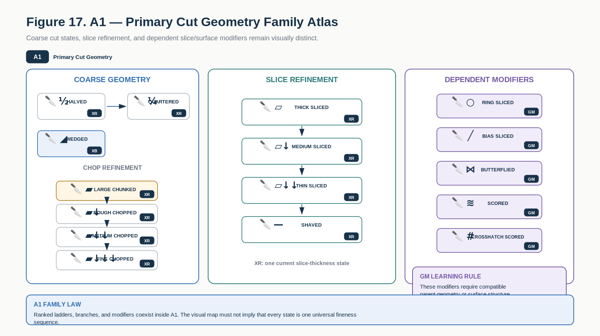
Figure 17. A1 Family Atlas organizes coarse cut geometry, slice refinement, and compatible modifiers.
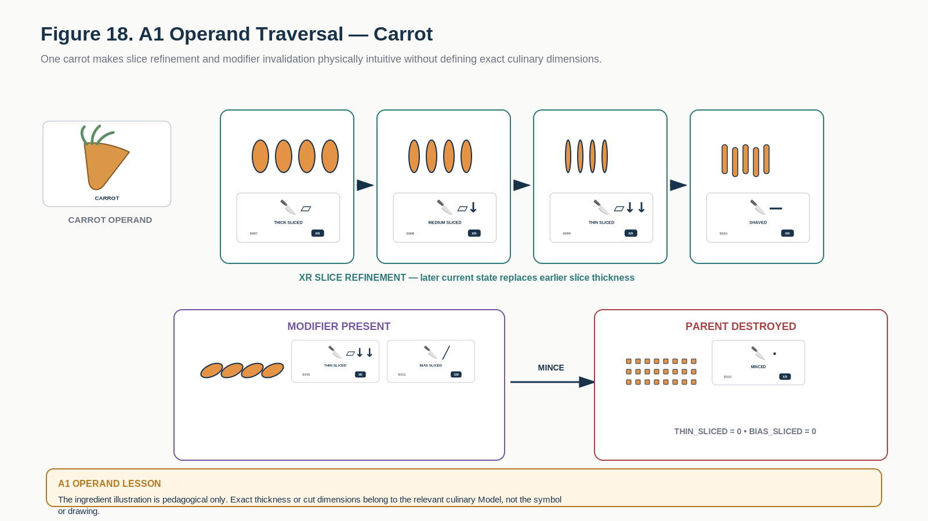
Figure 18. A1 operand traversal shows a carrot moving through slice refinement and demonstrates modifier invalidation when slice geometry is destroyed.

A1 Learning Registry
Each row below is one exact educational Bit. The approved symbol tile is a candidate BOSS projection; the Description and formal transition behavior are grounded in the corresponding COOKING-128 state.
Symbol / Identity | Instructional Memory
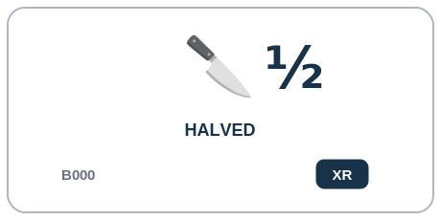  A1 | XR Exclusive Ranked | Halved B000  DESCRIPTION | Object has been divided into approximately two major portions.  PROFESSIONAL EXAMPLE | A prep specification can use Halved to identify this exact cut or reduction state before the ingredient moves to another operation.  PERSONAL EXAMPLE | I can use Halved when the ingredient in front of me matches that cut form, rather than relying on a vague phrase such as 'smaller pieces.'  INSTRUCTIONAL STATE | XR - Exclusive Ranked. Root/refinement geometry. May continue to quartering, wedges, chunks, slices, sticks, dice, or finer states. Backward reconstruction is not an ordinary cutting edge.
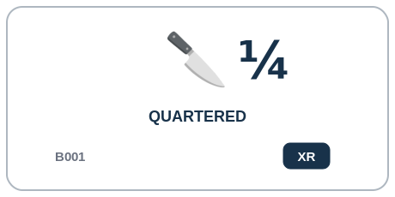  A1 | XR Exclusive Ranked | Quartered B001  DESCRIPTION | Object has been divided into approximately four major portions.  PROFESSIONAL EXAMPLE | A prep specification can use Quartered to identify this exact cut or reduction state before the ingredient moves to another operation.  PERSONAL EXAMPLE | I can use Quartered when the ingredient in front of me matches that cut form, rather than relying on a vague phrase such as 'smaller pieces.'  INSTRUCTIONAL STATE | XR - Exclusive Ranked. Common edge HALVED->QUARTERED. Further reduction is permitted; reconstruction to HALVED is prohibited under ordinary reduction Operators.
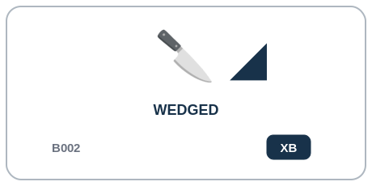  A1 | XB Exclusive Branch | Wedged B002  DESCRIPTION | Object has been divided into tapered radial sections.  PROFESSIONAL EXAMPLE | A prep specification can use Wedged to identify this exact cut or reduction state before the ingredient moves to another operation.  PERSONAL EXAMPLE | I can use Wedged when the ingredient in front of me matches that cut form, rather than relying on a vague phrase such as 'smaller pieces.'  INSTRUCTIONAL STATE | XB - Exclusive Branch. Branch geometry. May refine into chop, slice, dice, crush, grind, or other compatible states under object-specific Rules.
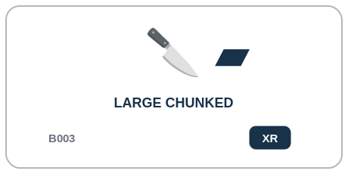  A1 | XR Exclusive Ranked | Large Chunked B003  DESCRIPTION | Object has been cut into large irregular pieces.  PROFESSIONAL EXAMPLE | A prep specification can use Large Chunked to identify this exact cut or reduction state before the ingredient moves to another operation.  PERSONAL EXAMPLE | I can use Large Chunked when the ingredient in front of me matches that cut form, rather than relying on a vague phrase such as 'smaller pieces.'  INSTRUCTIONAL STATE | XR - Exclusive Ranked. Coarse root of the chop ladder. Canonical refinement LARGE_CHUNKED->ROUGH_CHOPPED.
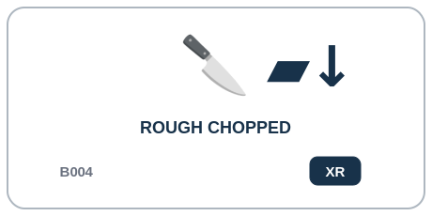  A1 | XR Exclusive Ranked | Rough Chopped B004  DESCRIPTION | Object has been chopped into intentionally irregular coarse pieces.  PROFESSIONAL EXAMPLE | A prep specification can use Rough Chopped to identify this exact cut or reduction state before the ingredient moves to another operation.  PERSONAL EXAMPLE | I can use Rough Chopped when the ingredient in front of me matches that cut form, rather than relying on a vague phrase such as 'smaller pieces.'  INSTRUCTIONAL STATE | XR - Exclusive Ranked. Canonical refinement ROUGH_CHOPPED->MEDIUM_CHOPPED. Forward skips are allowed when the Operator can directly produce the target.
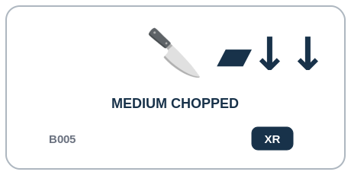  A1 | XR Exclusive Ranked | Medium Chopped B005  DESCRIPTION | Object has been chopped into moderately sized pieces.  PROFESSIONAL EXAMPLE | A prep specification can use Medium Chopped to identify this exact cut or reduction state before the ingredient moves to another operation.  PERSONAL EXAMPLE | I can use Medium Chopped when the ingredient in front of me matches that cut form, rather than relying on a vague phrase such as 'smaller pieces.'  INSTRUCTIONAL STATE | XR - Exclusive Ranked. Canonical refinement MEDIUM_CHOPPED->FINE_CHOPPED.
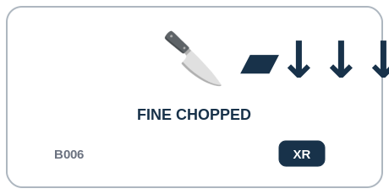  A1 | XR Exclusive Ranked | Fine Chopped B006  DESCRIPTION | Object has been chopped into small pieces while retaining visibly discrete pieces.  PROFESSIONAL EXAMPLE | A prep specification can use Fine Chopped to identify this exact cut or reduction state before the ingredient moves to another operation.  PERSONAL EXAMPLE | I can use Fine Chopped when the ingredient in front of me matches that cut form, rather than relying on a vague phrase such as 'smaller pieces.'  INSTRUCTIONAL STATE | XR - Exclusive Ranked. Terminal named chop state in v0.1; may continue to mince, grind, blend, or other finer compatible transformations.
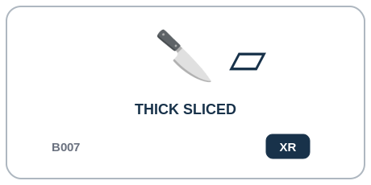  A1 | XR Exclusive Ranked | Thick Sliced B007  DESCRIPTION | Object has been divided into relatively thick planar slices.  PROFESSIONAL EXAMPLE | A prep specification can use Thick Sliced to identify this exact cut or reduction state before the ingredient moves to another operation.  PERSONAL EXAMPLE | I can use Thick Sliced when the ingredient in front of me matches that cut form, rather than relying on a vague phrase such as 'smaller pieces.'  INSTRUCTIONAL STATE | XR - Exclusive Ranked. Root of slice thickness ladder. Canonical refinement THICK_SLICED->MEDIUM_SLICED.
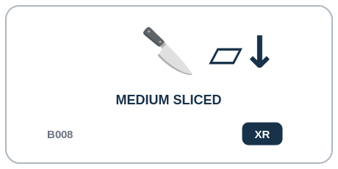  A1 | XR Exclusive Ranked | Medium Sliced B008  DESCRIPTION | Object has been divided into medium-thickness planar slices.  PROFESSIONAL EXAMPLE | A prep specification can use Medium Sliced to identify this exact cut or reduction state before the ingredient moves to another operation.  PERSONAL EXAMPLE | I can use Medium Sliced when the ingredient in front of me matches that cut form, rather than relying on a vague phrase such as 'smaller pieces.'  INSTRUCTIONAL STATE | XR - Exclusive Ranked. Canonical refinement MEDIUM_SLICED->THIN_SLICED.
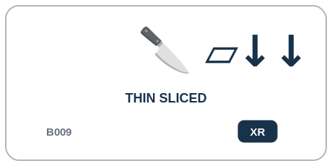  A1 | XR Exclusive Ranked | Thin Sliced B009  DESCRIPTION | Object has been divided into thin planar slices.  PROFESSIONAL EXAMPLE | A prep specification can use Thin Sliced to identify this exact cut or reduction state before the ingredient moves to another operation.  PERSONAL EXAMPLE | I can use Thin Sliced when the ingredient in front of me matches that cut form, rather than relying on a vague phrase such as 'smaller pieces.'  INSTRUCTIONAL STATE | XR - Exclusive Ranked. Canonical refinement THIN_SLICED->SHAVED.
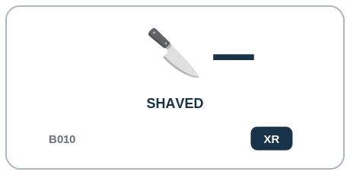  A1 | XR Exclusive Ranked | Shaved B010  DESCRIPTION | Object has been cut into extremely thin sheets or flakes.  PROFESSIONAL EXAMPLE | A prep specification can use Shaved to identify this exact cut or reduction state before the ingredient moves to another operation.  PERSONAL EXAMPLE | I can use Shaved when the ingredient in front of me matches that cut form, rather than relying on a vague phrase such as 'smaller pieces.'  INSTRUCTIONAL STATE | XR - Exclusive Ranked. Finest named planar slice state in v0.1. No ordinary backward slice edge.
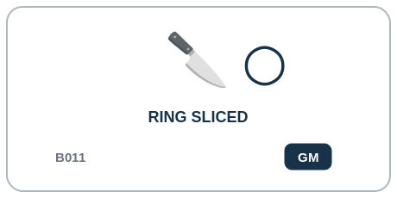  A1 | GM Gated Modifier | Ring Sliced B011  DESCRIPTION | A cylindrical or layered object has been sliced crosswise into rings.  PROFESSIONAL EXAMPLE | A prep specification can use Ring Sliced to identify this exact cut or reduction state before the ingredient moves to another operation.  PERSONAL EXAMPLE | I can use Ring Sliced when the ingredient in front of me matches that cut form, rather than relying on a vague phrase such as 'smaller pieces.'  INSTRUCTIONAL STATE | GM - Gated Modifier. Requires a slice-family dominant geometry. Normally mutex with BIAS_SLICED. Clears when the dominant geometry ceases to be a slice state.
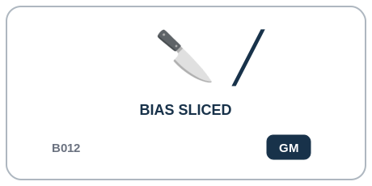  A1 | GM Gated Modifier | Bias Sliced B012  DESCRIPTION | Object has been sliced diagonally relative to its primary axis.  PROFESSIONAL EXAMPLE | A prep specification can use Bias Sliced to identify this exact cut or reduction state before the ingredient moves to another operation.  PERSONAL EXAMPLE | I can use Bias Sliced when the ingredient in front of me matches that cut form, rather than relying on a vague phrase such as 'smaller pieces.'  INSTRUCTIONAL STATE | GM - Gated Modifier. Requires a slice-family dominant geometry. Normally mutex with RING_SLICED. Clears when the dominant geometry ceases to be a slice state.
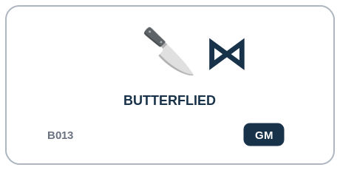  A1 | GM Gated Modifier | Butterflied B013  DESCRIPTION | Object has been cut almost through and opened to increase surface area while preserving connection.  PROFESSIONAL EXAMPLE | A prep specification can use Butterflied to identify this exact cut or reduction state before the ingredient moves to another operation.  PERSONAL EXAMPLE | I can use Butterflied when the ingredient in front of me matches that cut form, rather than relying on a vague phrase such as 'smaller pieces.'  INSTRUCTIONAL STATE | GM - Gated Modifier. Valid only while the connected parent structure remains meaningful. Any severing primary-geometry transition normally clears this modifier.
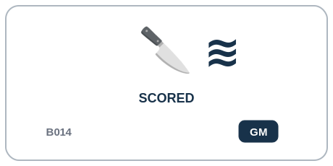  A1 | GM Gated Modifier | Scored B014  DESCRIPTION | Surface has received shallow cuts without complete sectioning.  PROFESSIONAL EXAMPLE | A prep specification can use Scored to identify this exact cut or reduction state before the ingredient moves to another operation.  PERSONAL EXAMPLE | I can use Scored when the ingredient in front of me matches that cut form, rather than relying on a vague phrase such as 'smaller pieces.'  INSTRUCTIONAL STATE | GM - Gated Modifier. May coexist with compatible geometry. Cleared only when the scored surface is no longer semantically addressable; exact invalidation is Operator/Model-specific.
  A1 | GM Gated Modifier | Crosshatch Scored B015  DESCRIPTION | Surface has been scored in intersecting directions to form a crosshatch pattern.  PROFESSIONAL EXAMPLE | A prep specification can use Crosshatch Scored to identify this exact cut or reduction state before the ingredient moves to another operation.  PERSONAL EXAMPLE | I can use Crosshatch Scored when the ingredient in front of me matches that cut form, rather than relying on a vague phrase such as 'smaller pieces.'  INSTRUCTIONAL STATE | GM - Gated Modifier. IMPLY(CROSSHATCH_SCORED->SCORED). It cannot remain active while SCORED is false.

Part 8 | B1 - Precision Cuts & Comminution
B016-B031 | What precise reduction geometry or particle form currently dominates?
B1 teaches structured sticks and dice, fine particle reduction, and branch comminution methods. Dimensional relationships such as JULIENNE to SMALL_DICE remain Model-dependent rather than universal equivalences.
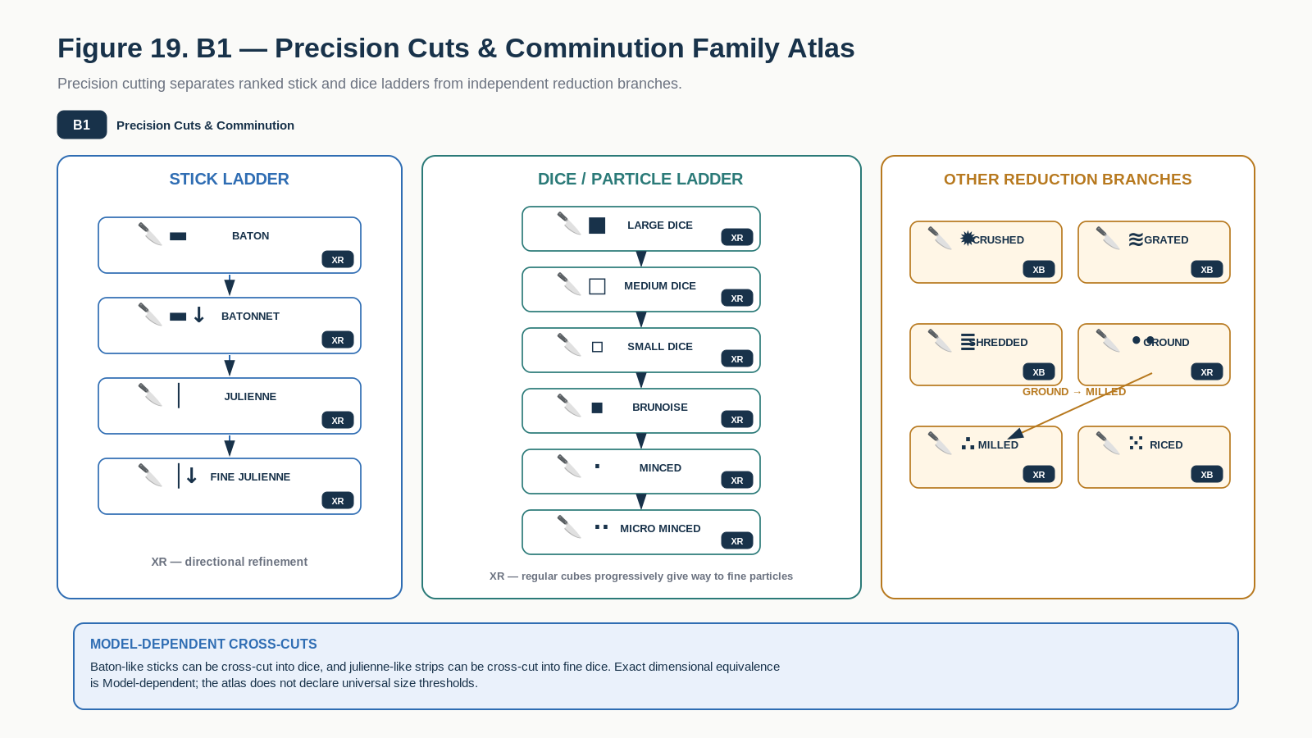
Figure 19. B1 Family Atlas separates stick and dice refinement from branch reductions such as crushing, grating, shredding, and ricing.
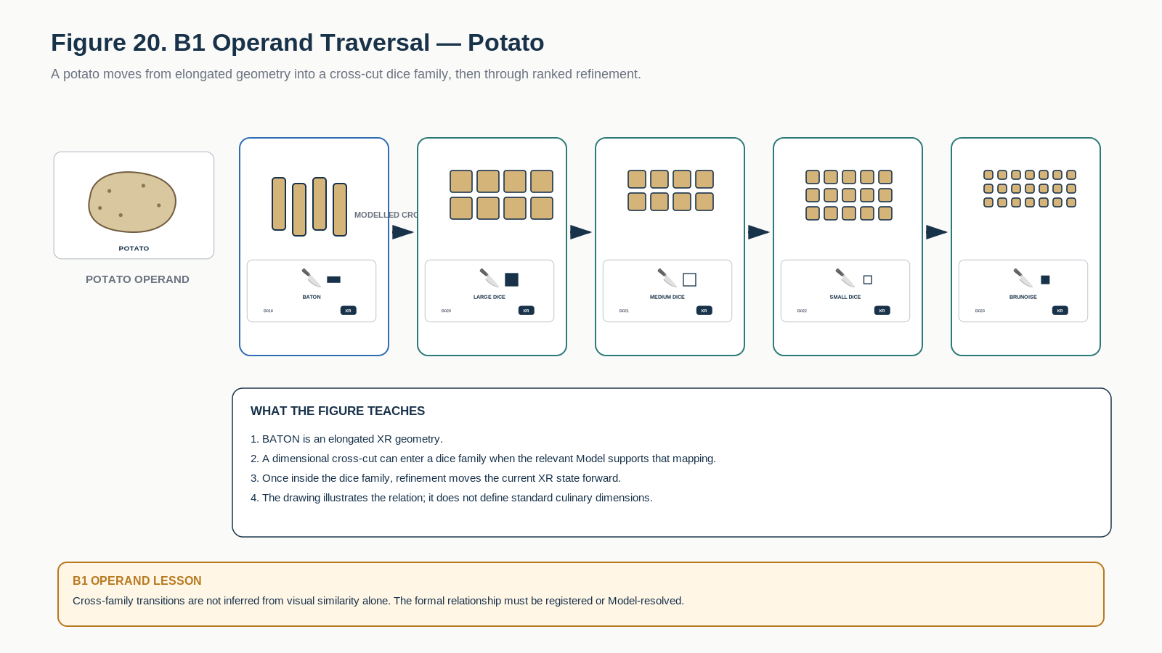
Figure 20. B1 operand traversal shows modeled cross-cutting and ranked dice refinement on one potato operand.

B1 Learning Registry
Each row below is one exact educational Bit. The approved symbol tile is a candidate BOSS projection; the Description and formal transition behavior are grounded in the corresponding COOKING-128 state.
Symbol / Identity | Instructional Memory
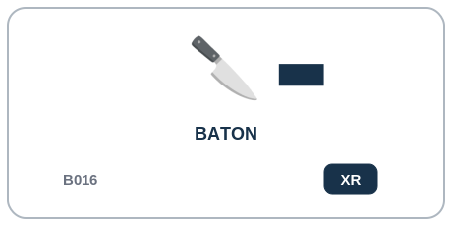  B1 | XR Exclusive Ranked | Baton B016  DESCRIPTION | Food has been cut into large elongated rectangular sticks.  PROFESSIONAL EXAMPLE | A prep specification can use Baton to identify this exact cut or reduction state before the ingredient moves to another operation.  PERSONAL EXAMPLE | I can use Baton when the ingredient in front of me matches that cut form, rather than relying on a vague phrase such as 'smaller pieces.'  INSTRUCTIONAL STATE | XR - Exclusive Ranked. Root of stick refinement ladder. Canonical BATON->BATONNET; cross-cut commonly yields LARGE_DICE.
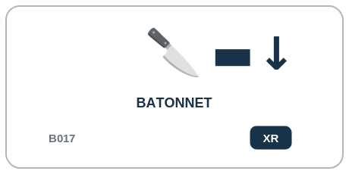  B1 | XR Exclusive Ranked | Batonnet B017  DESCRIPTION | Food has been cut into smaller standardized rectangular sticks.  PROFESSIONAL EXAMPLE | A prep specification can use Batonnet to identify this exact cut or reduction state before the ingredient moves to another operation.  PERSONAL EXAMPLE | I can use Batonnet when the ingredient in front of me matches that cut form, rather than relying on a vague phrase such as 'smaller pieces.'  INSTRUCTIONAL STATE | XR - Exclusive Ranked. Canonical BATONNET->JULIENNE; cross-cut commonly yields MEDIUM_DICE subject to dimensions.
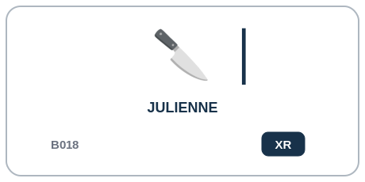  B1 | XR Exclusive Ranked | Julienne B018  DESCRIPTION | Food has been cut into fine matchstick-like strips.  PROFESSIONAL EXAMPLE | A prep specification can use Julienne to identify this exact cut or reduction state before the ingredient moves to another operation.  PERSONAL EXAMPLE | I can use Julienne when the ingredient in front of me matches that cut form, rather than relying on a vague phrase such as 'smaller pieces.'  INSTRUCTIONAL STATE | XR - Exclusive Ranked. Canonical JULIENNE->FINE_JULIENNE; cross-cut commonly yields SMALL_DICE or BRUNOISE according to dimensional Model.
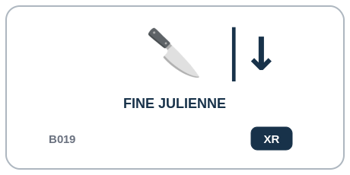  B1 | XR Exclusive Ranked | Fine Julienne B019  DESCRIPTION | Food has been cut into exceptionally fine elongated strips.  PROFESSIONAL EXAMPLE | A prep specification can use Fine Julienne to identify this exact cut or reduction state before the ingredient moves to another operation.  PERSONAL EXAMPLE | I can use Fine Julienne when the ingredient in front of me matches that cut form, rather than relying on a vague phrase such as 'smaller pieces.'  INSTRUCTIONAL STATE | XR - Exclusive Ranked. Fine stick state; cross-cut may yield BRUNOISE or MINCED when dimensions and food structure permit.
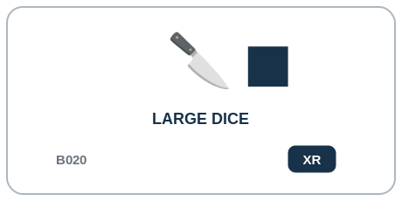  B1 | XR Exclusive Ranked | Large Dice B020  DESCRIPTION | Food has been cut into relatively large cube-like pieces.  PROFESSIONAL EXAMPLE | A prep specification can use Large Dice to identify this exact cut or reduction state before the ingredient moves to another operation.  PERSONAL EXAMPLE | I can use Large Dice when the ingredient in front of me matches that cut form, rather than relying on a vague phrase such as 'smaller pieces.'  INSTRUCTIONAL STATE | XR - Exclusive Ranked. Root of dice refinement ladder. Canonical LARGE_DICE->MEDIUM_DICE.
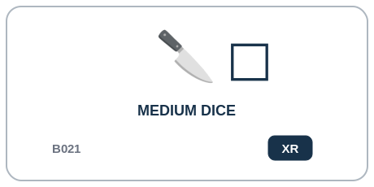  B1 | XR Exclusive Ranked | Medium Dice B021  DESCRIPTION | Food has been cut into medium cube-like pieces.  PROFESSIONAL EXAMPLE | A prep specification can use Medium Dice to identify this exact cut or reduction state before the ingredient moves to another operation.  PERSONAL EXAMPLE | I can use Medium Dice when the ingredient in front of me matches that cut form, rather than relying on a vague phrase such as 'smaller pieces.'  INSTRUCTIONAL STATE | XR - Exclusive Ranked. Canonical MEDIUM_DICE->SMALL_DICE.
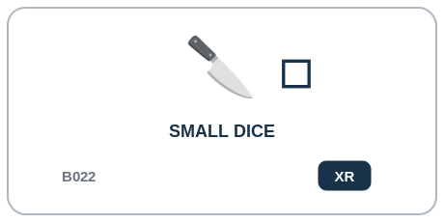  B1 | XR Exclusive Ranked | Small Dice B022  DESCRIPTION | Food has been cut into small cube-like pieces.  PROFESSIONAL EXAMPLE | A prep specification can use Small Dice to identify this exact cut or reduction state before the ingredient moves to another operation.  PERSONAL EXAMPLE | I can use Small Dice when the ingredient in front of me matches that cut form, rather than relying on a vague phrase such as 'smaller pieces.'  INSTRUCTIONAL STATE | XR - Exclusive Ranked. Canonical SMALL_DICE->BRUNOISE. Natural-language labels such as fine dice are resolved by a dimensional Model, not by the bit alone.
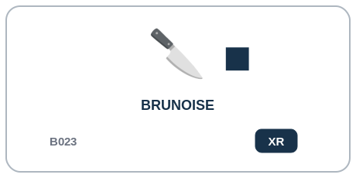  B1 | XR Exclusive Ranked | Brunoise B023  DESCRIPTION | Food has been cut into very fine, approximately uniform cubes.  PROFESSIONAL EXAMPLE | A prep specification can use Brunoise to identify this exact cut or reduction state before the ingredient moves to another operation.  PERSONAL EXAMPLE | I can use Brunoise when the ingredient in front of me matches that cut form, rather than relying on a vague phrase such as 'smaller pieces.'  INSTRUCTIONAL STATE | XR - Exclusive Ranked. Canonical BRUNOISE->MINCED where further reduction is intended.
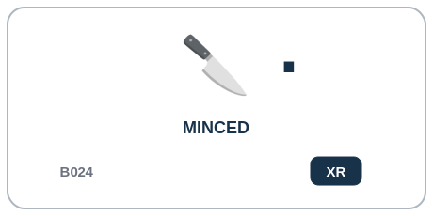  B1 | XR Exclusive Ranked | Minced B024  DESCRIPTION | Food has been reduced into very small discrete particles.  PROFESSIONAL EXAMPLE | A prep specification can use Minced to identify this exact cut or reduction state before the ingredient moves to another operation.  PERSONAL EXAMPLE | I can use Minced when the ingredient in front of me matches that cut form, rather than relying on a vague phrase such as 'smaller pieces.'  INSTRUCTIONAL STATE | XR - Exclusive Ranked. Canonical MINCED->MICRO_MINCED. Ordinary cutting Operators cannot reconstruct larger dice from this state.
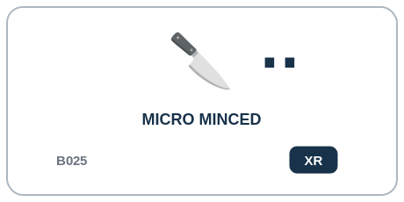  B1 | XR Exclusive Ranked | Micro Minced B025  DESCRIPTION | Food has been reduced beyond ordinary mince into extremely fine particles while remaining non-paste.  PROFESSIONAL EXAMPLE | A prep specification can use Micro Minced to identify this exact cut or reduction state before the ingredient moves to another operation.  PERSONAL EXAMPLE | I can use Micro Minced when the ingredient in front of me matches that cut form, rather than relying on a vague phrase such as 'smaller pieces.'  INSTRUCTIONAL STATE | XR - Exclusive Ranked. Finest discrete knife-cut particle state in v0.1; may continue into blending/puree branches where structurally meaningful.
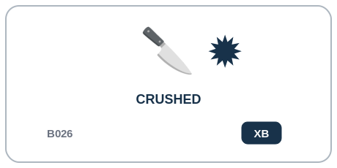  B1 | XB Exclusive Branch | Crushed B026  DESCRIPTION | Food structure has been broken primarily by compressive force rather than precise cutting.  PROFESSIONAL EXAMPLE | A prep specification can use Crushed to identify this exact cut or reduction state before the ingredient moves to another operation.  PERSONAL EXAMPLE | I can use Crushed when the ingredient in front of me matches that cut form, rather than relying on a vague phrase such as 'smaller pieces.'  INSTRUCTIONAL STATE | XB - Exclusive Branch. Branch state. May continue to mince, grind, mash, or blend depending on food and Operator compatibility.
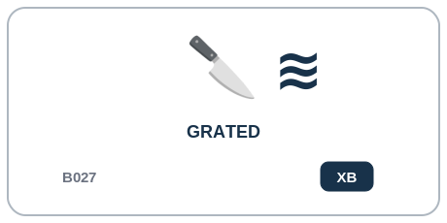  B1 | XB Exclusive Branch | Grated B027  DESCRIPTION | Food has been mechanically reduced through a grating surface.  PROFESSIONAL EXAMPLE | A prep specification can use Grated to identify this exact cut or reduction state before the ingredient moves to another operation.  PERSONAL EXAMPLE | I can use Grated when the ingredient in front of me matches that cut form, rather than relying on a vague phrase such as 'smaller pieces.'  INSTRUCTIONAL STATE | XB - Exclusive Branch. Branch state. May continue to finer grind, mince, blend, or other transformations; not part of a universal knife-cut rank.
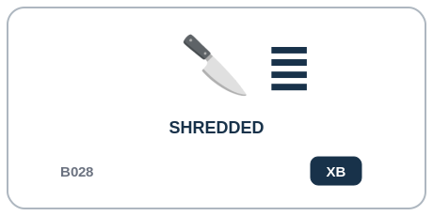  B1 | XB Exclusive Branch | Shredded B028  DESCRIPTION | Food has been reduced into elongated irregular strands or strips.  PROFESSIONAL EXAMPLE | A prep specification can use Shredded to identify this exact cut or reduction state before the ingredient moves to another operation.  PERSONAL EXAMPLE | I can use Shredded when the ingredient in front of me matches that cut form, rather than relying on a vague phrase such as 'smaller pieces.'  INSTRUCTIONAL STATE | XB - Exclusive Branch. Branch state. May continue to finer chop, mince, grind, or blend where compatible.
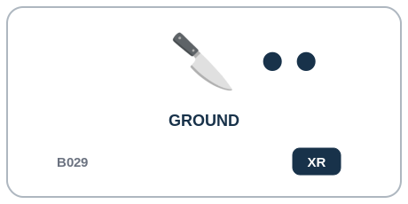  B1 | XR Exclusive Ranked | Ground B029  DESCRIPTION | Food has been mechanically reduced into small particles through grinding.  PROFESSIONAL EXAMPLE | A prep specification can use Ground to identify this exact cut or reduction state before the ingredient moves to another operation.  PERSONAL EXAMPLE | I can use Ground when the ingredient in front of me matches that cut form, rather than relying on a vague phrase such as 'smaller pieces.'  INSTRUCTIONAL STATE | XR - Exclusive Ranked. Canonical compatible refinement GROUND->MILLED when material and equipment permit.
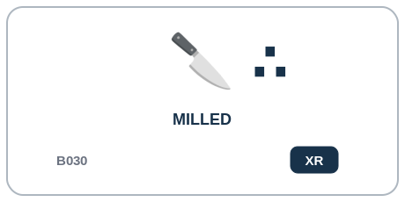  B1 | XR Exclusive Ranked | Milled B030  DESCRIPTION | Food has undergone fine grinding toward flour, meal, powder, or similarly fine particulate material.  PROFESSIONAL EXAMPLE | A prep specification can use Milled to identify this exact cut or reduction state before the ingredient moves to another operation.  PERSONAL EXAMPLE | I can use Milled when the ingredient in front of me matches that cut form, rather than relying on a vague phrase such as 'smaller pieces.'  INSTRUCTIONAL STATE | XR - Exclusive Ranked. Finest named dry particle-reduction state in v0.1. Further processing normally changes another semantic group rather than reversing milling.
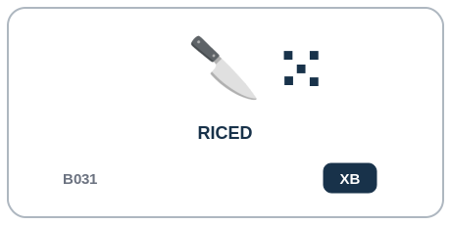  B1 | XB Exclusive Branch | Riced B031  DESCRIPTION | Soft food has been forced through small openings to form small rice-like particles.  PROFESSIONAL EXAMPLE | A prep specification can use Riced to identify this exact cut or reduction state before the ingredient moves to another operation.  PERSONAL EXAMPLE | I can use Riced when the ingredient in front of me matches that cut form, rather than relying on a vague phrase such as 'smaller pieces.'  INSTRUCTIONAL STATE | XB - Exclusive Branch. Branch state commonly capable of continuing to MASHED, BLENDED, or other soft-texture transformations.

Part 9 | C1 - Surface Preparation & Forming
B032-B047 | What structural preparation or forming process has been completed?
C1 teaches removal, surface preparation, structural modification, and forming as process history. Most of these facts accumulate rather than replacing one another.
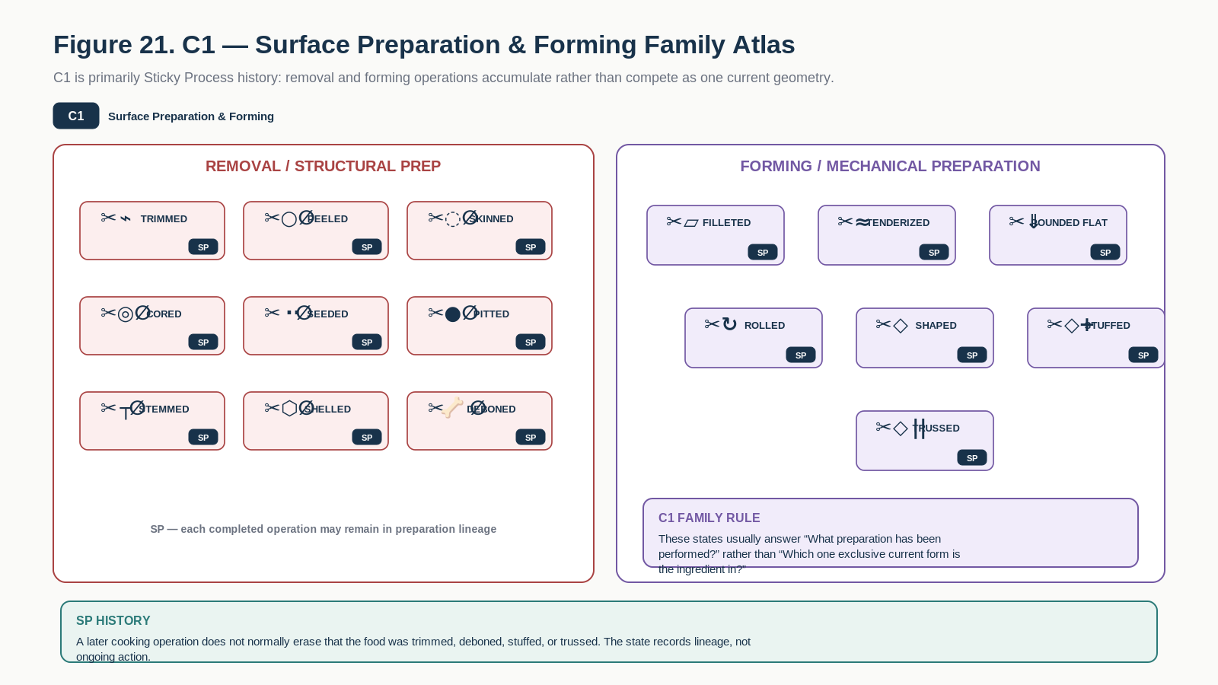
Figure 21. C1 Family Atlas groups removal, structural preparation, and forming processes that normally persist as preparation history.
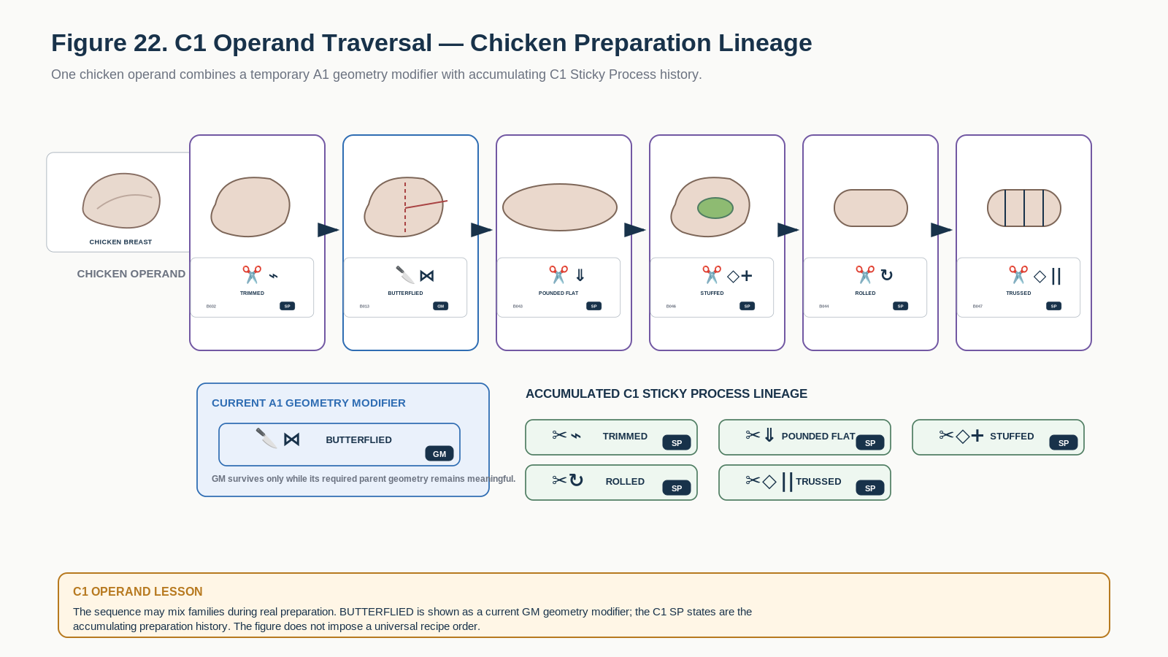
Figure 22. C1 operand traversal accumulates preparation history on a chicken operand while keeping the A1 BUTTERFLIED modifier conceptually distinct.

C1 Learning Registry
Each row below is one exact educational Bit. The approved symbol tile is a candidate BOSS projection; the Description and formal transition behavior are grounded in the corresponding COOKING-128 state.
Symbol / Identity | Instructional Memory
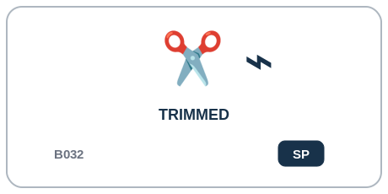  C1 | SP Sticky Process | Trimmed B032  DESCRIPTION | Unwanted edges, ends, fat, connective tissue, damaged material, or excess portions have been removed.  PROFESSIONAL EXAMPLE | A professional kitchen can record Trimmed after the preparation or forming step is completed, preserving it as part of the ingredient's process lineage.  PERSONAL EXAMPLE | I can use Trimmed to remember that I already performed that preparation step even after I continue cooking the ingredient.  INSTRUCTIONAL STATE | SP - Sticky Process. Sticky process state. SET once the operation is validly completed; may coexist with other surface-preparation states. No universal implication is assumed unless a recipe/Ruleset declares one.
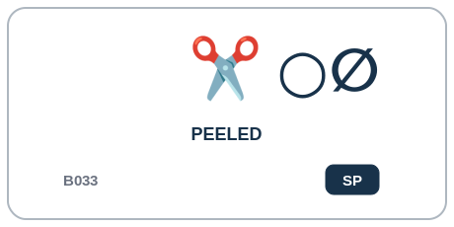  C1 | SP Sticky Process | Peeled B033  DESCRIPTION | Outer peel or rind has been removed.  PROFESSIONAL EXAMPLE | A professional kitchen can record Peeled after the preparation or forming step is completed, preserving it as part of the ingredient's process lineage.  PERSONAL EXAMPLE | I can use Peeled to remember that I already performed that preparation step even after I continue cooking the ingredient.  INSTRUCTIONAL STATE | SP - Sticky Process. Sticky process state. SET once the operation is validly completed; may coexist with other surface-preparation states. No universal implication is assumed unless a recipe/Ruleset declares one.
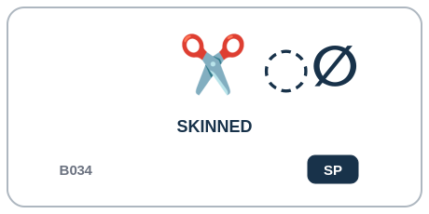  C1 | SP Sticky Process | Skinned B034  DESCRIPTION | Skin or membrane has been removed from meat, fish, produce, or another ingredient.  PROFESSIONAL EXAMPLE | A professional kitchen can record Skinned after the preparation or forming step is completed, preserving it as part of the ingredient's process lineage.  PERSONAL EXAMPLE | I can use Skinned to remember that I already performed that preparation step even after I continue cooking the ingredient.  INSTRUCTIONAL STATE | SP - Sticky Process. Sticky process state. SET once the operation is validly completed; may coexist with other surface-preparation states. No universal implication is assumed unless a recipe/Ruleset declares one.
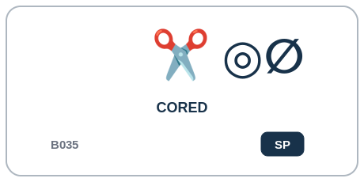  C1 | SP Sticky Process | Cored B035  DESCRIPTION | Central core structure has been removed.  PROFESSIONAL EXAMPLE | A professional kitchen can record Cored after the preparation or forming step is completed, preserving it as part of the ingredient's process lineage.  PERSONAL EXAMPLE | I can use Cored to remember that I already performed that preparation step even after I continue cooking the ingredient.  INSTRUCTIONAL STATE | SP - Sticky Process. Sticky process state. SET once the operation is validly completed; may coexist with other surface-preparation states. No universal implication is assumed unless a recipe/Ruleset declares one.
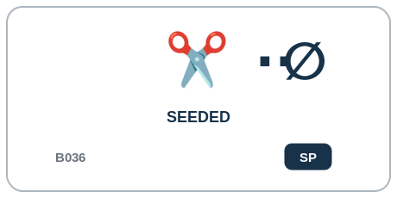  C1 | SP Sticky Process | Seeded B036  DESCRIPTION | Seeds and associated internal structures have been removed.  PROFESSIONAL EXAMPLE | A professional kitchen can record Seeded after the preparation or forming step is completed, preserving it as part of the ingredient's process lineage.  PERSONAL EXAMPLE | I can use Seeded to remember that I already performed that preparation step even after I continue cooking the ingredient.  INSTRUCTIONAL STATE | SP - Sticky Process. Sticky process state. SET once the operation is validly completed; may coexist with other surface-preparation states. No universal implication is assumed unless a recipe/Ruleset declares one.
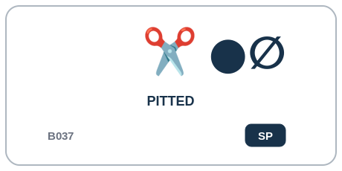  C1 | SP Sticky Process | Pitted B037  DESCRIPTION | A stone, pit, or large seed has been removed.  PROFESSIONAL EXAMPLE | A professional kitchen can record Pitted after the preparation or forming step is completed, preserving it as part of the ingredient's process lineage.  PERSONAL EXAMPLE | I can use Pitted to remember that I already performed that preparation step even after I continue cooking the ingredient.  INSTRUCTIONAL STATE | SP - Sticky Process. Sticky process state. SET once the operation is validly completed; may coexist with other surface-preparation states. No universal implication is assumed unless a recipe/Ruleset declares one.
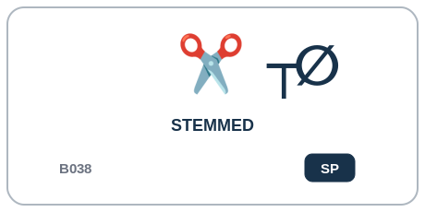  C1 | SP Sticky Process | Stemmed B038  DESCRIPTION | Stem or stalk attachment has been removed.  PROFESSIONAL EXAMPLE | A professional kitchen can record Stemmed after the preparation or forming step is completed, preserving it as part of the ingredient's process lineage.  PERSONAL EXAMPLE | I can use Stemmed to remember that I already performed that preparation step even after I continue cooking the ingredient.  INSTRUCTIONAL STATE | SP - Sticky Process. Sticky process state. SET once the operation is validly completed; may coexist with other surface-preparation states. No universal implication is assumed unless a recipe/Ruleset declares one.
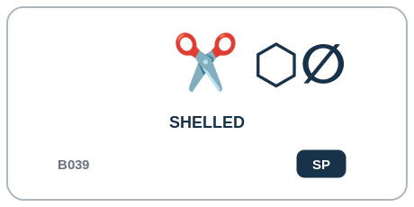  C1 | SP Sticky Process | Shelled B039  DESCRIPTION | External shell, husk, pod, or similar casing has been removed.  PROFESSIONAL EXAMPLE | A professional kitchen can record Shelled after the preparation or forming step is completed, preserving it as part of the ingredient's process lineage.  PERSONAL EXAMPLE | I can use Shelled to remember that I already performed that preparation step even after I continue cooking the ingredient.  INSTRUCTIONAL STATE | SP - Sticky Process. Sticky process state. SET once the operation is validly completed; may coexist with other surface-preparation states. No universal implication is assumed unless a recipe/Ruleset declares one.
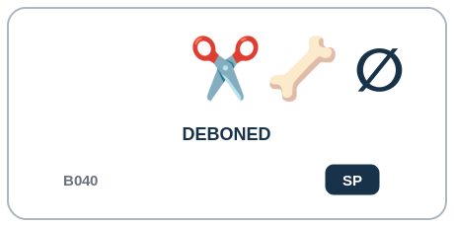  C1 | SP Sticky Process | Deboned B040  DESCRIPTION | Bone structure has been removed.  PROFESSIONAL EXAMPLE | A professional kitchen can record Deboned after the preparation or forming step is completed, preserving it as part of the ingredient's process lineage.  PERSONAL EXAMPLE | I can use Deboned to remember that I already performed that preparation step even after I continue cooking the ingredient.  INSTRUCTIONAL STATE | SP - Sticky Process. Sticky process state. SET once the operation is validly completed; may coexist with other surface-preparation states. No universal implication is assumed unless a recipe/Ruleset declares one.
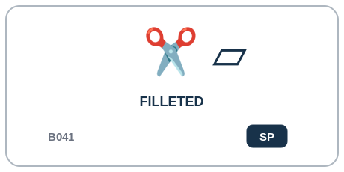  C1 | SP Sticky Process | Filleted B041  DESCRIPTION | Food has been separated into a boneless or structurally defined fillet.  PROFESSIONAL EXAMPLE | A professional kitchen can record Filleted after the preparation or forming step is completed, preserving it as part of the ingredient's process lineage.  PERSONAL EXAMPLE | I can use Filleted to remember that I already performed that preparation step even after I continue cooking the ingredient.  INSTRUCTIONAL STATE | SP - Sticky Process. Sticky process state. SET once the operation is validly completed; may coexist with other surface-preparation states. No universal implication is assumed unless a recipe/Ruleset declares one.
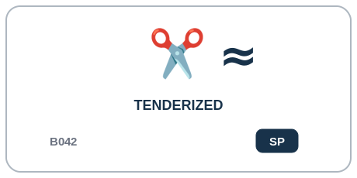  C1 | SP Sticky Process | Tenderized B042  DESCRIPTION | Structural fibers have been mechanically disrupted to reduce toughness.  PROFESSIONAL EXAMPLE | A professional kitchen can record Tenderized after the preparation or forming step is completed, preserving it as part of the ingredient's process lineage.  PERSONAL EXAMPLE | I can use Tenderized to remember that I already performed that preparation step even after I continue cooking the ingredient.  INSTRUCTIONAL STATE | SP - Sticky Process. Sticky process state. SET once the operation is validly completed; may coexist with other surface-preparation states. No universal implication is assumed unless a recipe/Ruleset declares one.
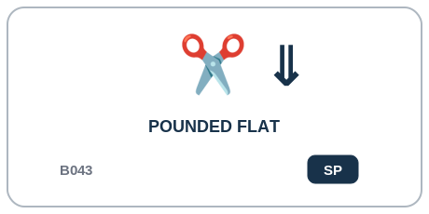  C1 | SP Sticky Process | Pounded Flat B043  DESCRIPTION | Food has been flattened through repeated impact or compression.  PROFESSIONAL EXAMPLE | A professional kitchen can record Pounded Flat after the preparation or forming step is completed, preserving it as part of the ingredient's process lineage.  PERSONAL EXAMPLE | I can use Pounded Flat to remember that I already performed that preparation step even after I continue cooking the ingredient.  INSTRUCTIONAL STATE | SP - Sticky Process. Sticky process state. SET once the operation is validly completed; may coexist with other surface-preparation states. No universal implication is assumed unless a recipe/Ruleset declares one.
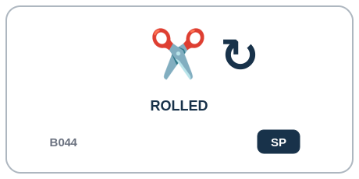  C1 | SP Sticky Process | Rolled B044  DESCRIPTION | Material has been flattened, elongated, or formed through rolling.  PROFESSIONAL EXAMPLE | A professional kitchen can record Rolled after the preparation or forming step is completed, preserving it as part of the ingredient's process lineage.  PERSONAL EXAMPLE | I can use Rolled to remember that I already performed that preparation step even after I continue cooking the ingredient.  INSTRUCTIONAL STATE | SP - Sticky Process. Sticky process state. SET once the operation is validly completed; may coexist with other surface-preparation states. No universal implication is assumed unless a recipe/Ruleset declares one.
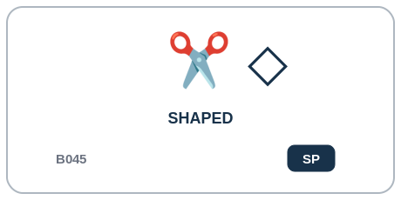  C1 | SP Sticky Process | Shaped B045  DESCRIPTION | Material has been intentionally formed into a defined geometry.  PROFESSIONAL EXAMPLE | A professional kitchen can record Shaped after the preparation or forming step is completed, preserving it as part of the ingredient's process lineage.  PERSONAL EXAMPLE | I can use Shaped to remember that I already performed that preparation step even after I continue cooking the ingredient.  INSTRUCTIONAL STATE | SP - Sticky Process. Sticky process state. SET once the operation is validly completed; may coexist with other surface-preparation states. No universal implication is assumed unless a recipe/Ruleset declares one.
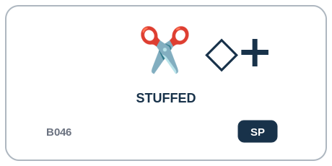  C1 | SP Sticky Process | Stuffed B046  DESCRIPTION | One food structure has been filled with another ingredient or mixture.  PROFESSIONAL EXAMPLE | A professional kitchen can record Stuffed after the preparation or forming step is completed, preserving it as part of the ingredient's process lineage.  PERSONAL EXAMPLE | I can use Stuffed to remember that I already performed that preparation step even after I continue cooking the ingredient.  INSTRUCTIONAL STATE | SP - Sticky Process. Sticky process state. SET once the operation is validly completed; may coexist with other surface-preparation states. No universal implication is assumed unless a recipe/Ruleset declares one.
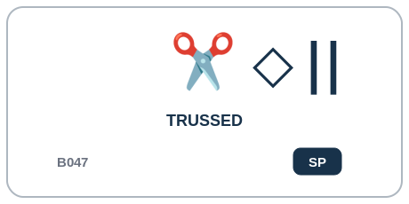  C1 | SP Sticky Process | Trussed B047  DESCRIPTION | Food has been mechanically bound or secured to maintain a desired cooking geometry.  PROFESSIONAL EXAMPLE | A professional kitchen can record Trussed after the preparation or forming step is completed, preserving it as part of the ingredient's process lineage.  PERSONAL EXAMPLE | I can use Trussed to remember that I already performed that preparation step even after I continue cooking the ingredient.  INSTRUCTIONAL STATE | SP - Sticky Process. Sticky process state. Common preceding states include STUFFED or ROLLED, but neither is universally required.

Part 10 | D1 - Mixing & Mechanical Transformation
B048-B063 | What mechanical process has occurred, and what texture or structural result currently exists?
D1 deliberately separates mechanical method history from texture rank and dynamic structural results. WHISKED or WHIPPED may contribute to AERATED or FOAMED, but method does not automatically establish result.
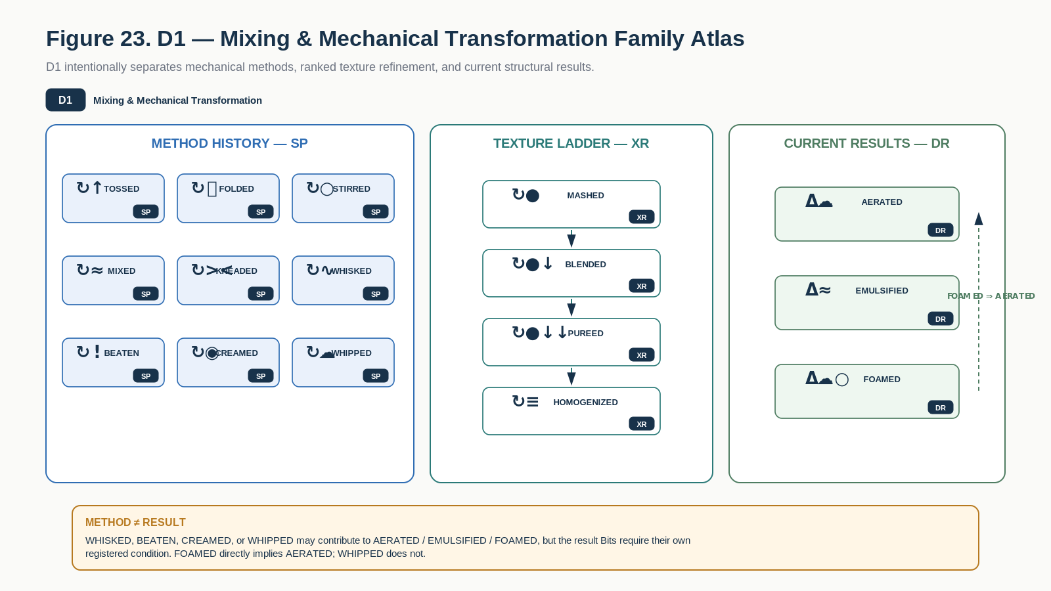
Figure 23. D1 Family Atlas separates mechanical methods, ranked texture refinement, and dynamic structural results.
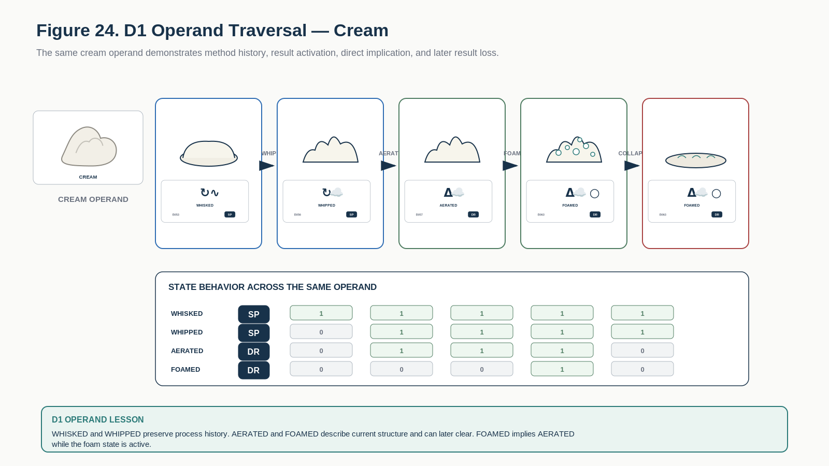
Figure 24. D1 operand traversal shows method history, derived aeration and foam, direct FOAMED => AERATED implication, and later collapse.

D1 Learning Registry
Each row below is one exact educational Bit. The approved symbol tile is a candidate BOSS projection; the Description and formal transition behavior are grounded in the corresponding COOKING-128 state.
Symbol / Identity | Instructional Memory
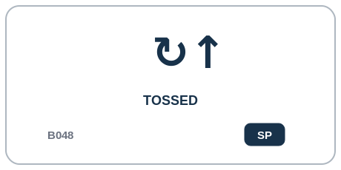  D1 | SP Sticky Process | Tossed B048  DESCRIPTION | Components have been gently redistributed through lifting and turning.  PROFESSIONAL EXAMPLE | A mixing station can record Tossed when that mechanical method has been applied, without assuming a particular material result.  PERSONAL EXAMPLE | I can use Tossed to record the mixing method I performed without pretending it guarantees aeration, foam, or emulsion.  INSTRUCTIONAL STATE | SP - Sticky Process. Sticky process history. The process may contribute to derived structural states but does not by itself guarantee AERATED, EMULSIFIED, or FOAMED.
  D1 | SP Sticky Process | Folded B049  DESCRIPTION | Components have been combined through gentle overlapping movements intended to preserve structure or aeration.  PROFESSIONAL EXAMPLE | A mixing station can record Folded when that mechanical method has been applied, without assuming a particular material result.  PERSONAL EXAMPLE | I can use Folded to record the mixing method I performed without pretending it guarantees aeration, foam, or emulsion.  INSTRUCTIONAL STATE | SP - Sticky Process. Sticky process history. The process may contribute to derived structural states but does not by itself guarantee AERATED, EMULSIFIED, or FOAMED.
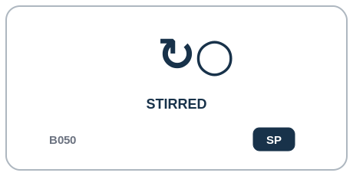  D1 | SP Sticky Process | Stirred B050  DESCRIPTION | Components have been circulated through repeated low-to-moderate shear movement.  PROFESSIONAL EXAMPLE | A mixing station can record Stirred when that mechanical method has been applied, without assuming a particular material result.  PERSONAL EXAMPLE | I can use Stirred to record the mixing method I performed without pretending it guarantees aeration, foam, or emulsion.  INSTRUCTIONAL STATE | SP - Sticky Process. Sticky process history. The process may contribute to derived structural states but does not by itself guarantee AERATED, EMULSIFIED, or FOAMED.
  D1 | SP Sticky Process | Mixed B051  DESCRIPTION | Multiple components have been mechanically combined toward more uniform distribution.  PROFESSIONAL EXAMPLE | A mixing station can record Mixed when that mechanical method has been applied, without assuming a particular material result.  PERSONAL EXAMPLE | I can use Mixed to record the mixing method I performed without pretending it guarantees aeration, foam, or emulsion.  INSTRUCTIONAL STATE | SP - Sticky Process. Sticky process history. The process may contribute to derived structural states but does not by itself guarantee AERATED, EMULSIFIED, or FOAMED.
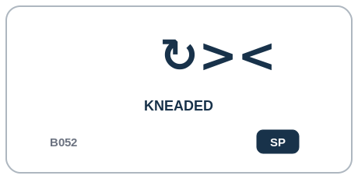  D1 | SP Sticky Process | Kneaded B052  DESCRIPTION | A cohesive mass has been repeatedly compressed, folded, and stretched to alter structural organization.  PROFESSIONAL EXAMPLE | A mixing station can record Kneaded when that mechanical method has been applied, without assuming a particular material result.  PERSONAL EXAMPLE | I can use Kneaded to record the mixing method I performed without pretending it guarantees aeration, foam, or emulsion.  INSTRUCTIONAL STATE | SP - Sticky Process. Sticky process history. The process may contribute to derived structural states but does not by itself guarantee AERATED, EMULSIFIED, or FOAMED.
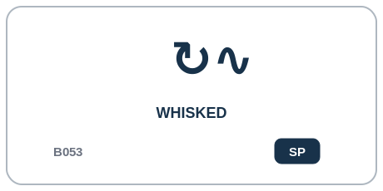  D1 | SP Sticky Process | Whisked B053  DESCRIPTION | Material has undergone rapid repeated agitation with a whisking motion.  PROFESSIONAL EXAMPLE | A mixing station can record Whisked when that mechanical method has been applied, without assuming a particular material result.  PERSONAL EXAMPLE | I can use Whisked to record the mixing method I performed without pretending it guarantees aeration, foam, or emulsion.  INSTRUCTIONAL STATE | SP - Sticky Process. Sticky process history. The process may contribute to derived structural states but does not by itself guarantee AERATED, EMULSIFIED, or FOAMED.
  D1 | SP Sticky Process | Beaten B054  DESCRIPTION | Material has undergone vigorous repeated mechanical agitation.  PROFESSIONAL EXAMPLE | A mixing station can record Beaten when that mechanical method has been applied, without assuming a particular material result.  PERSONAL EXAMPLE | I can use Beaten to record the mixing method I performed without pretending it guarantees aeration, foam, or emulsion.  INSTRUCTIONAL STATE | SP - Sticky Process. Sticky process history. The process may contribute to derived structural states but does not by itself guarantee AERATED, EMULSIFIED, or FOAMED.
  D1 | SP Sticky Process | Creamed B055  DESCRIPTION | Ingredients have been mechanically worked into a softened, smooth, often aerated mixture.  PROFESSIONAL EXAMPLE | A mixing station can record Creamed when that mechanical method has been applied, without assuming a particular material result.  PERSONAL EXAMPLE | I can use Creamed to record the mixing method I performed without pretending it guarantees aeration, foam, or emulsion.  INSTRUCTIONAL STATE | SP - Sticky Process. Sticky process history. The process may contribute to derived structural states but does not by itself guarantee AERATED, EMULSIFIED, or FOAMED.
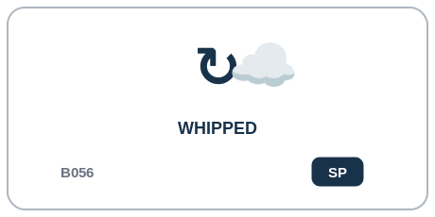  D1 | SP Sticky Process | Whipped B056  DESCRIPTION | Material has been aggressively aerated into an expanded structure.  PROFESSIONAL EXAMPLE | A mixing station can record Whipped when that mechanical method has been applied, without assuming a particular material result.  PERSONAL EXAMPLE | I can use Whipped to record the mixing method I performed without pretending it guarantees aeration, foam, or emulsion.  INSTRUCTIONAL STATE | SP - Sticky Process. Sticky process history. The process may contribute to derived structural states but does not by itself guarantee AERATED, EMULSIFIED, or FOAMED.
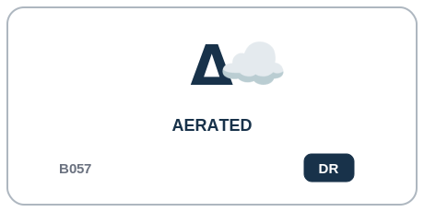  D1 | DR Dynamic Result | Aerated B057  DESCRIPTION | Gas has been deliberately incorporated into the food structure.  PROFESSIONAL EXAMPLE | A process-control or culinary quality check can mark Aerated only when the corresponding material-structure condition is actually satisfied.  PERSONAL EXAMPLE | I can use Aerated only while the mixture actually has that current structure; if the structure is lost, the result can clear.  INSTRUCTIONAL STATE | DR - Dynamic Result. Dynamic result. DERIVE+ when the relevant aeration Model threshold is met; DERIVE- if the structure loses the modeled aerated condition. FOAMED implies AERATED.
  D1 | XR Exclusive Ranked | Mashed B058  DESCRIPTION | Soft solid material has been compressed and broken into a coarse cohesive mass.  PROFESSIONAL EXAMPLE | A production kitchen can use Mashed as the current dominant texture state after mechanical refinement.  PERSONAL EXAMPLE | I can use Mashed for the texture I have now after progressively refining the food.  INSTRUCTIONAL STATE | XR - Exclusive Ranked. Root of dominant texture-reduction ladder. Canonical MASHED->BLENDED.
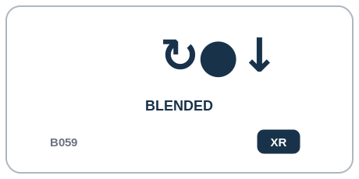  D1 | XR Exclusive Ranked | Blended B059  DESCRIPTION | Ingredients have undergone high-speed mechanical mixing and particle reduction.  PROFESSIONAL EXAMPLE | A production kitchen can use Blended as the current dominant texture state after mechanical refinement.  PERSONAL EXAMPLE | I can use Blended for the texture I have now after progressively refining the food.  INSTRUCTIONAL STATE | XR - Exclusive Ranked. Canonical BLENDED->PUREED. Previous process events remain in provenance; dominant texture state is replaced.
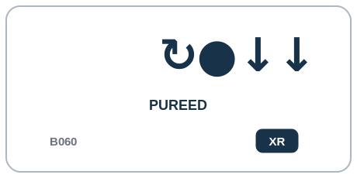  D1 | XR Exclusive Ranked | Pureed B060  DESCRIPTION | Material has been reduced into a substantially smooth semi-fluid or paste-like consistency.  PROFESSIONAL EXAMPLE | A production kitchen can use Pureed as the current dominant texture state after mechanical refinement.  PERSONAL EXAMPLE | I can use Pureed for the texture I have now after progressively refining the food.  INSTRUCTIONAL STATE | XR - Exclusive Ranked. Canonical PUREED->HOMOGENIZED where a more uniform microstructure is intentionally produced.
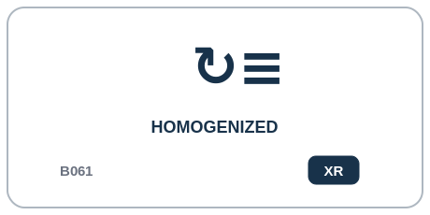  D1 | XR Exclusive Ranked | Homogenized B061  DESCRIPTION | Material has been mechanically processed toward highly uniform particle or droplet distribution.  PROFESSIONAL EXAMPLE | A production kitchen can use Homogenized as the current dominant texture state after mechanical refinement.  PERSONAL EXAMPLE | I can use Homogenized for the texture I have now after progressively refining the food.  INSTRUCTIONAL STATE | XR - Exclusive Ranked. Finest named dominant texture-refinement state in v0.1. Ordinary texture-reduction Operators do not move backward.
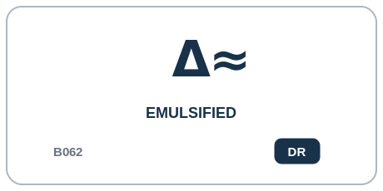  D1 | DR Dynamic Result | Emulsified B062  DESCRIPTION | Normally immiscible liquid phases have been dispersed into a stabilized or temporarily stabilized emulsion.  PROFESSIONAL EXAMPLE | A process-control or culinary quality check can mark Emulsified only when the corresponding material-structure condition is actually satisfied.  PERSONAL EXAMPLE | I can use Emulsified only while the mixture actually has that current structure; if the structure is lost, the result can clear.  INSTRUCTIONAL STATE | DR - Dynamic Result. Dynamic result. DERIVE+ when emulsion conditions pass; DERIVE- when the emulsion breaks or is otherwise invalidated.
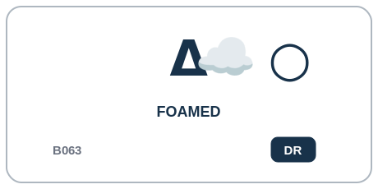  D1 | DR Dynamic Result | Foamed B063  DESCRIPTION | Gas has been dispersed throughout a liquid or semi-solid matrix to form a foam structure.  PROFESSIONAL EXAMPLE | A process-control or culinary quality check can mark Foamed only when the corresponding material-structure condition is actually satisfied.  PERSONAL EXAMPLE | I can use Foamed only while the mixture actually has that current structure; if the structure is lost, the result can clear.  INSTRUCTIONAL STATE | DR - Dynamic Result. Dynamic result. IMPLY(FOAMED->AERATED). Clearing AERATED necessarily clears FOAMED.

Part 11 | E1 - Conditioning, Coating & Preservation
B064-B079 | What nonthermal conditioning, preservation, extraction, or coating state applies?
E1 combines conditioning and preservation process history with a current coating-stage branch and the dynamic REHYDRATED result. This Family is a compact lesson in SP, DR, and XB living side by side.
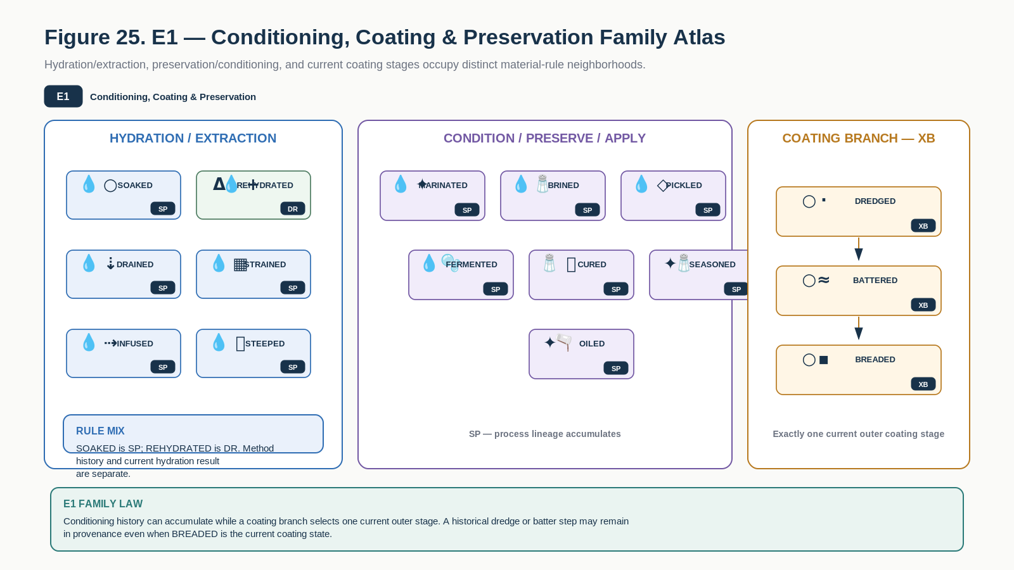
Figure 25. E1 Family Atlas separates hydration/extraction, preservation/conditioning, and the exclusive coating-stage branch.
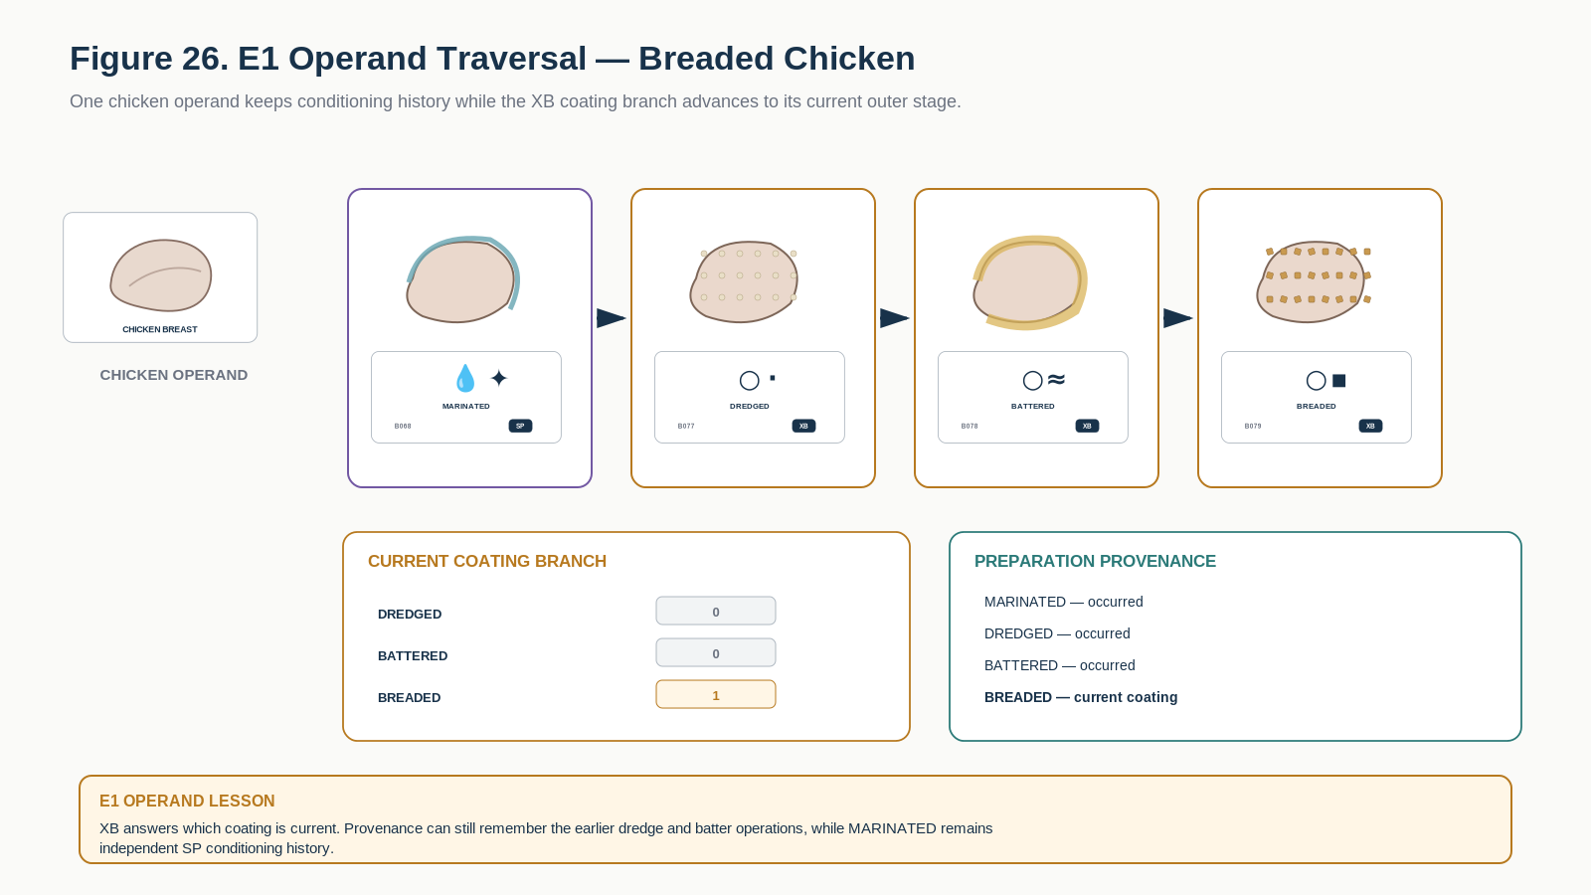
Figure 26. E1 operand traversal distinguishes persistent conditioning history from the current outer coating stage.

E1 Learning Registry
Each row below is one exact educational Bit. The approved symbol tile is a candidate BOSS projection; the Description and formal transition behavior are grounded in the corresponding COOKING-128 state.
Symbol / Identity | Instructional Memory
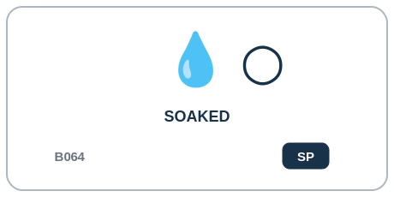  E1 | SP Sticky Process | Soaked B064  DESCRIPTION | Food has remained immersed in liquid long enough for meaningful hydration, extraction, or exchange.  PROFESSIONAL EXAMPLE | A preparation workflow can record Soaked after the conditioning, preservation, extraction, or application step has occurred.  PERSONAL EXAMPLE | I can use Soaked to remember that I performed that conditioning or preservation step before later cooking stages.  INSTRUCTIONAL STATE | SP - Sticky Process. Sticky process state. It may lead to REHYDRATED through a moisture/uptake Model but does not guarantee it.
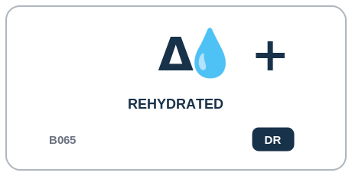  E1 | DR Dynamic Result | Rehydrated B065  DESCRIPTION | Previously dried material has absorbed liquid and regained substantial moisture.  PROFESSIONAL EXAMPLE | A conditioning workflow can mark Rehydrated when the current hydration or material condition is verified, separately from the process that produced it.  PERSONAL EXAMPLE | I can use Rehydrated when the food currently has the regained-moisture result, while still keeping the earlier soaking or conditioning history separate.  INSTRUCTIONAL STATE | DR - Dynamic Result. Dynamic result. Commonly DERIVE+ after SOAKED plus a moisture threshold; may DERIVE- after subsequent drying/dehydration if current rehydration is no longer true.
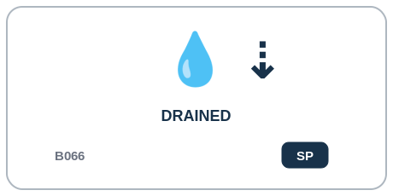  E1 | SP Sticky Process | Drained B066  DESCRIPTION | Free liquid has been intentionally removed primarily by gravity.  PROFESSIONAL EXAMPLE | A preparation workflow can record Drained after the conditioning, preservation, extraction, or application step has occurred.  PERSONAL EXAMPLE | I can use Drained to remember that I performed that conditioning or preservation step before later cooking stages.  INSTRUCTIONAL STATE | SP - Sticky Process. Sticky conditioning/process state. Multiple conditioning states may coexist; no automatic implication is assumed unless a Model/Ruleset declares it.
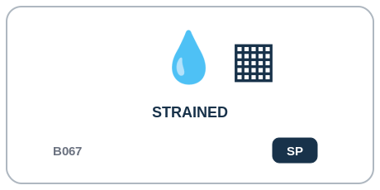  E1 | SP Sticky Process | Strained B067  DESCRIPTION | Solids and liquids have been separated through a mesh, sieve, cloth, or similar barrier.  PROFESSIONAL EXAMPLE | A preparation workflow can record Strained after the conditioning, preservation, extraction, or application step has occurred.  PERSONAL EXAMPLE | I can use Strained to remember that I performed that conditioning or preservation step before later cooking stages.  INSTRUCTIONAL STATE | SP - Sticky Process. Sticky conditioning/process state. Multiple conditioning states may coexist; no automatic implication is assumed unless a Model/Ruleset declares it.
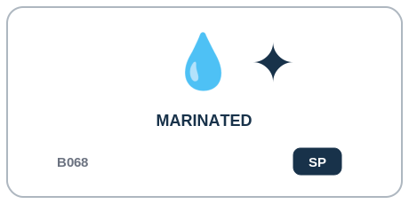  E1 | SP Sticky Process | Marinated B068  DESCRIPTION | Food has been exposed to a flavored liquid or paste for sufficient time to alter its surface composition or flavor.  PROFESSIONAL EXAMPLE | A preparation workflow can record Marinated after the conditioning, preservation, extraction, or application step has occurred.  PERSONAL EXAMPLE | I can use Marinated to remember that I performed that conditioning or preservation step before later cooking stages.  INSTRUCTIONAL STATE | SP - Sticky Process. Sticky conditioning/process state. Multiple conditioning states may coexist; no automatic implication is assumed unless a Model/Ruleset declares it.
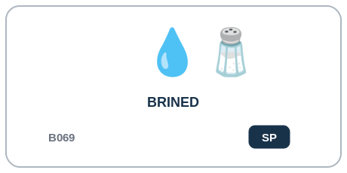  E1 | SP Sticky Process | Brined B069  DESCRIPTION | Food has undergone controlled exposure to a salt-containing solution.  PROFESSIONAL EXAMPLE | A preparation workflow can record Brined after the conditioning, preservation, extraction, or application step has occurred.  PERSONAL EXAMPLE | I can use Brined to remember that I performed that conditioning or preservation step before later cooking stages.  INSTRUCTIONAL STATE | SP - Sticky Process. Sticky conditioning/process state. Multiple conditioning states may coexist; no automatic implication is assumed unless a Model/Ruleset declares it.
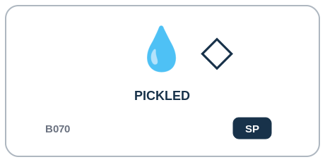  E1 | SP Sticky Process | Pickled B070  DESCRIPTION | Food has undergone preservation or flavor transformation through acidic or fermentation-associated pickling conditions.  PROFESSIONAL EXAMPLE | A preparation workflow can record Pickled after the conditioning, preservation, extraction, or application step has occurred.  PERSONAL EXAMPLE | I can use Pickled to remember that I performed that conditioning or preservation step before later cooking stages.  INSTRUCTIONAL STATE | SP - Sticky Process. Sticky conditioning/process state. Multiple conditioning states may coexist; no automatic implication is assumed unless a Model/Ruleset declares it.
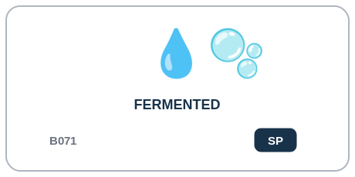  E1 | SP Sticky Process | Fermented B071  DESCRIPTION | Food has undergone a deliberate biologically mediated fermentation process.  PROFESSIONAL EXAMPLE | A preparation workflow can record Fermented after the conditioning, preservation, extraction, or application step has occurred.  PERSONAL EXAMPLE | I can use Fermented to remember that I performed that conditioning or preservation step before later cooking stages.  INSTRUCTIONAL STATE | SP - Sticky Process. Sticky conditioning/process state. Multiple conditioning states may coexist; no automatic implication is assumed unless a Model/Ruleset declares it.
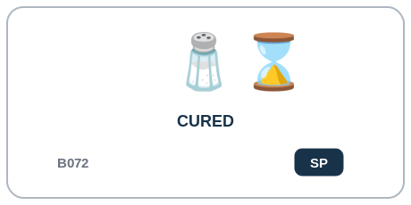  E1 | SP Sticky Process | Cured B072  DESCRIPTION | Food has undergone a deliberate preservation/transformation treatment using salt, sugar, curing agents, drying, or related controlled processes.  PROFESSIONAL EXAMPLE | A preparation workflow can record Cured after the conditioning, preservation, extraction, or application step has occurred.  PERSONAL EXAMPLE | I can use Cured to remember that I performed that conditioning or preservation step before later cooking stages.  INSTRUCTIONAL STATE | SP - Sticky Process. Sticky conditioning/process state. Multiple conditioning states may coexist; no automatic implication is assumed unless a Model/Ruleset declares it.
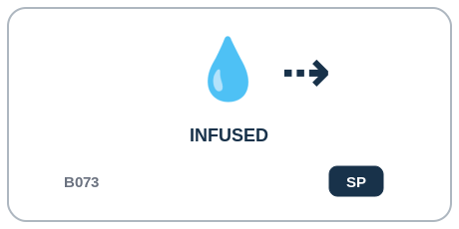  E1 | SP Sticky Process | Infused B073  DESCRIPTION | Flavor/aromatic compounds have been transferred from one ingredient into another medium.  PROFESSIONAL EXAMPLE | A preparation workflow can record Infused after the conditioning, preservation, extraction, or application step has occurred.  PERSONAL EXAMPLE | I can use Infused to remember that I performed that conditioning or preservation step before later cooking stages.  INSTRUCTIONAL STATE | SP - Sticky Process. Sticky conditioning/process state. Multiple conditioning states may coexist; no automatic implication is assumed unless a Model/Ruleset declares it.
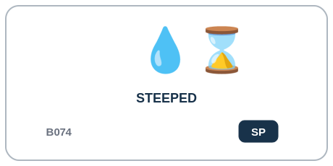  E1 | SP Sticky Process | Steeped B074  DESCRIPTION | Material has remained in liquid for extraction of soluble or aromatic components.  PROFESSIONAL EXAMPLE | A preparation workflow can record Steeped after the conditioning, preservation, extraction, or application step has occurred.  PERSONAL EXAMPLE | I can use Steeped to remember that I performed that conditioning or preservation step before later cooking stages.  INSTRUCTIONAL STATE | SP - Sticky Process. Sticky process state. A declared extraction Model may derive or authorize INFUSED; steeping alone does not universally imply infusion.
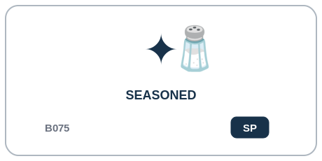  E1 | SP Sticky Process | Seasoned B075  DESCRIPTION | Flavoring agents have been deliberately applied to alter taste/aroma.  PROFESSIONAL EXAMPLE | A preparation workflow can record Seasoned after the conditioning, preservation, extraction, or application step has occurred.  PERSONAL EXAMPLE | I can use Seasoned to remember that I performed that conditioning or preservation step before later cooking stages.  INSTRUCTIONAL STATE | SP - Sticky Process. Sticky conditioning/process state. Multiple conditioning states may coexist; no automatic implication is assumed unless a Model/Ruleset declares it.
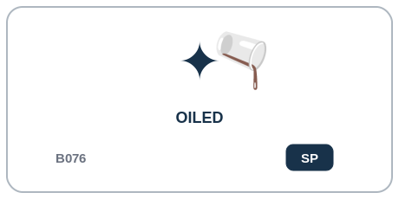  E1 | SP Sticky Process | Oiled B076  DESCRIPTION | A deliberate surface coating of oil or culinary fat has been applied.  PROFESSIONAL EXAMPLE | A preparation workflow can record Oiled after the conditioning, preservation, extraction, or application step has occurred.  PERSONAL EXAMPLE | I can use Oiled to remember that I performed that conditioning or preservation step before later cooking stages.  INSTRUCTIONAL STATE | SP - Sticky Process. Sticky conditioning/process state. Multiple conditioning states may coexist; no automatic implication is assumed unless a Model/Ruleset declares it.
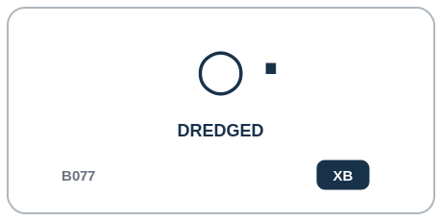  E1 | XB Exclusive Branch | Dredged B077  DESCRIPTION | Surface has been coated with a dry particulate layer such as flour or starch.  PROFESSIONAL EXAMPLE | A coating station can use Dredged as the current outer coating stage while retaining earlier steps in provenance.  PERSONAL EXAMPLE | I can use Dredged for the coating that is currently on the food while earlier coating steps remain part of the preparation history.  INSTRUCTIONAL STATE | XB - Exclusive Branch. Current outer coating-stage member. Legal entry from no coating; may transition to BATTERED or BREADED. Entering another coating-stage member clears this bit.
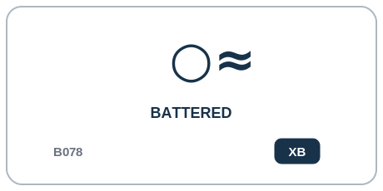  E1 | XB Exclusive Branch | Battered B078  DESCRIPTION | Surface has been coated with a wet batter.  PROFESSIONAL EXAMPLE | A coating station can use Battered as the current outer coating stage while retaining earlier steps in provenance.  PERSONAL EXAMPLE | I can use Battered for the coating that is currently on the food while earlier coating steps remain part of the preparation history.  INSTRUCTIONAL STATE | XB - Exclusive Branch. Current outer coating-stage member. Legal entry from no coating or DREDGED; may transition to BREADED. Entering another coating-stage member clears this bit.
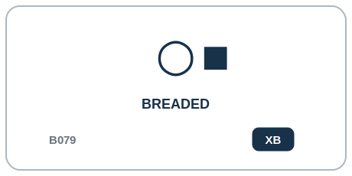  E1 | XB Exclusive Branch | Breaded B079  DESCRIPTION | Surface has been coated with breadcrumbs, crumbs, meal, or similar particulate coating.  PROFESSIONAL EXAMPLE | A coating station can use Breaded as the current outer coating stage while retaining earlier steps in provenance.  PERSONAL EXAMPLE | I can use Breaded for the coating that is currently on the food while earlier coating steps remain part of the preparation history.  INSTRUCTIONAL STATE | XB - Exclusive Branch. Current outer coating-stage member. Legal entry from no coating, DREDGED, or BATTERED. Prior coating steps survive in Transition Events rather than multiple active coating-stage bits.

Part 12 | F1 - Bulk, Moist, Enclosed & Long-Duration Heat
B080-B095 | What bulk, moist, enclosed, controlled, or extended thermal method has been applied?
F1 records bulk, moist, enclosed, controlled, and extended thermal methods as sticky process history. The central lesson is that a method such as BOILED or ROASTED does not automatically assert SOFTENED, BROWNED, or CRISPED.
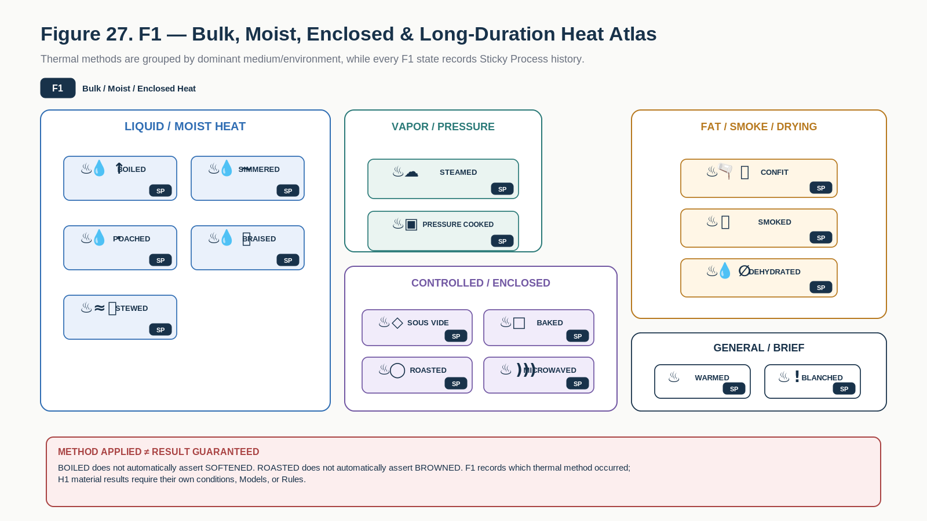
Figure 27. F1 Family Atlas groups bulk, moist, enclosed, controlled, long-duration, smoke, and drying thermal methods.
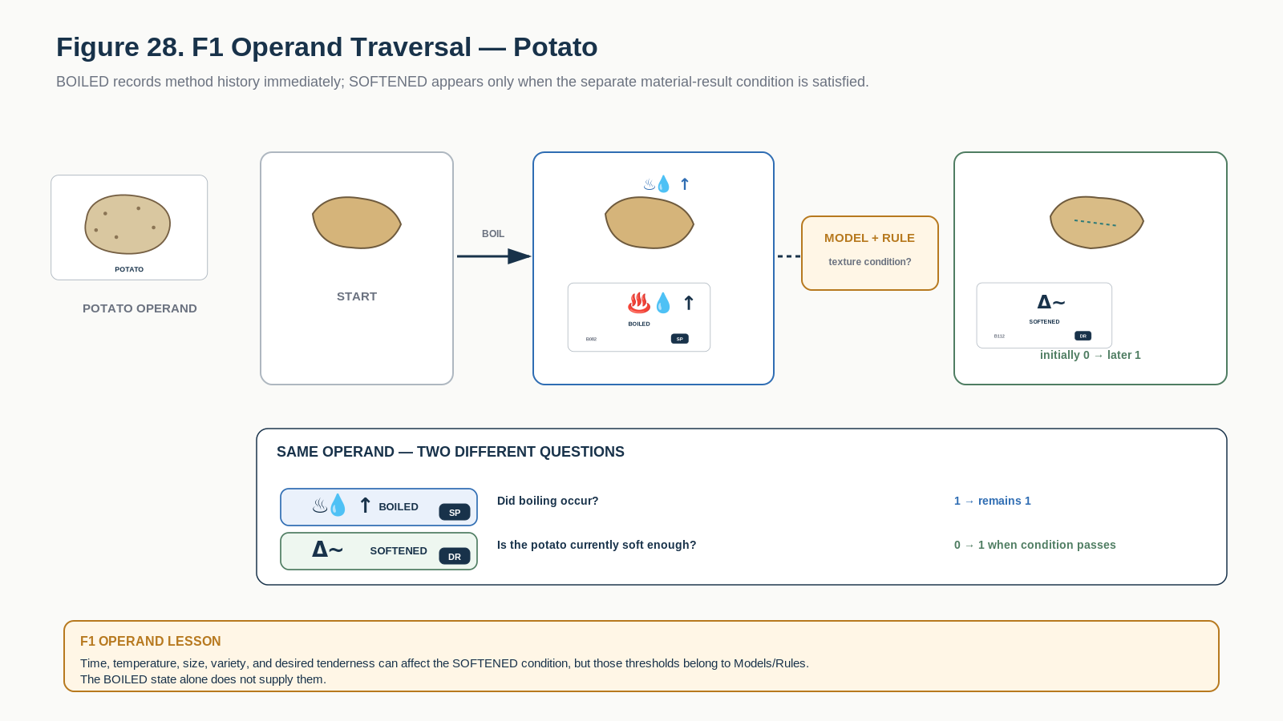
Figure 28. F1 operand traversal demonstrates that BOILED is process history while SOFTENED is a separately resolved current material result.

F1 Learning Registry
Each row below is one exact educational Bit. The approved symbol tile is a candidate BOSS projection; the Description and formal transition behavior are grounded in the corresponding COOKING-128 state.
Symbol / Identity | Instructional Memory
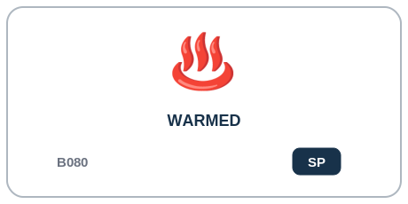  F1 | SP Sticky Process | Warmed B080  DESCRIPTION | Temperature has been raised without intentionally producing a stronger named cooking transformation.  PROFESSIONAL EXAMPLE | A kitchen controller or recipe compiler can record Warmed as thermal-method history while evaluating physical results such as browning or softening separately.  PERSONAL EXAMPLE | I can use Warmed to say which heat method I used, then separately describe whether the food actually became browned, crisp, softened, or another result.  INSTRUCTIONAL STATE | SP - Sticky Process. Sticky thermal-method history. Setting this bit does not clear other thermal methods and does not by itself imply a resultant state such as BROWNED, SOFTENED, or CRISPED.
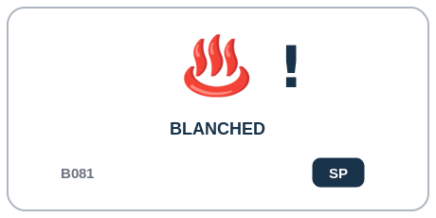  F1 | SP Sticky Process | Blanched B081  DESCRIPTION | Food has undergone brief high-temperature contact, typically followed by removal or cooling.  PROFESSIONAL EXAMPLE | A kitchen controller or recipe compiler can record Blanched as thermal-method history while evaluating physical results such as browning or softening separately.  PERSONAL EXAMPLE | I can use Blanched to say which heat method I used, then separately describe whether the food actually became browned, crisp, softened, or another result.  INSTRUCTIONAL STATE | SP - Sticky Process. Sticky thermal-method history. Setting this bit does not clear other thermal methods and does not by itself imply a resultant state such as BROWNED, SOFTENED, or CRISPED.
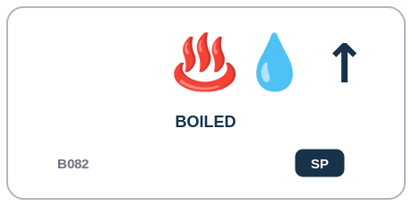  F1 | SP Sticky Process | Boiled B082  DESCRIPTION | Food has been cooked in or through vigorously boiling liquid.  PROFESSIONAL EXAMPLE | A kitchen controller or recipe compiler can record Boiled as thermal-method history while evaluating physical results such as browning or softening separately.  PERSONAL EXAMPLE | I can use Boiled to say which heat method I used, then separately describe whether the food actually became browned, crisp, softened, or another result.  INSTRUCTIONAL STATE | SP - Sticky Process. Sticky thermal-method history. Setting this bit does not clear other thermal methods and does not by itself imply a resultant state such as BROWNED, SOFTENED, or CRISPED.
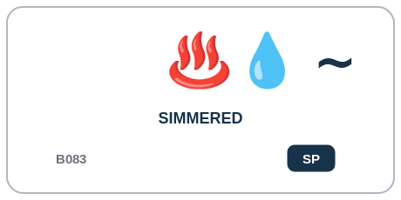  F1 | SP Sticky Process | Simmered B083  DESCRIPTION | Food has been cooked in liquid below vigorous boiling.  PROFESSIONAL EXAMPLE | A kitchen controller or recipe compiler can record Simmered as thermal-method history while evaluating physical results such as browning or softening separately.  PERSONAL EXAMPLE | I can use Simmered to say which heat method I used, then separately describe whether the food actually became browned, crisp, softened, or another result.  INSTRUCTIONAL STATE | SP - Sticky Process. Sticky thermal-method history. Setting this bit does not clear other thermal methods and does not by itself imply a resultant state such as BROWNED, SOFTENED, or CRISPED.
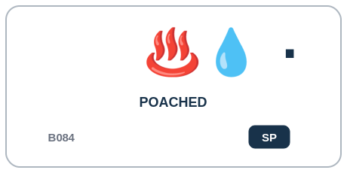  F1 | SP Sticky Process | Poached B084  DESCRIPTION | Food has been gently cooked while substantially surrounded by hot liquid below a vigorous boil.  PROFESSIONAL EXAMPLE | A kitchen controller or recipe compiler can record Poached as thermal-method history while evaluating physical results such as browning or softening separately.  PERSONAL EXAMPLE | I can use Poached to say which heat method I used, then separately describe whether the food actually became browned, crisp, softened, or another result.  INSTRUCTIONAL STATE | SP - Sticky Process. Sticky thermal-method history. Setting this bit does not clear other thermal methods and does not by itself imply a resultant state such as BROWNED, SOFTENED, or CRISPED.
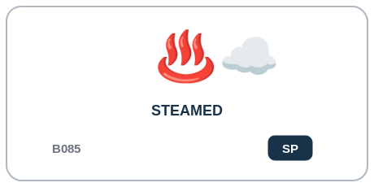  F1 | SP Sticky Process | Steamed B085  DESCRIPTION | Food has been cooked primarily by contact with steam.  PROFESSIONAL EXAMPLE | A kitchen controller or recipe compiler can record Steamed as thermal-method history while evaluating physical results such as browning or softening separately.  PERSONAL EXAMPLE | I can use Steamed to say which heat method I used, then separately describe whether the food actually became browned, crisp, softened, or another result.  INSTRUCTIONAL STATE | SP - Sticky Process. Sticky thermal-method history. Setting this bit does not clear other thermal methods and does not by itself imply a resultant state such as BROWNED, SOFTENED, or CRISPED.
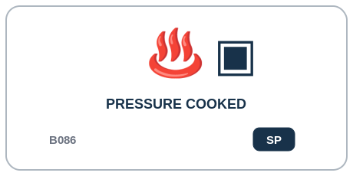  F1 | SP Sticky Process | Pressure Cooked B086  DESCRIPTION | Food has been thermally processed inside a pressurized cooking environment.  PROFESSIONAL EXAMPLE | A kitchen controller or recipe compiler can record Pressure Cooked as thermal-method history while evaluating physical results such as browning or softening separately.  PERSONAL EXAMPLE | I can use Pressure Cooked to say which heat method I used, then separately describe whether the food actually became browned, crisp, softened, or another result.  INSTRUCTIONAL STATE | SP - Sticky Process. Sticky thermal-method history. Setting this bit does not clear other thermal methods and does not by itself imply a resultant state such as BROWNED, SOFTENED, or CRISPED.
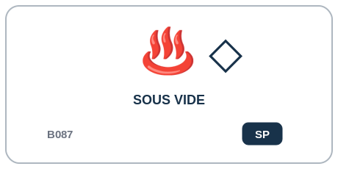  F1 | SP Sticky Process | Sous Vide B087  DESCRIPTION | Food has undergone controlled low-variation thermal processing while enclosed in a sealed or controlled package.  PROFESSIONAL EXAMPLE | A kitchen controller or recipe compiler can record Sous Vide as thermal-method history while evaluating physical results such as browning or softening separately.  PERSONAL EXAMPLE | I can use Sous Vide to say which heat method I used, then separately describe whether the food actually became browned, crisp, softened, or another result.  INSTRUCTIONAL STATE | SP - Sticky Process. Sticky thermal-method history. Setting this bit does not clear other thermal methods and does not by itself imply a resultant state such as BROWNED, SOFTENED, or CRISPED.
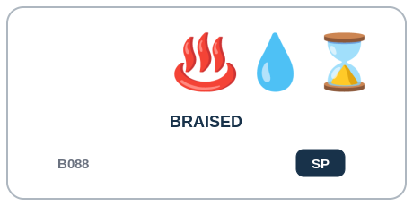  F1 | SP Sticky Process | Braised B088  DESCRIPTION | Food has undergone a combined process typically involving prolonged cooking with limited liquid; initial surface cooking may occur but is not required.  PROFESSIONAL EXAMPLE | A kitchen controller or recipe compiler can record Braised as thermal-method history while evaluating physical results such as browning or softening separately.  PERSONAL EXAMPLE | I can use Braised to say which heat method I used, then separately describe whether the food actually became browned, crisp, softened, or another result.  INSTRUCTIONAL STATE | SP - Sticky Process. Sticky thermal-method history. Setting this bit does not clear other thermal methods and does not by itself imply a resultant state such as BROWNED, SOFTENED, or CRISPED.
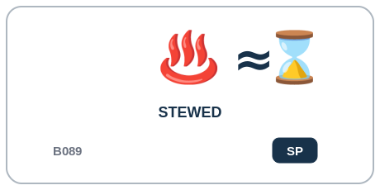  F1 | SP Sticky Process | Stewed B089  DESCRIPTION | Food has undergone prolonged cooking while substantially surrounded by liquid or sauce.  PROFESSIONAL EXAMPLE | A kitchen controller or recipe compiler can record Stewed as thermal-method history while evaluating physical results such as browning or softening separately.  PERSONAL EXAMPLE | I can use Stewed to say which heat method I used, then separately describe whether the food actually became browned, crisp, softened, or another result.  INSTRUCTIONAL STATE | SP - Sticky Process. Sticky thermal-method history. Setting this bit does not clear other thermal methods and does not by itself imply a resultant state such as BROWNED, SOFTENED, or CRISPED.
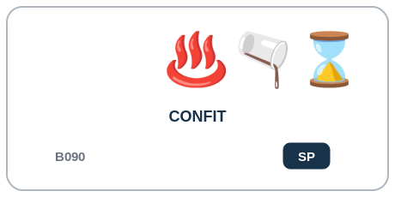  F1 | SP Sticky Process | Confit B090  DESCRIPTION | Food has undergone prolonged controlled cooking while substantially surrounded by fat or another defined confit medium.  PROFESSIONAL EXAMPLE | A kitchen controller or recipe compiler can record Confit as thermal-method history while evaluating physical results such as browning or softening separately.  PERSONAL EXAMPLE | I can use Confit to say which heat method I used, then separately describe whether the food actually became browned, crisp, softened, or another result.  INSTRUCTIONAL STATE | SP - Sticky Process. Sticky thermal-method history. Setting this bit does not clear other thermal methods and does not by itself imply a resultant state such as BROWNED, SOFTENED, or CRISPED.
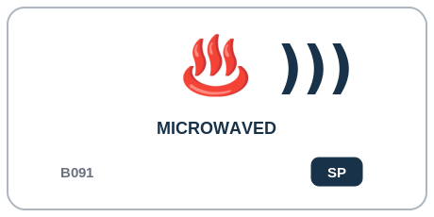  F1 | SP Sticky Process | Microwaved B091  DESCRIPTION | Food has been heated primarily through microwave-frequency electromagnetic energy.  PROFESSIONAL EXAMPLE | A kitchen controller or recipe compiler can record Microwaved as thermal-method history while evaluating physical results such as browning or softening separately.  PERSONAL EXAMPLE | I can use Microwaved to say which heat method I used, then separately describe whether the food actually became browned, crisp, softened, or another result.  INSTRUCTIONAL STATE | SP - Sticky Process. Sticky thermal-method history. Setting this bit does not clear other thermal methods and does not by itself imply a resultant state such as BROWNED, SOFTENED, or CRISPED.
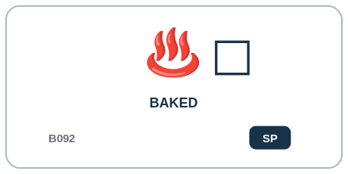  F1 | SP Sticky Process | Baked B092  DESCRIPTION | Food has undergone enclosed dry-environment heating, especially where structural setting is a major objective.  PROFESSIONAL EXAMPLE | A kitchen controller or recipe compiler can record Baked as thermal-method history while evaluating physical results such as browning or softening separately.  PERSONAL EXAMPLE | I can use Baked to say which heat method I used, then separately describe whether the food actually became browned, crisp, softened, or another result.  INSTRUCTIONAL STATE | SP - Sticky Process. Sticky thermal-method history. Setting this bit does not clear other thermal methods and does not by itself imply a resultant state such as BROWNED, SOFTENED, or CRISPED.
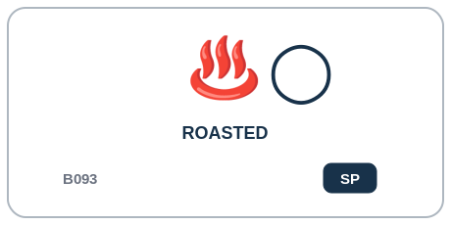  F1 | SP Sticky Process | Roasted B093  DESCRIPTION | Food has undergone sustained dry heat intended primarily to cook and develop surface flavor.  PROFESSIONAL EXAMPLE | A kitchen controller or recipe compiler can record Roasted as thermal-method history while evaluating physical results such as browning or softening separately.  PERSONAL EXAMPLE | I can use Roasted to say which heat method I used, then separately describe whether the food actually became browned, crisp, softened, or another result.  INSTRUCTIONAL STATE | SP - Sticky Process. Sticky thermal-method history. Setting this bit does not clear other thermal methods and does not by itself imply a resultant state such as BROWNED, SOFTENED, or CRISPED.
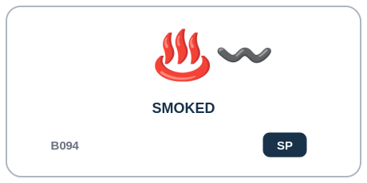  F1 | SP Sticky Process | Smoked B094  DESCRIPTION | Food has been deliberately exposed to culinary smoke as part of its processing.  PROFESSIONAL EXAMPLE | A kitchen controller or recipe compiler can record Smoked as thermal-method history while evaluating physical results such as browning or softening separately.  PERSONAL EXAMPLE | I can use Smoked to say which heat method I used, then separately describe whether the food actually became browned, crisp, softened, or another result.  INSTRUCTIONAL STATE | SP - Sticky Process. Sticky thermal-method history. Setting this bit does not clear other thermal methods and does not by itself imply a resultant state such as BROWNED, SOFTENED, or CRISPED.
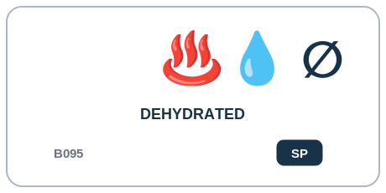  F1 | SP Sticky Process | Dehydrated B095  DESCRIPTION | Moisture has been deliberately removed to create a substantially drier food state.  PROFESSIONAL EXAMPLE | A kitchen controller or recipe compiler can record Dehydrated as thermal-method history while evaluating physical results such as browning or softening separately.  PERSONAL EXAMPLE | I can use Dehydrated to say which heat method I used, then separately describe whether the food actually became browned, crisp, softened, or another result.  INSTRUCTIONAL STATE | SP - Sticky Process. Sticky thermal-method history. Setting this bit does not clear other thermal methods and does not by itself imply a resultant state such as BROWNED, SOFTENED, or CRISPED.

Part 13 | G1 - Surface, Fat & Direct High Heat
B096-B111 | What concentrated surface, fat-mediated, radiant, or flame-based thermal method has occurred?
G1 records direct high-heat, pan, frying, radiant, flame, grill, barbecue, and related methods. Surface result severity is resolved separately in H1.
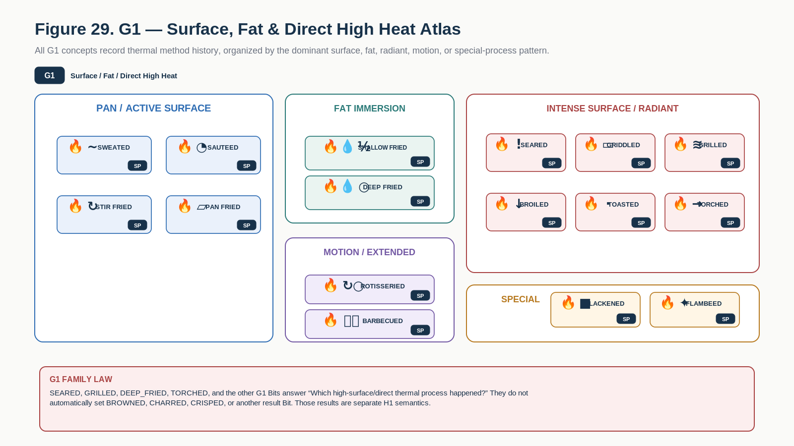
Figure 29. G1 Family Atlas groups pan, frying, radiant, flame, grill, barbecue, and other direct high-heat methods.
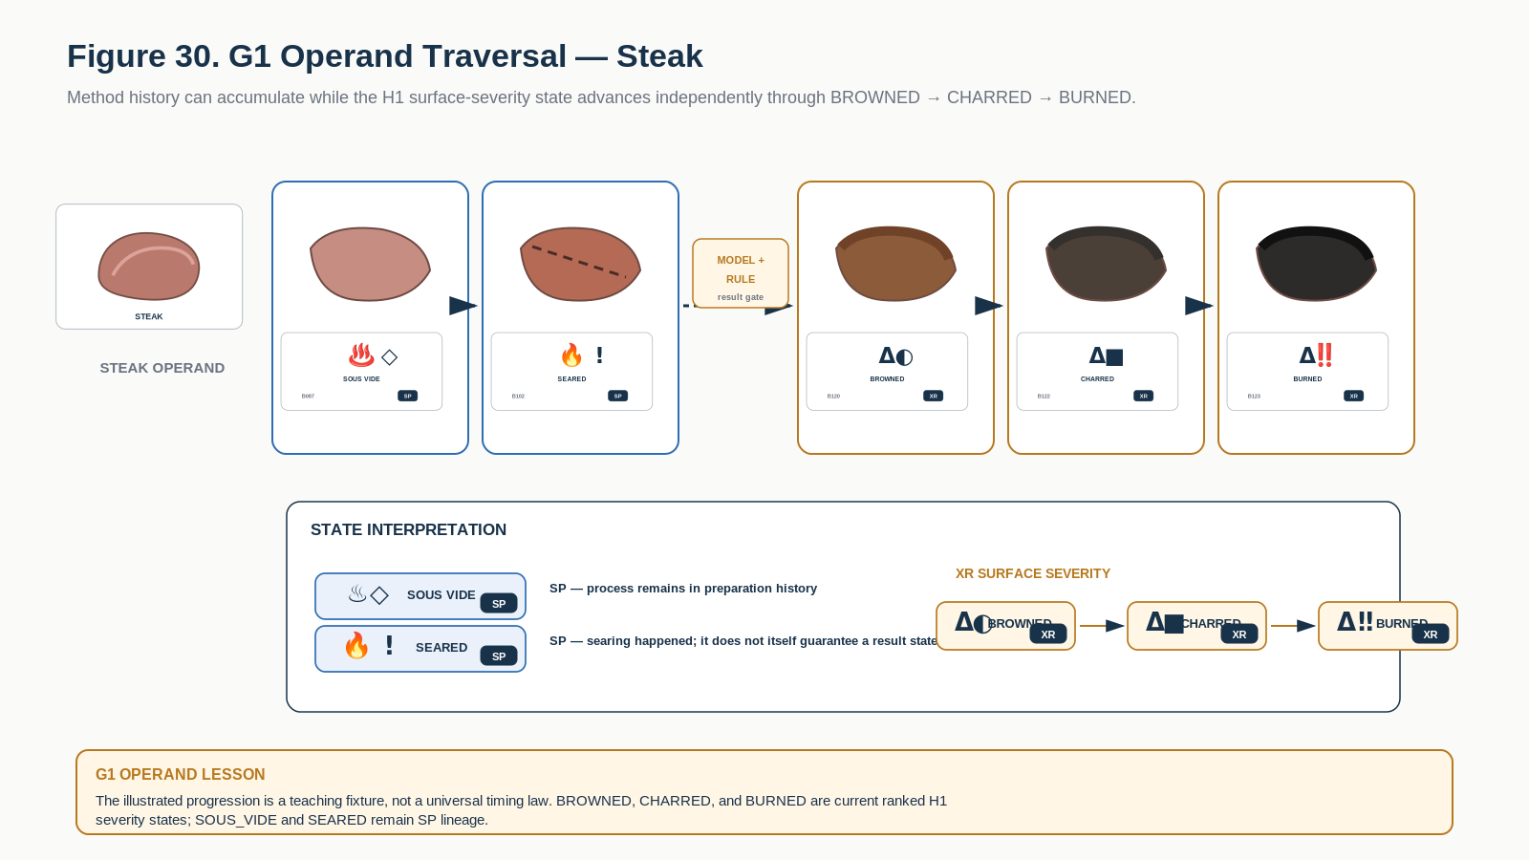
Figure 30. G1 operand traversal keeps SOUS_VIDE and SEARED history while a separate result gate advances surface severity from BROWNED to CHARRED to BURNED.

G1 Learning Registry
Each row below is one exact educational Bit. The approved symbol tile is a candidate BOSS projection; the Description and formal transition behavior are grounded in the corresponding COOKING-128 state.
Symbol / Identity | Instructional Memory
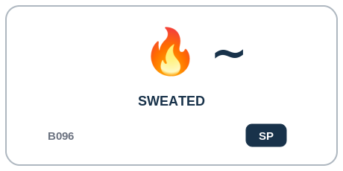  G1 | SP Sticky Process | Sweated B096  DESCRIPTION | Food has been gently heated, commonly with fat, to soften and release moisture without substantial browning.  PROFESSIONAL EXAMPLE | A kitchen controller or recipe compiler can record Sweated as thermal-method history while evaluating physical results such as browning or softening separately.  PERSONAL EXAMPLE | I can use Sweated to say which heat method I used, then separately describe whether the food actually became browned, crisp, softened, or another result.  INSTRUCTIONAL STATE | SP - Sticky Process. Sticky thermal-method history. Multiple thermal methods may coexist in one preparation lineage. Resultant physical states are derived independently by Models and Rules.
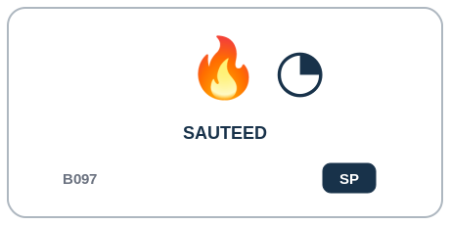  G1 | SP Sticky Process | Sauteed B097  DESCRIPTION | Food has been rapidly cooked on a hot surface using a relatively small amount of fat.  PROFESSIONAL EXAMPLE | A kitchen controller or recipe compiler can record Sauteed as thermal-method history while evaluating physical results such as browning or softening separately.  PERSONAL EXAMPLE | I can use Sauteed to say which heat method I used, then separately describe whether the food actually became browned, crisp, softened, or another result.  INSTRUCTIONAL STATE | SP - Sticky Process. Sticky thermal-method history. Multiple thermal methods may coexist in one preparation lineage. Resultant physical states are derived independently by Models and Rules.
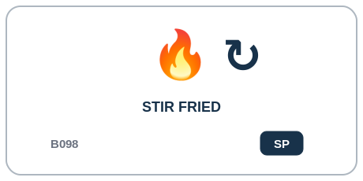  G1 | SP Sticky Process | Stir Fried B098  DESCRIPTION | Food has been rapidly cooked under high heat while being actively and repeatedly moved.  PROFESSIONAL EXAMPLE | A kitchen controller or recipe compiler can record Stir Fried as thermal-method history while evaluating physical results such as browning or softening separately.  PERSONAL EXAMPLE | I can use Stir Fried to say which heat method I used, then separately describe whether the food actually became browned, crisp, softened, or another result.  INSTRUCTIONAL STATE | SP - Sticky Process. Sticky thermal-method history. Requires an agitation condition but not specifically the STIRRED bit; TOSSED, STIRRED, or machine-specific movement may satisfy the Rule.
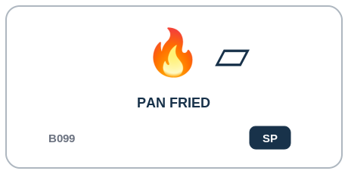  G1 | SP Sticky Process | Pan Fried B099  DESCRIPTION | Food has been cooked on a heated pan surface with a moderate amount of fat.  PROFESSIONAL EXAMPLE | A kitchen controller or recipe compiler can record Pan Fried as thermal-method history while evaluating physical results such as browning or softening separately.  PERSONAL EXAMPLE | I can use Pan Fried to say which heat method I used, then separately describe whether the food actually became browned, crisp, softened, or another result.  INSTRUCTIONAL STATE | SP - Sticky Process. Sticky thermal-method history. Multiple thermal methods may coexist in one preparation lineage. Resultant physical states are derived independently by Models and Rules.
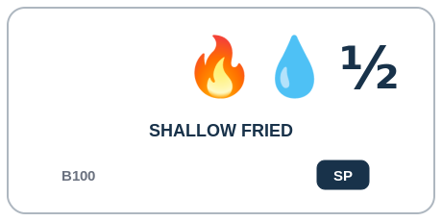  G1 | SP Sticky Process | Shallow Fried B100  DESCRIPTION | Food has been fried while only partially submerged in hot fat.  PROFESSIONAL EXAMPLE | A kitchen controller or recipe compiler can record Shallow Fried as thermal-method history while evaluating physical results such as browning or softening separately.  PERSONAL EXAMPLE | I can use Shallow Fried to say which heat method I used, then separately describe whether the food actually became browned, crisp, softened, or another result.  INSTRUCTIONAL STATE | SP - Sticky Process. Sticky thermal-method history. Multiple thermal methods may coexist in one preparation lineage. Resultant physical states are derived independently by Models and Rules.
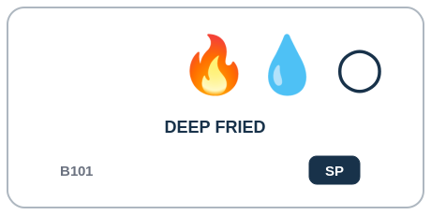  G1 | SP Sticky Process | Deep Fried B101  DESCRIPTION | Food has been fried while substantially or completely immersed in hot fat.  PROFESSIONAL EXAMPLE | A kitchen controller or recipe compiler can record Deep Fried as thermal-method history while evaluating physical results such as browning or softening separately.  PERSONAL EXAMPLE | I can use Deep Fried to say which heat method I used, then separately describe whether the food actually became browned, crisp, softened, or another result.  INSTRUCTIONAL STATE | SP - Sticky Process. Sticky thermal-method history. Multiple thermal methods may coexist in one preparation lineage. Resultant physical states are derived independently by Models and Rules.
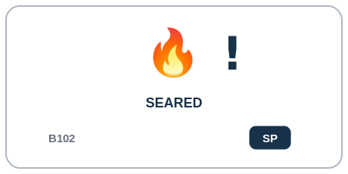  G1 | SP Sticky Process | Seared B102  DESCRIPTION | A food surface has received intense heat intended to rapidly produce strong surface browning.  PROFESSIONAL EXAMPLE | A kitchen controller or recipe compiler can record Seared as thermal-method history while evaluating physical results such as browning or softening separately.  PERSONAL EXAMPLE | I can use Seared to say which heat method I used, then separately describe whether the food actually became browned, crisp, softened, or another result.  INSTRUCTIONAL STATE | SP - Sticky Process. Sticky thermal-method history. Multiple thermal methods may coexist in one preparation lineage. Resultant physical states are derived independently by Models and Rules.
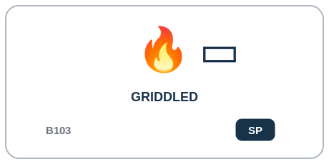  G1 | SP Sticky Process | Griddled B103  DESCRIPTION | Food has been cooked through direct contact with a broad heated flat surface.  PROFESSIONAL EXAMPLE | A kitchen controller or recipe compiler can record Griddled as thermal-method history while evaluating physical results such as browning or softening separately.  PERSONAL EXAMPLE | I can use Griddled to say which heat method I used, then separately describe whether the food actually became browned, crisp, softened, or another result.  INSTRUCTIONAL STATE | SP - Sticky Process. Sticky thermal-method history. Multiple thermal methods may coexist in one preparation lineage. Resultant physical states are derived independently by Models and Rules.
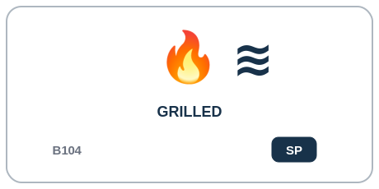  G1 | SP Sticky Process | Grilled B104  DESCRIPTION | Food has been cooked using intense radiant/contact heat associated with a grill.  PROFESSIONAL EXAMPLE | A kitchen controller or recipe compiler can record Grilled as thermal-method history while evaluating physical results such as browning or softening separately.  PERSONAL EXAMPLE | I can use Grilled to say which heat method I used, then separately describe whether the food actually became browned, crisp, softened, or another result.  INSTRUCTIONAL STATE | SP - Sticky Process. Sticky thermal-method history. Multiple thermal methods may coexist in one preparation lineage. Resultant physical states are derived independently by Models and Rules.
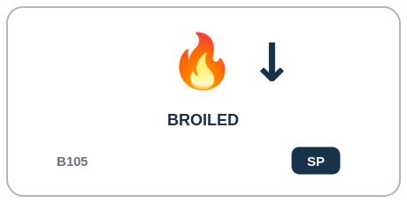  G1 | SP Sticky Process | Broiled B105  DESCRIPTION | Food has been cooked using intense radiant heat primarily from above.  PROFESSIONAL EXAMPLE | A kitchen controller or recipe compiler can record Broiled as thermal-method history while evaluating physical results such as browning or softening separately.  PERSONAL EXAMPLE | I can use Broiled to say which heat method I used, then separately describe whether the food actually became browned, crisp, softened, or another result.  INSTRUCTIONAL STATE | SP - Sticky Process. Sticky thermal-method history. Multiple thermal methods may coexist in one preparation lineage. Resultant physical states are derived independently by Models and Rules.
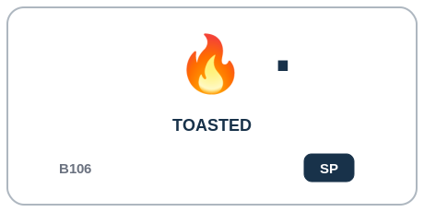  G1 | SP Sticky Process | Toasted B106  DESCRIPTION | Surface moisture has been reduced and browning/aromatic development produced through relatively dry heating.  PROFESSIONAL EXAMPLE | A kitchen controller or recipe compiler can record Toasted as thermal-method history while evaluating physical results such as browning or softening separately.  PERSONAL EXAMPLE | I can use Toasted to say which heat method I used, then separately describe whether the food actually became browned, crisp, softened, or another result.  INSTRUCTIONAL STATE | SP - Sticky Process. Sticky thermal-method history. Multiple thermal methods may coexist in one preparation lineage. Resultant physical states are derived independently by Models and Rules.
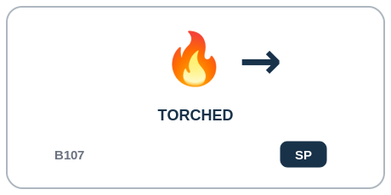  G1 | SP Sticky Process | Torched B107  DESCRIPTION | Surface has been directly exposed to a concentrated flame or torch.  PROFESSIONAL EXAMPLE | A kitchen controller or recipe compiler can record Torched as thermal-method history while evaluating physical results such as browning or softening separately.  PERSONAL EXAMPLE | I can use Torched to say which heat method I used, then separately describe whether the food actually became browned, crisp, softened, or another result.  INSTRUCTIONAL STATE | SP - Sticky Process. Sticky thermal-method history. Multiple thermal methods may coexist in one preparation lineage. Resultant physical states are derived independently by Models and Rules.
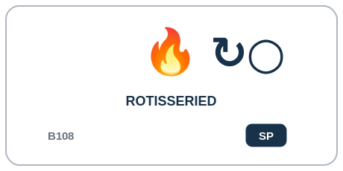  G1 | SP Sticky Process | Rotisseried B108  DESCRIPTION | Food has been cooked while rotating relative to a heat source.  PROFESSIONAL EXAMPLE | A kitchen controller or recipe compiler can record Rotisseried as thermal-method history while evaluating physical results such as browning or softening separately.  PERSONAL EXAMPLE | I can use Rotisseried to say which heat method I used, then separately describe whether the food actually became browned, crisp, softened, or another result.  INSTRUCTIONAL STATE | SP - Sticky Process. Sticky thermal-method history. Multiple thermal methods may coexist in one preparation lineage. Resultant physical states are derived independently by Models and Rules.
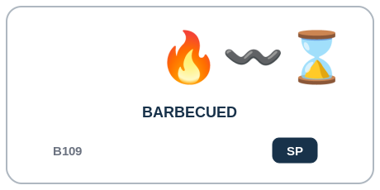  G1 | SP Sticky Process | Barbecued B109  DESCRIPTION | Food has undergone a controlled barbecue process involving dry heat, smoke, or both over an extended period.  PROFESSIONAL EXAMPLE | A kitchen controller or recipe compiler can record Barbecued as thermal-method history while evaluating physical results such as browning or softening separately.  PERSONAL EXAMPLE | I can use Barbecued to say which heat method I used, then separately describe whether the food actually became browned, crisp, softened, or another result.  INSTRUCTIONAL STATE | SP - Sticky Process. Sticky thermal-method history. Multiple thermal methods may coexist in one preparation lineage. Resultant physical states are derived independently by Models and Rules.
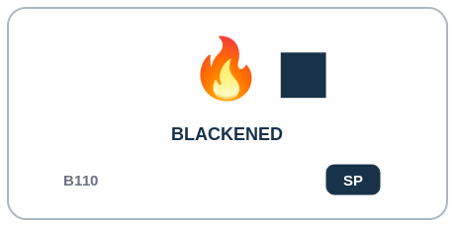  G1 | SP Sticky Process | Blackened B110  DESCRIPTION | Surface has undergone an intentional high-heat seasoning/crust process producing a very dark exterior.  PROFESSIONAL EXAMPLE | A kitchen controller or recipe compiler can record Blackened as thermal-method history while evaluating physical results such as browning or softening separately.  PERSONAL EXAMPLE | I can use Blackened to say which heat method I used, then separately describe whether the food actually became browned, crisp, softened, or another result.  INSTRUCTIONAL STATE | SP - Sticky Process. Sticky thermal-method history. Multiple thermal methods may coexist in one preparation lineage. Resultant physical states are derived independently by Models and Rules.
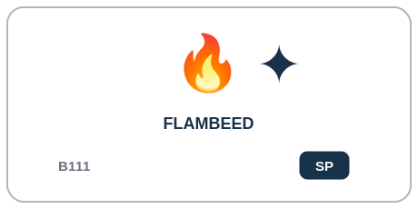  G1 | SP Sticky Process | Flambeed B111  DESCRIPTION | Volatile alcohol has been intentionally ignited as part of the cooking process.  PROFESSIONAL EXAMPLE | A kitchen controller or recipe compiler can record Flambeed as thermal-method history while evaluating physical results such as browning or softening separately.  PERSONAL EXAMPLE | I can use Flambeed to say which heat method I used, then separately describe whether the food actually became browned, crisp, softened, or another result.  INSTRUCTIONAL STATE | SP - Sticky Process. Sticky thermal-method history. Multiple thermal methods may coexist in one preparation lineage. Resultant physical states are derived independently by Models and Rules.

Part 14 | H1 - Resultant Transformation & Finishing
B112-B127 | What material result, finishing action, or service state now applies?
H1 is intentionally heterogeneous: it contains dynamic results, persistent transformations, an exclusive surface-heat severity ladder, finishing process history, and the PLATED workflow stage.
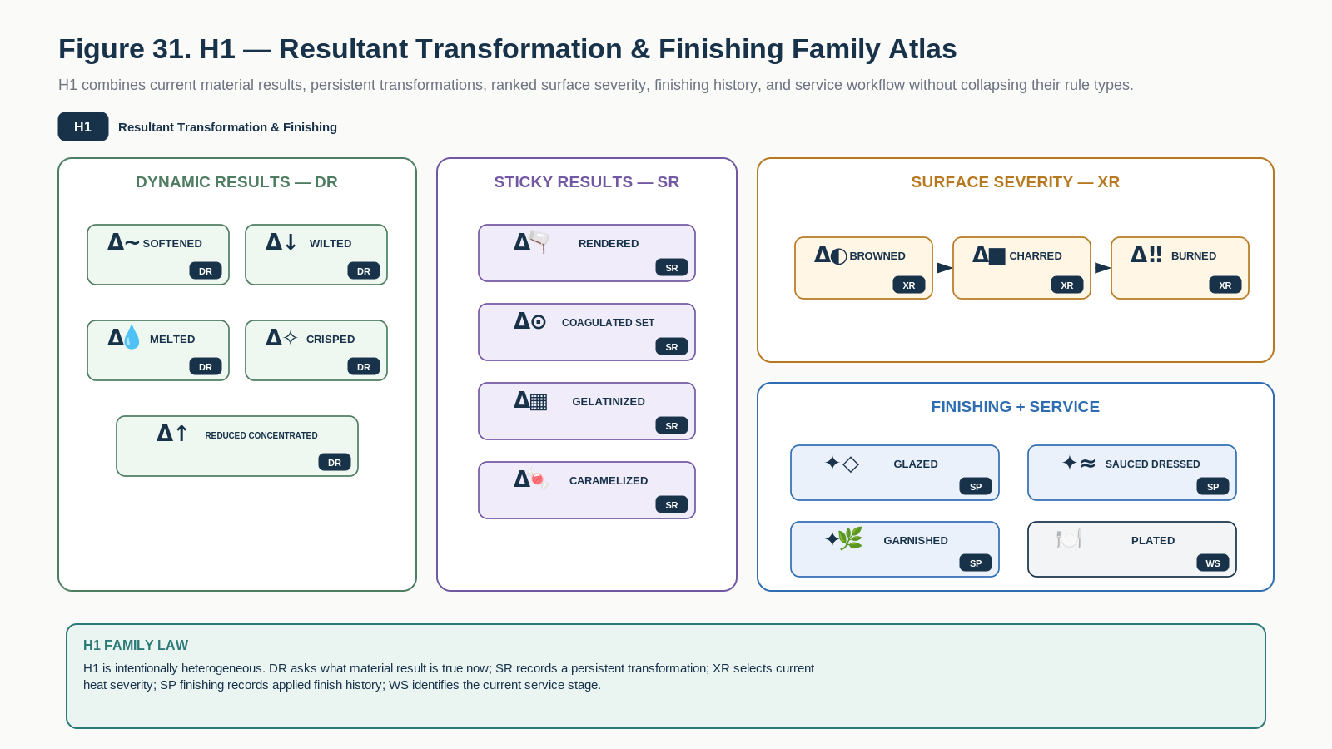
Figure 31. H1 Family Atlas shows dynamic results, persistent transformations, ranked heat severity, finishing history, and the plating workflow stage together.
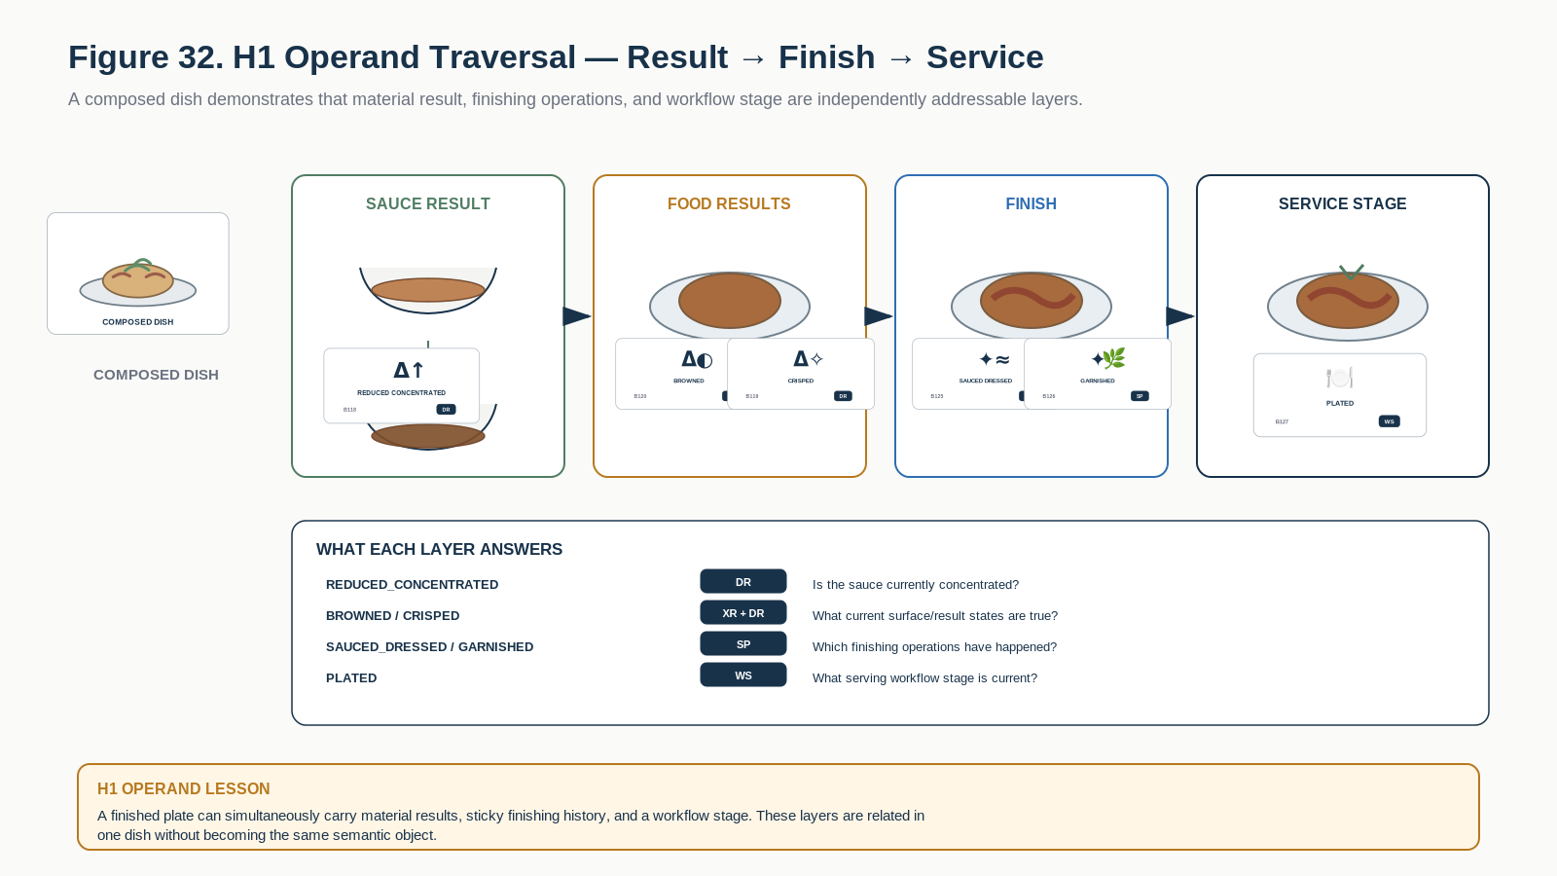
Figure 32. H1 operand traversal separates current result, finishing actions, and service stage on one composed dish.

H1 Learning Registry
Each row below is one exact educational Bit. The approved symbol tile is a candidate BOSS projection; the Description and formal transition behavior are grounded in the corresponding COOKING-128 state.
Symbol / Identity | Instructional Memory
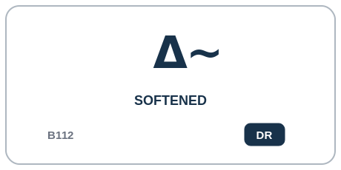  H1 | DR Dynamic Result | Softened B112  DESCRIPTION | Structure has become measurably softer through cooking or conditioning.  PROFESSIONAL EXAMPLE | A culinary quality model can mark Softened when the defined material-result condition is satisfied, using the registered persistence behavior for this state.  PERSONAL EXAMPLE | I can use Softened while that result is true now and clear it later if the material no longer has that condition.  INSTRUCTIONAL STATE | DR - Dynamic Result. Dynamic result. Model-driven entry/exit according to food-specific structure, moisture, temperature, and time; not implied by any single cooking method.
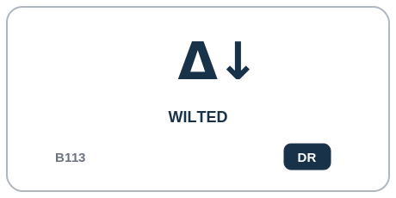  H1 | DR Dynamic Result | Wilted B113  DESCRIPTION | Leafy or structurally delicate material has lost rigidity and volume.  PROFESSIONAL EXAMPLE | A culinary quality model can mark Wilted when the defined material-result condition is satisfied, using the registered persistence behavior for this state.  PERSONAL EXAMPLE | I can use Wilted while that result is true now and clear it later if the material no longer has that condition.  INSTRUCTIONAL STATE | DR - Dynamic Result. Dynamic result. May be entered by heat, salt, acid, or other modeled causes; may clear only if the active Model considers recovery meaningful.
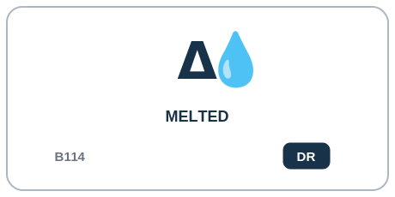  H1 | DR Dynamic Result | Melted B114  DESCRIPTION | A material has transitioned substantially from solid toward liquid under thermal conditions.  PROFESSIONAL EXAMPLE | A culinary quality model can mark Melted when the defined material-result condition is satisfied, using the registered persistence behavior for this state.  PERSONAL EXAMPLE | I can use Melted while that result is true now and clear it later if the material no longer has that condition.  INSTRUCTIONAL STATE | DR - Dynamic Result. Dynamic result. Commonly uses entry and exit thresholds/hysteresis; may clear on resolidification.
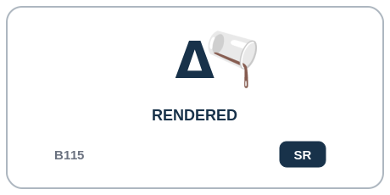  H1 | SR Sticky Result | Rendered B115  DESCRIPTION | Fat or another renderable component has been thermally released from surrounding structure.  PROFESSIONAL EXAMPLE | A culinary quality model can mark Rendered when the defined material-result condition is satisfied, using the registered persistence behavior for this state.  PERSONAL EXAMPLE | I can use Rendered after that persistent transformation has occurred; ordinary cooling or waiting does not silently return the food to its earlier material state.  INSTRUCTIONAL STATE | SR - Sticky Result. Sticky result transformation. Cooling does not automatically restore the pre-rendered structure.
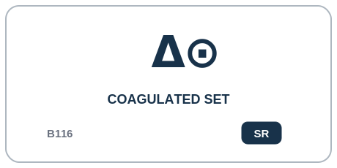  H1 | SR Sticky Result | Coagulated Set B116  DESCRIPTION | Proteins or comparable structural components have transitioned into a set/coagulated state.  PROFESSIONAL EXAMPLE | A culinary quality model can mark Coagulated Set when the defined material-result condition is satisfied, using the registered persistence behavior for this state.  PERSONAL EXAMPLE | I can use Coagulated Set after that persistent transformation has occurred; ordinary cooling or waiting does not silently return the food to its earlier material state.  INSTRUCTIONAL STATE | SR - Sticky Result. Sticky result transformation. Entry is Model-driven; ordinary source reversal does not clear the bit.
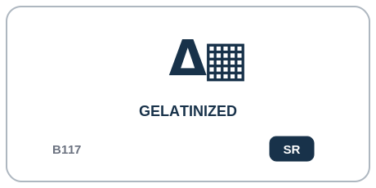  H1 | SR Sticky Result | Gelatinized B117  DESCRIPTION | Starch or another relevant material has undergone gelatinization or equivalent hydration/thermal structural development.  PROFESSIONAL EXAMPLE | A culinary quality model can mark Gelatinized when the defined material-result condition is satisfied, using the registered persistence behavior for this state.  PERSONAL EXAMPLE | I can use Gelatinized after that persistent transformation has occurred; ordinary cooling or waiting does not silently return the food to its earlier material state.  INSTRUCTIONAL STATE | SR - Sticky Result. Sticky result transformation. Entry is Model-driven and persists within the preparation lineage.
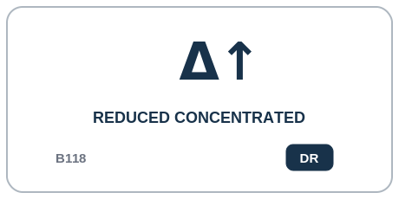  H1 | DR Dynamic Result | Reduced Concentrated B118  DESCRIPTION | Liquid content has been reduced sufficiently to increase concentration.  PROFESSIONAL EXAMPLE | A culinary quality model can mark Reduced Concentrated when the defined material-result condition is satisfied, using the registered persistence behavior for this state.  PERSONAL EXAMPLE | I can use Reduced Concentrated while that result is true now and clear it later if the material no longer has that condition.  INSTRUCTIONAL STATE | DR - Dynamic Result. Dynamic result. May clear if the preparation is subsequently diluted or otherwise falls outside the concentration condition.
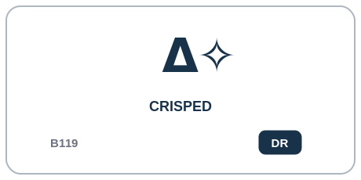  H1 | DR Dynamic Result | Crisped B119  DESCRIPTION | Surface or structure has developed a deliberately crisp texture.  PROFESSIONAL EXAMPLE | A culinary quality model can mark Crisped when the defined material-result condition is satisfied, using the registered persistence behavior for this state.  PERSONAL EXAMPLE | I can use Crisped while that result is true now and clear it later if the material no longer has that condition.  INSTRUCTIONAL STATE | DR - Dynamic Result. Dynamic result. May enter through drying/heat and clear through moisture migration, soaking, or another invalidating condition.
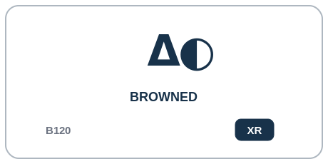  H1 | XR Exclusive Ranked | Browned B120  DESCRIPTION | Significant culinary browning has developed on the relevant surface.  PROFESSIONAL EXAMPLE | A culinary quality model can mark Browned when the defined material-result condition is satisfied, using the registered persistence behavior for this state.  PERSONAL EXAMPLE | I can use Browned as the current member of its ranked result family rather than keeping every earlier severity level active.  INSTRUCTIONAL STATE | XR - Exclusive Ranked. First member of exclusive surface heat-severity ladder BROWNED->CHARRED->BURNED. Entry to a higher severity clears this bit.
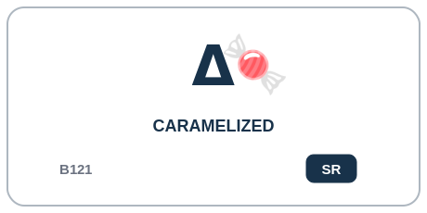  H1 | SR Sticky Result | Caramelized B121  DESCRIPTION | Sugars or sugar-rich material have undergone substantial caramelization.  PROFESSIONAL EXAMPLE | A culinary quality model can mark Caramelized when the defined material-result condition is satisfied, using the registered persistence behavior for this state.  PERSONAL EXAMPLE | I can use Caramelized after that persistent transformation has occurred; ordinary cooling or waiting does not silently return the food to its earlier material state.  INSTRUCTIONAL STATE | SR - Sticky Result. Sticky result transformation. Orthogonal to surface-severity ladder; may coexist with BROWNED, CHARRED, or BURNED where the Model supports it.
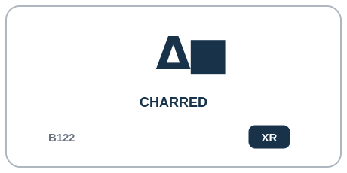  H1 | XR Exclusive Ranked | Charred B122  DESCRIPTION | Surface has undergone intentional localized carbonization beyond ordinary browning.  PROFESSIONAL EXAMPLE | A culinary quality model can mark Charred when the defined material-result condition is satisfied, using the registered persistence behavior for this state.  PERSONAL EXAMPLE | I can use Charred as the current member of its ranked result family rather than keeping every earlier severity level active.  INSTRUCTIONAL STATE | XR - Exclusive Ranked. Second member of exclusive surface heat-severity ladder. Entry clears BROWNED; ordinary cooking Operators do not move backward to BROWNED.
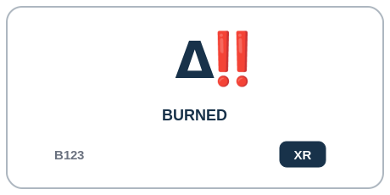  H1 | XR Exclusive Ranked | Burned B123  DESCRIPTION | Material has exceeded intended culinary browning/char and entered an undesirable burned state.  PROFESSIONAL EXAMPLE | A culinary quality model can mark Burned when the defined material-result condition is satisfied, using the registered persistence behavior for this state.  PERSONAL EXAMPLE | I can use Burned as the current member of its ranked result family rather than keeping every earlier severity level active.  INSTRUCTIONAL STATE | XR - Exclusive Ranked. Highest member of exclusive surface heat-severity ladder. Entry clears BROWNED and CHARRED. Removal requires an explicit material-removal/replacement operation, not cooling.
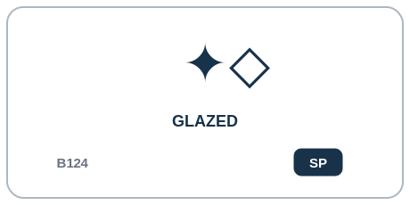  H1 | SP Sticky Process | Glazed B124  DESCRIPTION | A deliberate glossy, adherent finishing layer has been formed or applied.  PROFESSIONAL EXAMPLE | A finishing station can record Glazed after the finishing operation has been applied to the dish.  PERSONAL EXAMPLE | I can use Glazed to remember that this finishing step has been applied before serving.  INSTRUCTIONAL STATE | SP - Sticky Process. Sticky finishing-process state for the current preparation lineage; may coexist with SAUCED_DRESSED and GARNISHED.
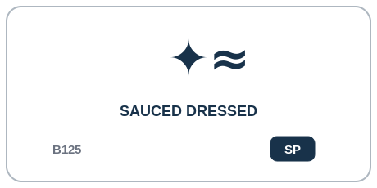  H1 | SP Sticky Process | Sauced Dressed B125  DESCRIPTION | A prepared sauce or dressing has been applied as a finishing or integration operation.  PROFESSIONAL EXAMPLE | A finishing station can record Sauced Dressed after the finishing operation has been applied to the dish.  PERSONAL EXAMPLE | I can use Sauced Dressed to remember that this finishing step has been applied before serving.  INSTRUCTIONAL STATE | SP - Sticky Process. Sticky finishing-process state. Current quantity/coverage belongs to richer Models if needed.
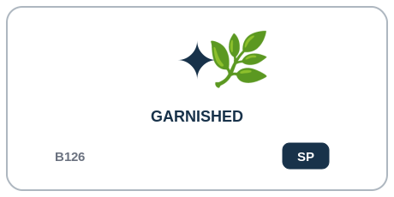  H1 | SP Sticky Process | Garnished B126  DESCRIPTION | A finishing ingredient or decorative edible component has been applied.  PROFESSIONAL EXAMPLE | A finishing station can record Garnished after the finishing operation has been applied to the dish.  PERSONAL EXAMPLE | I can use Garnished to remember that this finishing step has been applied before serving.  INSTRUCTIONAL STATE | SP - Sticky Process. Sticky finishing-process state. Detailed garnish geometry/composition is external to COOKING-128.
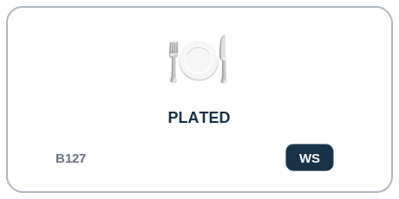  H1 | WS Workflow Stage | Plated B127  DESCRIPTION | Food has been intentionally arranged into its serving presentation state.  PROFESSIONAL EXAMPLE | A service workflow can mark Plated as the current production stage and clear it if the dish returns for rework.  PERSONAL EXAMPLE | I can use Plated when the dish is currently arranged for service, then clear the stage if I take it back for rework.  INSTRUCTIONAL STATE | WS - Workflow Stage. Workflow stage. Enter via PLATE; may be explicitly cleared by RETURN_TO_PRODUCTION, rework, or service-reset without erasing prior plating provenance.

Part 15 | Cross-Family Culinary Composition
A real preparation is not one cooking label. One food operand can accumulate preparation history, occupy current geometry and coating branches, satisfy material results, and move through service workflow at the same time. Composition is the point of the language.
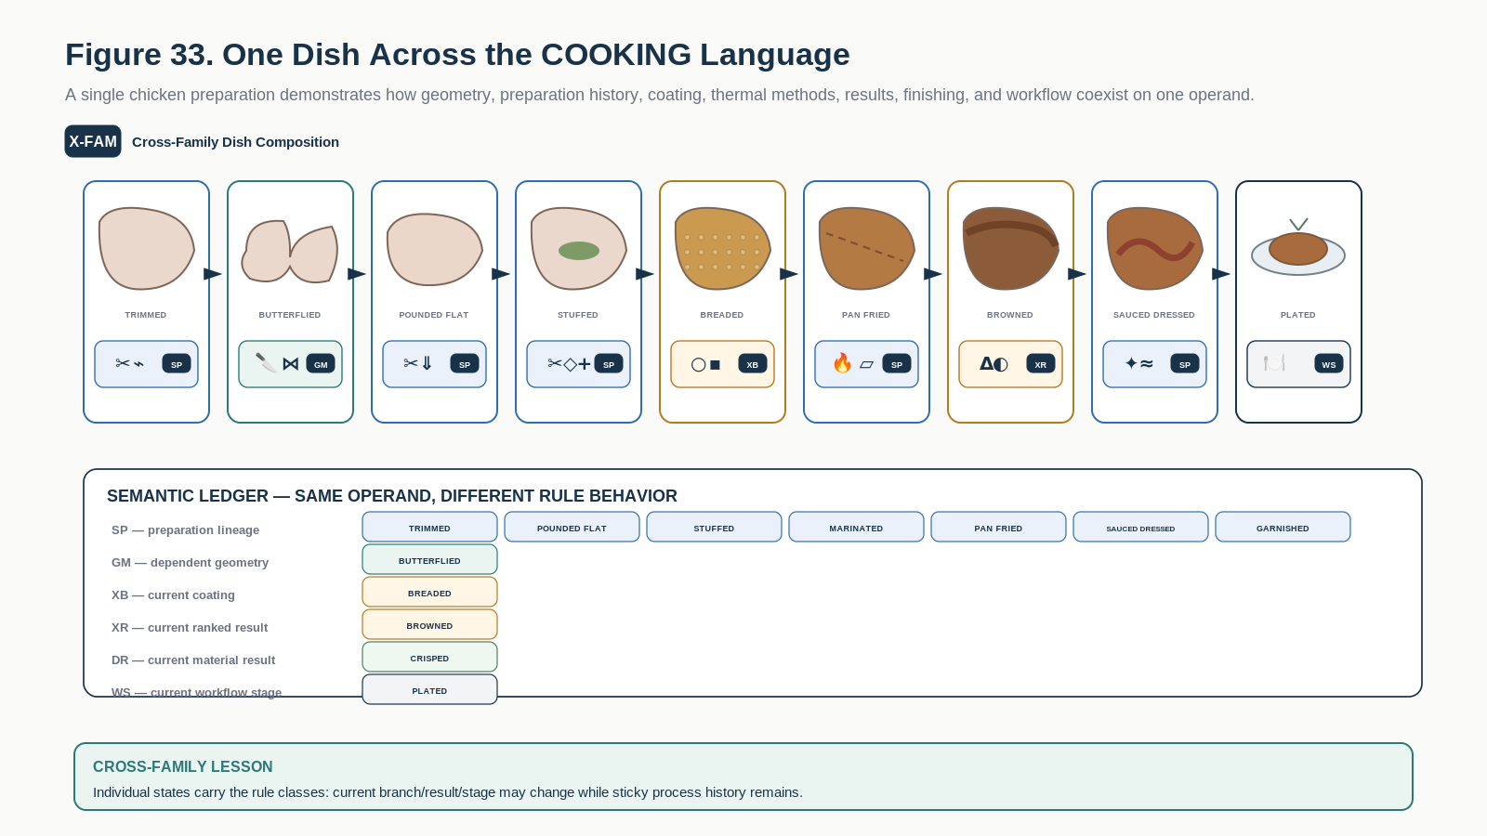
Figure 33. A real dish composes states from many COOKING families and rule classes without collapsing them into one monolithic cooking label.
The figure demonstrates how states remain independently typed. TRIMMED or MARINATED can persist as SP history; BREADED can be the current XB coating state; BROWNED can occupy an XR severity family; CRISPED can be a DR result; and PLATED can be the current WS stage. None of those facts requires the others merely because they are present on the same dish.
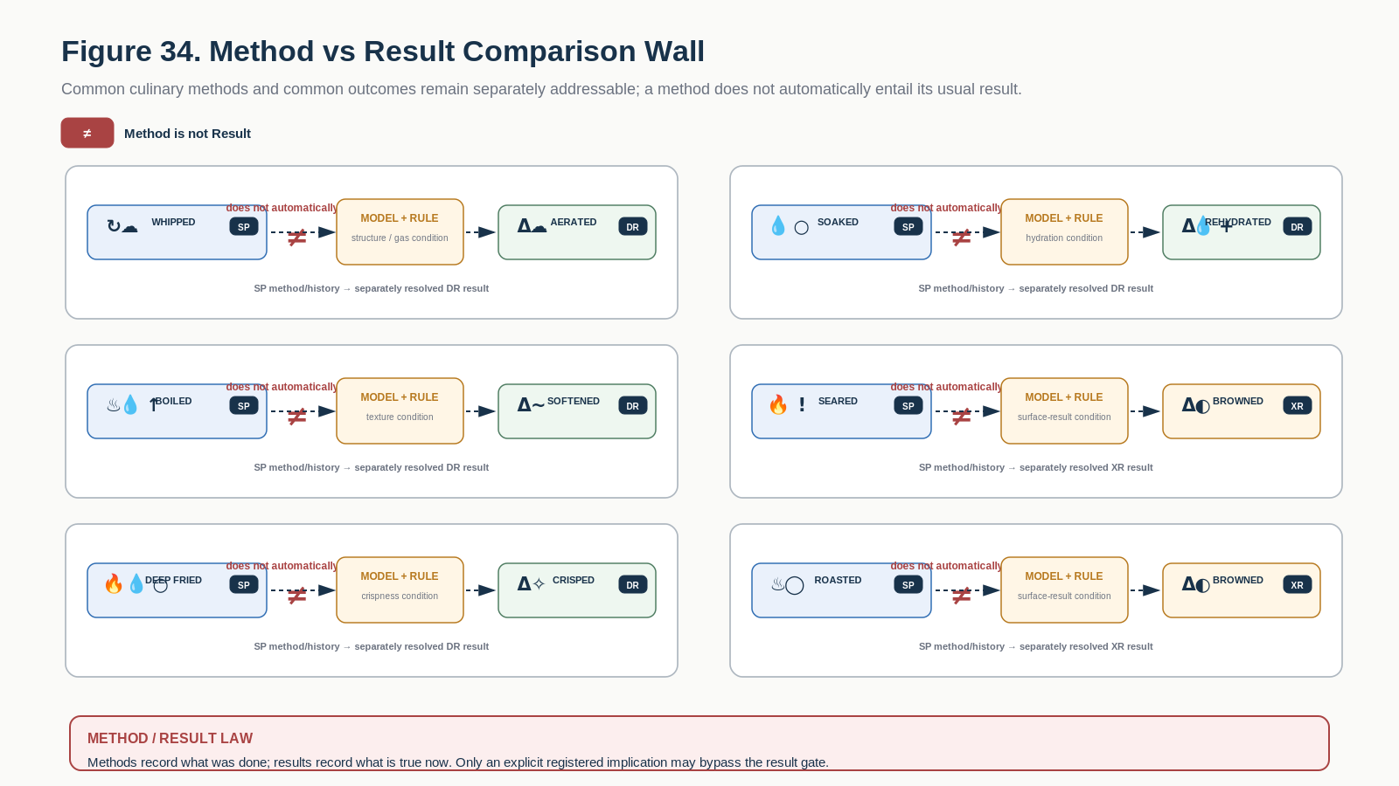
Figure 34. Common culinary methods and results remain distinct: association does not become automatic causation without the required Model and Rule.
METHOD != RESULT | WHIPPED != AERATED; SOAKED != REHYDRATED; BOILED != SOFTENED; SEARED != BROWNED; DEEP_FRIED != CRISPED; ROASTED != BROWNED. Models and Rules establish result predicates unless the formal specification declares a direct implication.

Part 16 | Learning Views and Study Projections
The same 128 educational Bits can be projected into many study views without changing the taxonomy. A learner may build Knife Skills, Thermal Methods, Material Results, SP History, DR Results, Beginner Set, or Method-vs-Result views over the same stable addresses.
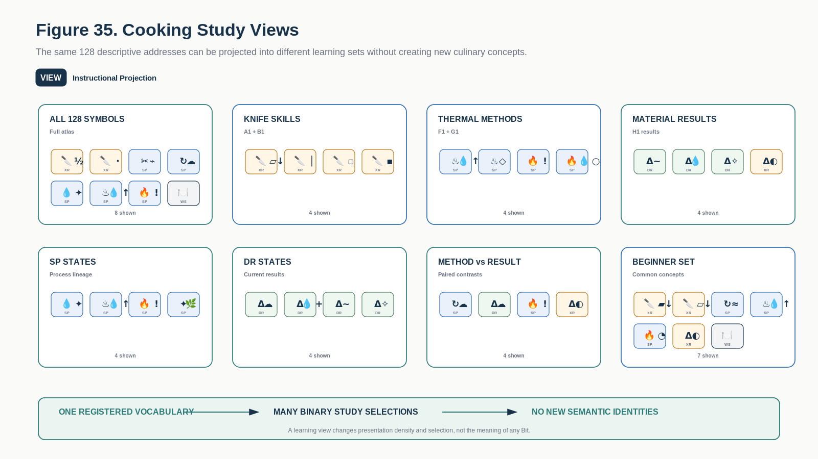
Figure 35. Study views are different educational projections over the same 128 registered concepts; they do not create new semantics.
- Symbol Wall - recognition-first view over all 128 concepts.
- Family Atlas - one Reader Family with its internal ladders, branches, and modifiers.
- Material Rule Atlas - all states sharing XR, XB, GM, SP, DR, SR, or WS behavior.
- Targeted study set - a temporary selection such as Knife Skills or Thermal Methods.
- Contrast view - pairs that are commonly conflated, especially method versus result.

Part 17 | Natural-Language Alias and Ambiguity Routing
Ordinary cooking language may route to registered concepts, but surface wording does not become semantic identity. Safe ambiguity is preferable to invented precision. A compiler can preserve the original phrase, nominate one or more candidates, and request additional context when needed.
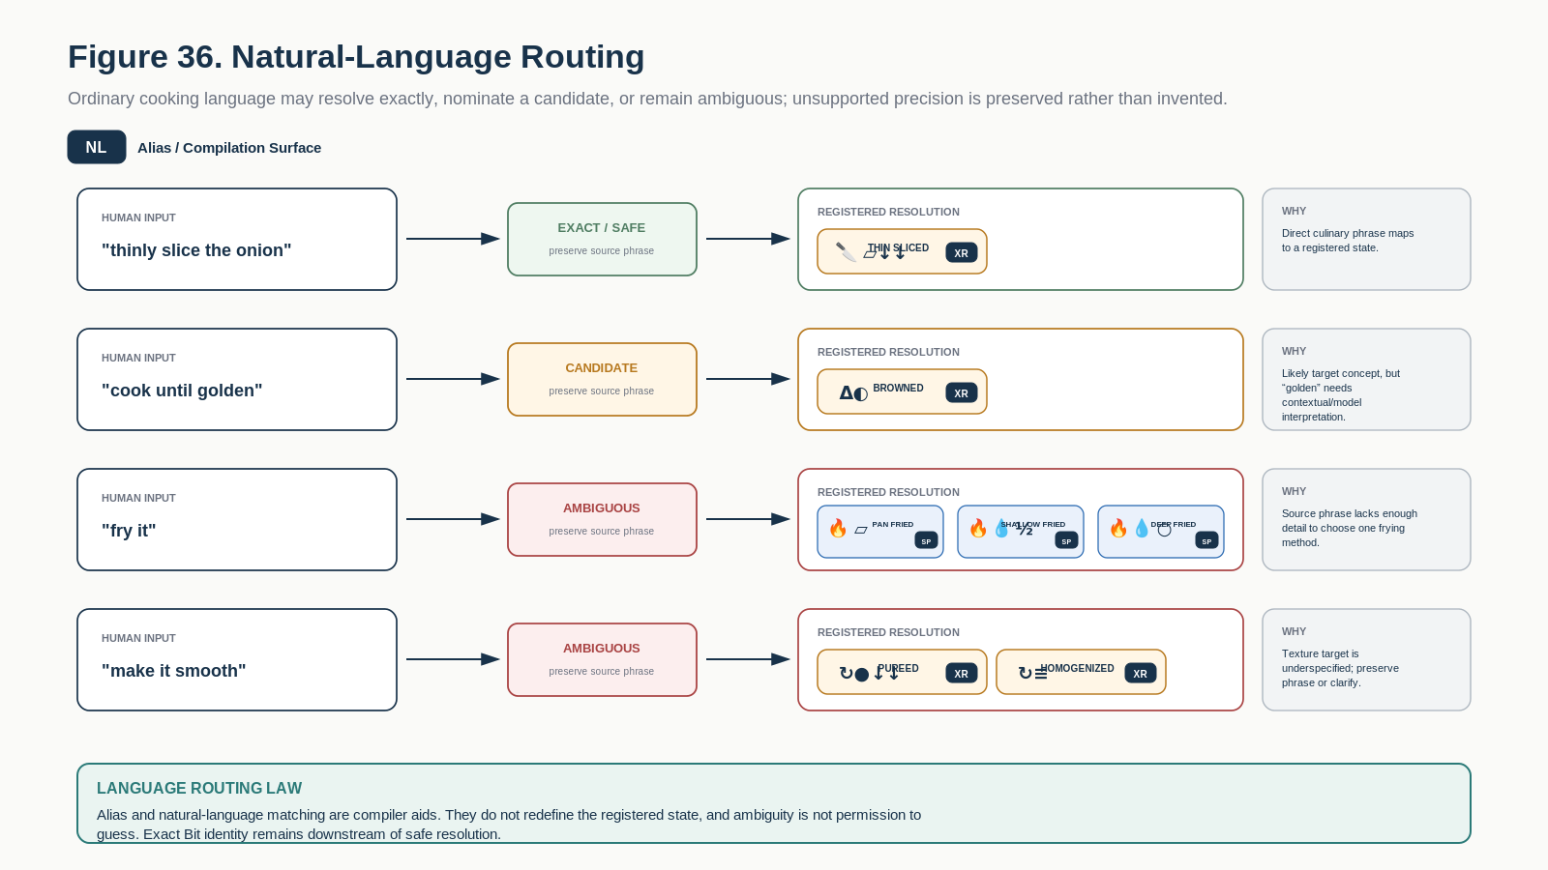
Figure 36. Natural-language routing can resolve exact phrases, nominate candidates, or preserve ambiguity instead of inventing precision.
Human phrase | Educational routing
"thinly slice the onion" | THIN_SLICED candidate with ordinary slice-family interpretation
"cook until golden" | BROWNED candidate; exact threshold and food-specific interpretation require context / Model
"fry it" | Ambiguous among PAN_FRIED, SHALLOW_FRIED, DEEP_FRIED, or another context-specific method
"make it smooth" | Possible PUREED or HOMOGENIZED target depending on intended texture and Model
"low and slow" | Insufficiently specific thermal language; preserve phrase and resolve through recipe/context
ALIAS LAW | Natural language can route to a registered concept. It does not redefine that concept, and unresolved language should remain unresolved rather than being silently guessed.

Part 18 | Interface and Instructional Card Requirements
The canonical Bit-level educational interface is the Cooking Learning Card. Higher-level views compose those same cards into palettes, atlases, study sets, and reversible zoom paths.
Requirement | Educational interface contract
DREQ-COOK-EDU-01 | Select one exact B000-B127 educational concept by registered identity.
DREQ-COOK-EDU-02 | Display the approved candidate BOSS symbol while keeping the Bit identity inspectable.
DREQ-COOK-EDU-03 | Expose Description, Professional Example, Personal Example, and Instructional State as distinct memory layers.
DREQ-COOK-EDU-04 | Show the Material Cooking Rule class and explain its behavior without executing it.
DREQ-COOK-EDU-05 | Permit reversible zoom from Symbol Wall -> Family -> exact concept -> formal COOKING-128 binding.
DREQ-COOK-EDU-06 | Keep educational Bit selection distinct from formal food-state assertion.
DREQ-COOK-EDU-07 | Preserve ambiguous natural-language input rather than silently assigning a Bit.
DREQ-COOK-EDU-08 | Allow study views to select subsets without creating new semantic concepts.
DREQ-COOK-EDU-09 | Do not infer method-to-result causation unless the formal Model/Rule contract establishes it.

Part 19 | Educational Laws
Law | Requirement
Law 1 - Educational Boundary | Selecting a COOKING_DESCRIPTIVE-128 Bit SHALL select a concept for learning and SHALL NOT assert the corresponding formal state on a food operand.
Law 2 - Exact Formal Binding | Every educational Bit SHALL bind to the same B000-B127 concept identity in COOKING-128 v0.1.
Law 3 - Symbol Projection | Visible symbols are candidate BOSS projections and MAY change without changing Bit identity, Reader placement, or historical educational records.
Law 4 - Morphology Is Pedagogical | Family stems and modifiers MAY support recognition but SHALL NOT be parsed as semantic authority at runtime.
Law 5 - Memory Separation | Symbol, Description, Professional Example, Personal Example, and Instructional State SHALL remain distinguishable learning layers.
Law 6 - Material Rule Preservation | XR, XB, GM, SP, DR, SR, and WS SHALL retain their formal behavioral distinctions when taught or visualized.
Law 7 - Method Is Not Result | A method/process concept SHALL NOT automatically establish a material-result concept unless formal Rules declare the relation.
Law 8 - History Is Not Current Condition | SP history MAY remain true while a DR result clears or an XR/XB current state is replaced.
Law 9 - Branch Is Not Rank | XB alternatives SHALL NOT be presented as a single severity or refinement ladder.
Law 10 - Modifier Requires Parent | A GM concept SHALL NOT remain educationally represented as valid when the parent structure required for its interpretation has been invalidated.
Law 11 - No Automatic Causation | Common culinary associations MAY be shown as examples, but the educational SK SHALL NOT promote them into universal causal Rules.
Law 12 - Alias Is Not Identity | Natural-language aliases MAY route to educational concepts but SHALL NOT create new Bit identities or redefine existing ones.
Law 13 - Study Projection | A study set is a Bit selection over the same 128 concepts and SHALL NOT mutate the taxonomy.
Law 14 - Formal Authority | COOKING-128 remains the operational authority for formal state type and transition semantics.
Law 15 - No Silent Runtime Execution | No educational card, symbol, figure, or study view SHALL execute a cooking Operator merely because the represented concept is selected.
Law 16 - Unknown Preservation | When a phrase or intended state cannot be safely resolved, the system SHALL preserve ambiguity rather than invent a precise concept.

Part 20 | Consolidated 128-Bit Registry Index
This index provides one compact navigation surface over the full educational Word. Detailed memory appears in the Family registries above.
Bit | Reader | Concept | Description | Rule
B000 | A1 | Halved | Object has been divided into approximately two major portions. | XR - Exclusive Ranked
B001 | A1 | Quartered | Object has been divided into approximately four major portions. | XR - Exclusive Ranked
B002 | A1 | Wedged | Object has been divided into tapered radial sections. | XB - Exclusive Branch
B003 | A1 | Large Chunked | Object has been cut into large irregular pieces. | XR - Exclusive Ranked
B004 | A1 | Rough Chopped | Object has been chopped into intentionally irregular coarse pieces. | XR - Exclusive Ranked
B005 | A1 | Medium Chopped | Object has been chopped into moderately sized pieces. | XR - Exclusive Ranked
B006 | A1 | Fine Chopped | Object has been chopped into small pieces while retaining visibly discrete pieces. | XR - Exclusive Ranked
B007 | A1 | Thick Sliced | Object has been divided into relatively thick planar slices. | XR - Exclusive Ranked
B008 | A1 | Medium Sliced | Object has been divided into medium-thickness planar slices. | XR - Exclusive Ranked
B009 | A1 | Thin Sliced | Object has been divided into thin planar slices. | XR - Exclusive Ranked
B010 | A1 | Shaved | Object has been cut into extremely thin sheets or flakes. | XR - Exclusive Ranked
B011 | A1 | Ring Sliced | A cylindrical or layered object has been sliced crosswise into rings. | GM - Gated Modifier
B012 | A1 | Bias Sliced | Object has been sliced diagonally relative to its primary axis. | GM - Gated Modifier
B013 | A1 | Butterflied | Object has been cut almost through and opened to increase surface area while preserving connection. | GM - Gated Modifier
B014 | A1 | Scored | Surface has received shallow cuts without complete sectioning. | GM - Gated Modifier
B015 | A1 | Crosshatch Scored | Surface has been scored in intersecting directions to form a crosshatch pattern. | GM - Gated Modifier
B016 | B1 | Baton | Food has been cut into large elongated rectangular sticks. | XR - Exclusive Ranked
B017 | B1 | Batonnet | Food has been cut into smaller standardized rectangular sticks. | XR - Exclusive Ranked
B018 | B1 | Julienne | Food has been cut into fine matchstick-like strips. | XR - Exclusive Ranked
B019 | B1 | Fine Julienne | Food has been cut into exceptionally fine elongated strips. | XR - Exclusive Ranked
B020 | B1 | Large Dice | Food has been cut into relatively large cube-like pieces. | XR - Exclusive Ranked
B021 | B1 | Medium Dice | Food has been cut into medium cube-like pieces. | XR - Exclusive Ranked
B022 | B1 | Small Dice | Food has been cut into small cube-like pieces. | XR - Exclusive Ranked
B023 | B1 | Brunoise | Food has been cut into very fine, approximately uniform cubes. | XR - Exclusive Ranked
B024 | B1 | Minced | Food has been reduced into very small discrete particles. | XR - Exclusive Ranked
B025 | B1 | Micro Minced | Food has been reduced beyond ordinary mince into extremely fine particles while remaining non-paste. | XR - Exclusive Ranked
B026 | B1 | Crushed | Food structure has been broken primarily by compressive force rather than precise cutting. | XB - Exclusive Branch
B027 | B1 | Grated | Food has been mechanically reduced through a grating surface. | XB - Exclusive Branch
B028 | B1 | Shredded | Food has been reduced into elongated irregular strands or strips. | XB - Exclusive Branch
B029 | B1 | Ground | Food has been mechanically reduced into small particles through grinding. | XR - Exclusive Ranked
B030 | B1 | Milled | Food has undergone fine grinding toward flour, meal, powder, or similarly fine particulate material. | XR - Exclusive Ranked
B031 | B1 | Riced | Soft food has been forced through small openings to form small rice-like particles. | XB - Exclusive Branch
B032 | C1 | Trimmed | Unwanted edges, ends, fat, connective tissue, damaged material, or excess portions have been removed. | SP - Sticky Process
B033 | C1 | Peeled | Outer peel or rind has been removed. | SP - Sticky Process
B034 | C1 | Skinned | Skin or membrane has been removed from meat, fish, produce, or another ingredient. | SP - Sticky Process
B035 | C1 | Cored | Central core structure has been removed. | SP - Sticky Process
B036 | C1 | Seeded | Seeds and associated internal structures have been removed. | SP - Sticky Process
B037 | C1 | Pitted | A stone, pit, or large seed has been removed. | SP - Sticky Process
B038 | C1 | Stemmed | Stem or stalk attachment has been removed. | SP - Sticky Process
B039 | C1 | Shelled | External shell, husk, pod, or similar casing has been removed. | SP - Sticky Process
B040 | C1 | Deboned | Bone structure has been removed. | SP - Sticky Process
B041 | C1 | Filleted | Food has been separated into a boneless or structurally defined fillet. | SP - Sticky Process
B042 | C1 | Tenderized | Structural fibers have been mechanically disrupted to reduce toughness. | SP - Sticky Process
B043 | C1 | Pounded Flat | Food has been flattened through repeated impact or compression. | SP - Sticky Process
B044 | C1 | Rolled | Material has been flattened, elongated, or formed through rolling. | SP - Sticky Process
B045 | C1 | Shaped | Material has been intentionally formed into a defined geometry. | SP - Sticky Process
B046 | C1 | Stuffed | One food structure has been filled with another ingredient or mixture. | SP - Sticky Process
B047 | C1 | Trussed | Food has been mechanically bound or secured to maintain a desired cooking geometry. | SP - Sticky Process
B048 | D1 | Tossed | Components have been gently redistributed through lifting and turning. | SP - Sticky Process
B049 | D1 | Folded | Components have been combined through gentle overlapping movements intended to preserve structure or aeration. | SP - Sticky Process
B050 | D1 | Stirred | Components have been circulated through repeated low-to-moderate shear movement. | SP - Sticky Process
B051 | D1 | Mixed | Multiple components have been mechanically combined toward more uniform distribution. | SP - Sticky Process
B052 | D1 | Kneaded | A cohesive mass has been repeatedly compressed, folded, and stretched to alter structural organization. | SP - Sticky Process
B053 | D1 | Whisked | Material has undergone rapid repeated agitation with a whisking motion. | SP - Sticky Process
B054 | D1 | Beaten | Material has undergone vigorous repeated mechanical agitation. | SP - Sticky Process
B055 | D1 | Creamed | Ingredients have been mechanically worked into a softened, smooth, often aerated mixture. | SP - Sticky Process
B056 | D1 | Whipped | Material has been aggressively aerated into an expanded structure. | SP - Sticky Process
B057 | D1 | Aerated | Gas has been deliberately incorporated into the food structure. | DR - Dynamic Result
B058 | D1 | Mashed | Soft solid material has been compressed and broken into a coarse cohesive mass. | XR - Exclusive Ranked
B059 | D1 | Blended | Ingredients have undergone high-speed mechanical mixing and particle reduction. | XR - Exclusive Ranked
B060 | D1 | Pureed | Material has been reduced into a substantially smooth semi-fluid or paste-like consistency. | XR - Exclusive Ranked
B061 | D1 | Homogenized | Material has been mechanically processed toward highly uniform particle or droplet distribution. | XR - Exclusive Ranked
B062 | D1 | Emulsified | Normally immiscible liquid phases have been dispersed into a stabilized or temporarily stabilized emulsion. | DR - Dynamic Result
B063 | D1 | Foamed | Gas has been dispersed throughout a liquid or semi-solid matrix to form a foam structure. | DR - Dynamic Result
B064 | E1 | Soaked | Food has remained immersed in liquid long enough for meaningful hydration, extraction, or exchange. | SP - Sticky Process
B065 | E1 | Rehydrated | Previously dried material has absorbed liquid and regained substantial moisture. | DR - Dynamic Result
B066 | E1 | Drained | Free liquid has been intentionally removed primarily by gravity. | SP - Sticky Process
B067 | E1 | Strained | Solids and liquids have been separated through a mesh, sieve, cloth, or similar barrier. | SP - Sticky Process
B068 | E1 | Marinated | Food has been exposed to a flavored liquid or paste for sufficient time to alter its surface composition or flavor. | SP - Sticky Process
B069 | E1 | Brined | Food has undergone controlled exposure to a salt-containing solution. | SP - Sticky Process
B070 | E1 | Pickled | Food has undergone preservation or flavor transformation through acidic or fermentation-associated pickling conditions. | SP - Sticky Process
B071 | E1 | Fermented | Food has undergone a deliberate biologically mediated fermentation process. | SP - Sticky Process
B072 | E1 | Cured | Food has undergone a deliberate preservation/transformation treatment using salt, sugar, curing agents, drying, or related controlled processes. | SP - Sticky Process
B073 | E1 | Infused | Flavor/aromatic compounds have been transferred from one ingredient into another medium. | SP - Sticky Process
B074 | E1 | Steeped | Material has remained in liquid for extraction of soluble or aromatic components. | SP - Sticky Process
B075 | E1 | Seasoned | Flavoring agents have been deliberately applied to alter taste/aroma. | SP - Sticky Process
B076 | E1 | Oiled | A deliberate surface coating of oil or culinary fat has been applied. | SP - Sticky Process
B077 | E1 | Dredged | Surface has been coated with a dry particulate layer such as flour or starch. | XB - Exclusive Branch
B078 | E1 | Battered | Surface has been coated with a wet batter. | XB - Exclusive Branch
B079 | E1 | Breaded | Surface has been coated with breadcrumbs, crumbs, meal, or similar particulate coating. | XB - Exclusive Branch
B080 | F1 | Warmed | Temperature has been raised without intentionally producing a stronger named cooking transformation. | SP - Sticky Process
B081 | F1 | Blanched | Food has undergone brief high-temperature contact, typically followed by removal or cooling. | SP - Sticky Process
B082 | F1 | Boiled | Food has been cooked in or through vigorously boiling liquid. | SP - Sticky Process
B083 | F1 | Simmered | Food has been cooked in liquid below vigorous boiling. | SP - Sticky Process
B084 | F1 | Poached | Food has been gently cooked while substantially surrounded by hot liquid below a vigorous boil. | SP - Sticky Process
B085 | F1 | Steamed | Food has been cooked primarily by contact with steam. | SP - Sticky Process
B086 | F1 | Pressure Cooked | Food has been thermally processed inside a pressurized cooking environment. | SP - Sticky Process
B087 | F1 | Sous Vide | Food has undergone controlled low-variation thermal processing while enclosed in a sealed or controlled package. | SP - Sticky Process
B088 | F1 | Braised | Food has undergone a combined process typically involving prolonged cooking with limited liquid; initial surface cooking may occur but is not required. | SP - Sticky Process
B089 | F1 | Stewed | Food has undergone prolonged cooking while substantially surrounded by liquid or sauce. | SP - Sticky Process
B090 | F1 | Confit | Food has undergone prolonged controlled cooking while substantially surrounded by fat or another defined confit medium. | SP - Sticky Process
B091 | F1 | Microwaved | Food has been heated primarily through microwave-frequency electromagnetic energy. | SP - Sticky Process
B092 | F1 | Baked | Food has undergone enclosed dry-environment heating, especially where structural setting is a major objective. | SP - Sticky Process
B093 | F1 | Roasted | Food has undergone sustained dry heat intended primarily to cook and develop surface flavor. | SP - Sticky Process
B094 | F1 | Smoked | Food has been deliberately exposed to culinary smoke as part of its processing. | SP - Sticky Process
B095 | F1 | Dehydrated | Moisture has been deliberately removed to create a substantially drier food state. | SP - Sticky Process
B096 | G1 | Sweated | Food has been gently heated, commonly with fat, to soften and release moisture without substantial browning. | SP - Sticky Process
B097 | G1 | Sauteed | Food has been rapidly cooked on a hot surface using a relatively small amount of fat. | SP - Sticky Process
B098 | G1 | Stir Fried | Food has been rapidly cooked under high heat while being actively and repeatedly moved. | SP - Sticky Process
B099 | G1 | Pan Fried | Food has been cooked on a heated pan surface with a moderate amount of fat. | SP - Sticky Process
B100 | G1 | Shallow Fried | Food has been fried while only partially submerged in hot fat. | SP - Sticky Process
B101 | G1 | Deep Fried | Food has been fried while substantially or completely immersed in hot fat. | SP - Sticky Process
B102 | G1 | Seared | A food surface has received intense heat intended to rapidly produce strong surface browning. | SP - Sticky Process
B103 | G1 | Griddled | Food has been cooked through direct contact with a broad heated flat surface. | SP - Sticky Process
B104 | G1 | Grilled | Food has been cooked using intense radiant/contact heat associated with a grill. | SP - Sticky Process
B105 | G1 | Broiled | Food has been cooked using intense radiant heat primarily from above. | SP - Sticky Process
B106 | G1 | Toasted | Surface moisture has been reduced and browning/aromatic development produced through relatively dry heating. | SP - Sticky Process
B107 | G1 | Torched | Surface has been directly exposed to a concentrated flame or torch. | SP - Sticky Process
B108 | G1 | Rotisseried | Food has been cooked while rotating relative to a heat source. | SP - Sticky Process
B109 | G1 | Barbecued | Food has undergone a controlled barbecue process involving dry heat, smoke, or both over an extended period. | SP - Sticky Process
B110 | G1 | Blackened | Surface has undergone an intentional high-heat seasoning/crust process producing a very dark exterior. | SP - Sticky Process
B111 | G1 | Flambeed | Volatile alcohol has been intentionally ignited as part of the cooking process. | SP - Sticky Process
B112 | H1 | Softened | Structure has become measurably softer through cooking or conditioning. | DR - Dynamic Result
B113 | H1 | Wilted | Leafy or structurally delicate material has lost rigidity and volume. | DR - Dynamic Result
B114 | H1 | Melted | A material has transitioned substantially from solid toward liquid under thermal conditions. | DR - Dynamic Result
B115 | H1 | Rendered | Fat or another renderable component has been thermally released from surrounding structure. | SR - Sticky Result
B116 | H1 | Coagulated Set | Proteins or comparable structural components have transitioned into a set/coagulated state. | SR - Sticky Result
B117 | H1 | Gelatinized | Starch or another relevant material has undergone gelatinization or equivalent hydration/thermal structural development. | SR - Sticky Result
B118 | H1 | Reduced Concentrated | Liquid content has been reduced sufficiently to increase concentration. | DR - Dynamic Result
B119 | H1 | Crisped | Surface or structure has developed a deliberately crisp texture. | DR - Dynamic Result
B120 | H1 | Browned | Significant culinary browning has developed on the relevant surface. | XR - Exclusive Ranked
B121 | H1 | Caramelized | Sugars or sugar-rich material have undergone substantial caramelization. | SR - Sticky Result
B122 | H1 | Charred | Surface has undergone intentional localized carbonization beyond ordinary browning. | XR - Exclusive Ranked
B123 | H1 | Burned | Material has exceeded intended culinary browning/char and entered an undesirable burned state. | XR - Exclusive Ranked
B124 | H1 | Glazed | A deliberate glossy, adherent finishing layer has been formed or applied. | SP - Sticky Process
B125 | H1 | Sauced Dressed | A prepared sauce or dressing has been applied as a finishing or integration operation. | SP - Sticky Process
B126 | H1 | Garnished | A finishing ingredient or decorative edible component has been applied. | SP - Sticky Process
B127 | H1 | Plated | Food has been intentionally arranged into its serving presentation state. | WS - Workflow Stage

Part 21 | Implementation Handoff
A conforming educational implementation can remain simple. The minimum data surface is a stable educational registry plus links to the already-registered formal state and BOSS projection.
Component | Minimum contract
Educational Bit Registry | Bit ID, Reader Family, canonical concept name, educational status, formal COOKING-128 binding, version.
BOSS Symbol Projection | Stable BOSS Key, primary candidate symbol, alternates, symbol-pack version.
Instructional Memory | Description, Professional Example, Personal Example, Instructional State, aliases, optional references.
Material Rule Registry | XR/XB/GM/SP/DR/SR/WS identity, definition, teaching examples, relation to formal state type.
Family View | A1-H1 palette, relationship map, operand traversal, important contrasts.
Study Set | Named selection of educational Bits without new semantic identity.
Alias Table | Phrase, locale, candidate Bit(s), confidence/authority, disambiguation note.
Reader / DARTBOARD | Deterministically project symbol, memory, Family, Material Rule, and formal binding without mutating the formal word.
The Pass 6 asset library is already structured for later MIRROR-aware use: semantic identity can remain stable while a symbol tile, operand illustration, or figure presentation is replaced by another approved visual realization.

Part 22 | Formal Summary
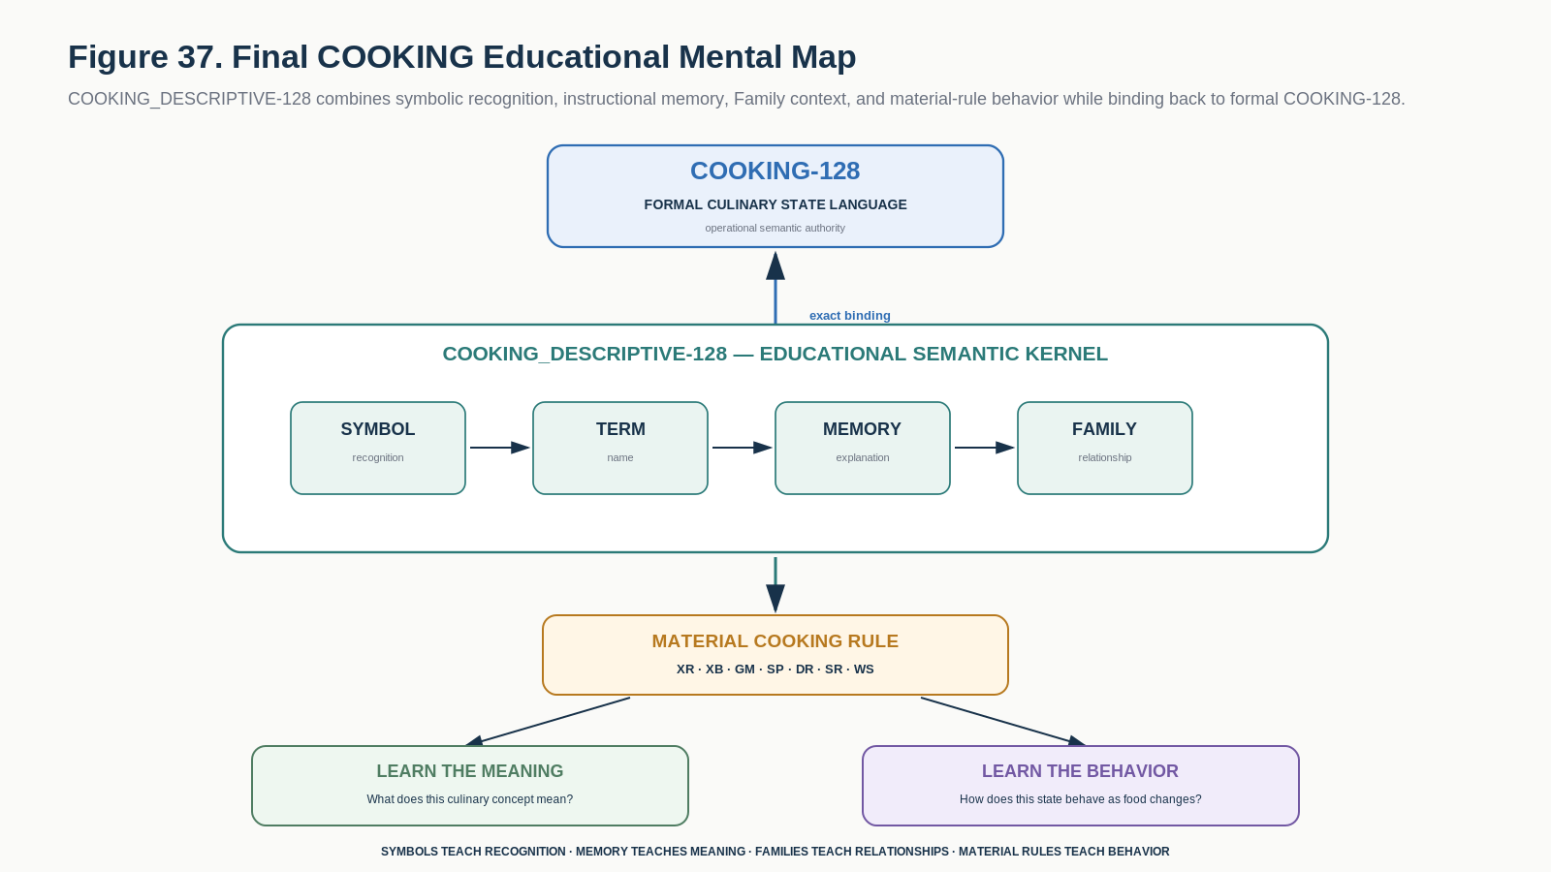
Figure 37. Final mental map: symbols support recognition, memory supports explanation, families support relationships, material rules support behavior, and COOKING-128 preserves formal state.
FORMAL SUMMARY | COOKING_DESCRIPTIVE-128 = 128 stable instructional concept addresses + candidate BOSS symbol projections + five ordered learning-memory layers + A1-H1 Family context + seven Material Cooking Rules + exact one-to-one binding to formal COOKING-128 v0.1.

A conforming educational implementation SHALL let a learner select any B000-B127 concept and deterministically retrieve its symbol, Description, Professional Example, Personal Example, and Instructional State. It SHALL preserve the distinction between educational participation and formal food-state assertion, between method history and material result, between branch and rank, and between visible symbol shape and semantic identity. Study views MAY rearrange or filter the 128 concepts for learning, but they SHALL NOT create new meanings or execute cooking operations.

Part 23 | Glossary and Related Specifications
Term | Definition
Educational Bit | A B000-B127 instructional address whose active state selects a culinary concept for study rather than asserting that state on a food operand.
Cooking Learning Card | Bit-level educational interface containing Symbol, Description, Professional Example, Personal Example, and Instructional State.
Candidate BOSS Projection | Replaceable human-facing symbol assigned to a stable semantic identity.
Family Stem | Recurring mnemonic symbol root used to make related culinary concepts visually recognizable.
Instructional State | Educational explanation of the Material Cooking Rule governing the concept.
Material Cooking Rule | One of XR, XB, GM, SP, DR, SR, or WS; describes how a culinary state fact behaves through continuing preparation.
XR - Exclusive Ranked | At most one active member in a directional causal/refinement family.
XB - Exclusive Branch | At most one active member in an alternative branch family that is not one total order.
GM - Gated Modifier | Modifier meaningful only while a compatible parent state remains meaningful.
SP - Sticky Process | Fact that a process has been applied in the current preparation lineage.
DR - Dynamic Result | Current modeled/observed condition that may later enter or clear.
SR - Sticky Result | Persistent transformation not automatically cleared by reversing the source condition.
WS - Workflow Stage | Current production or service stage rather than material transformation.
Study View | Named selection or projection over the same 128 educational Bits.
Operand | The food or preparation being transformed in instructional figures.
Formal Binding | Exact one-to-one link from the educational concept to the corresponding COOKING-128 formal state identity.

Related Specifications
- COOKING-128 Formal Specification v0.1 - formal operational authority for the 128 culinary states, state types, transition semantics, Operators, Rules, Models, and provenance.
- SOMATIC_STATE-124 Descriptive Semantic Kernel Specification v0.1 - precedent for candidate BOSS symbol morphology, replaceable presentation handles, and descriptive memory over stable Bit identity.
- FORMAL_LOGIC-45 Descriptive Semantic Kernel Specification v0.1 - precedent for descriptive concept selection, symbolic palettes, study projections, and the non-executable educational boundary.

