CERBERUS
AUDIO_EFFECT-64
Candidate Semantic Kernel Specification
Renderer-Neutral Procedural Non-Musical Audio Application
CORE SPECIFICATION STATEMENT
AUDIO_EFFECT-64 defines a bounded procedural Application Semantic Kernel that maps an accepted typed Effect Signal into a renderer-neutral non-musical audio request. It declares the requested audio operation, semantic destination parameter, source Input Range contract, destination Output Range contract, spectral region, spatialization behavior, distance/attenuation behavior, normalized Wet/Dry mix, response/filter shape, semantic audio bus/layer, procedural variation mode, evaluation behavior, Formula Profile, determinism posture, and interpretation version.

Field | Specification
Document | CERBERUS AUDIO_EFFECT-64 Candidate Semantic Kernel Specification
Version | 0.2
Date | August 2026
Series / Member | AUDIO_EFFECT-64 / AUDIO_EFFECT-64¹
Effects Studio Role | AUDIO_EFFECT / Perceptual-View Application
Bounded Question | How does a procedural Signal control non-musical audio presentation?
Output | Renderer-neutral Audio Request
Authoring Basis | CERBERUS SK Specification Authoring Standard v1.0; Effects Studio SK Interoperability Reference v0.1; MASK-32-64 visual precedent
Spec Class | Candidate Spec — Reader topology, Bit allocation, Candidate D requirements, and conformance are fixed; exact registered D#.#, BOSS, COLOR, and Formula Profile identities remain promotion gates.
PROCESS SOUND. PRESERVE SOURCE. KEEP MUSIC SEMANTICS SEPARATE.

Section Index
Ref. | Section
Part 1 | Purpose, scope, ownership, interoperability, and normative laws
Part 2 | Member architecture, mathematical inventory, Range/Formula boundaries, and Reader topology
Part 3 | AUDIO_EFFECT-64¹ Reader-role interface specifications — A1 through O1
Part 4 | Interface-0, Candidate D requirements, complete DARTBOARD, and control-to-Bit trace
Part 5 | Binary encoding, Reader algorithm, typed output, interoperability, and composition
Part 6 | Worked examples, invalid states, conformance, and minimum-resolution gate
Part 7 | Implementation handoff and Candidate-to-Formal promotion gate
Appendices | Complete Reader enumerations, B000:B063 map, D requirements, and conformance checklist
MINIMUM SUFFICIENT RESOLUTION
The current Candidate Spec defines one member: AUDIO_EFFECT-64¹. A later 128² member SHALL be added only if it introduces a coherent new atomic AUDIO capability that cannot be represented by Formula Profile, Application Binding, graph composition, or another specialist SK. Any future extension must preserve B000:B063 literally.

Part 1 — Purpose, Scope, Ownership, and Core Laws

1. Purpose and Bounded Question
AUDIO_EFFECT-64 is the bounded non-musical audio Application word of the Effects Studio. It receives an accepted typed procedural Signal and expresses how that Signal should control renderer-neutral audio presentation. It is deliberately not a waveform file, music datatype, device mixer configuration, or universal DSP implementation.
BOUNDED QUESTION
How does a procedural Signal control non-musical audio presentation?

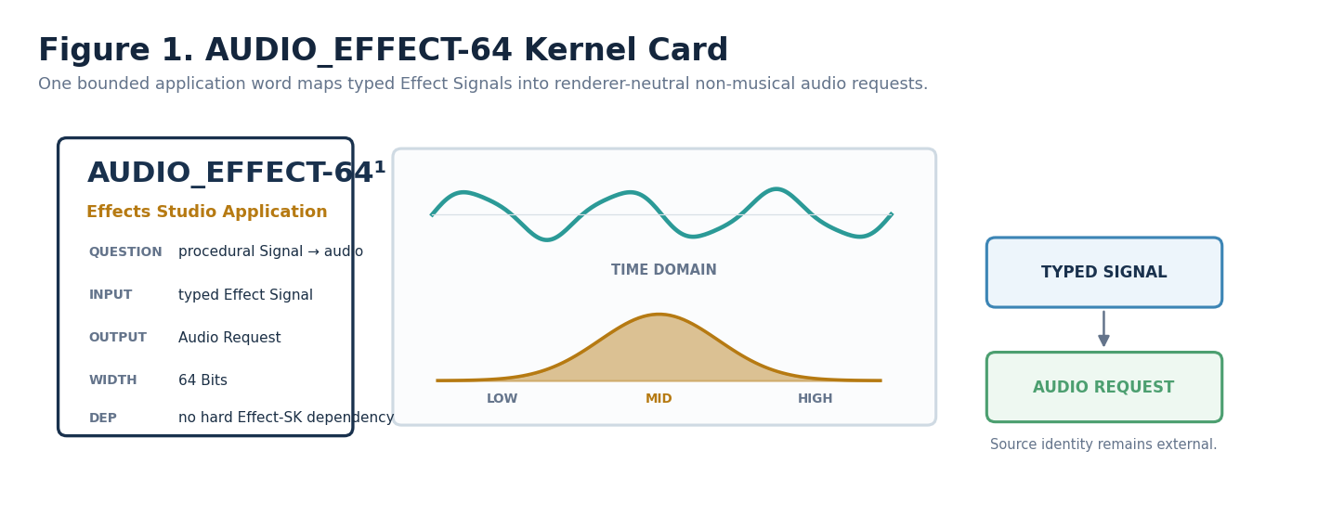
Figure 1. AUDIO_EFFECT-64 kernel card.

2. Source Preservation and Presentation Boundary
AUDIO_EFFECT produces derived presentation requests. Processing MAY alter runtime or preview presentation, but it SHALL NOT silently rewrite the canonical source audio asset, provenance, world state, or external endpoint configuration. Explicit save, promotion, or source-mutation operations remain separately governed.
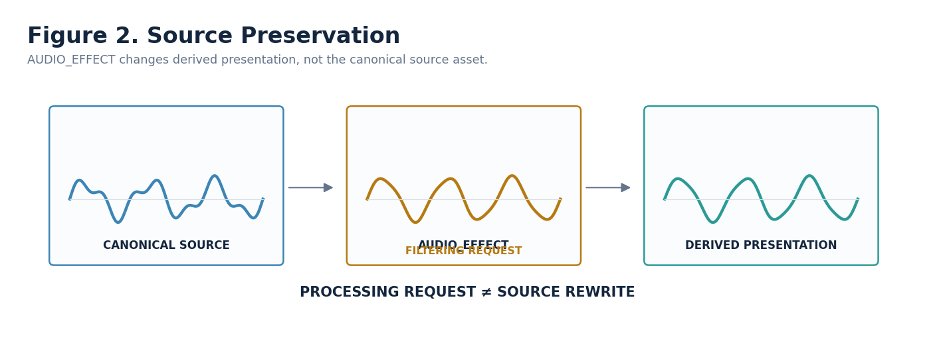
Figure 2. Source audio remains canonical while AUDIO_EFFECT produces a derived presentation request.

3. AUDIO_EFFECT and MUSIC Are Distinct
AUDIO_EFFECT owns non-musical processing and presentation semantics such as gain, filtering, spatialization, delay-like and reverberation-like behavior, distortion, pitch-shift requests, texture modulation, and renderer-neutral parameter control. MUSIC owns musical semantic identity such as notes, intervals, harmony, rhythm, articulation, and musical structure.
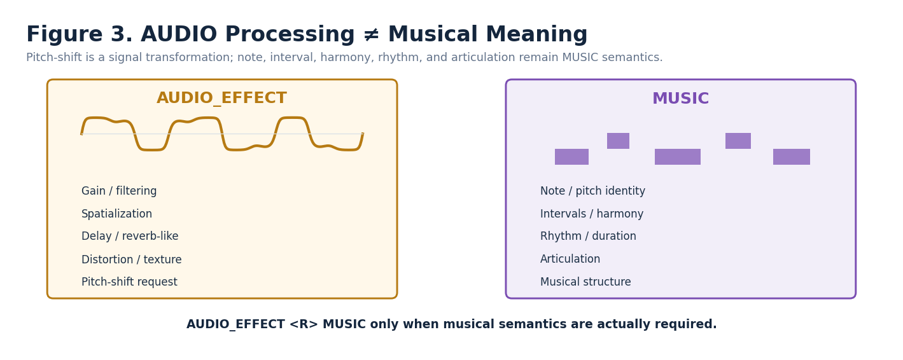
Figure 3. AUDIO processing and musical meaning remain separate semantic contracts.
MUSICAL NON-OWNERSHIP
AUDIO_EFFECT SHALL NOT infer note, interval, chord, rhythm, key, articulation, or other MUSIC semantics from audio parameter values. When actual musical meaning is required, semantic continuation SHALL route to the registered MUSIC contract rather than duplicating that meaning locally.

4. Ownership Firewall
AUDIO_EFFECT owns | AUDIO_EFFECT does NOT own
Non-musical audio-operation semantics | Canonical source recording or waveform identity
Semantic destination parameter | MUSIC note/harmony/rhythm identity
Input and Output Range-contract selection | Speaker, device, listener, or venue identity
Frequency-region scope | Universal physical frequency-band boundaries
Spatialization and attenuation semantics | Canonical world/venue geometry or device routing
Normalized Wet/Dry mix | Global timing and orchestration
Response/filter-shape selection | Renderer-specific DSP algorithm implementation
Semantic bus/layer class | Hard-coded mixer bus or hardware channel
Variation, evaluation, Formula Profile, determinism, version | Endpoint permissions, source mutation, or physical rendering authority

5. Dependencies and Interoperability
AUDIO_EFFECT has no hard dependency on another Effect SK. It accepts typed Effect Signals directly according to this Candidate contract. Optional spatial/domain context may be required by selected Formula Profiles or bindings. Accepting a Signal does not create a constituent dependency on the SK that produced it.
Contract | Candidate AUDIO_EFFECT-64 posture
Accepts directly | Scalar; Signed Scalar; Vector when spatial semantics are declared; Event; Field; Path
Emits | Renderer-neutral Audio Request
Common transformed inputs | Probability, Mask, or Angular only after an explicit compatible transform/profile
<R> | MUSIC when actual musical semantics are required
Compound | Complete AUDIO_EFFECT members may be saved as constituents of larger Effect Assemblies
Runtime graph | Typed producer output → AUDIO_EFFECT input; AUDIO_EFFECT → Application Binding / renderer
External owners | Source identity; global timing; device/venue/listener identity; endpoint calibration; physical mixer routing

6. Normative AUDIO Laws
Law | Normative statement
AUDIO-R01 Bounded Application | AUDIO_EFFECT SHALL describe non-musical audio presentation only and SHALL NOT absorb MUSIC, source-asset, venue, or device ownership because spare states exist.
AUDIO-R02 Source Preservation | Changing AUDIO_EFFECT state SHALL NOT silently mutate canonical source audio or provenance.
AUDIO-R03 Musical Non-Ownership | Pitch-shift and other signal transforms SHALL NOT imply note, interval, chord, or other MUSIC meaning.
AUDIO-R04 Math/Meaning Separation | SCALAR-4 and SCALAR-8 SHALL remain reusable mathematical groups. AUDIO meaning belongs to Reader placements.
AUDIO-R05 Range Separation | C1/D1 SHALL declare semantic Range contracts; universal physical Hz/dB/device ranges SHALL NOT be baked into the base word.
AUDIO-R06 Explicit Formula | M1 SHALL select a registered Formula Profile. The selector Bits SHALL NOT contain hidden DSP equations.
AUDIO-R07 No Silent Coercion | Signal Class conversion SHALL be explicit and inspectable.
AUDIO-R08 Spatial Non-Ownership | F1/G1 SHALL not own source, listener, venue, Frame, or endpoint identity.
AUDIO-R09 Wet/Dry Normalization | H1 SHALL resolve w = H1 / 255. SCALAR-8 itself SHALL NOT globally mean Wet/Dry.
AUDIO-R10 Variation vs Determinism | K1 variation source and N1 replay guarantee SHALL remain distinct.
AUDIO-R11 Local Evaluation | L1 controls local evaluation posture; global start/duration/repetition remain external.
AUDIO-R12 Null Visibility | Missing required source/domain/profile state SHALL produce explicit unresolved/failure behavior defined by the selected Formula Profile; no value is fabricated.
AUDIO-R13 Interface Explicitness | Every canonical Reader role SHALL bind a Candidate D requirement; Formal promotion requires exact registered D#.# for every interactive target.
AUDIO-R14 Minimum Resolution | AUDIO_EFFECT-64¹ is the minimum sufficient member. Future resolution SHALL add coherent capability and preserve the existing prefix.
AUDIO-R15 Rebuildability | The logical interface SHALL be reconstructible from Spec, placements, Reader metadata, exact D/BOSS/COLOR records, Formula Profiles, and state; rendered UI is disposable.

Part 2 — Member Architecture and Mathematical Construction

7. Reusable Scalar Mathematics
AUDIO_EFFECT-64 reuses two generic mathematical BitGroups. Their identities describe only how constituent Bits combine. Domain names such as Filtering, Frequency Region, Environmental Bus, or Wet/Dry belong to Reader placements, not to the mathematical BitGroup records.
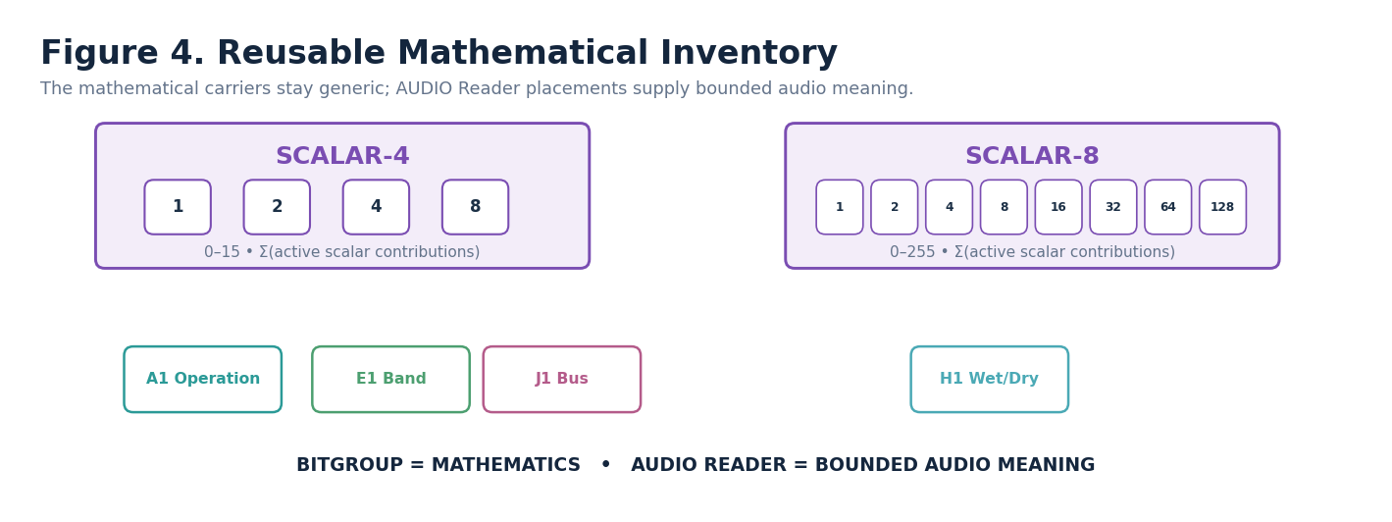
Figure 4. Reusable mathematical inventory.
BitGroup | Width | Formula | Range | Composition posture
SCALAR-4 | 4 | Σ active constituent scalar Bits | 0–15 | Noncontinuing in AUDIO_EFFECT-64¹
SCALAR-8 | 8 | Σ active constituent scalar Bits | 0–255 | Noncontinuing in AUDIO_EFFECT-64¹

8. AUDIO_EFFECT-64¹ Physical Architecture
The complete first member fits exactly into 64 Bits. Fourteen SCALAR-4 placements consume 56 Bits and one SCALAR-8 placement consumes 8 Bits. No padding is required.
Reader | Physical Bits | BitGroup | Reader meaning
A1 | B000:B003 | SCALAR-4 | Audio Operation Class
B1 | B004:B007 | SCALAR-4 | Audio Parameter Target
C1 | B008:B011 | SCALAR-4 | Input Range
D1 | B012:B015 | SCALAR-4 | Output Range
E1 | B016:B019 | SCALAR-4 | Frequency Band / Region
F1 | B020:B023 | SCALAR-4 | Spatialization Mode
G1 | B024:B027 | SCALAR-4 | Distance / Attenuation
H1 | B028:B035 | SCALAR-8 | Mix / Wet-Dry
I1 | B036:B039 | SCALAR-4 | Response / Filter Shape
J1 | B040:B043 | SCALAR-4 | Bus / Layer Class
K1 | B044:B047 | SCALAR-4 | Variation Mode
L1 | B048:B051 | SCALAR-4 | Evaluation Mode
M1 | B052:B055 | SCALAR-4 | Formula Profile
N1 | B056:B059 | SCALAR-4 | Determinism Mode
O1 | B060:B063 | SCALAR-4 | Version / Reserved
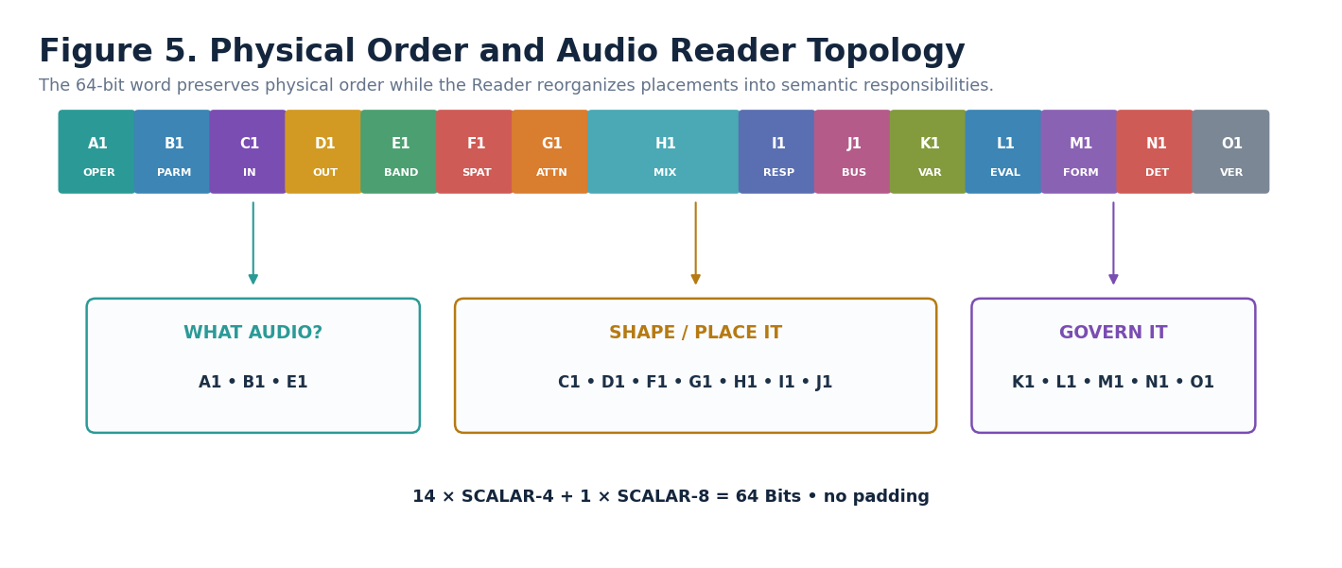
Figure 5. Physical order and semantic Reader topology.
EXACT WIDTH
14 × SCALAR-4 = 56 Bits. 1 × SCALAR-8 = 8 Bits. Total = 64 Bits. AUDIO_EFFECT-64¹ has no reserved padding outside the declared O1 Version/Reserved semantic role.

9. Range Contract Boundary
The source reference requires Input Range and Output Range responsibilities. In this Candidate Spec, those responsibilities are represented as registered Range-contract selectors rather than arbitrary min/max physical values stored directly in the word. This keeps the base SK renderer-neutral while still making source and destination range semantics inspectable.
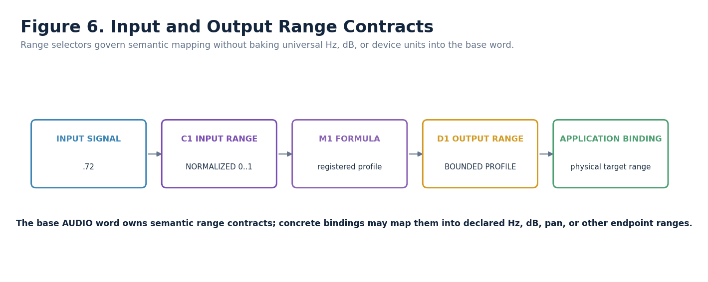
Figure 6. Range contracts keep semantic mapping separate from concrete physical units.

10. Reader / Formula Profile Boundary
M1 selects a governed Formula Profile. That profile owns the exact equation, accepted Signal Classes, required domain fields, units/basis, invalid conditions, output class, determinism notes, and human explanation. The word stores a bounded selection of that profile; it does not embed opaque DSP code.
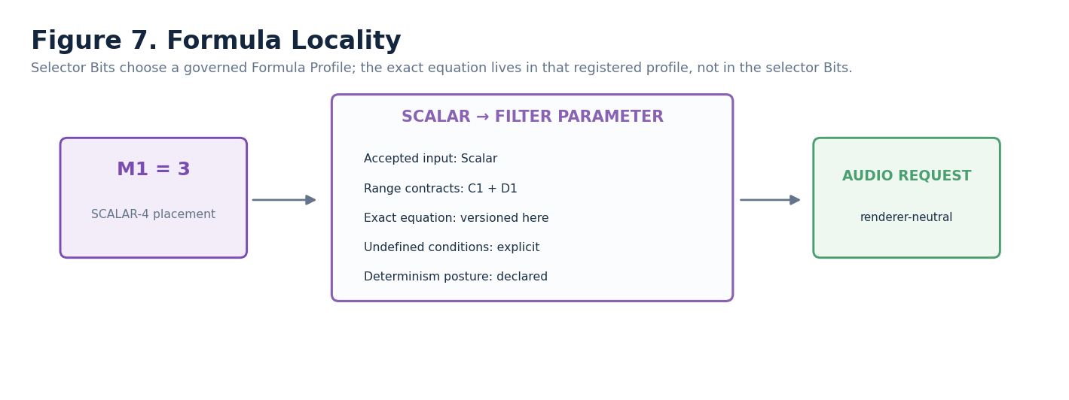
Figure 7. Formula locality and profile-owned equations.

Part 3 — AUDIO_EFFECT-64¹ Reader-Role Interface Specifications
FIGURE CONTRACT
Each semantic Reader role below uses the same visual grammar: declaration strip, real interface control, role-specific consequence viewport, Candidate D Class/requirement, mathematical carrier, zero/unset behavior, validation boundary, and non-ownership. The shell repeats; the semantic diagram does not.

11. Audio Operation Class — A1
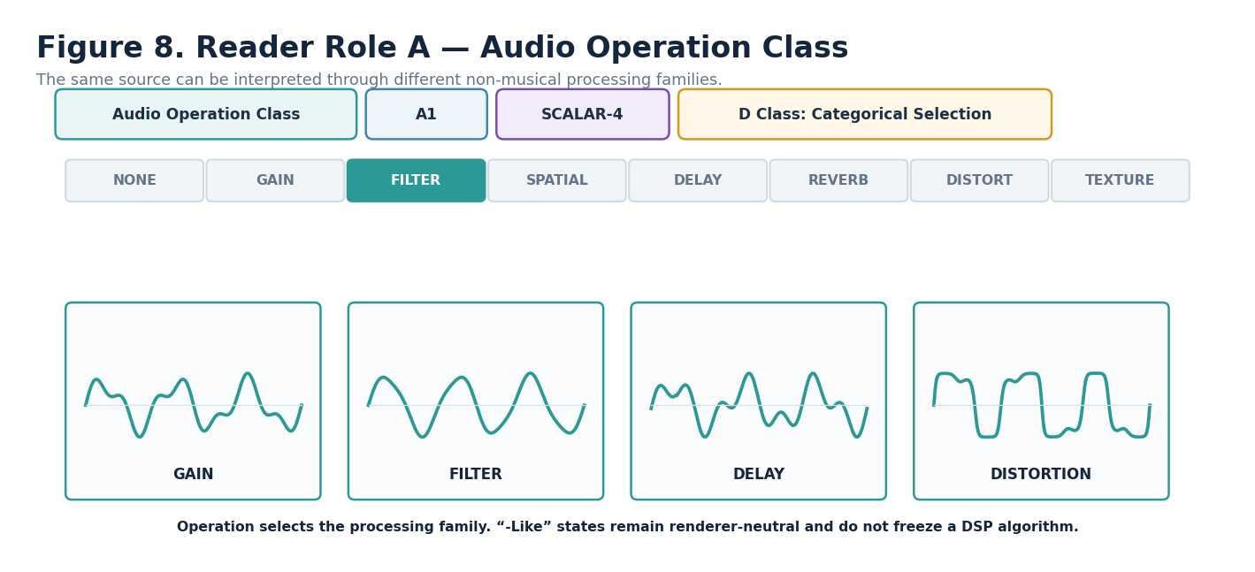
Figure 8. Audio Operation Class — A1.
DECLARATION
Audio Operation Class | A1 | SCALAR-4 | DREQ-CAT.AUDIO_OPERATION
Property | Contract
D Class | Categorical Selection
D Requirement Key | DREQ-CAT.AUDIO_OPERATION
Purpose | Defines the non-musical audio processing family requested by the word.
Representative states | 0 NO_EFFECT/UNSET; 1 GAIN; 2 FILTERING; 3 SPATIALIZATION; 4 DELAY_LIKE; 5 REVERBERATION_LIKE; 6 DISTORTION; 7 TEXTURE_MODULATION; 8–15 RESERVED
Validation / boundary | A1=0 is the safe no-effect state and suppresses AUDIO processing output. “-Like” preserves renderer neutrality.

12. Audio Parameter Target — B1
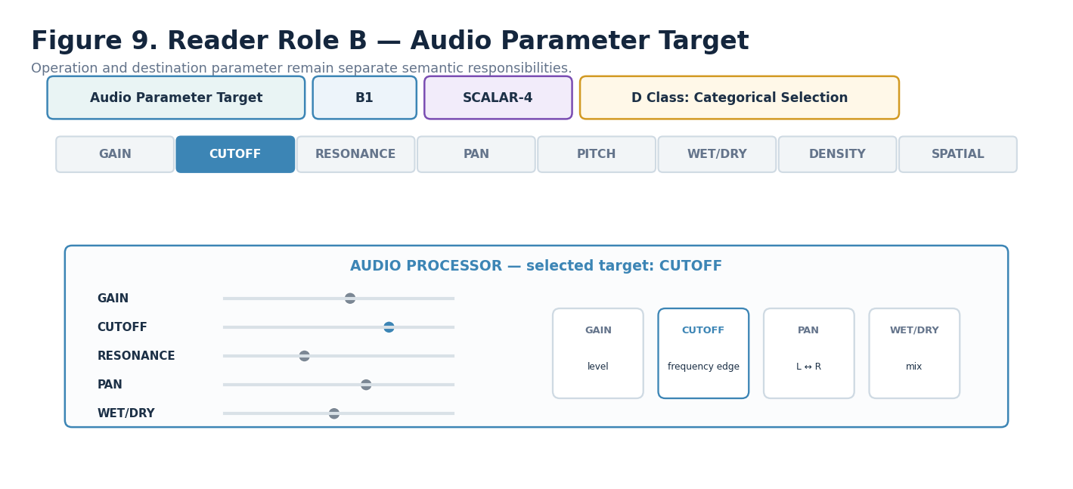
Figure 9. Audio Parameter Target — B1.
DECLARATION
Audio Parameter Target | B1 | SCALAR-4 | DREQ-CAT.AUDIO_PARAMETER
Property | Contract
D Class | Categorical Selection
D Requirement Key | DREQ-CAT.AUDIO_PARAMETER
Purpose | Declares the destination audio quantity affected by the selected operation.
Representative states | 0 FORMULA/BINDING_DEFAULT; 1 GAIN; 2 CUTOFF; 3 RESONANCE; 4 PAN; 5 PITCH_SHIFT; 6 WET_DRY; 7 DENSITY; 8 SPATIAL_PARAMETER; 9–15 RESERVED
Validation / boundary | Operation Class and Parameter Target are distinct. Pitch-shift remains non-musical unless continued to MUSIC.

13. Input Range — C1
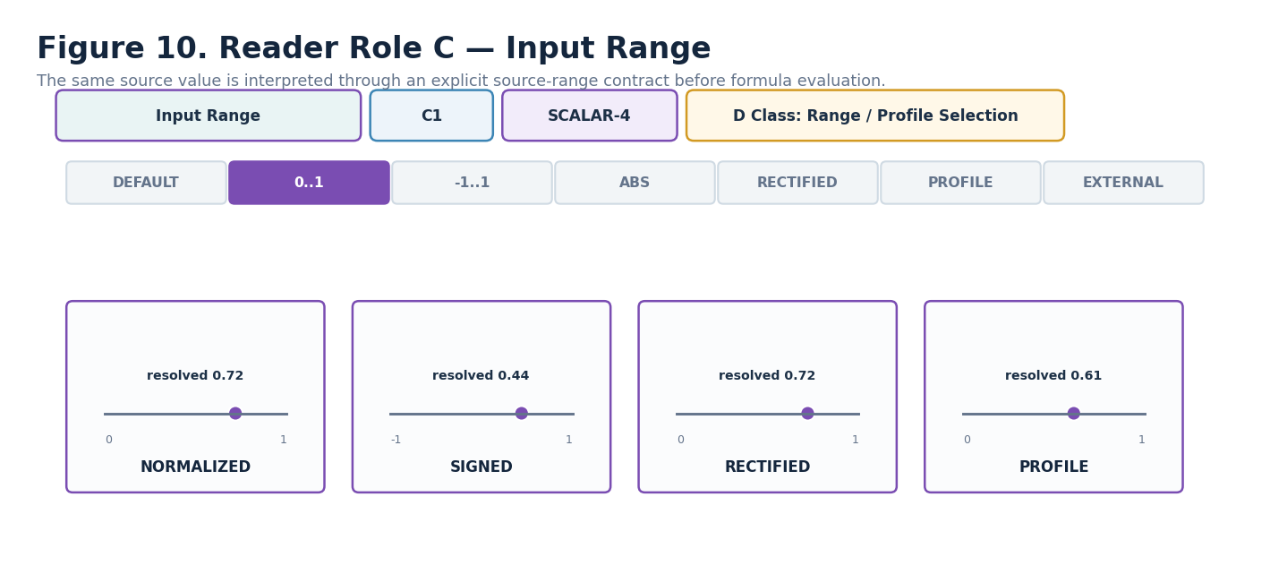
Figure 10. Input Range — C1.
DECLARATION
Input Range | C1 | SCALAR-4 | DREQ-RANGE.INPUT_PROFILE
Property | Contract
D Class | Range / Profile Selection
D Requirement Key | DREQ-RANGE.INPUT_PROFILE
Purpose | Declares how the incoming procedural source interval is interpreted before Formula evaluation.
Representative states | 0 FORMULA_DEFAULT; 1 NORMALIZED_0_1; 2 SIGNED_NEG1_POS1; 3 ABSOLUTE/PASS_THROUGH; 4 RECTIFIED_NORMALIZED; 5 BOUNDED_PROFILE; 6 EXTERNAL_RANGE; 7–15 RESERVED
Validation / boundary | C1 is semantic range interpretation, not raw physical units. Required profile/context missing → explicit Formula Profile failure behavior.

14. Output Range — D1
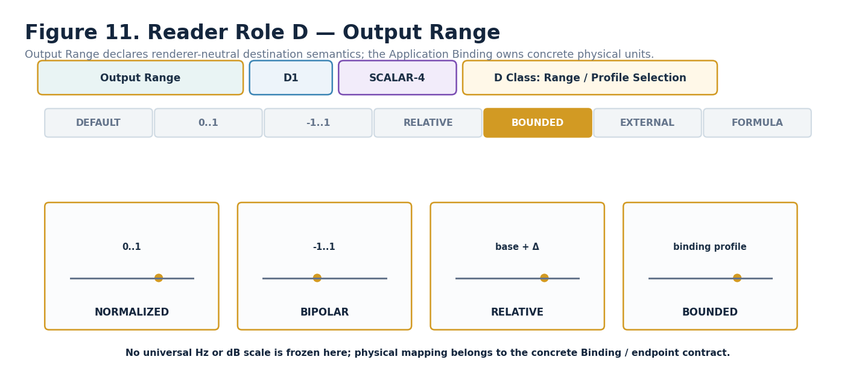
Figure 11. Output Range — D1.
DECLARATION
Output Range | D1 | SCALAR-4 | DREQ-RANGE.OUTPUT_PROFILE
Property | Contract
D Class | Range / Profile Selection
D Requirement Key | DREQ-RANGE.OUTPUT_PROFILE
Purpose | Declares renderer-neutral destination-range semantics for the requested audio parameter.
Representative states | 0 BINDING_DEFAULT; 1 NORMALIZED_0_1; 2 BIPOLAR_NEG1_POS1; 3 RELATIVE_TO_BASELINE; 4 BOUNDED_TARGET_PROFILE; 5 EXTERNAL_RANGE; 6 FORMULA_DEFINED; 7–15 RESERVED
Validation / boundary | Concrete Hz, dB, pan, time, or device ranges belong to binding/profile contracts, not to D1 itself.

15. Frequency Band / Region — E1
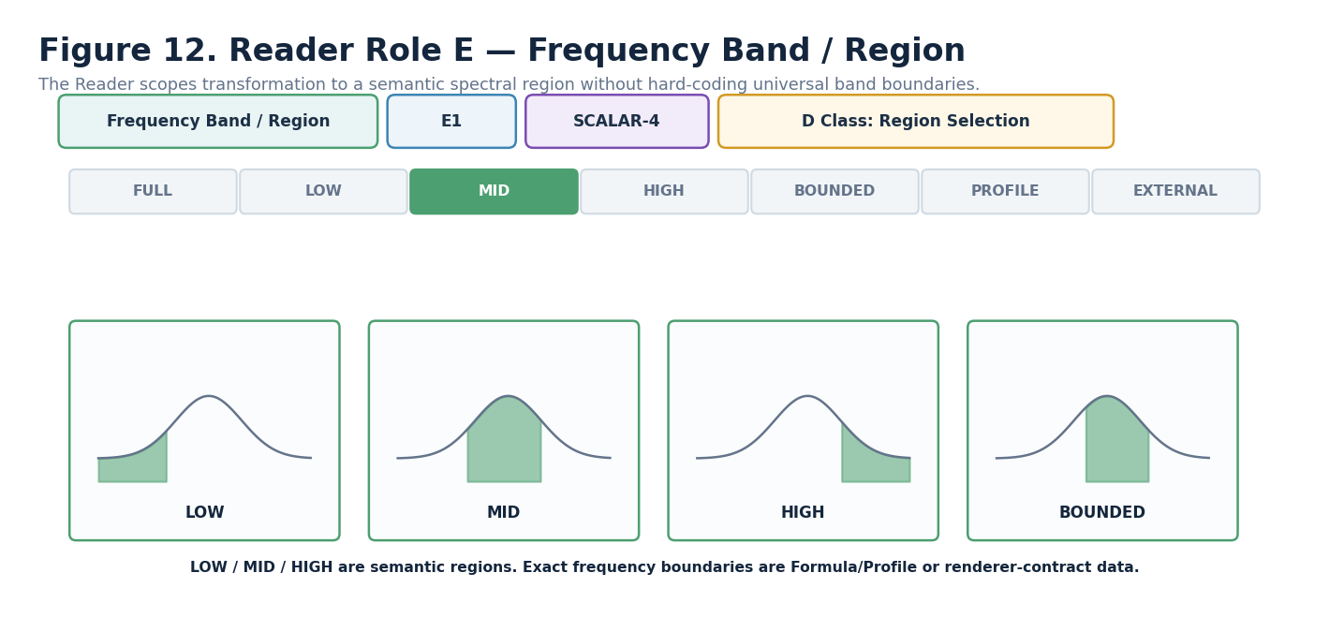
Figure 12. Frequency Band / Region — E1.
DECLARATION
Frequency Band / Region | E1 | SCALAR-4 | DREQ-RANGE.FREQUENCY_REGION
Property | Contract
D Class | Region Selection
D Requirement Key | DREQ-RANGE.FREQUENCY_REGION
Purpose | Scopes the requested audio transformation to a semantic spectral region.
Representative states | 0 FULL_BAND; 1 LOW; 2 MID; 3 HIGH; 4 BOUNDED_RANGE; 5 PROFILE; 6 EXTERNAL; 7–15 RESERVED
Validation / boundary | LOW/MID/HIGH are semantic regions. Exact physical band boundaries require a Formula/Profile or external contract.

16. Spatialization Mode — F1
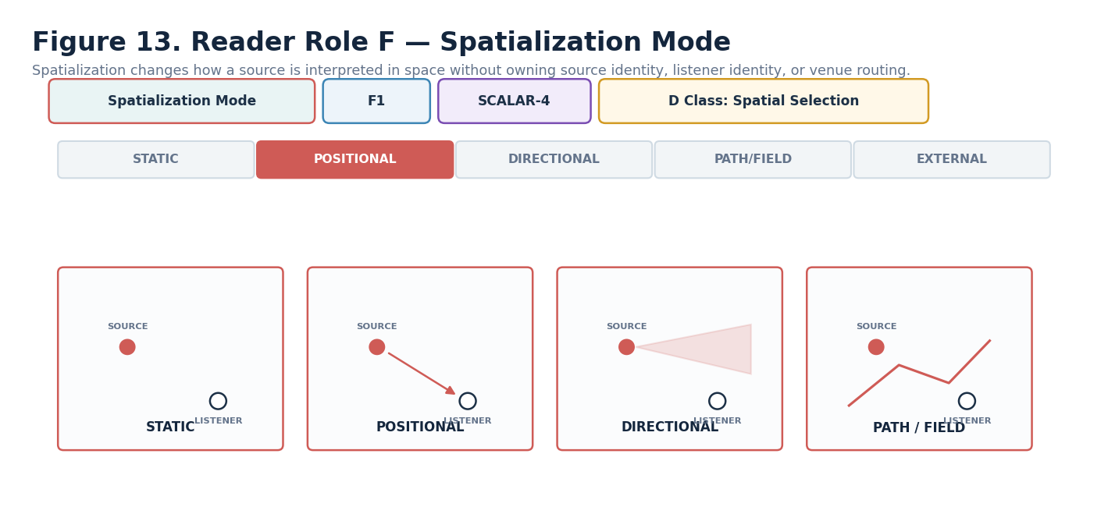
Figure 13. Spatialization Mode — F1.
DECLARATION
Spatialization Mode | F1 | SCALAR-4 | DREQ-SPATIAL.AUDIO_MODE
Property | Contract
D Class | Spatial Selection
D Requirement Key | DREQ-SPATIAL.AUDIO_MODE
Purpose | Declares how the audio request should be interpreted relative to spatial source/listener context.
Representative states | 0 MONO_STATIC; 1 POSITIONAL; 2 DIRECTIONAL; 3 PATH_FIELD_BASED; 4 EXTERNAL; 5–15 RESERVED
Validation / boundary | F1 does not own actual source, listener, venue, Frame, or device-routing identity.

17. Distance / Attenuation — G1
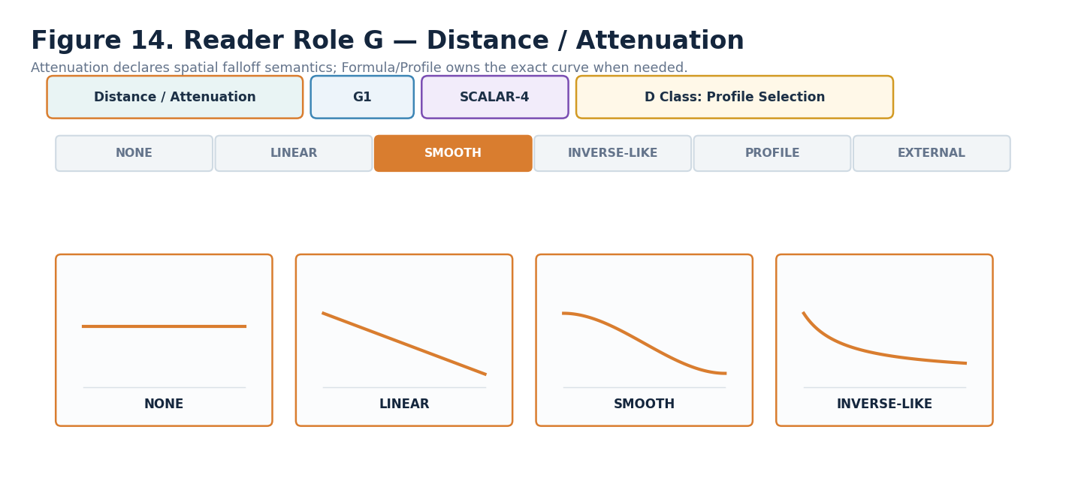
Figure 14. Distance / Attenuation — G1.
DECLARATION
Distance / Attenuation | G1 | SCALAR-4 | DREQ-PROFILE.ATTENUATION
Property | Contract
D Class | Profile Selection
D Requirement Key | DREQ-PROFILE.ATTENUATION
Purpose | Declares semantic spatial falloff behavior for source/listener separation or an equivalent domain metric.
Representative states | 0 NONE/FORMULA_DEFAULT; 1 LINEAR; 2 SMOOTH; 3 INVERSE_LIKE; 4 BOUNDED_PROFILE; 5 EXTERNAL_ATTENUATION; 6 MODEL/FORMULA; 7–15 RESERVED
Validation / boundary | Exact falloff equation is Formula/Profile-owned. No physical acoustics model is silently assumed.

18. Mix / Wet-Dry — H1
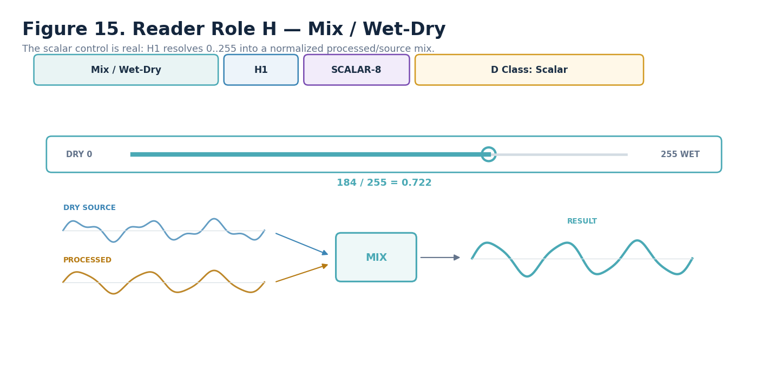
Figure 15. Mix / Wet-Dry — H1.
DECLARATION
Mix / Wet-Dry | H1 | SCALAR-8 | DREQ-SCALAR.SLIDER_NUMERIC
Property | Contract
D Class | Scalar
D Requirement Key | DREQ-SCALAR.SLIDER_NUMERIC
Purpose | Carries normalized processed/source mix as w = H1 / 255.
Representative states | 0 → 0.000 fully dry; 64 → 0.251; 128 → 0.502; 184 → 0.722; 255 → 1.000 fully wet
Validation / boundary | Normalization is AUDIO Reader semantics, not SCALAR-8 identity. Formula Profile may declare H1 not applicable for operations without a meaningful mix.

19. Response / Filter Shape — I1
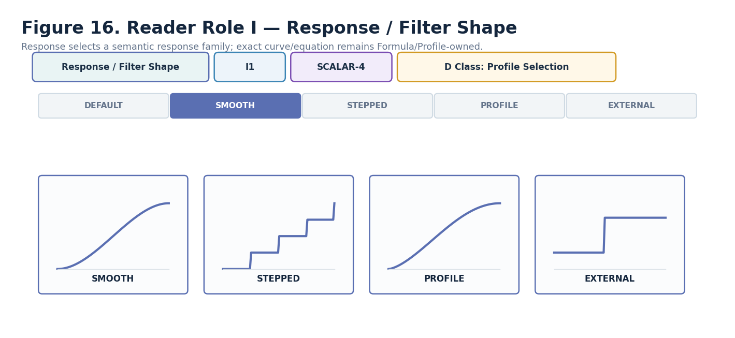
Figure 16. Response / Filter Shape — I1.
DECLARATION
Response / Filter Shape | I1 | SCALAR-4 | DREQ-PROFILE.AUDIO_RESPONSE
Property | Contract
D Class | Profile Selection
D Requirement Key | DREQ-PROFILE.AUDIO_RESPONSE
Purpose | Selects a semantic response family for temporal/frequency control behavior.
Representative states | 0 FORMULA_DEFAULT; 1 SMOOTH; 2 STEPPED; 3 PROFILE/MODEL; 4 EXTERNAL; 5–15 RESERVED
Validation / boundary | I1 does not freeze a DSP filter topology. Exact response mathematics live in the selected Formula/Profile.

20. Bus / Layer Class — J1
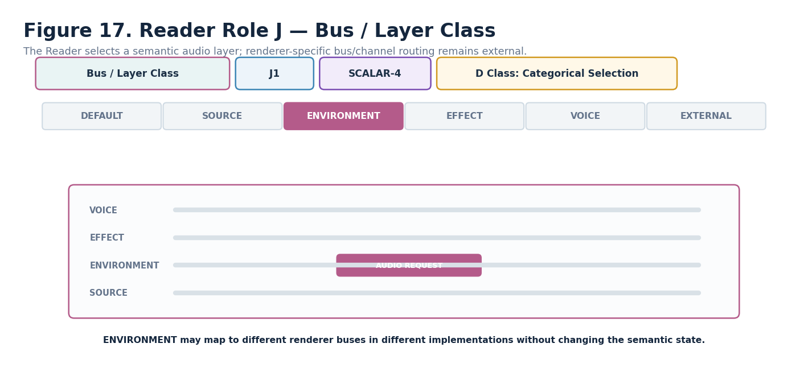
Figure 17. Bus / Layer Class — J1.
DECLARATION
Bus / Layer Class | J1 | SCALAR-4 | DREQ-CAT.AUDIO_LAYER
Property | Contract
D Class | Categorical Selection
D Requirement Key | DREQ-CAT.AUDIO_LAYER
Purpose | Declares the semantic audio layer to which the request belongs.
Representative states | 0 DEFAULT; 1 SOURCE; 2 ENVIRONMENTAL; 3 EFFECT; 4 VOICE; 5 EXTERNAL; 6–15 RESERVED
Validation / boundary | A semantic layer is not a hard-coded mixer bus ID. Renderer mappings may differ while the Reader meaning remains stable.

21. Variation Mode — K1
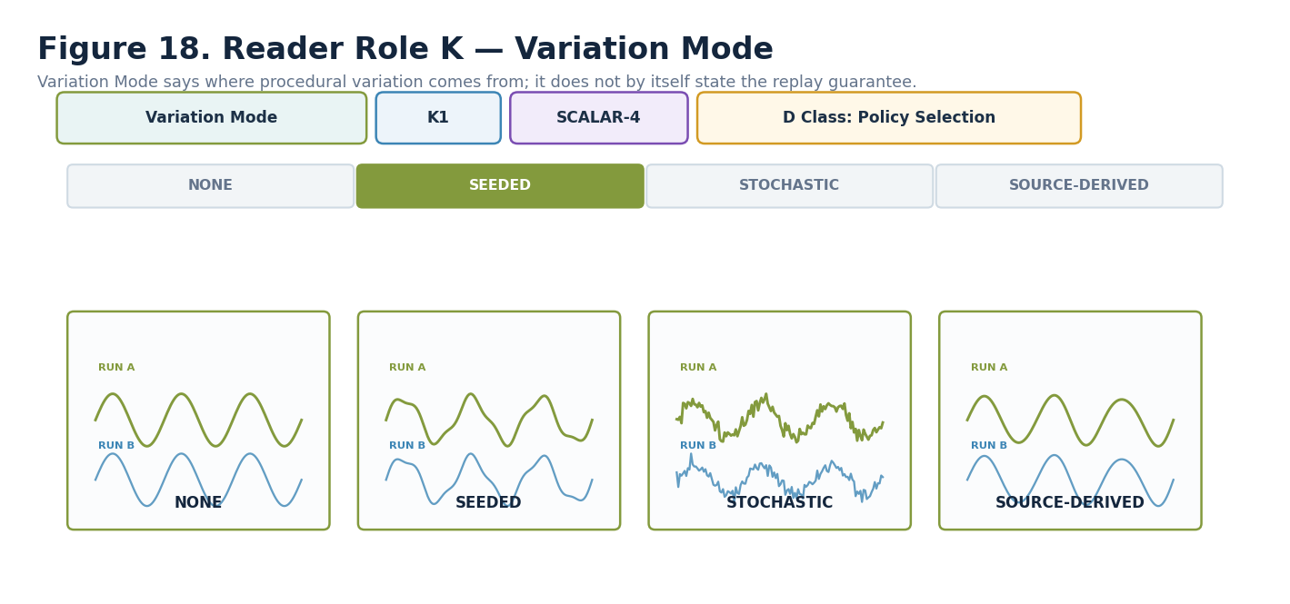
Figure 18. Variation Mode — K1.
DECLARATION
Variation Mode | K1 | SCALAR-4 | DREQ-POLICY.VARIATION
Property | Contract
D Class | Policy Selection
D Requirement Key | DREQ-POLICY.VARIATION
Purpose | Declares where procedural audio variation originates.
Representative states | 0 NONE; 1 SEEDED; 2 STOCHASTIC; 3 SOURCE_DERIVED; 4–15 RESERVED
Validation / boundary | Variation source is separate from N1 replay guarantee. SOURCE_DERIVED may remain fully deterministic.

22. Evaluation Mode — L1
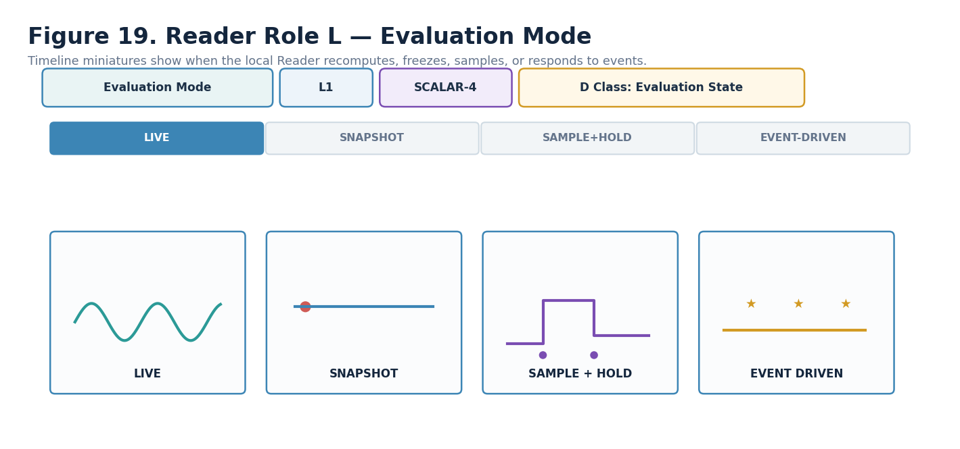
Figure 19. Evaluation Mode — L1.
DECLARATION
Evaluation Mode | L1 | SCALAR-4 | DREQ-EVAL.MODE
Property | Contract
D Class | Evaluation State
D Requirement Key | DREQ-EVAL.MODE
Purpose | Declares when the AUDIO Reader recomputes or holds its local request relative to supplied source/context.
Representative states | 0 LIVE; 1 SNAPSHOT; 2 SAMPLE_AND_HOLD; 3 EVENT_DRIVEN; 4–15 RESERVED
Validation / boundary | Global start, duration, repetition, synchronization, and shared anchors remain externally owned.

23. Formula Profile — M1
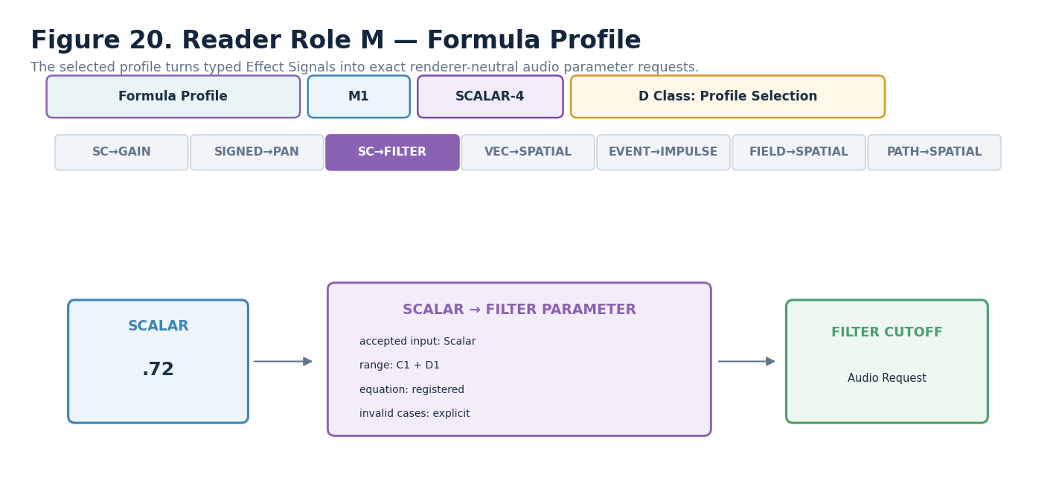
Figure 20. Formula Profile — M1.
DECLARATION
Formula Profile | M1 | SCALAR-4 | DREQ-PROFILE.AUDIO_FORMULA
Property | Contract
D Class | Profile Selection
D Requirement Key | DREQ-PROFILE.AUDIO_FORMULA
Purpose | Selects the registered mathematical interpretation that maps the typed Signal and declared context into the requested audio parameter.
Representative states | 0 UNSET; 1 SCALAR_TO_GAIN; 2 SIGNED_TO_PAN; 3 SCALAR_TO_FILTER_PARAMETER; 4 VECTOR_TO_SPATIALIZATION; 5 EVENT_TO_AUDIO_IMPULSE; 6 FIELD_TO_SPATIAL_PARAMETER; 7 PATH_TO_SPATIALIZATION; 8 SCALAR_TO_PITCH_SHIFT_REQUEST; 9 SCALAR_TO_TEXTURE_DENSITY; 10 EXTERNAL_AUDIO_FORMULA; 11–15 RESERVED
Validation / boundary | These are Candidate profile semantics. Formal implementation requires exact registered Formula Profile identities/versions.

24. Determinism Mode — N1
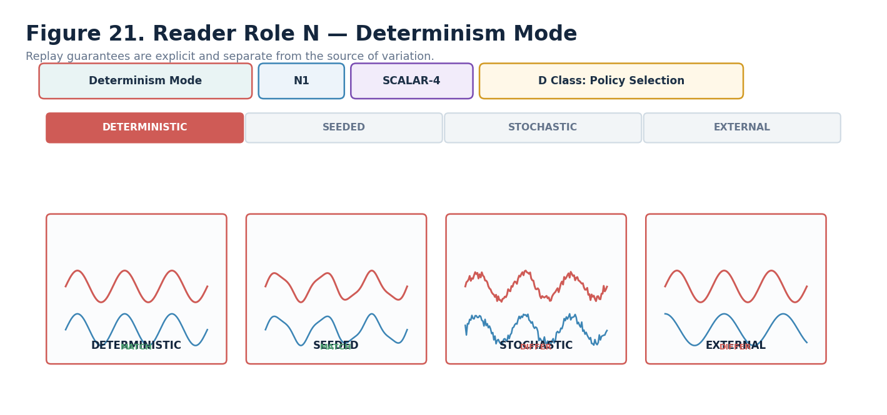
Figure 21. Determinism Mode — N1.
DECLARATION
Determinism Mode | N1 | SCALAR-4 | DREQ-POLICY.DETERMINISM
Property | Contract
D Class | Policy Selection
D Requirement Key | DREQ-POLICY.DETERMINISM
Purpose | Declares the replay/determinism posture of the AUDIO request evaluation.
Representative states | 0 DETERMINISTIC; 1 SEEDED_DETERMINISTIC; 2 RUNTIME_STOCHASTIC; 3 EXTERNALLY_DRIVEN; 4–15 RESERVED
Validation / boundary | Runtime stochastic output SHALL NOT promise exact replay. Seeded deterministic output must resolve the same semantic inputs + seed reproducibly.

25. Interpretation Version — O1
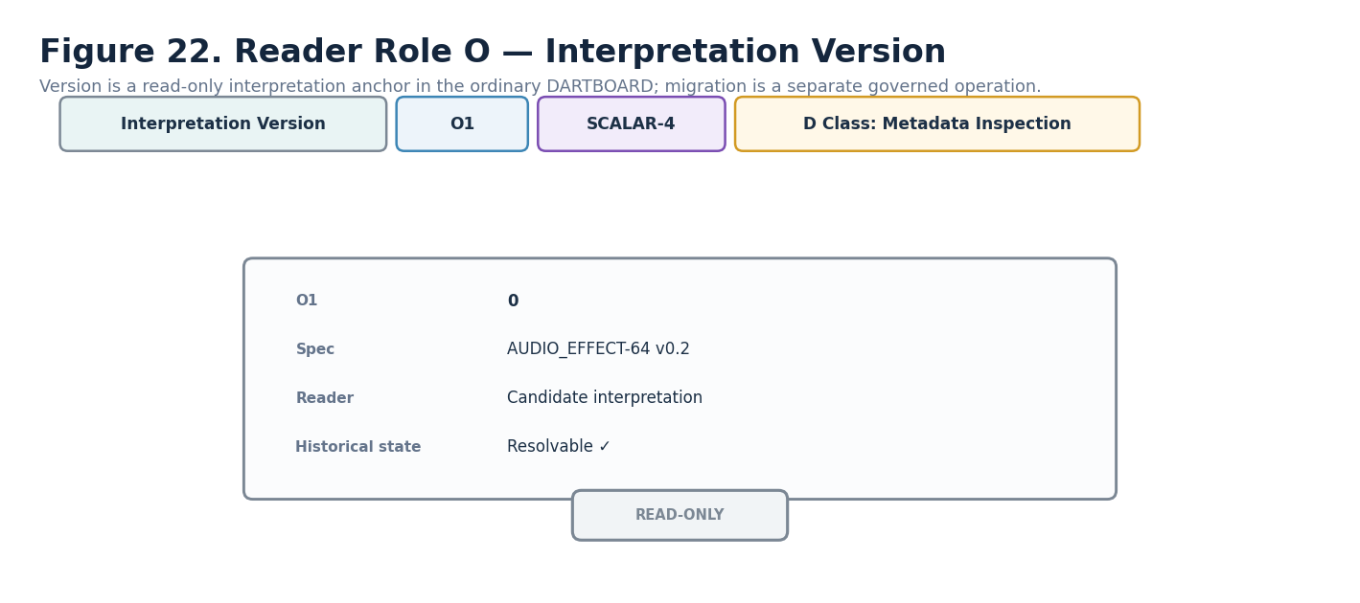
Figure 22. Interpretation Version — O1.
DECLARATION
Interpretation Version | O1 | SCALAR-4 | DREQ-META.VERSION_INSPECT
Property | Contract
D Class | Metadata Inspection
D Requirement Key | DREQ-META.VERSION_INSPECT
Purpose | Pins the interpretation/version state required to preserve historical Reader meaning and replay.
Representative states | 0 CURRENT_BASE_INTERPRETATION; 1–15 REGISTERED/RESERVED according to future version governance
Validation / boundary | O1 is read-only in the ordinary DARTBOARD. Migration or reinterpretation is a separate governed operation; version changes are not casual UI edits.

Part 4 — Interface-0, D Requirements, and Generated DARTBOARD

26. Candidate D Requirement Index
Reader | Semantic role | Candidate D Class | Candidate D requirement
A1 | Audio Operation Class | Categorical Selection | DREQ-CAT.AUDIO_OPERATION
B1 | Audio Parameter Target | Categorical Selection | DREQ-CAT.AUDIO_PARAMETER
C1 | Input Range | Range / Profile Selection | DREQ-RANGE.INPUT_PROFILE
D1 | Output Range | Range / Profile Selection | DREQ-RANGE.OUTPUT_PROFILE
E1 | Frequency Band / Region | Region Selection | DREQ-RANGE.FREQUENCY_REGION
F1 | Spatialization Mode | Spatial Selection | DREQ-SPATIAL.AUDIO_MODE
G1 | Distance / Attenuation | Profile Selection | DREQ-PROFILE.ATTENUATION
H1 | Mix / Wet-Dry | Scalar | DREQ-SCALAR.SLIDER_NUMERIC
I1 | Response / Filter Shape | Profile Selection | DREQ-PROFILE.AUDIO_RESPONSE
J1 | Bus / Layer Class | Categorical Selection | DREQ-CAT.AUDIO_LAYER
K1 | Variation Mode | Policy Selection | DREQ-POLICY.VARIATION
L1 | Evaluation Mode | Evaluation State | DREQ-EVAL.MODE
M1 | Formula Profile | Profile Selection | DREQ-PROFILE.AUDIO_FORMULA
N1 | Determinism Mode | Policy Selection | DREQ-POLICY.DETERMINISM
O1 | Interpretation Version | Metadata Inspection | DREQ-META.VERSION_INSPECT
CANDIDATE STATUS
These are authored D requirements, not exact registered D#.# contracts. Promotion to Formal status requires exact reusable D records to be selected or registered and bound to every canonical/default interactive Reader target. O1 remains read-only metadata inspection.

27. Interface-0 Composition
Interface-0 assembles declared metadata rather than inferring behavior. A supplies the symbol, B the Reader/interface name, C the interface color/treatment, and D the exact interaction contract. H1 Wet/Dry is shown as the concrete AUDIO example.
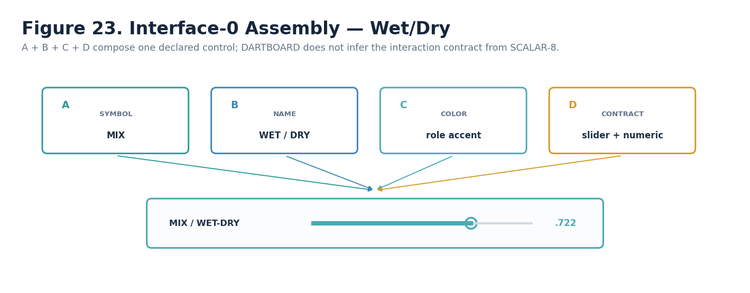
Figure 23. Interface-0 composition for Wet/Dry.

28. Complete AUDIO_EFFECT-64¹ Interface
The full generated surface assembles the declared Reader controls in semantic order. A coherent assembled surface is a design-validation test: if the individual roles cannot form one understandable panel, the Spec is not yet ready for implementation.
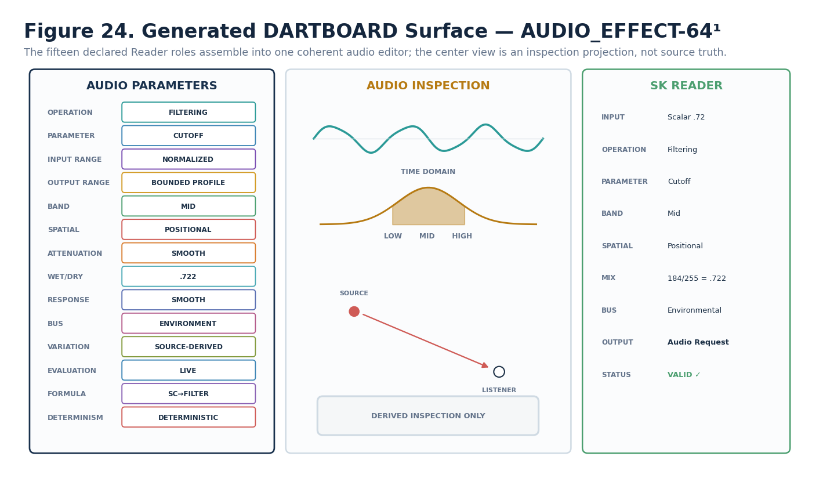
Figure 24. Generated DARTBOARD surface for AUDIO_EFFECT-64¹.

29. One Control to Exact Bits
Interface reconstruction remains reversible. The semantic H1 control resolves through the Reader to SCALAR-8 and physical Bits B028:B035. A runtime can therefore inspect, write, reread, and validate the same target without storing a rendered widget as canonical state.
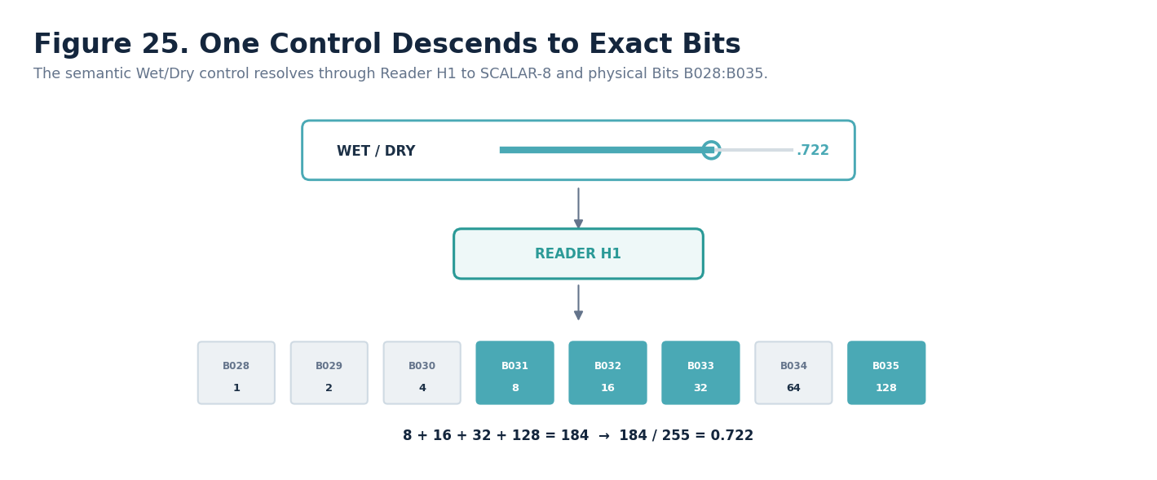
Figure 25. Wet/Dry control descends through Reader H1 to exact physical Bits.

Part 5 — Binary Encoding, Reader Contract, and Interoperability

30. Complete Physical Bit Layout
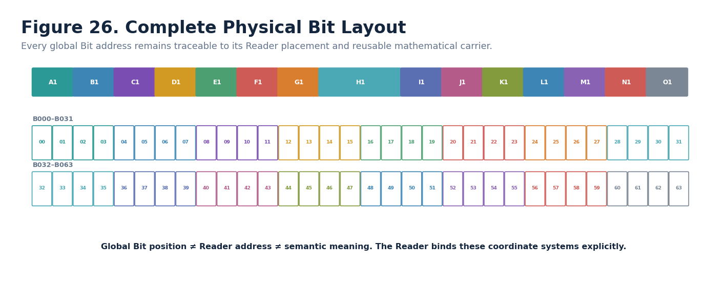
Figure 26. Complete B000:B063 physical layout.
Global Bit | Reader | BitGroup | Local Bit | Contribution | Reader interpretation | Validity
B000 | A1 | SCALAR-4 | 0 | 1 | Audio Operation Class | Reserved enum combinations governed by Reader
B001 | A1 | SCALAR-4 | 1 | 2 | Audio Operation Class | Reserved enum combinations governed by Reader
B002 | A1 | SCALAR-4 | 2 | 4 | Audio Operation Class | Reserved enum combinations governed by Reader
B003 | A1 | SCALAR-4 | 3 | 8 | Audio Operation Class | Reserved enum combinations governed by Reader
B004 | B1 | SCALAR-4 | 0 | 1 | Audio Parameter Target | Reserved enum combinations governed by Reader
B005 | B1 | SCALAR-4 | 1 | 2 | Audio Parameter Target | Reserved enum combinations governed by Reader
B006 | B1 | SCALAR-4 | 2 | 4 | Audio Parameter Target | Reserved enum combinations governed by Reader
B007 | B1 | SCALAR-4 | 3 | 8 | Audio Parameter Target | Reserved enum combinations governed by Reader
B008 | C1 | SCALAR-4 | 0 | 1 | Input Range | Reserved enum combinations governed by Reader
B009 | C1 | SCALAR-4 | 1 | 2 | Input Range | Reserved enum combinations governed by Reader
B010 | C1 | SCALAR-4 | 2 | 4 | Input Range | Reserved enum combinations governed by Reader
B011 | C1 | SCALAR-4 | 3 | 8 | Input Range | Reserved enum combinations governed by Reader
B012 | D1 | SCALAR-4 | 0 | 1 | Output Range | Reserved enum combinations governed by Reader
B013 | D1 | SCALAR-4 | 1 | 2 | Output Range | Reserved enum combinations governed by Reader
B014 | D1 | SCALAR-4 | 2 | 4 | Output Range | Reserved enum combinations governed by Reader
B015 | D1 | SCALAR-4 | 3 | 8 | Output Range | Reserved enum combinations governed by Reader
B016 | E1 | SCALAR-4 | 0 | 1 | Frequency Band / Region | Reserved enum combinations governed by Reader
B017 | E1 | SCALAR-4 | 1 | 2 | Frequency Band / Region | Reserved enum combinations governed by Reader
B018 | E1 | SCALAR-4 | 2 | 4 | Frequency Band / Region | Reserved enum combinations governed by Reader
B019 | E1 | SCALAR-4 | 3 | 8 | Frequency Band / Region | Reserved enum combinations governed by Reader
B020 | F1 | SCALAR-4 | 0 | 1 | Spatialization Mode | Reserved enum combinations governed by Reader
B021 | F1 | SCALAR-4 | 1 | 2 | Spatialization Mode | Reserved enum combinations governed by Reader
B022 | F1 | SCALAR-4 | 2 | 4 | Spatialization Mode | Reserved enum combinations governed by Reader
B023 | F1 | SCALAR-4 | 3 | 8 | Spatialization Mode | Reserved enum combinations governed by Reader
B024 | G1 | SCALAR-4 | 0 | 1 | Distance / Attenuation | Reserved enum combinations governed by Reader
B025 | G1 | SCALAR-4 | 1 | 2 | Distance / Attenuation | Reserved enum combinations governed by Reader
B026 | G1 | SCALAR-4 | 2 | 4 | Distance / Attenuation | Reserved enum combinations governed by Reader
B027 | G1 | SCALAR-4 | 3 | 8 | Distance / Attenuation | Reserved enum combinations governed by Reader
B028 | H1 | SCALAR-8 | 0 | 1 | Mix / Wet-Dry | Reserved enum combinations governed by Reader
B029 | H1 | SCALAR-8 | 1 | 2 | Mix / Wet-Dry | Reserved enum combinations governed by Reader
B030 | H1 | SCALAR-8 | 2 | 4 | Mix / Wet-Dry | Reserved enum combinations governed by Reader
B031 | H1 | SCALAR-8 | 3 | 8 | Mix / Wet-Dry | Reserved enum combinations governed by Reader
B032 | H1 | SCALAR-8 | 4 | 16 | Mix / Wet-Dry | Reserved enum combinations governed by Reader
B033 | H1 | SCALAR-8 | 5 | 32 | Mix / Wet-Dry | Reserved enum combinations governed by Reader
B034 | H1 | SCALAR-8 | 6 | 64 | Mix / Wet-Dry | Reserved enum combinations governed by Reader
B035 | H1 | SCALAR-8 | 7 | 128 | Mix / Wet-Dry | Reserved enum combinations governed by Reader
B036 | I1 | SCALAR-4 | 0 | 1 | Response / Filter Shape | Reserved enum combinations governed by Reader
B037 | I1 | SCALAR-4 | 1 | 2 | Response / Filter Shape | Reserved enum combinations governed by Reader
B038 | I1 | SCALAR-4 | 2 | 4 | Response / Filter Shape | Reserved enum combinations governed by Reader
B039 | I1 | SCALAR-4 | 3 | 8 | Response / Filter Shape | Reserved enum combinations governed by Reader
B040 | J1 | SCALAR-4 | 0 | 1 | Bus / Layer Class | Reserved enum combinations governed by Reader
B041 | J1 | SCALAR-4 | 1 | 2 | Bus / Layer Class | Reserved enum combinations governed by Reader
B042 | J1 | SCALAR-4 | 2 | 4 | Bus / Layer Class | Reserved enum combinations governed by Reader
B043 | J1 | SCALAR-4 | 3 | 8 | Bus / Layer Class | Reserved enum combinations governed by Reader
B044 | K1 | SCALAR-4 | 0 | 1 | Variation Mode | Reserved enum combinations governed by Reader
B045 | K1 | SCALAR-4 | 1 | 2 | Variation Mode | Reserved enum combinations governed by Reader
B046 | K1 | SCALAR-4 | 2 | 4 | Variation Mode | Reserved enum combinations governed by Reader
B047 | K1 | SCALAR-4 | 3 | 8 | Variation Mode | Reserved enum combinations governed by Reader
B048 | L1 | SCALAR-4 | 0 | 1 | Evaluation Mode | Reserved enum combinations governed by Reader
B049 | L1 | SCALAR-4 | 1 | 2 | Evaluation Mode | Reserved enum combinations governed by Reader
B050 | L1 | SCALAR-4 | 2 | 4 | Evaluation Mode | Reserved enum combinations governed by Reader
B051 | L1 | SCALAR-4 | 3 | 8 | Evaluation Mode | Reserved enum combinations governed by Reader
B052 | M1 | SCALAR-4 | 0 | 1 | Formula Profile | Reserved enum combinations governed by Reader
B053 | M1 | SCALAR-4 | 1 | 2 | Formula Profile | Reserved enum combinations governed by Reader
B054 | M1 | SCALAR-4 | 2 | 4 | Formula Profile | Reserved enum combinations governed by Reader
B055 | M1 | SCALAR-4 | 3 | 8 | Formula Profile | Reserved enum combinations governed by Reader
B056 | N1 | SCALAR-4 | 0 | 1 | Determinism Mode | Reserved enum combinations governed by Reader
B057 | N1 | SCALAR-4 | 1 | 2 | Determinism Mode | Reserved enum combinations governed by Reader
B058 | N1 | SCALAR-4 | 2 | 4 | Determinism Mode | Reserved enum combinations governed by Reader
B059 | N1 | SCALAR-4 | 3 | 8 | Determinism Mode | Reserved enum combinations governed by Reader
B060 | O1 | SCALAR-4 | 0 | 1 | Version / Reserved | Reserved enum combinations governed by Reader
B061 | O1 | SCALAR-4 | 1 | 2 | Version / Reserved | Reserved enum combinations governed by Reader
B062 | O1 | SCALAR-4 | 2 | 4 | Version / Reserved | Reserved enum combinations governed by Reader
B063 | O1 | SCALAR-4 | 3 | 8 | Version / Reserved | Reserved enum combinations governed by Reader

31. Reader / Formula Contract
The mathematical BitGroup Formula resolves each placement value. The AUDIO Reader then assigns bounded semantics, validates cross-role conditions, invokes the selected Formula Profile, applies Range/Profile declarations, and emits a typed renderer-neutral Audio Request. DARTBOARD consumes these resolved targets; it does not independently reinterpret Bits.
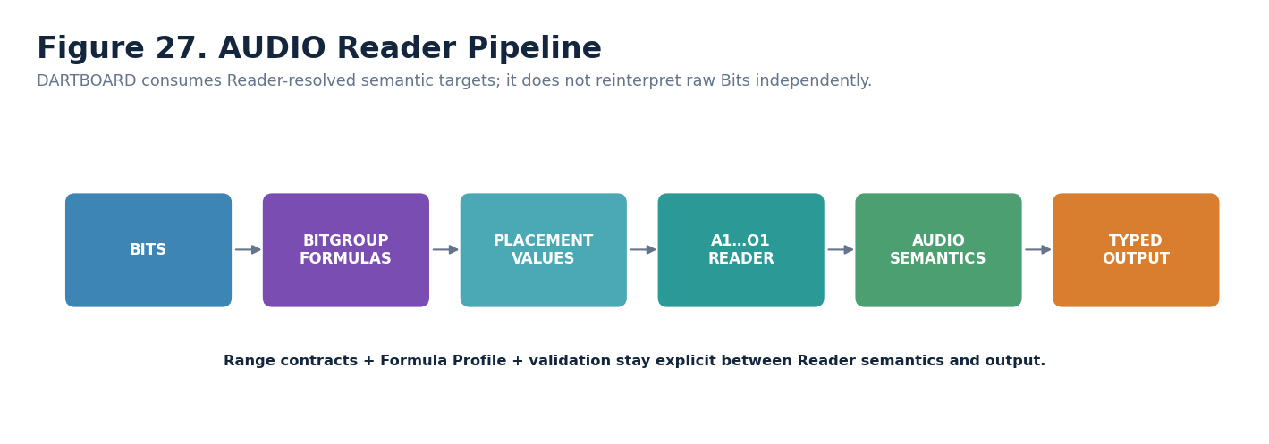
Figure 27. AUDIO Reader pipeline.
Reader requirement | AUDIO_EFFECT-64 Candidate contract
Formula sources | SCALAR-4 and SCALAR-8 mathematical formulas plus exact registered Formula Profile at implementation
Lane composition | No multi-placement numeric continuation in 64¹; each Reader role is one placement
Semantic roles | A1–O1 as enumerated in Part 3
Output | Renderer-neutral Audio Request with validity, provenance, Reader version, and external binding context
Null / failure | Formula Profile MUST declare behavior for missing/invalid source/domain/profile state; default Candidate posture is UNRESOLVED / NO AUDIO REQUEST
Determinism | N1 explicit posture; stochastic execution cannot claim deterministic replay
Human explanation | DARTBOARD Reader panel exposes concise resolved values and why a request is valid or unresolved

32. Interoperability Card
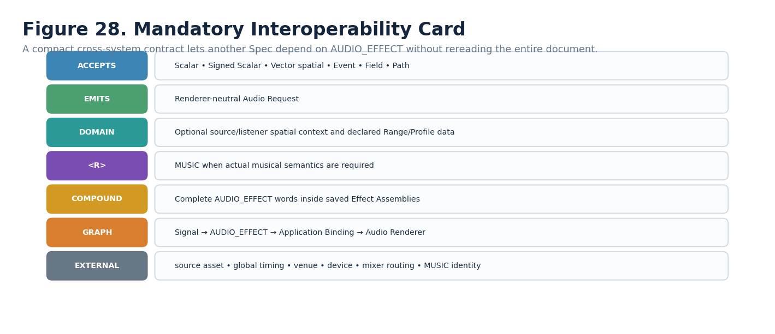
Figure 28. Mandatory AUDIO_EFFECT interoperability card.

33. <R>, Compound, and Runtime Graph Remain Distinct
AUDIO_EFFECT may continue semantically to MUSIC through <R> when musical meaning is requested. Complete AUDIO_EFFECT words may also be members of a Compound Effect Assembly. Runtime graph edges determine execution flow between instantiated producers/consumers. These grammars SHALL NOT be collapsed.

34. Composition Beats Width
A sophisticated audio chain can be constructed from several complete AUDIO_EFFECT-64¹ words with explicit graph order. This preserves bounded questions and local inspectability rather than forcing unrelated DSP parameters into one oversized state word.
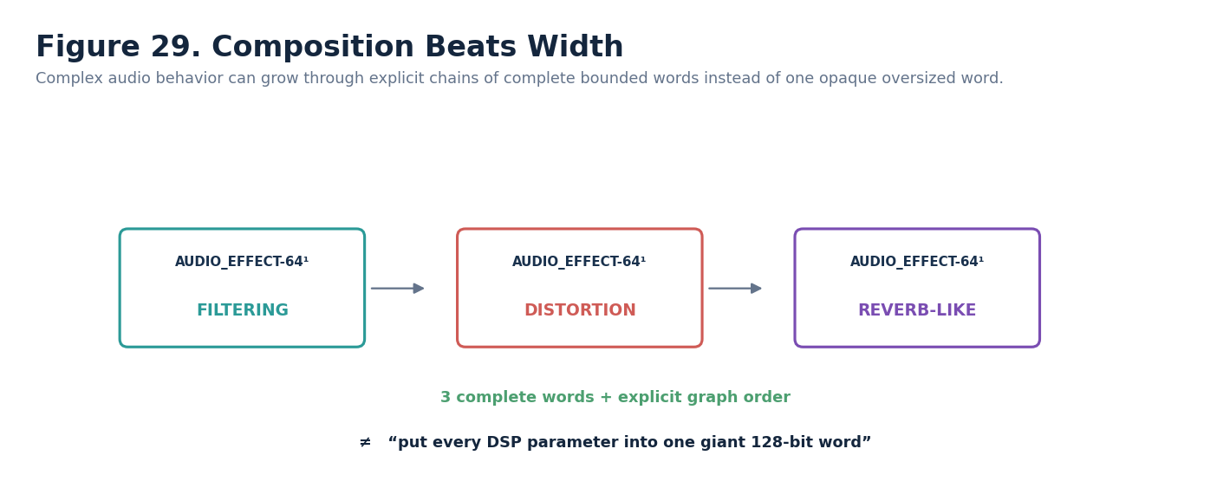
Figure 29. Complex audio behavior grows through composition of complete bounded words.

Part 6 — Worked Examples, Invalid States, and Conformance

35. Worked Example Set
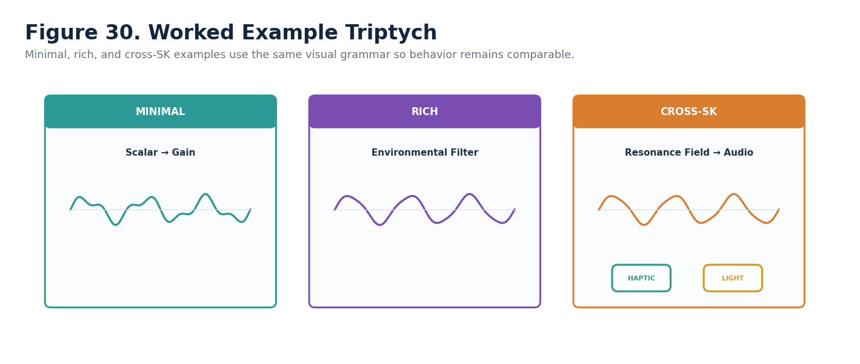
Figure 30. Minimal, rich, and cross-SK worked example set.
Example | Representative state | Resolved consequence
Minimal | Scalar .65 → A1 GAIN; B1 GAIN; C1 NORMALIZED; D1 BOUNDED_PROFILE; H1 255; L1 LIVE; M1 SCALAR_TO_GAIN; N1 DETERMINISTIC | Renderer-neutral gain request; source identity unchanged
Rich | Environmental filtering with B1 CUTOFF; E1 MID; F1 POSITIONAL; G1 SMOOTH; H1 184; I1 SMOOTH; J1 ENVIRONMENTAL; K1 SOURCE_DERIVED | Bounded positional environmental-filter request with .722 processed mix
Cross-SK | Resonance Field feeds AUDIO_EFFECT plus HAPTIC_EFFECT/LIGHT_EFFECT through separate graph edges | One upstream provenance chain; each specialist retains its own semantics and renderer-neutral output

36. Invalid / Unresolved Example
A positional/spatial Formula Profile that requires source coordinates is invalid when the Application Binding/domain does not provide them. The correct result is explicit unresolved state, not an assumed origin.
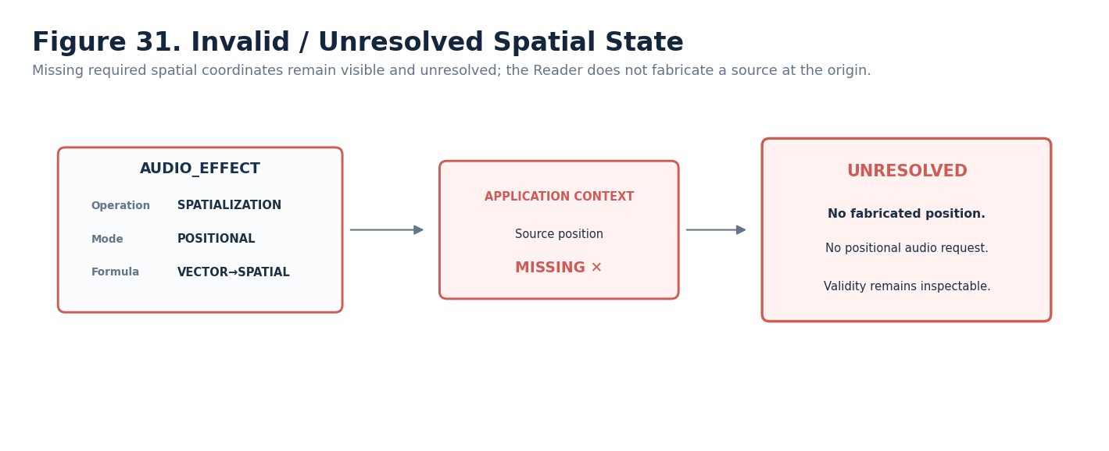
Figure 31. Missing spatial context produces a visible unresolved state.

37. AUDIO → MUSIC Continuation Example
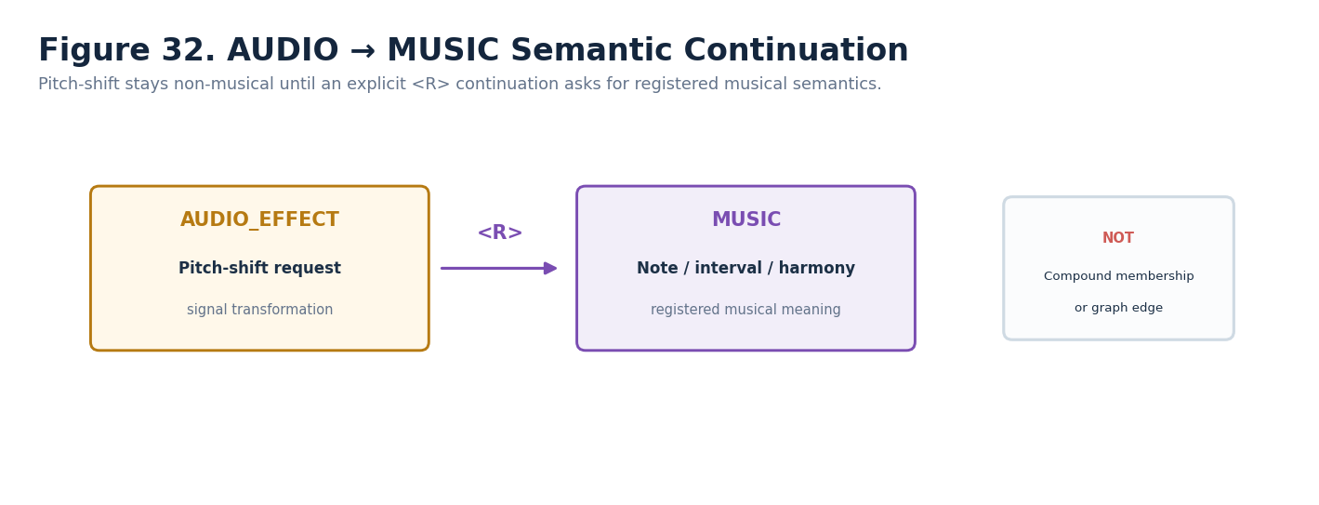
Figure 32. Pitch-shift remains AUDIO semantics until explicit continuation to MUSIC.

38. Conformance Test Matrix
ID | Test | PASS condition
AUDIO-C01 | All-zero word | A1=0 resolves no audio processing request without consulting inactive roles.
AUDIO-C02 | Math/meaning separation | SCALAR-4/8 retain generic identities; changing Reader placement changes semantic meaning without cloning BitGroups.
AUDIO-C03 | Operation vs parameter | A1 FILTERING + B1 CUTOFF differs from A1 FILTERING + B1 RESONANCE.
AUDIO-C04 | Range separation | C1/D1 do not fabricate universal physical units; binding/profile supplies concrete range when needed.
AUDIO-C05 | Frequency region | LOW/MID/HIGH remain semantic regions and do not silently hard-code universal Hz cutoffs.
AUDIO-C06 | Spatial preservation | F1/G1 do not mutate or invent source/listener/venue identity.
AUDIO-C07 | Wet/Dry | H1=184 resolves 184/255 ≈ 0.722.
AUDIO-C08 | Formula locality | M1 selects registered Formula Profile; selector Bits do not embed hidden DSP equations.
AUDIO-C09 | Variation/determinism | K1 SEEDED + N1 SEEDED_DETERMINISTIC replays identically given same inputs/seed.
AUDIO-C10 | Stochastic replay | N1 RUNTIME_STOCHASTIC does not claim exact replay.
AUDIO-C11 | Evaluation | LIVE / SNAPSHOT / SAMPLE_AND_HOLD / EVENT_DRIVEN behave distinctly.
AUDIO-C12 | Null behavior | Missing required spatial/profile input produces declared unresolved/failure behavior; no fabricated value appears.
AUDIO-C13 | AUDIO vs MUSIC | Pitch-shift request alone does not resolve note/interval/harmony semantics.
AUDIO-C14 | D explicitness | No canonical interactive target is activated as Formal until exact D#.# is registered and bound.
AUDIO-C15 | Interface rebuild | Same records reconstruct the same logical controls and targets independent of renderer styling.
AUDIO-C16 | Graph vs Compound | Changing runtime chain order does not rewrite Compound constituent identity.
AUDIO-C17 | Version replay | Historical Candidate/Formal words remain interpretable under their saved Reader/Formula/D contract versions.
AUDIO-C18 | Source preservation | Changing AUDIO state does not rewrite canonical source audio/provenance.

39. Minimum Sufficient Resolution
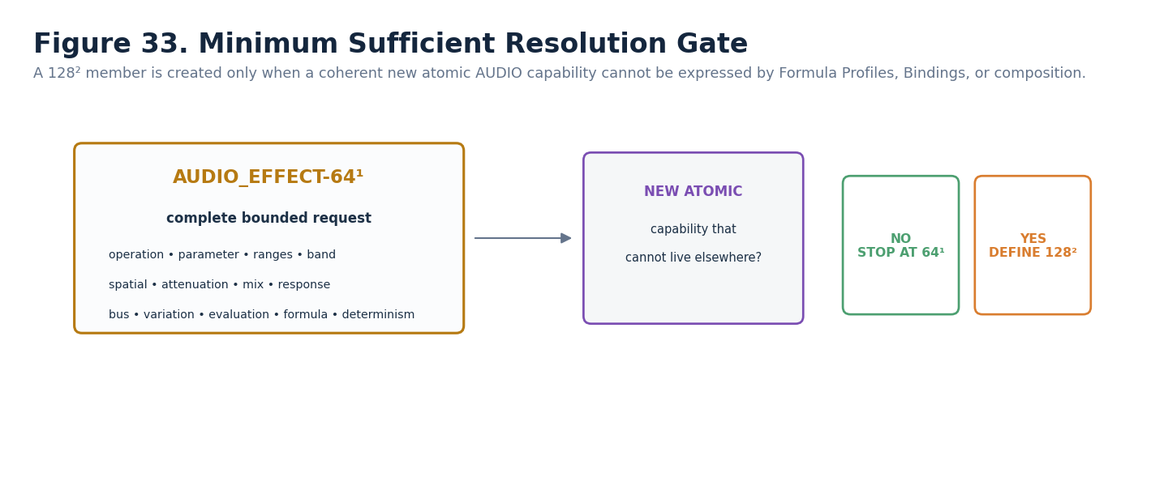
Figure 33. 64¹ stops unless a coherent new atomic AUDIO capability earns a later member.

Part 7 — Implementation Handoff and Promotion Gate

40. Registry-Level Build Requirements
Registry object | Required handoff
Bits | Reuse exact primitive scalar Bits 1,2,4,8 for SCALAR-4 and 1,2,4,8,16,32,64,128 for SCALAR-8 where exact canonical records already exist; create only missing exact primitives during implementation normalization.
BitGroups | SCALAR-4 and SCALAR-8 with canonical formulas and Composition Type metadata. No AUDIO-specific duplicate BitGroups.
Pure BitWord | AUDIO_EFFECT-64¹ with exact B000:B063 physical order.
Placements | A1–O1 exactly as frozen in this Candidate Spec.
Reader | Versioned AUDIO Reader with enumerations, Range semantics, Wet/Dry normalization, validation, Formula Profile selection, determinism, and typed output.
Formula Profiles | Register/reuse exact profiles matching the Candidate semantics selected by M1.
Compounds | None required to define AUDIO_EFFECT itself; larger Effect Assemblies may contain complete AUDIO_EFFECT words.

41. D, BOSS, and COLOR Requirements
Registry | Current Candidate requirement | Promotion condition
D Table | Register exact reusable matches for every DREQ key in Part 4. | Every canonical/default interactive target binds exact D#.#; no interface inference remains.
BOSS | Select/register exact symbols for AUDIO and Reader-role controls where symbols are used. | Every canonical symbol resolves by exact BOSS identity.
COLOR | Select/register canonical interface color/profile records; figure colors here are explanatory projections. | Every canonical color reference is exact and replaceable without changing semantics.
Formula Profiles | Resolve Candidate M1 meanings to exact registered profile identities/versions. | Every executable formula selection is exact, versioned, and inspectable.

42. Deterministic AI / Skill Handoff
Once exact registry structures and D/BOSS/COLOR/Formula Profile records exist, a deterministic assembly Skill may consume this Spec and perform exact search/reuse/create operations. It MUST NOT redesign the bounded question, reinterpret scalar mathematics, choose an interface from D Class alone, invent enum meaning, or silently replace unresolved dependencies.
Assembly stage | Expected operation
Parse Spec | Read physical ranges, Reader roles, enumeration tables, formulas, Candidate D requirements, and tests.
Resolve exact identities | Search registered BIGFOOT/D/BOSS/COLOR/Formula structures for exact matches.
Reuse or create | Reuse exact matches; create only structures explicitly required by this Spec.
Write placements | Assign physical order and Reader addresses exactly as specified.
Bind interface | Attach exact D#.#, BOSS, COLOR, and exact semantic targets after registration.
Validate | Run encoding, Reader, interface, invalid-state, source-preservation, AUDIO/MUSIC separation, and interoperability tests.
Save / trace | Record source Spec version, created/reused identities, and implementation provenance.
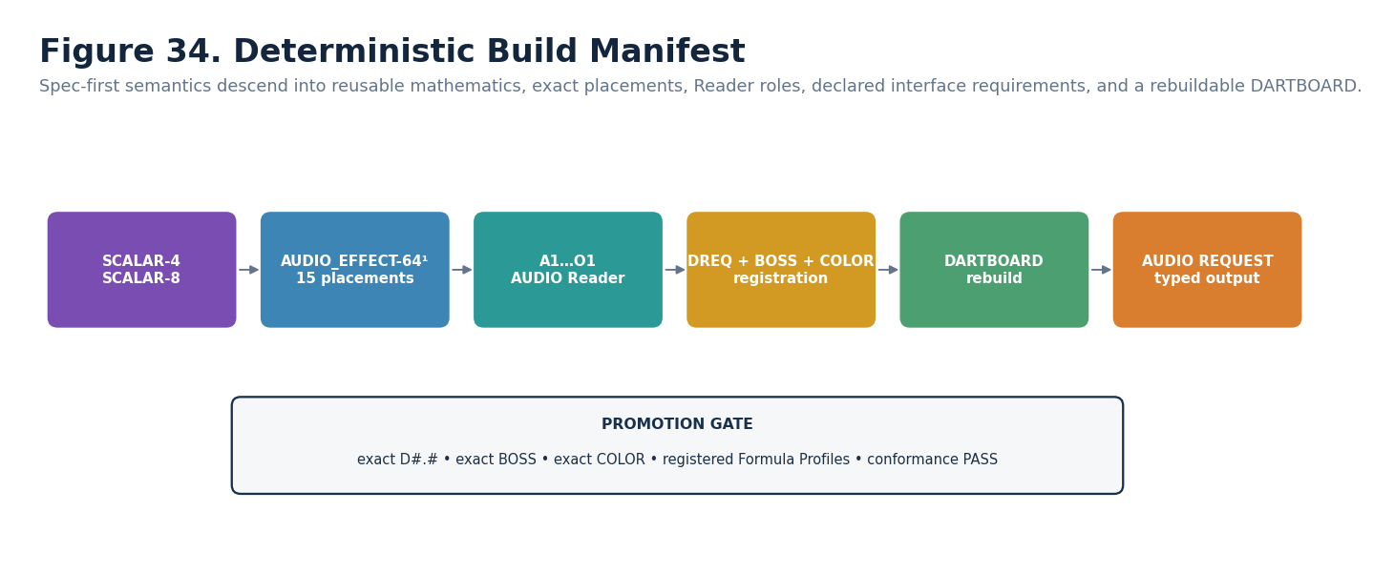
Figure 34. Deterministic implementation path from reusable mathematics to generated DARTBOARD and typed output.

43. Candidate → Formal Promotion Checklist
Gate | Status
Semantic boundary frozen | YES — non-musical audio application question defined.
Bit allocation frozen | YES — B000:B063 allocated.
Reader roles frozen | YES — A1–O1 defined.
Candidate D requirements authored | YES — exact D#.# registration still pending.
Exact BOSS/COLOR bound | PENDING implementation normalization.
Formula Profiles exact | PENDING exact registered identities/versions.
Visual role figures complete | YES — every semantic Reader role has an interface/consequence figure; O1 is explicitly read-only.
Conformance passed | PENDING runtime/registry implementation.
Rebuildability verified | PENDING exact D/BOSS/COLOR registry binding.
CLOSING LAW
AUDIO_EFFECT is powerful because it remains only a renderer-neutral non-musical audio application contract. Source identity stays upstream. Musical meaning stays in MUSIC. Spatial and endpoint identity stay external. Mathematical BitGroups stay reusable. Interfaces are declared rather than inferred. Complexity grows through explicit composition rather than semantic sprawl.

Appendix A — Complete Reader Enumeration Index
Audio Operation Class — A1
0 NO_EFFECT/UNSET; 1 GAIN; 2 FILTERING; 3 SPATIALIZATION; 4 DELAY_LIKE; 5 REVERBERATION_LIKE; 6 DISTORTION; 7 TEXTURE_MODULATION; 8–15 RESERVED
Audio Parameter Target — B1
0 FORMULA/BINDING_DEFAULT; 1 GAIN; 2 CUTOFF; 3 RESONANCE; 4 PAN; 5 PITCH_SHIFT; 6 WET_DRY; 7 DENSITY; 8 SPATIAL_PARAMETER; 9–15 RESERVED
Input Range — C1
0 FORMULA_DEFAULT; 1 NORMALIZED_0_1; 2 SIGNED_NEG1_POS1; 3 ABSOLUTE/PASS_THROUGH; 4 RECTIFIED_NORMALIZED; 5 BOUNDED_PROFILE; 6 EXTERNAL_RANGE; 7–15 RESERVED
Output Range — D1
0 BINDING_DEFAULT; 1 NORMALIZED_0_1; 2 BIPOLAR_NEG1_POS1; 3 RELATIVE_TO_BASELINE; 4 BOUNDED_TARGET_PROFILE; 5 EXTERNAL_RANGE; 6 FORMULA_DEFINED; 7–15 RESERVED
Frequency Band / Region — E1
0 FULL_BAND; 1 LOW; 2 MID; 3 HIGH; 4 BOUNDED_RANGE; 5 PROFILE; 6 EXTERNAL; 7–15 RESERVED
Spatialization Mode — F1
0 MONO_STATIC; 1 POSITIONAL; 2 DIRECTIONAL; 3 PATH_FIELD_BASED; 4 EXTERNAL; 5–15 RESERVED
Distance / Attenuation — G1
0 NONE/FORMULA_DEFAULT; 1 LINEAR; 2 SMOOTH; 3 INVERSE_LIKE; 4 BOUNDED_PROFILE; 5 EXTERNAL_ATTENUATION; 6 MODEL/FORMULA; 7–15 RESERVED
Mix / Wet-Dry — H1
0 → 0.000 fully dry; 64 → 0.251; 128 → 0.502; 184 → 0.722; 255 → 1.000 fully wet
Response / Filter Shape — I1
0 FORMULA_DEFAULT; 1 SMOOTH; 2 STEPPED; 3 PROFILE/MODEL; 4 EXTERNAL; 5–15 RESERVED
Bus / Layer Class — J1
0 DEFAULT; 1 SOURCE; 2 ENVIRONMENTAL; 3 EFFECT; 4 VOICE; 5 EXTERNAL; 6–15 RESERVED
Variation Mode — K1
0 NONE; 1 SEEDED; 2 STOCHASTIC; 3 SOURCE_DERIVED; 4–15 RESERVED
Evaluation Mode — L1
0 LIVE; 1 SNAPSHOT; 2 SAMPLE_AND_HOLD; 3 EVENT_DRIVEN; 4–15 RESERVED
Formula Profile — M1
0 UNSET; 1 SCALAR_TO_GAIN; 2 SIGNED_TO_PAN; 3 SCALAR_TO_FILTER_PARAMETER; 4 VECTOR_TO_SPATIALIZATION; 5 EVENT_TO_AUDIO_IMPULSE; 6 FIELD_TO_SPATIAL_PARAMETER; 7 PATH_TO_SPATIALIZATION; 8 SCALAR_TO_PITCH_SHIFT_REQUEST; 9 SCALAR_TO_TEXTURE_DENSITY; 10 EXTERNAL_AUDIO_FORMULA; 11–15 RESERVED
Determinism Mode — N1
0 DETERMINISTIC; 1 SEEDED_DETERMINISTIC; 2 RUNTIME_STOCHASTIC; 3 EXTERNALLY_DRIVEN; 4–15 RESERVED
Interpretation Version — O1
0 CURRENT_BASE_INTERPRETATION; 1–15 REGISTERED/RESERVED according to future version governance

Appendix B — B000:B063 Reader Summary
Reader | Bits | BitGroup | Meaning
A1 | B000:B003 | SCALAR-4 | Audio Operation Class
B1 | B004:B007 | SCALAR-4 | Audio Parameter Target
C1 | B008:B011 | SCALAR-4 | Input Range
D1 | B012:B015 | SCALAR-4 | Output Range
E1 | B016:B019 | SCALAR-4 | Frequency Band / Region
F1 | B020:B023 | SCALAR-4 | Spatialization Mode
G1 | B024:B027 | SCALAR-4 | Distance / Attenuation
H1 | B028:B035 | SCALAR-8 | Mix / Wet-Dry
I1 | B036:B039 | SCALAR-4 | Response / Filter Shape
J1 | B040:B043 | SCALAR-4 | Bus / Layer Class
K1 | B044:B047 | SCALAR-4 | Variation Mode
L1 | B048:B051 | SCALAR-4 | Evaluation Mode
M1 | B052:B055 | SCALAR-4 | Formula Profile
N1 | B056:B059 | SCALAR-4 | Determinism Mode
O1 | B060:B063 | SCALAR-4 | Version / Reserved
Full per-Bit contributions are listed in Section 30. The summary here is intentionally placement-level for fast implementation reference.

Appendix C — Candidate D Requirement Index
Reader | Semantic role | Candidate D Class | Candidate D requirement
A1 | Audio Operation Class | Categorical Selection | DREQ-CAT.AUDIO_OPERATION
B1 | Audio Parameter Target | Categorical Selection | DREQ-CAT.AUDIO_PARAMETER
C1 | Input Range | Range / Profile Selection | DREQ-RANGE.INPUT_PROFILE
D1 | Output Range | Range / Profile Selection | DREQ-RANGE.OUTPUT_PROFILE
E1 | Frequency Band / Region | Region Selection | DREQ-RANGE.FREQUENCY_REGION
F1 | Spatialization Mode | Spatial Selection | DREQ-SPATIAL.AUDIO_MODE
G1 | Distance / Attenuation | Profile Selection | DREQ-PROFILE.ATTENUATION
H1 | Mix / Wet-Dry | Scalar | DREQ-SCALAR.SLIDER_NUMERIC
I1 | Response / Filter Shape | Profile Selection | DREQ-PROFILE.AUDIO_RESPONSE
J1 | Bus / Layer Class | Categorical Selection | DREQ-CAT.AUDIO_LAYER
K1 | Variation Mode | Policy Selection | DREQ-POLICY.VARIATION
L1 | Evaluation Mode | Evaluation State | DREQ-EVAL.MODE
M1 | Formula Profile | Profile Selection | DREQ-PROFILE.AUDIO_FORMULA
N1 | Determinism Mode | Policy Selection | DREQ-POLICY.DETERMINISM
O1 | Interpretation Version | Metadata Inspection | DREQ-META.VERSION_INSPECT
These keys are Candidate requirements only. They SHALL NOT be represented as exact registered D#.# contracts until the corresponding D records exist and are explicitly bound.

Appendix D — Deterministic Build Checklist
# | Check
1 | Bounded question remains non-musical audio presentation.
2 | A1=0 produces no audio request.
3 | SCALAR-4 and SCALAR-8 are reused rather than cloned under AUDIO names.
4 | B000:B063 physical placement order matches the Candidate Spec.
5 | All fifteen Reader roles resolve through the AUDIO Reader.
6 | H1 resolves w = raw/255.
7 | C1/D1 do not silently invent physical units.
8 | F1/G1 do not own venue/listener/source identity.
9 | M1 resolves to an exact registered Formula Profile before Formal implementation.
10 | K1 and N1 remain distinct.
11 | L1 remains local evaluation, not global timing.
12 | O1 remains inspectable and read-only in the ordinary interface.
13 | Every interactive role binds an exact D#.# before Formal status.
14 | BOSS and COLOR are exact projections, not semantic identity.
15 | Invalid/missing source context remains visibly unresolved.
16 | AUDIO_EFFECT never infers MUSIC semantics from audio values.
17 | Generated DARTBOARD can be rebuilt from registered records and state.
18 | Runtime graph topology remains distinct from Compound membership.
19 | Source audio/provenance remains unchanged unless a separate authorized mutation occurs.
20 | Historical versions remain interpretable.

