CERBERUS EDUCATION ARCHITECTURE
AI-Mediated Learning Networks
University Architecture for Curriculum Routing, Adaptive Study, Collaborative Learning, and Human-Governed Education
● ─ ═ ▦ ⧉ ○ ◎ ◆ ⊛
STEP THREAD CORD SHEET FOLD STUDENT INSTRUCTOR AI MEDIATION COMMONALITY

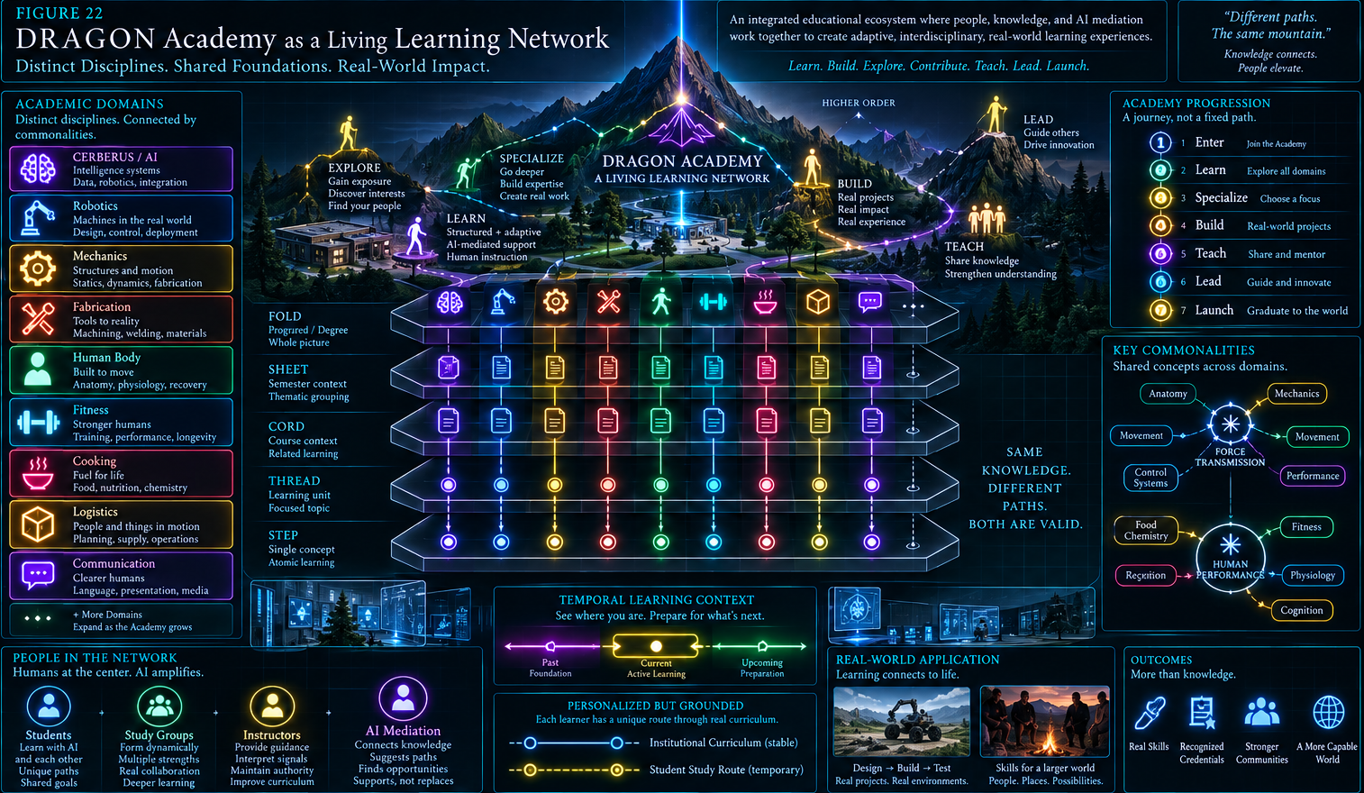
Version 0.1 | OCTOGROOVE PASS 7 CANDIDATE
AI should not replace the university. It should make the university easier to navigate as a living learning network.
Independent research by Shane Conrad | DRAGON Academy reference deployment

Executive Orientation
Universities increasingly possess the ingredients required for highly connected learning - curricula, schedules, readings, assignments, instructors, peer communities, digital resources, and AI systems - but those ingredients are usually exposed to students as separate administrative surfaces. An AI assistant may answer questions about a file or a course while still knowing little about how today's material relates to next week's classes, where prerequisite gaps lie, which other courses are teaching analogous structures, or which willing peers occupy the same learning territory.
AI-Mediated Learning Networks proposes a different institutional architecture. Educational material is represented as structured, traversable context; time is treated as part of the curriculum; AI generates temporary study routes through authoritative educational structure; conceptual commonalities can be discovered across course boundaries; willing students can be clustered into useful study groups; unresolved questions can be escalated to instructors; and formal assessment, curriculum authority, student identity, and credentialing remain governed by humans and institutions.
CENTRAL THESIS
The university should expose the topology of its education to AI, not merely give students a chatbot.

The architecture is broader than tutoring. AI is best understood as an educational router: it connects students to curriculum, recent material, upcoming material, prerequisites, applications, peers, instructors, and other courses. Its value comes from recognizing useful routes between already meaningful educational objects, not from becoming the sovereign source of educational truth.
DRAGON Academy is used as a reference deployment because its curriculum is deliberately interdisciplinary. Robotics, mechanics, fabrication, human anatomy, fitness, cooking, logistics, communication, and CERBERUS/AI create many legitimate cross-domain intersections. The general architecture is not specific to DRAGON; another university or learning institution could map its own programs into the same compositional and governance model.
ORIENTATION LAW
AI MEDIATION != AI AUTHORITY | STUDY ROUTE != CURRICULUM | STUDENT MODEL != STUDENT

Definitive architecture sentence
An AI-mediated university is a governed learning environment in which authoritative curriculum is organized as traversable context, learner-specific and group-specific routes are generated temporarily over that structure, conceptual and social relationships can be discovered without collapsing institutional or personal boundaries, and humans retain authority over instruction, disclosure, assessment, curriculum, and credentials.

Visual Grammar and Paper Map
The figures use a compact recurring grammar so that object identity, relationship type, and temporary state remain visually distinguishable across the paper.
Symbol | Educational object | Symbol | Network object
● | STEP - smallest visible learning unit | ○ | STUDENT - learner in the network
─ | THREAD - coherent bounded learning context | ◎ | INSTRUCTOR - human instructional authority
═ | CORD - composition of Threads | ◆ | AI MEDIATION - routing/resolution node
▦ | SHEET - composition of Cords | ⊛ | COMMONALITY - shared concept across domains
⧉ | FOLD - composition of Sheets | ━ | STUDY ROUTE - temporary active path

Document Map
# | Section | Purpose
1 | From Chatbot to Learning Network | Why educational structure matters more than attaching AI to files.
2 | Curriculum as Structured Context | BOOTSTRAP composition, flexible Threads, and lowest sufficient context.
3 | Temporal Learning and Prospective Tutoring | Recent, current, and upcoming curriculum as one bounded learning window.
4 | Study Routes and Adaptive Navigation | Temporary routes, recovery, convergence, and study order.
5 | Hidden Curriculum Graph and Interest Routing | Derived conceptual relationships and application-driven personalization.
6 | AI-Mediated Social Learning | Study-group discovery, consent, group routes, and peer teaching.
7 | Instructor Mediation and Curriculum Evolution | Aggregated signals, escalation, and governed curriculum improvement.
8 | Assessment, Credential, and Student-Model Boundaries | Formal authority and learner-model separation.
9 | University Learning Server | Institution-scale learning-routing infrastructure.
10 | DRAGON Academy Reference Deployment | Interdisciplinary reference implementation.
11 | Governance and Operational Principles | Core invariants for authority, privacy, uncertainty, and derived knowledge.
12 | Closing Architecture | The university as a living, navigable knowledge environment.

1. From Chatbot to Learning Network
The central transition is from AI beside educational resources to AI operating within a governed structure of learning relationships.
A conventional AI integration often begins with retrieval: upload course files, ask questions, and return answers. That is useful, but it leaves the learner responsible for much of the difficult routing work. The student must still determine which prerequisite matters, whether material in another class is relevant, what to study before next week, whether the same concept is appearing under different vocabulary, and when a question should move from self-study to an instructor.
A learning network changes the unit of integration. The AI receives not only resources but their curricular location, temporal position, relationships, and authority. A reading belongs to a Thread; the Thread belongs to a larger composition; an upcoming lab may depend on material introduced elsewhere; a student may be enrolled in several Cords whose concepts intersect. These relationships make educational context navigable.
The difference is architectural rather than cosmetic. Adding a chat window to a learning-management system still leaves the university represented as separate pages and files. A mediated network exposes the relationships that make those pages part of an education: sequence, dependency, recurrence, application, ownership, temporal position, and human responsibility.
The proposed architecture therefore treats AI as connective infrastructure. It may retrieve, compare, route, explain, cluster, or prepare, but it does not become the owner of the curriculum or the replacement for the instructor. The university remains a human institution. AI supplies a new capacity to see and traverse the institution as a coherent learning system.
This routing view also avoids making the AI the center of the educational diagram. The meaningful endpoints already exist: students, instructors, curriculum, resources, projects, assessments, and communities. The mediation layer is valuable because it can connect them at useful moments while leaving their identities and authorities intact.
NETWORK LAW
INFORMATION ACCESS != EDUCATIONAL CONTEXT

Figure 01 - From Chatbot to Learning Network
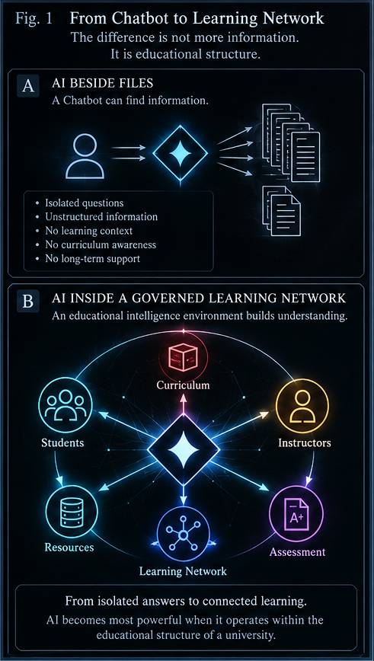
Figure 1. A chatbot beside files can retrieve information; a learning-network mediator can route among curriculum, students, instructors, resources, relationships, and collaborative opportunities without owning those endpoints.

2. Curriculum as Structured Context
The curriculum becomes more useful to both humans and AI when its compositional structure is explicit and its context can expand only as far as the task requires.

2.1 BOOTSTRAP as a compositional grammar
The paper adopts a compact compositional grammar: STEP -> THREAD -> CORD -> SHEET -> FOLD. These are structural levels, not fixed university labels. A conventional deployment might map a Thread to one lesson, a Cord to one course, a Sheet to one semester, and a Fold to one degree, but the architecture does not depend on those exact interpretations.
This distinction matters because educational organizations vary. A research program, apprenticeship, professional certification, interdisciplinary studio, or DRAGON Academy pathway may use different boundaries while retaining the same composition law. Stable composition combined with contextual interpretation allows the same infrastructure to scale from one concept to a multi-year program.
COMPOSITION LAW
COMPOSITION IS STABLE. EDUCATIONAL INTERPRETATION IS CONTEXTUAL.

2.2 Flexible Threads
A Thread is bounded by learning purpose rather than by an arbitrary count of files or links. One Thread may need only a short reading and a problem set. Another may combine a lecture, textbook section, simulation, dataset, worked examples, lab instructions, discussion prompts, instructor notes, and optional enrichment. The educational boundary should determine the amount and type of material.
That flexibility is particularly valuable for AI mediation. The AI can treat the Thread as a coherent instructional context while still distinguishing its internal resources. It does not need to infer from a folder name that ten unrelated files belong together; the institution has already provided a bounded unit of meaning.

2.3 Lowest sufficient educational context
Explicit composition allows context to be loaded progressively. A student asks a question; the AI first inspects the smallest relevant unit. If the current Step is insufficient, it expands to the Thread. If that is still insufficient, it may inspect neighboring Threads, the surrounding Cord, or a related Cord. It stops when the context required for a responsible answer has been reached.
This is important for both efficiency and epistemic discipline. An entire degree does not need to be loaded to answer every question, and larger context should not be treated as inherently better. Context is useful when it contributes meaning to the task. The correct target is not maximum context but sufficient context.
CONTEXT LAW
CONTEXT AVAILABILITY != CONTEXT NECESSITY

Figure 02 - BOOTSTRAP Curriculum Grammar
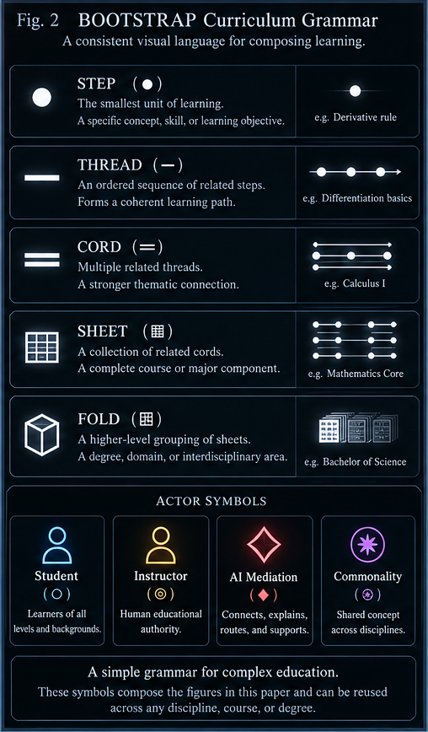
Figure 2. STEP, THREAD, CORD, SHEET, and FOLD provide increasing compositional scale without forcing one universal mapping between structural level and institutional label.
Figure 03 - Anatomy of a Learning Thread
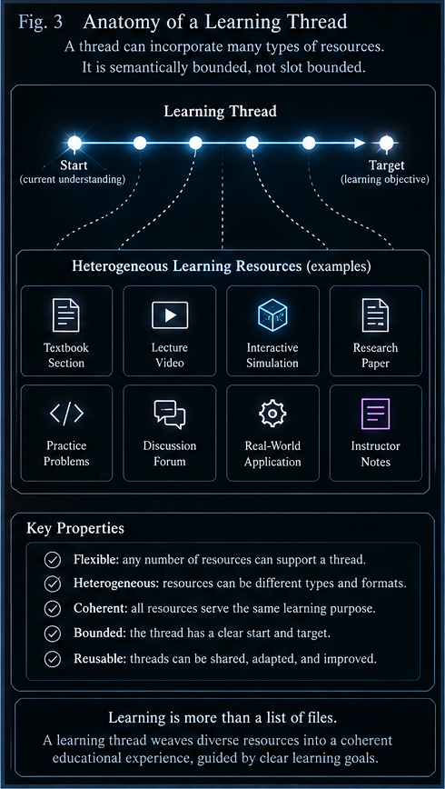
Figure 3. A Thread may draw on heterogeneous learning resources and remain coherent because its boundary is semantic and pedagogical rather than slot-based.
Figure 04 - Lowest Sufficient Educational Context
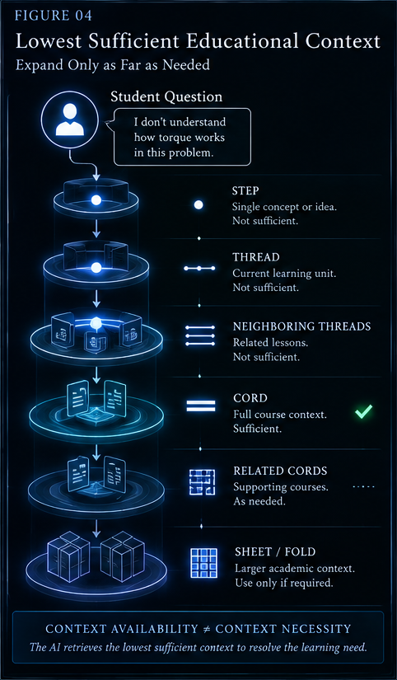
Figure 4. Educational context expands through the compositional hierarchy only until the learning problem can be resolved responsibly; larger available context remains available without being loaded by default.

3. Temporal Learning and Prospective Tutoring
A curriculum is not only structured by subject. It unfolds through time, and an AI can use that temporal structure to prepare rather than merely react.

3.1 The temporal learning window
Students normally experience several courses simultaneously. The useful study problem is therefore temporal as well as disciplinary: what was introduced recently, what is active now, and what will be required over the next several days or weeks? An AI that can read a bounded forward window can reason across this upcoming learning surface.
A practical learning window might include recent material, the current Threads, and the next two weeks of scheduled Threads across the student's enrolled Cords. The exact window is configurable. What matters is that the AI can compare curricular timing rather than treating every course as an isolated archive.
The temporal window supports continuity. A concept introduced last week can be reinforced because it is becoming important again; an upcoming topic can trigger a prerequisite refresher before the student reaches the lecture; several courses approaching the same concept can be studied together. The future curriculum becomes a legitimate source of preparation.

3.2 Prospective tutoring
Most tutoring systems are reactive: the learner asks about a current difficulty and the system responds. Prospective tutoring adds a second question: what is the learner about to need? If matrix multiplication is being introduced now and several upcoming Threads rely on coordinate transforms, coupled systems, graphics transformations, or state-space models, the AI can identify that present topic as unusually high-leverage.
This is not prediction of the student's fate or ability. It is curriculum foresight. The system is reading declared upcoming material and identifying dependencies or commonalities. The student may choose to practice more now because the value of the concept has become clearer.
PROSPECTIVE LEARNING LAW
FORESIGHT IS PREPARATION, NOT PREDICTION.

Figure 05 - The Temporal Learning Window
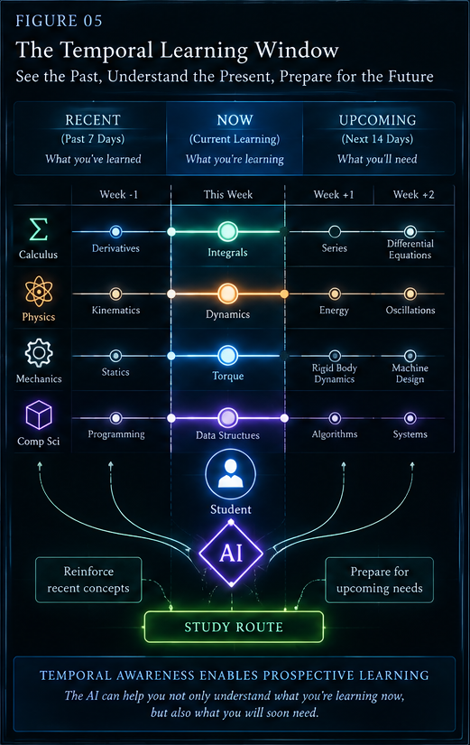
Figure 5. Recent, current, and upcoming curriculum can be considered together so that study decisions reflect continuity and future demand without changing disciplinary identity.
Figure 06 - Prospective Tutoring
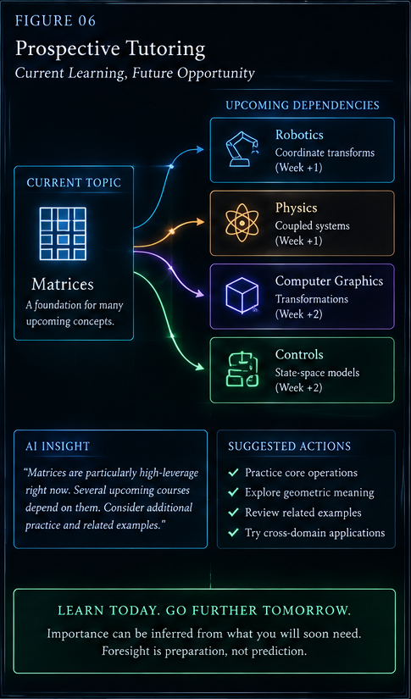
Figure 6. Present learning can be prioritized partly because of explicit upcoming curricular dependencies; the system prepares for future demand without claiming to predict future performance.

4. Study Routes and Adaptive Navigation
Curriculum defines the educational territory. Study Routes provide temporary, learner-specific paths through that territory.

4.1 The Study Route object
A Study Route is generated from several bounded inputs: authoritative curriculum, upcoming Threads, recent learning, available time, learner interests, and current learning observations. The output is not a new curriculum. It is a temporary ordered path through existing educational structure for a particular purpose and moment.
Different routes may serve different purposes. A Preparation Route previews prerequisites for tomorrow. A Recovery Route traces an error backward. A Transfer Route uses one course to reinforce another. A Convergence Route studies several classes around one shared concept. A Review Route revisits older material becoming relevant again. A Project Route gathers the concepts required for a build. These names are explanatory categories rather than mandatory implementation classes.
ROUTE LAW
STUDY ROUTE != CURRICULUM

4.2 Recovery through prerequisites
When a learner fails at a complex problem, the useful response is not always more practice at the same surface level. The system can trace dependencies backward: an incorrect stress calculation may originate in a faulty free-body diagram, which may originate in force decomposition, which may reveal a weakness in vector components. Once the actual gap is identified, practice can be targeted and the learner can return to the original problem.
This creates a causal recovery loop rather than a repetition loop. The system uses the curriculum graph to determine what the current task depends on, and the student receives a route that repairs the supporting structure before moving forward again.

4.3 Cross-course convergence
The strongest advantage of a network view appears when several courses approach related conceptual machinery. Calculus may introduce rate of change, physics may apply it to motion, dynamics may formalize system response, and controls may use it in state change. Administrative boundaries separate those courses, but the learner can benefit from seeing the common structure deliberately.
A commonality node does not imply that the disciplines are the same. Each course retains its vocabulary, methods, assumptions, and domain authority. The common node makes a legitimate shared concept navigable. Repetition across courses can become intentional rather than accidental.
COMMONALITY LAW
COMMONALITY != DISCIPLINARY MERGER

4.4 Curriculum order and study order
Curriculum order is persistent institutional structure; study order is a temporary response to current goals, weaknesses, projects, and future dependencies. A learner may revisit, preview, or apply material without changing curricular authority.
Figure 07 - Study Route Construction
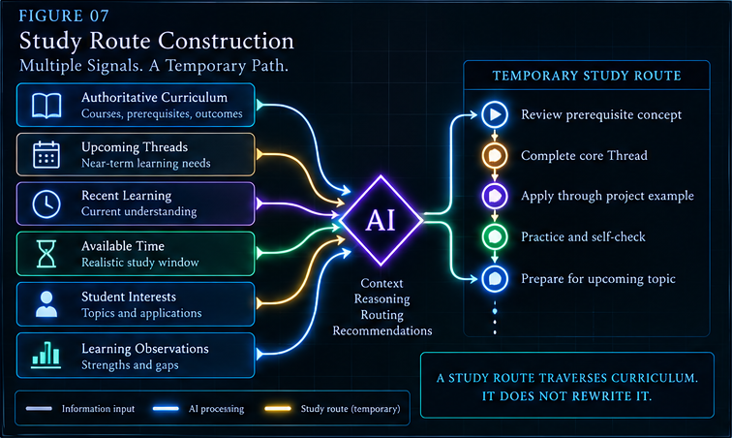
Figure 7. Multiple bounded inputs can be resolved into a temporary Study Route that traverses authoritative curriculum without rewriting it.
Figure 08 - Recovery Through Prerequisites
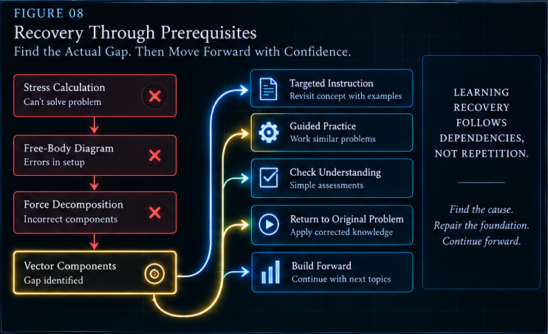
Figure 8. Recovery traces the dependency chain backward to the actual gap, repairs the prerequisite, and then returns the learner to the original problem and forward curriculum.
Figure 09 - Cross-Course Learning Convergence
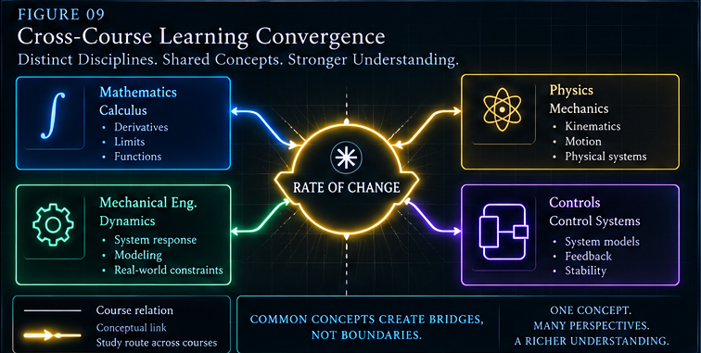
Figure 9. Distinct courses can converge on a neutral shared concept while retaining separate disciplinary identities; a temporary Study Route can deliberately traverse that intersection.
Figure 10 - Curriculum Order != Study Order
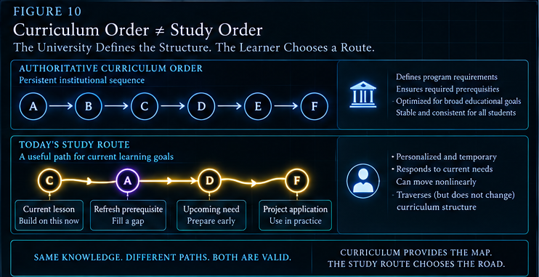
Figure 10. The institution preserves a stable curricular sequence while the learner may follow a temporary route that revisits, previews, or applies selected material for current goals.

5. Hidden Curriculum Graph and Interest Routing
The institution has a declared curriculum, while AI can also expose derived conceptual relationships and application routes that cross administrative boundaries.

5.1 Declared and derived learning graphs
Universities already declare important relationships: prerequisites, co-requisites, course sequences, program requirements, and assessment conditions. Those relationships are authoritative because the institution intentionally defines them. A second graph can be derived from content, practice, expert input, and repeated usage: shared concepts, analogous models, recurring mathematical structures, applications, and cross-course dependencies.
The derived graph can be richer than the catalog, but it must remain distinguishable from declared structure. An AI may notice that vector decomposition appears across mechanics, biomechanics, robotics, and physics, yet that observation does not silently become an official prerequisite. Derived relations inform navigation; institutional relations govern institutional requirements.
GRAPH LAW
DECLARED PREREQUISITE != DERIVED CONCEPTUAL DEPENDENCY

5.2 Interest as a learning router
Personalization need not mean altering what is true or lowering what must be learned. It can change the examples, applications, and routes through which the learner encounters the same required concept. Differential equations can be connected to motor dynamics for a robotics student, population systems for an ecology student, oscillation for a music student, or flight dynamics for an aerospace student.
This form of personalization keeps the common educational core stable while making transfer more meaningful. It can also surface interdisciplinary possibilities: a student may discover a field, project, or peer community because a required concept was routed through an application they already care about.
PERSONALIZATION LAW
PERSONALIZED ROUTE != PERSONALIZED TRUTH

Figure 11 - Declared Curriculum and Hidden Learning Graph
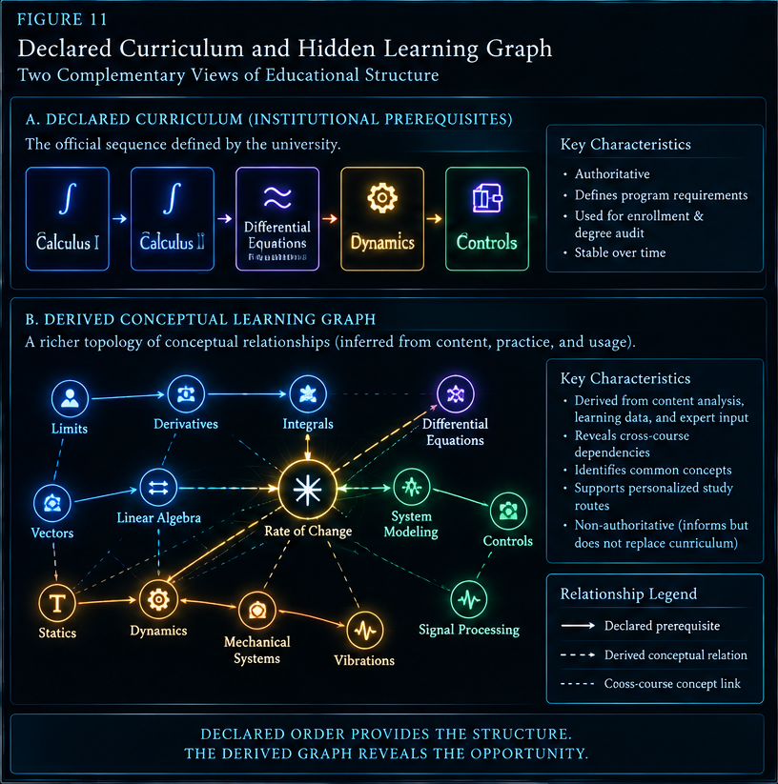
Figure 11. Formal curriculum relations and derived conceptual topology coexist as complementary layers; derived links reveal learning opportunity without impersonating institutional authority.
Figure 12 - Interest as a Learning Router
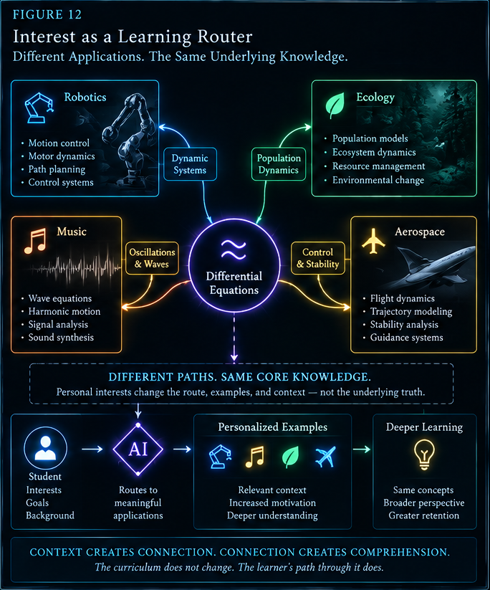
Figure 12. Different interests can generate different application routes into the same governed concept; the curriculum remains shared while context becomes personally meaningful.

6. AI-Mediated Social Learning
Once willing students connect to the same structured curriculum, AI can help discover useful learning communities rather than treating every learner as an isolated endpoint.

6.1 Dynamic study-group discovery
A university-scale system can look for candidate study groups using explicit educational signals: shared upcoming curriculum, current difficulties, complementary strengths, common interests, project needs, compatible availability, or cross-disciplinary overlap. This is much richer than matching everyone enrolled in the same course code.
For example, a mechanical engineering student interested in robotics and needing support with control programming may be well matched with a computing student who understands control software but wants more physical-system intuition, and a physics student studying rotational mechanics. The value comes from the intersection of curriculum, complementarity, and interest.
The matching logic should remain interpretable. Students should be told why a group is suggested rather than being silently clustered by an opaque similarity score. A proposed group is a temporary possibility, not a permanent social classification.

6.2 Consent before disclosure
A potential match must not automatically disclose student identities. The system can privately determine that several consenting users occupy compatible learning territory, send invitations independently, and reveal the group only after relevant participants opt in. A declined invitation simply ends that route.
This separation is especially important when learning models, schedules, or interests contribute to matching. The fact that the system can compute a useful social possibility does not grant permission to expose the underlying data or the identities of other students.
SOCIAL BOUNDARY
POSSIBLE MATCH != DISCLOSURE != MEMBERSHIP

6.3 Group Study Routes
Once a study group exists, the AI can generate a route for the group as a whole. A session may begin with an independent diagnostic, move to comparison of approaches, assign explanation roles, introduce a shared challenge, apply the concept to a project, and collect unresolved questions for instructor review. Different members can benefit from different parts of the same session.
The AI does not need to dominate the meeting. Its best role is logistical and pedagogical coordination: keep the group on a useful path, bring in the right resources, balance participation, and recognize when human expertise is needed.

6.4 Peer teaching as a learning operation
Explaining a concept, challenging another explanation, comparing methods, and applying an idea to a new case are valuable forms of practice. AI mediation can deliberately create these human activities rather than replacing them with generated answers. A learner who understands equations but lacks intuition may benefit from a peer who explains the physical picture; that peer may strengthen their own understanding by teaching it.
The social-learning architecture therefore treats students as contributors to one another's learning. The AI routes roles and resources; the students reason, explain, question, and build shared understanding.
Figure 13 - Dynamic Study-Group Discovery
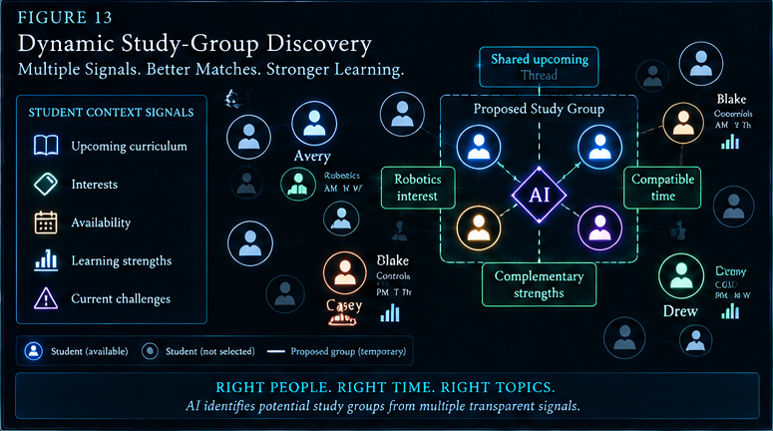
Figure 13. Candidate study groups can emerge from multiple transparent signals such as curriculum overlap, interest, availability, and complementary strengths while remaining temporary proposals.
Figure 14 - Matching Possibility != Social Disclosure
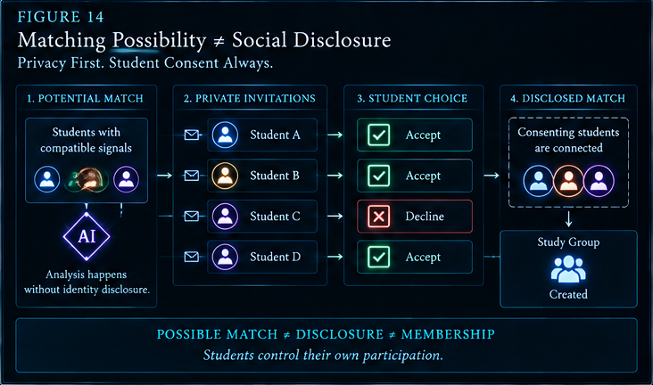
Figure 14. Candidate matching can occur privately, while identity disclosure and group membership require explicit student choice.
Figure 15 - AI-Generated Group Study Route
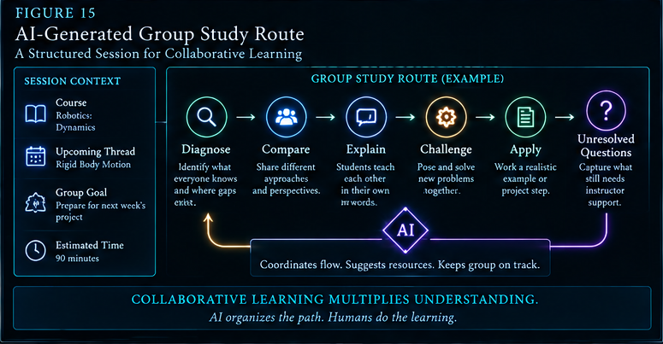
Figure 15. AI can structure a collaborative session around diagnosis, comparison, explanation, challenge, application, and unresolved questions while humans perform the learning activity.
Figure 16 - Peer Teaching as Learning Activity
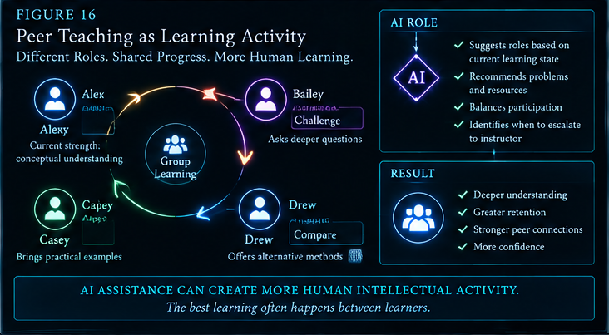
Figure 16. Peer roles such as explain, challenge, compare, and apply can be intentionally routed so that AI mediation strengthens human learning interaction.

7. Instructor Mediation and Curriculum Evolution
AI can surface patterns and unresolved questions to instructors without replacing professional judgment or turning education into surveillance.

7.1 Instructor learning intelligence
At class scale, the system can aggregate educational signals that are difficult for an instructor to observe manually: repeated clarification requests, prerequisite difficulties, unresolved questions, cross-course connections, or topics generating unusually high engagement. These signals are evidence for professional judgment, not automated verdicts about the instructor or the students.
The most useful view is instructional rather than surveillance-oriented. Instead of ranking individual students, the system might report that many learners are confusing two concepts, that a prerequisite is repeatedly failing, or that several related courses are encountering the same issue. The instructor can decide whether to reteach, reorganize, add an example, coordinate with another instructor, or leave the curriculum unchanged.
INSTRUCTOR LAW
DATA INFORMS. PEOPLE TEACH.

7.2 Question escalation and curriculum improvement
A governed question path begins with the most local authoritative material. The AI checks the current course context, related curriculum, and approved supplementary sources. If the question remains unresolved, the correct outcome is not fabrication. The unresolved state itself becomes useful information and can be routed to an instructor.
An instructor answer may resolve the student's immediate question and, when appropriate, become a governed improvement to the course corpus. If many students encounter the same uncertainty, the institution gains evidence that a missing explanation, example, or sequencing problem may exist. Learning difficulty can feed curriculum improvement without allowing AI uncertainty to masquerade as knowledge.
ESCALATION LAW
UNABLE TO RESOLVE != PERMISSION TO FABRICATE

Figure 17 - Instructor Learning Intelligence
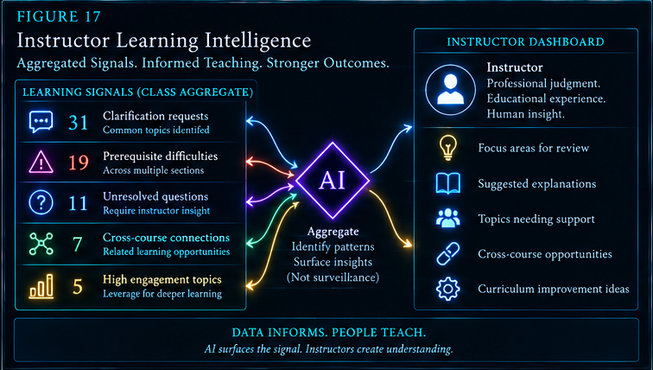
Figure 17. Aggregated learning signals can help instructors identify class-wide needs and cross-course opportunities without converting the system into individual behavioral surveillance.
Figure 18 - Question Escalation and Curriculum Improvement
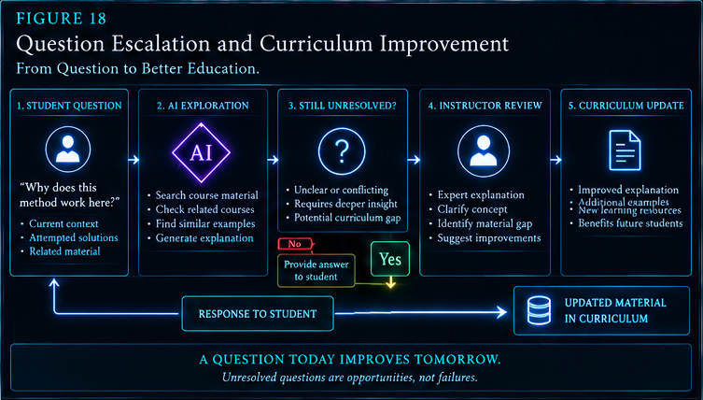
Figure 18. Unresolved questions move from student to AI exploration to explicit uncertainty to instructor review; governed responses can improve future curriculum.

8. Assessment, Credential, and Student-Model Boundaries
AI may support learning extensively while formal judgment, institutional credentials, and the identity of the learner remain distinct from machine-generated observations.

8.1 Practice, assessment, and credentials
AI can provide enormous amounts of rehearsal: practice questions, worked examples, oral questioning, simulated cases, explanation exercises, flashcards, diagnostics, and project suggestions. It can also support formative assessment by identifying likely gaps and giving immediate feedback. Formal summative assessment and credentials occupy a different authority layer.
The architecture separates exposure, competence, assessment, and credentialing. Reading the full instructional structure of a degree does not make an AI a graduate of that degree, just as encountering course material does not automatically prove a student's competence. A university credential remains an institutional act tied to declared assessment and professional conditions.
This distinction allows AI to be deeply integrated without making it the credentialing sovereign. The system can help a student become competent while the university retains responsibility for deciding when competence has been demonstrated according to the program's rules.
CREDENTIAL BOUNDARY
EXPOSURE != COMPETENCE != ASSESSMENT != CREDENTIAL

8.2 Curriculum != Student Model
The curriculum describes shared educational structure: what the institution teaches, how concepts are defined, which relationships are declared, and what outcomes are expected. A student model is different. It contains provisional observations about one learner in one context: current difficulty applying torque, recent success with vectors, an indicated interest in robotics, or a preference for collaborative practice.
Those observations must remain revisable and time-dependent. A temporary struggle must not become a permanent machine identity such as "bad at mathematics." A model may help choose a study route, but it does not define the person. An AI prediction does not become a grade, and a study recommendation does not become a requirement merely because it was generated confidently.
The system should preserve a strong asymmetry: curriculum can be stable and institutionally governed; learner observations remain contextual, evidence-based, and easy to revise or discard. Personalization should open opportunities, not close them.
HUMAN MODEL LAW
OBSERVATION ABOUT PERFORMANCE != IDENTITY OF PERSON

Figure 19 - Practice, Assessment, and Credential Authority
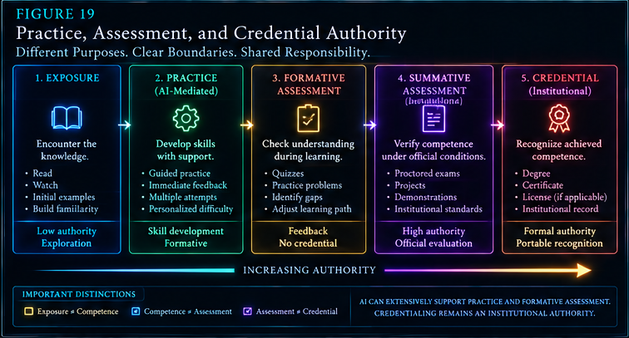
Figure 19. AI support can be extensive in practice and formative learning while formal assessment and credential authority remain institutionally governed.
Figure 20 - Curriculum != Student Model
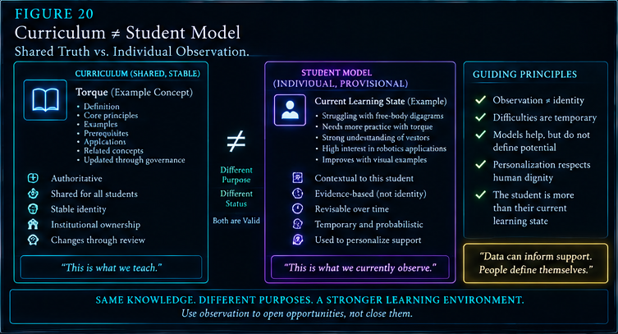
Figure 20. Shared curriculum is a governed institutional object; the student model is an individual, provisional, revisable support structure and must not be treated as the learner's identity.

9. University Learning Server
At institutional scale, the architecture becomes a shared learning environment connecting curriculum, relations, student context, human education, and AI mediation.

9.1 Institutional architecture
A university can host the authoritative learning corpus and expose bounded context to students and AI systems through a common institutional service. The service does not need to centralize every educational action in one interface. Its essential function is to preserve the shared structure that allows different tools, courses, instructors, and students to operate over the same governed educational map.
The curriculum region stores compositional educational structure. A knowledge-relations region carries declared prerequisites and separately labeled derived commonalities or applications. Student context records enrollment, schedule, current learning observations, interests, availability, and collaboration preferences under appropriate privacy controls. Human education includes students, temporary groups, and instructors. AI mediation connects these regions through retrieval, reasoning, routing, matching, analysis, and resource suggestion.
The AI layer should not sit above the system as a control tower. It sits between governed sources and human destinations. The institution controls the curriculum and credential system; instructors exercise professional judgment; students control social participation and personal disclosure; AI performs bounded mediation among them.

9.2 One practical deployment sequence
Stage | Capability | Purpose
1 | Structure curriculum | Publish courses, Threads, Steps, and temporal location in a traversable representation.
2 | Bound retrieval | Load the lowest sufficient context rather than arbitrary whole-corpus access.
3 | Add Study Routes | Generate temporary preparation, recovery, review, transfer, and project routes.
4 | Add conceptual relations | Keep declared dependencies and derived commonalities explicitly separate.
5 | Add opt-in social learning | Enable private candidate matching, student consent, and temporary group routing.
6 | Add instructor intelligence | Aggregate educational signals and route unresolved questions to instructors.
7 | Integrate formal boundaries | Keep summative assessment, credentials, and student-model governance explicit.

INSTITUTIONAL BOUNDARY
THE SERVER HOSTS THE LEARNING ENVIRONMENT. AI ROUTES THROUGH IT.

Figure 21 - University Learning Server
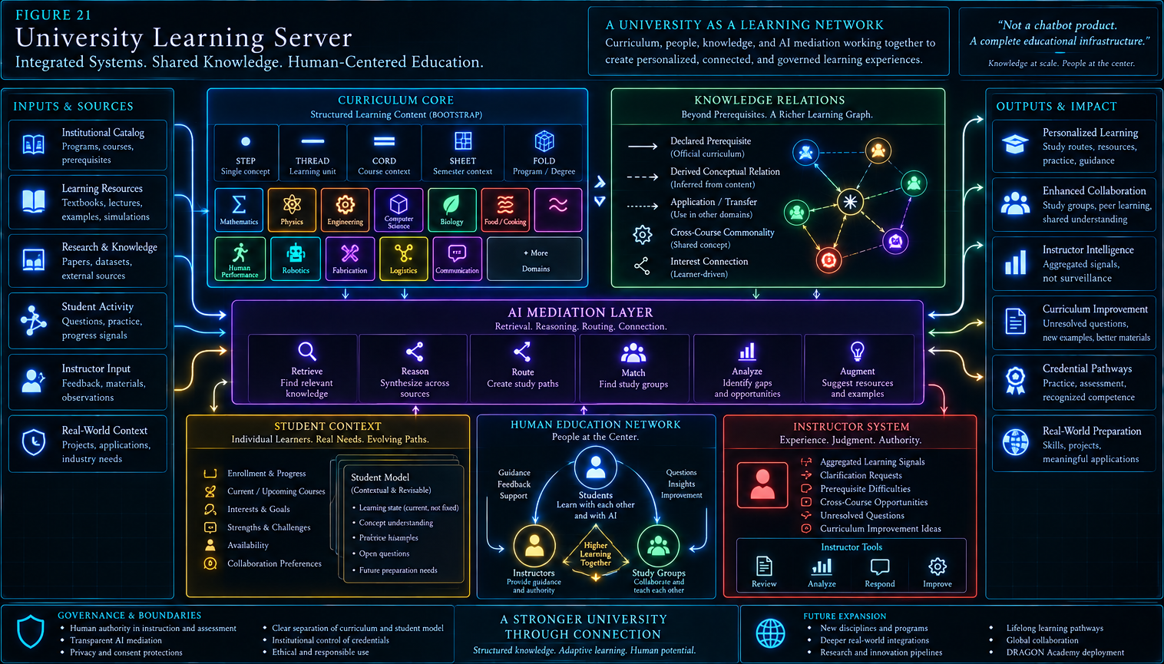
Figure 21. The institution hosts a governed learning network in which curriculum, knowledge relations, learner context, instructors, students, and AI mediation remain distinct but interoperable.

10. DRAGON Academy Reference Deployment
DRAGON Academy provides a natural proving ground because its learning environment is intentionally interdisciplinary and project-oriented.

10.1 Distinct disciplines, shared foundations
DRAGON Academy can organize its educational territory using the same compositional grammar while allowing each disciplinary Cord to retain its own identity. CERBERUS/AI, robotics, mechanics, fabrication, human body, fitness, cooking, logistics, and communication do not need to collapse into one synthetic subject. The learning network instead makes their legitimate intersections explicit and traversable.
Force transmission can connect anatomy, mechanics, robotics, and movement. Human performance can connect food chemistry, cooking, nutrition, fitness, recovery, and physiology. Systems reasoning can connect CERBERUS, robotics, logistics, planning, and communication. These commonalities can support projects and study routes while the disciplines remain responsible for their own methods and truth conditions.
The temporal learning window is especially useful in an Academy environment. A learner approaching a fabrication project can be routed back through relevant mechanics, forward into machine-operation requirements, sideways into safety or logistics, and into a study group with peers whose strengths complement the task. The same learner may later teach part of that route to newer students, turning peer explanation into a deliberate part of the educational network.

10.2 Progression through a living network
DRAGON can use this architecture across broad exposure, learning, specialization, building, teaching, leadership, and launch into the wider world. Those stages are not merely a fixed ladder of course codes. They are different ways of traversing a growing network of knowledge, practice, people, projects, and responsibility.
Because the general architecture is not specific to DRAGON, the deployment also functions as a demonstration. If the same routing, temporal, social, and governance principles work across a dense interdisciplinary Academy, they can be adapted to more conventional universities, professional schools, research programs, or public educational networks.
DRAGON DEPLOYMENT LAW
DISTINCT DOMAINS REMAIN DISTINCT WHILE THE LEARNING ENVIRONMENT BECOMES TRAVERSABLE.

Figure 22 - DRAGON Academy as a Living Learning Network
Figure 22. DRAGON Academy demonstrates the architecture as an interdisciplinary learning ecology: stable domains, temporal curriculum, temporary Study Routes, human instructors, student groups, and AI mediation cooperate without collapsing their identities or authorities.

11. Governance and Operational Principles
The architecture becomes useful only if routing capability grows alongside explicit boundaries for authority, uncertainty, privacy, and institutional responsibility.

11.1 Core invariants
Invariant | Operational consequence
AI mediation != AI authority | AI may retrieve, route, compare, and suggest without becoming the curriculum owner, instructor, assessor, or credentialing institution.
Study Route != Curriculum | A route is temporary and learner-specific; curriculum is persistent and institutionally governed.
Declared relation != Derived relation | Official prerequisites and program rules remain distinguishable from inferred conceptual relationships.
Matching possibility != Disclosure | Candidate social matching can be computed privately; identity disclosure requires student consent.
Student model != Student | Learning observations are contextual and revisable; they do not define the person.
Practice != Credential | AI-mediated rehearsal and formative support do not grant institutional credentials.
Unresolved != Fabricated | When authoritative context is insufficient, the system preserves uncertainty and escalates appropriately.
Domain commonality != Domain merger | Shared concepts can connect courses without erasing discipline-specific semantics and methods.

11.2 Student agency
Students should be able to see why a route, resource, or study group is being recommended and to decline it without penalty. Personal interests may help route examples or opportunities, but they should not silently constrain what a learner is allowed to study. Study recommendations are assistance, not hidden requirements.
Social features require stronger agency. A learner may opt into some forms of discovery and not others, such as same-course groups, cross-disciplinary project groups, exam review, peer tutoring, or interest-based collaboration. The institution should not equate technical matchability with permission to expose personal learning information.

11.3 Instructor and institutional authority
Instructors remain responsible for professional interpretation of class-level signals, explanation of unresolved material, and pedagogical judgment within their role. Institutions remain responsible for program structure, formal assessment rules, credentials, privacy policy, and governance of the learning corpus. AI can make those structures more legible without taking their authority.
This is the architectural reason to prefer AI as router rather than sovereign. The more capable the mediation layer becomes, the more important it is to preserve the distinction between finding a path and owning the territory through which the path runs. AI finds routes; humans and institutions own educational authority.

12. Closing Architecture
The long-term opportunity is not a better chatbot beside the university; it is a university whose knowledge, people, and time can be navigated as one governed learning network.
A student entering such an environment does not face five unrelated course silos and a generic assistant. The system can see that a concept learned yesterday will matter in two classes next week, that another course provides a useful analogy, that a prerequisite should be refreshed before tomorrow's lab, that several peers have opted into the same learning territory, and that one unresolved question should reach an instructor rather than be improvised by the model.
An instructor gains a complementary view. Instead of receiving only grades and office-hour anecdotes, the instructor can see aggregated educational patterns: repeated misconceptions, missing prerequisites, unresolved questions, cross-course opportunities, and places where the curriculum is not behaving as intended. The AI does not decide what to teach; it makes the learning environment easier to inspect and respond to.
At university scale, the institution acquires something more interesting than a course-management system: a living map of how its education actually connects. Administrative programs remain necessary, but the network can reveal conceptual bridges, recurring structures, temporal dependencies, and interdisciplinary opportunities that course catalogs alone do not express.
The architecture therefore reframes AI in higher education. The important question is not whether an AI can imitate a lecturer or whether a student can ask it questions. The important question is what becomes possible when the institution exposes the complete bounded structure of learning - curriculum, time, relationships, human roles, and governance - to a mediation system capable of routing across it.
CLOSING THESIS
THE AI DOES NOT EARN THE DEGREE, OWN THE CURRICULUM, OR REPLACE THE UNIVERSITY. IT HELPS PEOPLE NAVIGATE THE KNOWLEDGE, PEOPLE, AND OPPORTUNITIES THE UNIVERSITY ALREADY CONTAINS.

Architecture in one line
Structured curriculum + temporal awareness + bounded learner context + explicit relationships + human-governed AI mediation -> adaptive study, stronger collaboration, better instructor visibility, and a more connected university.

Figure Index
Fig. | Title | Architectural role
1 | From Chatbot to Learning Network | Transition from isolated retrieval to connected educational routing.
2 | BOOTSTRAP Curriculum Grammar | STEP -> THREAD -> CORD -> SHEET -> FOLD compositional scale.
3 | Anatomy of a Learning Thread | Variable-resource learning context bounded by meaning.
4 | Lowest Sufficient Educational Context | Progressive context expansion with an explicit stop condition.
5 | The Temporal Learning Window | Recent, current, and upcoming curriculum considered together.
6 | Prospective Tutoring | Current emphasis informed by future curricular dependencies.
7 | Study Route Construction | Temporary route generated over authoritative curriculum.
8 | Recovery Through Prerequisites | Backward dependency tracing and forward repair.
9 | Cross-Course Learning Convergence | Distinct disciplines connected through a neutral commonality.
10 | Curriculum Order != Study Order | Persistent institutional sequence versus temporary learner route.
11 | Declared Curriculum and Hidden Learning Graph | Official relations separated from derived conceptual topology.
12 | Interest as a Learning Router | Different applications, same governed conceptual core.
13 | Dynamic Study-Group Discovery | Transparent multi-signal candidate clustering.
14 | Matching Possibility != Social Disclosure | Consent boundary before identity disclosure and membership.
15 | AI-Generated Group Study Route | AI coordination of collaborative learning activity.
16 | Peer Teaching as Learning Activity | Human explanation, challenge, comparison, and application.
17 | Instructor Learning Intelligence | Aggregated instructional signals without surveillance framing.
18 | Question Escalation and Curriculum Improvement | Explicit unresolved state, instructor review, and governed improvement.
19 | Practice, Assessment, and Credential Authority | Separation of rehearsal, assessment, and credentials.
20 | Curriculum != Student Model | Stable shared curriculum versus provisional learner observations.
21 | University Learning Server | Institution-scale integration of curriculum, relations, humans, context, and AI.
22 | DRAGON Academy as a Living Learning Network | Reference deployment across interdisciplinary learning domains.

OctoGroove Pass 7 Composition Record
Field | Status / Output
Pass 7 - COMPOSE | Candidate assembled for whole-document verification.
Content architecture | Integrated into twelve publication sections.
Figure set | F01-F22 composed in sequence from the approved Pass 6 Wave outputs.
Visual grammar | BOOTSTRAP, actor, commonality, temporal, route, social, and governance motifs preserved.
Primary boundaries | AI authority, curriculum/route, declared/derived, match/disclosure, student/model, and assessment/credential distinctions retained.
Next gate | Pass 8 verification: render, inspect, verify terminology and figure integrity, then approve or revise.

